General Specification for refurbishment works at Mill Marsh Play Area
This specification is to be read with the Conditions of Contract, Working Arrangements, Contract Timetable, Assessment Criteria and Notes of Clarification as these are issued from time to time before and during the Contract. Such documents will form part of the specification for the works.
Background
The play equipment in Mill Marsh Park was installed in February 2010. It is a popular attraction and utilized daily by local families and visitors to the park. The equipment is inspected on a regular basis and maintenance carried out to ensure the equipment is safe to use. Due to the age of the equipment and the problem obtaining spare parts this is becoming increasingly difficult.
The refurbishment and replacement of the existing play equipment must enable greater consideration of the needs of all children with emphasis being placed on inclusive play equipment.

1. Site Location – Mill Marsh Park, St John's Lane, Bovey Tracey TQ13 9AL (geography.org.uk – 1716059.jpg)
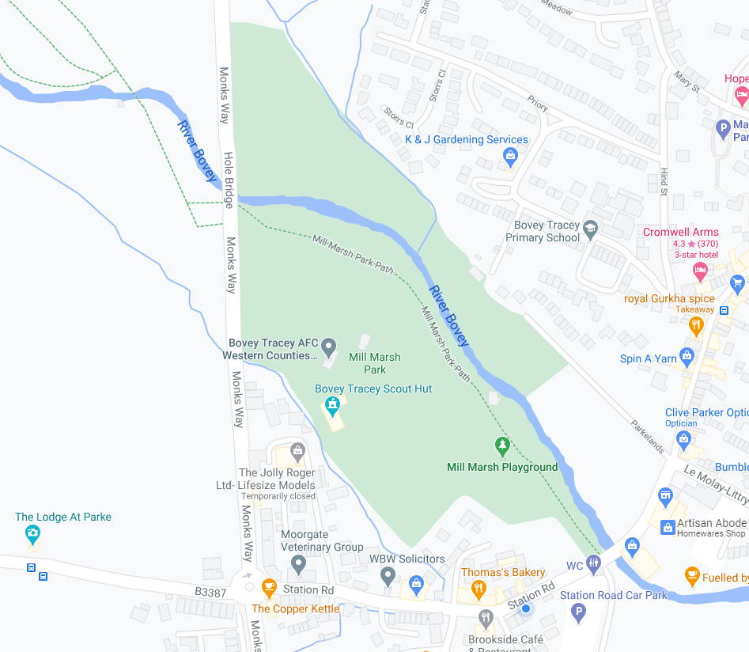
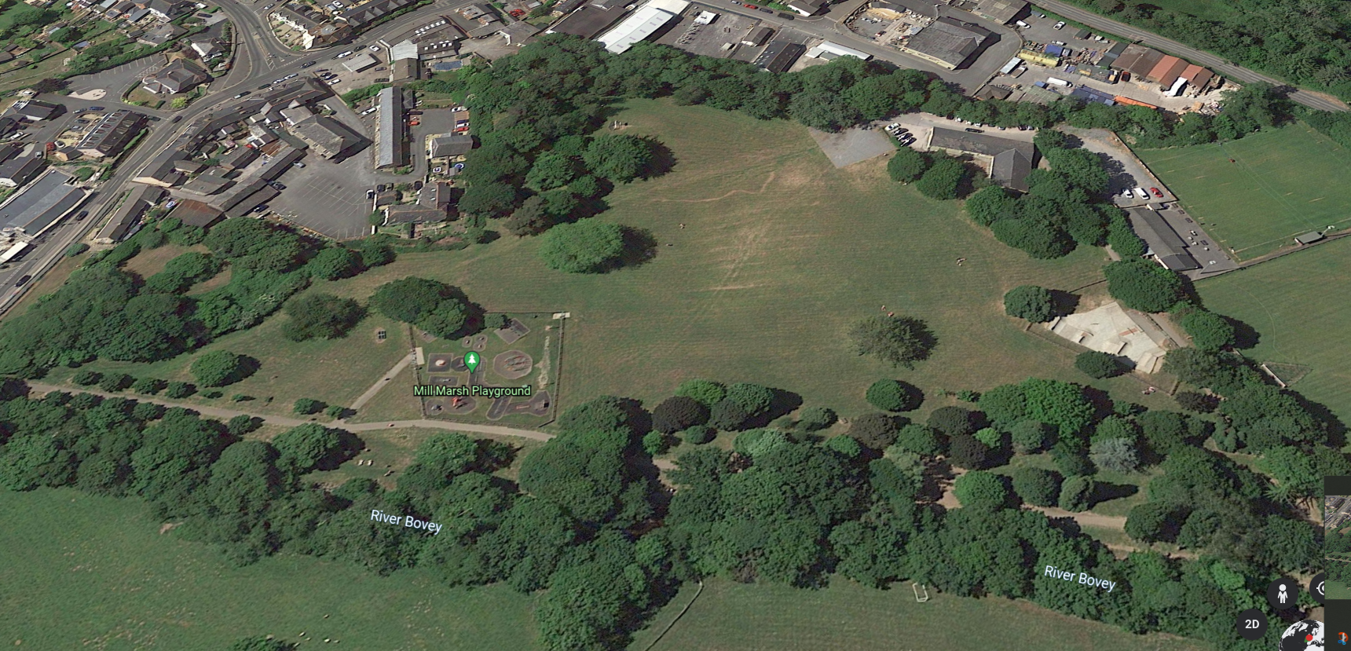

2. Usage

Age groups – Wide age range from pre-school through to teens (but these groups could be accommodated in different zones/areas)

Social issues – Some vandalism and general anti-social behaviour by teens but less than UK norm.

Consultation – Some consultation has taken place but further consultation involving the local primary schools and families in the area will be undertaken. Contractors will be provided with the results of consultation to date to inform their proposals.
3. Site features of note
Topography – The park land is flat, there is a designated play park area aimed at primary school children and a separate skate park. There is a pathway running through the park with grass laid either side. At the far end of the park there is a designated parking area and a Scout hut. The Town’s football club have their pitch adjacent to the park.

Vegetation – Grassland and longstanding and newer trees

Natural water bodies – River running down one side of the park

Constraints – There are some issues during the winter months with water running off from the Moorland and the occasional risk of flooding from the river in the park. The Park is a functional Flood Plain.

Traffic/busy roads – The park area is enclosed away from traffic

Site Access – large vehicle access is available at the Scout Club entrance (festivals, concerts etc. are held in the park)

4. Design and Build approach.
The purpose of this Specification is to generally define the Standards and outcomes to be achieved, rather than define the precise design or type of equipment provided. We therefore require the contractor to produce a set of proposals for the site that will meet the highest standards of safety, whilst also maximising the play value of the site. Adequate provision must be made for children of all age groups and abilities, as well as for parents/ carers. Whilst the Council does not wish to constrain design proposals, in its consideration of the site, the Council has clear views on some of the constraints and inclusions it wishes to see. These include;

    - Existing equipment to be upgraded where possible (unless at the end of its life span, <4 years)
    - New equipment to be made from the low carbon range.
    - The existing Play area is to be extended to the South East beyond the current fence line.
    - A dedicated toddler/pre-school play zone is to be included.
    - More challenging equipment for young teenagers must be included.
    - Imaginative play must be incorporated and proposals that include a unifying theme would be welcomed.
    - The site must include secure fencing preferably metal, designed to provide a safe barrier and to enhance the appearance of the site.
    - All equipment must be underlain with safety surfacing which must be fully water permeable. Please note, loose bound surfaces, such as bark, would not be deemed acceptable.

Contractors should be aware that the area is on a flood plain. Access across the play area must be as advised in the notes of clarification.

Tenderers have the opportunity within their plans, detailed drawings and Method Statements to explain how they will ensure that the Council’s requirements as defined in the assessment criteria will be achieved.

5. Design Principles
Meet community needs – Bovey Tracey is a growing community with many families, two primary schools and several pre-schools and nurseries. The Local Plan identifies numerous new residential developments for the area. Most residential developments will provide small pocket parks only. We are keen to create environments in the park for younger children as well as more physical opportunities for older children and teens.
Consultation to date has identified that there needs to be 2 distinct play zones one for younger and one for older children with both areas incorporating inclusive play equipment. We are keen to encourage fitness and are open to different design concepts such as obstacle courses, parkour, climbing features etc. The zip wire has proved to be popular, and this type of equipment should be included in the refurbishment.

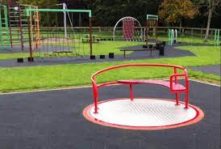

Consider environmental impact – Having declared a climate emergency in Bovey Tracey and Heathfield, the Council is keen to minimise any adverse impact on the environment and will prioritise proposals which include sustainable equipment.
Make use of space – Any proposals will need to make efficient use of the space available. Mill Marsh Park covers a large area, but the area set aside for equipped play must be designed in such a way that it does not prevent use for the wide variety of events that use the park.
Reuse of existing play equipment The Council is willing to discuss how some of the existing equipment can be recycled as part of a new design, however some of the equipment is nearing the end of its lifespan.
Create opportunities to build/explore/create to meet the needs of all children

6 Tender Process

The form of tender will be a Design and Build and has been offered in two stages. The first stage was a request from suitably qualified companies to register expressions of interest (EOI) in the work. Those registering interest were provided with draft documentation including conditions of contract, site details and a broad specification for the works. The Council is open to companies to suggest amendments to this specification that may enhance play value. These must still meet the Council’s requirements in the areas listed in the draft documents. To facilitate an opportunity for supplier involvement in setting the shape of the final tender a meeting was held with those interested parties who responded to the EOI. This was in accordance with the draft timetable attached. This also provided prospective suppliers with the opportunity to more fully understand the nature of the site and the priorities of the Council.

Following these meetings, and taking account of feedback from potential suppliers, the Council then modified its draft documentation and advertised for invitations to tender (ITT). Please note that all prospective suppliers who completed the EOI were not required to formally respond to the ITT. Parties who have not previously expressed an interest may, nonetheless, apply through the ITT process.

At this stage a prequalification questionnaire (PQQ) will be issued to all respondents to the ITT as part of the final tender documents. This will be part of the Council’s due diligence process and relates to issues of financial viability etc. Only those parties that meet the requirements of the PQQ will be invited to tender (The Shortlisted Companies). Those on the shortlist who are invited to tender will be allowed four weeks to complete and submit their proposals. This will be followed by a period during which the Council may wish to seek clarification and a further opportunity to submit final proposals. Contract evaluation and award will follow. It is intended at this stage to allow a mobilisation period from contract award to a start on site. At this stage it is envisaged that a letter of intent will be issued to the successful tenderer on 10th July 2023 an award will be made on 1st August 2023, with an on-site start date of 11th September. This will give contractors a nine-week lead time from letter of intent to start on site.

7. Nature of the tender/ approach to evaluation

Please refer also to the Council’s assessment criteria document which will form part of this specification for the works. It is proposed to apply the UK Government’s Crown Commercial services Guidance on awarding contracts - The Public Contracts Regulations 2015 & The Utilities Contracts Regulations 2016 as part of its contract evaluation. Specifically, the Council will apply the “Most Economically Advantageous Tender” (MEAT) approach. The Council will take into account a wide range of characteristics as award criteria and will evaluate the cost-effectiveness of tenders through life-cycle costing. This will be done through a best price-quality ratio (BPQR) assessment.

BPQR means price or cost plus other criteria. As set out in Regulation 67(2) of
the 2015 Regulations, ‘such other criteria’ will include qualitative, environmental
and social aspects.

Regulation 67(3)(b) provides for taking into account the organisation, qualification
and experience of staff assigned to performing the contract. It is the Council’s view that, in this case, the quality of the staff assigned will have a significant impact on the level of performance of this contract.

In order to minimise the wider societal costs impacted by this work the Council will apply Life Cycle Costing (LCC), i.e. as set out in Regulation 68(1), LCC will cover the following costs over the life cycle of the product, service or works, (to the extent that they are relevant):

(a) Costs, borne by the contracting authority or other users.
(i) costs relating to acquisition,
(ii) costs of use, such as consumption of energy and other resources,
(iii) maintenance costs,
(iv) end of life costs, such as collection and recycling costs;
(b) costs imputed to environmental externalities linked to the product, service or
works during its life cycle.

Please note that the Council has declared a climate emergency, and so will apply Regulation 68(2) which adds that the costs mentioned in Regulation 68(1)(b) may include the cost of emissions of greenhouse gases and of other pollutant emissions and other climate change mitigation costs.

For the assistance of prospective suppliers, the Council has specified, in the procurement documents, the relative weighting which it gives to each of the criteria chosen to determine the most economically advantageous tender.

The Council intends to specify a short Price Range ( detailed in accompanying documents) for the works to include all necessary design costs, regulatory compliance expenses, ground works, including drainage, site protection and reinstatement, provision and installation of equipment, surfacing, fencing, seating, ancillary shelters, bins, landscape works and all other works associated with the provision of a safe and ready to use facility for children’s play. All tenders must fall within this range. Tenders offering additional benefits, but which exceed the price range, will not be considered. Similarly, savings against the price range will not be taken into account in the tender evaluation process.

8. Specific requirements

Potential suppliers will be required to demonstrate within their proposals how these will meet the following technical and value criteria;

- Safety and avoidance of exposure to harm
- Play value
- Aesthetics and design
- Educational value
- Sustainability
- Inclusivity

1) Safety and avoidance of exposure to harm (See also Play England publication “Managing risk in play provision – Implementation Guide”)
Basic requirements – all equipment to comply with BS EN 1176 2020 Playground Equipment and Surfacing, Gates and Fences. Layout and design to follow recommendations of Design Council “Design Out Crime – A designers Guide”. All equipment, seats, fences etc. to be vandal resistant. Parent / carer accommodation to allow surveillance to be comfortable and sheltered.
Added value – surveillance equipment, alarms, first aid / resuscitation on site, communications systems, wireless connectivity.

2) Play value (see also Play England publications Design for Play and Quality in Play)
Basic requirements – Layout design and equipment to provide physical and cognitive challenge for a range of age groups. Equipment to stimulate imagination and provide both individual play opportunities and to encourage cooperation between groups. Opportunities to engage in play based cardiovascular and resistance exercise. A range of more challenging equipment to enable skills development over time, e.g. climbing wall. Proposals to include unusual / exciting opportunities for older children.
Added value – modular systems to enable new play experiences and to replace under used equipment with new and exciting challenges. Equipment to enable basic construction / creative skills to be developed. Opportunities to enable children to reconnect with nature. Utilisation of landscape features to provide play opportunities.

3) Aesthetics and design (see also Play England publication Design for Play)
Basic requirements – Sympathetic integration of new provision into the existing area to avoid any indication of “add on” provision. Design to respect the nature of the public park environment avoiding the impression of having been “dropped in” Design to maximise social interaction and facilitate supervision.
Added value – Thematic approach and design to reflect a coherent play journey aimed at sequential movement through opportunities to exercise different muscle groups and to stimulate imagination. Integration of play with carer / parent provision and opportunities for children’s social interaction. Avoidance of hard “zoning” Inclusion of exercise opportunities for adult carers / parents to use whilst overseeing their children’s play.

4) Educational value
Basic requirements – instruction / advice on use of equipment delivered to be comprehensible without the use of formal language. Designs to stimulate imagination, develop and stretch physical attributes and to create opportunities to develop social skills.
Added value – Thematic representation of the local area to introduce a sense of place and ownership to children from a young age. Learning tablets to develop motor skills and introduce children to the concept of technology and nature.

5) Sustainability
Basic requirements – As mentioned above, a whole life cost approach is taken by the Council. Suppliers must, therefore, provide evidence from their environmental impact assessments of their equipment’s manufacturing and installation, including safety surfacing toxicity impacts. Evidence of sources should be provided, with re-cycled, sustainably sourced and ethically produced materials used wherever possible. Suppliers should be able to demonstrate the various life spans of all products used to enable an accurate “whole life cost” calculation to be made.
Added value – The inclusion of equipment aimed at encouraging sustainable behaviours by users, e.g. bicycle stores, recycling waste bins. CO2 mitigation measures within the design and layout, planting, mini SUDS etc.

6) Inclusivity
Basic requirements – Equipment and layout must reflect an effective understanding of how user groups having differences in age, gender, race & culture and sensory, emotional and physical characteristics, can engage with equipment provided. The aim should be a combination of age-appropriate zoning, (E.g. separate toddlers play area) together with integration delivering similar levels of excitement and risk for all, whilst ensuring protection from harm.
Added value – Detailed consideration of everyday issues from a range of user viewpoints. For example, points of entry, low access equipment, multi-use, alternative systems of allowing moving equipment to be operated, accessible signage, progressive challenge.

7) Technical and construction requirements
The Council recognises that each play equipment manufacturer has its own set of technical specification for manufacture and installation. These specifications must be included with the contractor’s proposals for all items of equipment, surfacing, fencing and furniture, together with a copy of the Safe Operating Procedures for all operations to be undertaken on site. This must include proposals for the protection of the public during operations, and a named person responsible for ensuring compliance with the Construction, Design and Management Regulations 2015 All manufacturers’ specifications for each item to be supplied / installed must comply with relevant British Standards. Where they do not, then an alternative item (or component part), complying with the relevant BSI standard must be provided and installed at no additional cost. All compliant specifications will become part of the contractual specification for the work, whether or not they have been specifically agreed by the client.

The contract sum for all works within this tender is £210,000 Proposals should include a breakdown of costs for each element of the works. The Council reserves the right to accept all or part of the proposals and to commission additional works through Contract Variation order if deemed necessary by the Council.

