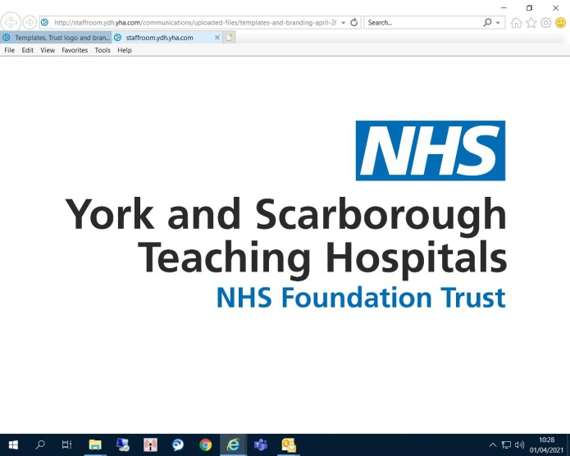

York & Scarborough Teaching Hospital NHS Foundation Trust

Wigginton Rd, Clifton, York YO31 8HE

07/08/2023

By Email – [mike.li@nhs.net](mailto:mike.li@nhs.net)

Dear Sirs

**Funeral Service Provision – Lot 1. York & Lot 2. Scarborough *–* Call for competition: FTS contract notice reference number – FTS-008384 *–* Invitation to Tender**

York and Scarborough Teaching Hospitals NHS Foundation Trust is issuing an invitation to tender ("**ITT**") in connection with a competitive procurement of Funeral Services. The ITT comprises the following documents:

|  |  |
| --- | --- |
| **Section A – Instructions and Information** | |
| 1 | Introduction and Background |
| 2 | Tender Timetable |
| 3 | Instructions to Bidders |
| 4 | Tender Evaluation Methodology and Criteria |
| Annex A1 | NHS Terms and Conditions |
| **Section B – Tender Schedules (to be returned by Bidders)** | |
| Annex B1 | Eligibility Questions and Responses |
| Annex B2 | Specification |
| Annex B3 | Tender Response Document |
| Annex B4 | Commercial Schedule |
| Annex B5 | Confidential and Commercially Sensitive Information |
| Annex B6 | Administrative Instructions |
| Annex B7 | Form of Tender |

Copies of these documents are enclosed.

The response documents in Section B of the ITT must be submitted via <https://health-family.force.com/s/Welcome> no later than 12:00:00 AM on 11/09/2023.

If you have any queries relating to this ITT, please see the contact details set out in Section A of the ITT.

Yours faithfully



Mike Li

Senior Buyer & Category Specialist

(Medical and Surgical)

For and on behalf of

York and Scarborough Teaching Hospitals NHS Foundation Trust