

www.gov.uk/naturalengland

Request for Quotation for Cromer Shoal Chalk Beds MCZ Chalk Ecology Video Analysis.

## 

## November 2022

## Imagery Data Analysis for Cromer Shoal Chalk Beds MCZ

You are invited to submit a quotation for the requirement described in the specification below.

Please confirm, by email, receipt of this document and whether you intend to submit a quote.

Your response should be returned to Shannon Cameron at following email address by:

Email: shannon.cameron@naturalengland.org.uk

Date: 25th November 2022

Time: 1700

Ensure you state ‘RFQ Final Submission’ in the subject field to make it clear that it is your response.

**Contact Details and Timeline**

Shannon Cameron will be your contact for any questions linked to the content of the RFQ or the process. Please submit any questions by email and note that, unless commercially sensitive, both the question and the response will be circulated to all tenderers.

|  |  |
| --- | --- |
| **Action** | **Date** |
| Date of issue of RFQ | 11 November 2022 |
| Deadline for clarifications questions | 24 November 2022 |
| Deadline for receipt of Quotation | 25 November 2022 |
| Intended date of Contract Award | 28 November 2022 |
| Intended Contract Start Date | 01 December 2022 |
| Intended Delivery Date / Contract Duration | 31 March 2023 |

### 

### Glossary

Unless the context otherwise requires the following words and expressions used within this Request for Quotation shall have the following meanings (to be interpreted in the singular or plural as the context requires):

|  |  |
| --- | --- |
| “Authority” | Means the Department for Environment, Food and Rural Affairs acting as part of Natural England |
| “RFQ” | Means this Request for Quotation and all related documents published by the Authority and made available to suppliers |
| “Contract” | Means the contract to be entered into by the Authority and the successful supplier. |

### Conditions applying to the RFQ

You should examine your response to the RFQ ensuring it is complete prior to submitting your completed quotation.

Your quotation must contain sufficient information to enable the Authority to evaluate it fairly and effectively. You should ensure that you have prepared your quotation fully and accurately and that prices quoted are arithmetically correct for the units stated.

The supplier by submitting a quotation is deemed to accept the terms and conditions in the RFQ. Failure to comply with the instructions set out in the RFQ may result in the supplier’s exclusion from this procurement.

### Acceptance of Quotations

By issuing this RFQ the Authority does not bind itself to accept any quotation and reserves the right not to award a contract to any supplier who submits a quotation.

#### Costs

The Authority will not reimburse you for any costs and expenses which you incur preparing and submitting your quotation, even if the Authority amends or terminates the procurement process.

#### Mandatory Requirements

The RFQ includes mandatory requirements and, if you do not comply with them, your quotation will not be evaluated.

#### Clarifications

The Authority reserves the right to discuss, confidentially, any aspect of your quotation with you prior to any award of Contract to clarify matters.

#### Amendments

The Authority may amend the RFQ at any time prior to the deadline for receipt. If it amends the RFQ the Authority will notify you in writing and may extend the deadline for receipt in order to give you a reasonable time in which to take the amendment into account.

#### Conditions of Contract

The Natural England Standard Condensed Terms and Conditions[1] will be included in any contract awarded as a result of this RFQ process. The Authority will not accept any material changes to these terms and conditions proposed by a supplier.

#### Specification

The Authority is Natural England. The Authority’s priorities are to secure a healthy natural environment; a sustainable, low-carbon economy; a thriving farming sector and a sustainable, healthy and secure food supply. Further information about the Authority can be found at: <https://www.gov.uk/government/organisations/natural-england>.

### About Natural England

Natural England (NE) is the government’s advisor on the natural environment. We provide practical advice, grounded in science, on how best to safeguard England’s natural wealth for the benefit of everyone. Our remit is to ensure sustainable stewardship of the land and sea so that people and nature can thrive. It is our responsibility to see that England’s rich natural environment can adapt and survive intact for future generations to enjoy.

### Project Background

The Cromer Shoal Chalk Beds Marine Conservation Zone (CSCB MCZ, Figure 1) along the north Norfolk coast is one of the most ecologically significant Marine Protected Areas for chalk habitats in the UK and Europe. It was designated in 2016 as part of Tranche 2 of the MCZ designation process under the Marine and Coastal Access Act (MCAA) 2009.

The MCZ was designated for nine chalk, rock, and sedimentary habitats, and one geological feature. The conservation objectives for those features were set as ‘maintain in favourable condition’ based on best available evidence at the time.

Subtidal chalk is a geomorphological feature comprising exposed chalk beds and outcrops. This feature is of significance because of the reef habitat the outcrops provide, and the associated communities that are attracted by the rocky substrate.

As part of NEs ongoing work at the site we are looking to obtain further understanding of the ecological reliance on the subtidal chalk feature. Attributes of the subtidal chalk feature at CSCB MCZ relevant to this work are listed below:

* Physical structure of rocky substrate
* presence and spatial distribution of biological communities,
* species composition of component communities, and
* non-native species and pathogens.

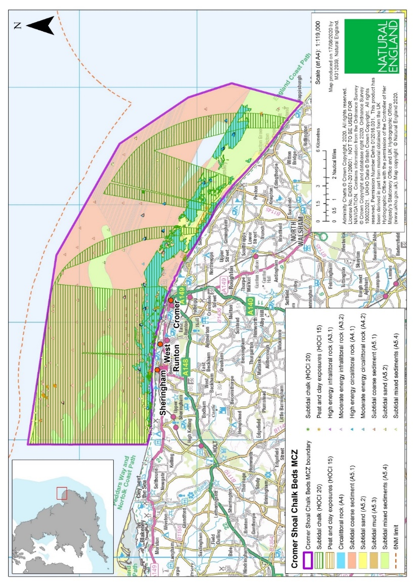

**Figure 1**: Cromer Shoal Chalk Beds Marine Conservation Zone Designation Map

### Project Aim and Objectives

This RFQ is for the analysis of seabed imagery from a nearshore survey undertaken by Eastern IFCA during the summer of 2022 within the CSCB MCZ.

The primary aims of the EIFCA survey focused on characterising the geological aspects of the site in order to determine the location and extent of rugged chalk features, and to record and characterise any incidents of anthropogenic damage to subtidal chalk. This evidence will inform an Adaptive Risk Management approach to understanding the impacts of the potting fishery on designated features within the site[2]. However, Natural England wish to further utilise the data collected to improve our knowledge of the biological communities present.

Through this contract Natural England therefore aim to obtain an assessment of benthic habitats, to include descriptions of the epifaunal communities observed and their association with subtidal chalk habitat categories of varying complexity.

The overarching objectives of this contract are to analyse and report on the Remotely Operated Vehicle (ROV) video footage collected by EIFCA in summer 2022. The specific objectives of the required analysis and reporting are as follows:

* As far as possible, identify and enumerate (using semi-quantitative methods) and record all taxa observed.
* Identify biotopes and map habitat types present to the highest EUNIS classification possible, likely to be EUNIS level 4.
* Where subtidal chalk is present, identify and map the structural complexity of the feature based on the following habitat categories adapted from O’Dell & Dewey (2022):
  + Absent - chalk not observed;
  + Pebble/cobble - chalk particles of between 4 – 256 mm diameter;
  + Pavement - flat chalk bedrock or veneered chalk;
  + Boulders - large chalk boulders on bedrock or sediment;
  + Rugged - elevated and complex chalk features formed by outcropping bedrock.
* Produce a concise, evidence based technical report detailing the findings including a written summary of the features and communities identified.
* Discuss results in the light of any previous data. If drawing upon “expert judgement” in addition to the collected and analysed data, this must be clearly identified and presented separately from the core results of this survey work.
* Provide all data to the relevant standards set out below including GI and Marine Recorder data.

### Acquired Data

Video footage was collected during the survey using a, high-definition low light colour camera (1080p, 30 frames per second) mounted on the Blue Robotics BlueROV2[3]. Details of image acquisition equipment used in this survey and acquisition methods can be found in Appendix 2.

### Areas surveyed by Eastern EIFCA are displayed in Figure 2. A total of 177 ROV transects were completed over 12 days and across 140 stations. The stations surveyed included 130 habitat stations (potting gear absent) and 10 gear stations (potting gear present. This work generated approximately 13.5 hours of seabed footage (based on an average duration of 3 minutes per habitat survey and 10 minutes per gear survey).

An example of the data acquired can be viewed online, here: [EIFCA Blue ROV2 in Cromer Shoal Chalk Beds MCZ - YouTube](https://www.youtube.com/watch?v=ebNZUhZMLGQ)

Survey and GI data will be provided as excel files. Video footage will be made available through BIIGLE[4] and can be provided as MKV or MP4 files.

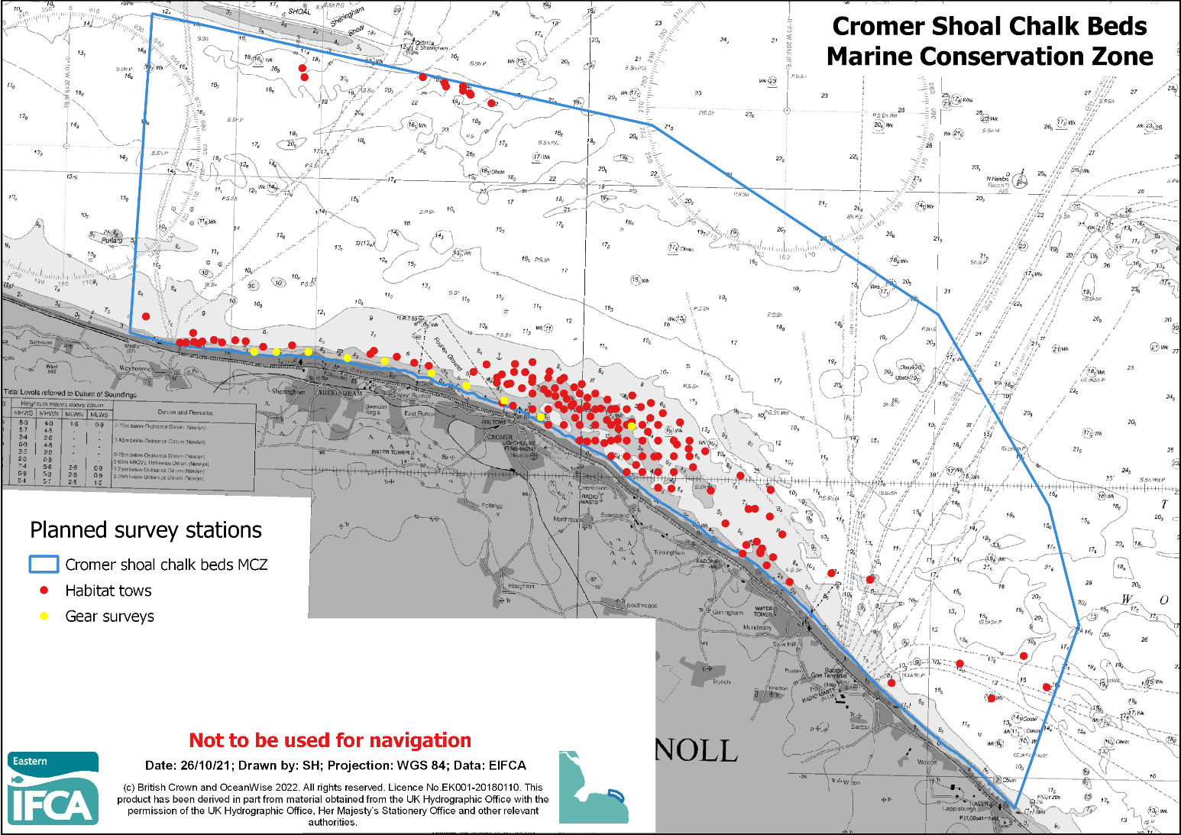**Figure 2**: 2022 planned ROV survey stations in Cromer Shoal Chalk Beds MCZ. Habitat surveys are shown in red and gear surveys in yellow. Please note that not all habitat surveys were completed, and an updated map will be provided prior to contract start.

### Imagery analysis

Data must be interpreted and analysed in consideration of the overarching objectives stated above (3. Project Aim and Objectives), and results presented in a way that is comparable with previous surveys (i.e., O’Dell and Dewey 2022).

**Video imagery analysis:**

* Segment video footage based on changes in habitat type, including changes in chalk habitat category.
* Assign dominant rock type and chalk habitat category (with an assessment of confidence) to each segment of seabed footage. Annotations should be made in BIIGLE using whole frame annotations. This data should also be supplied in table format as an appendix to the report.
* Assign habitats to highest possible EUNIS level, or where possible to level 4 biotope complexes using EUNIS guidance (Davies et al, 2004).
* Identify, quantify, and record all taxa to the lowest possible taxonomic level using either the SACFOR scale together with MNCR abundance guidance (Connor & Hiscock, 1996), or counts where the SACFOR scale was deemed inappropriate. In cases where taxa cannot be identified to a specific genus or species, a higher taxonomic classification should be used.
* In addition to annotations in BIIGLE, video imagery analysis data should be summarised in the report and presented appropriately in figures / tables.
* Catalogue species of conservation interest. These include any species mentioned in the following lists: UK Biodiversity Action Plan priority species or habitats, UK Species of Conservation Importance, nationally rare or scarce marine species (UK), IUCN Red List vulnerable species and any species protected by the OSPAR Convention.

### Project Deliverables

1. *Project Report*

Both the Draft (and Final Report) format will be provided on contract award, but will include:

1. Introduction
2. Details of all methodologies, survey strategies and analyses employed
3. Results, including comparison with existing data obtained by Natural England during site identification, or any other significant data sets for the site
4. Section on any particular species / communities of conservation interest encountered
5. Section on chalk characteristics observed
6. Conclusions and any recommendations

NE are to be provided with two electronic copies of the final report in MS Word and Adobe PDF formats.

**NE will publish this report in accordance with our Technical Publication Guidance**. Please refer to available guidance for writing Natural England Technical publications (<http://publications.naturalengland.org.uk/publication/5790636781600768>)

The intellectual property rights and copyright for all outputs will lie with Natural England. All data will be made available by Natural England under the [Open Government Licence](http://www.nationalarchives.gov.uk/doc/open-government-licence/) at the end of the project via the MEDIN Data Archiving Centres. For further information see:

<https://assets.publishing.service.gov.uk/government/uploads/system/uploads/attachment_data/file/901862/NE-terms-of-use.pdf>.

1. *Presentation*

A virtual presentation to Natural England and Eastern IFCA Staff upon completion of the project to include full methods and results. Please note the presentation will be recorded.

1. *GIS Shapefiles and Metadata*

Data must be additionally provided as ArcGIS files including layer files and raw data in MS Excel format should be provided.

Tenderers should pay particular consideration to the data and GIS required formats for information compatibility including MEDIN metadata standards and Marine Recorder provision:

* All biological (taxon) data must be entered into the JNCC Marine Recorder database by the contractor if data quality allows. A Snapshot file of the data should also be provided. <https://www.esdm.co.uk/marine-recorder>
* All GIS datasets need to be provided in ESRI ArcGIS format compatible with ArcGIS 10.2.2 and have attached metadata.
* The MESH metadata catalogue should be populated for all mapped data collected.
* All GIS files containing habitat data for each individual survey need to be produced to the MESH translated habitat Data Exchange Format (DEF) to the most detailed EUNIS habitat level possible. MNCR (v15.03) data should be added to the ORIG_HAB column. The GUI provided by Natural England for each survey will be used, and as much information as possible (e.g. survey name, originally assigned feature/habitat name etc.) from the original dataset, as well as any documentation provided (where available) should be included in the resulting datasets to maintain a useful audit trail. As specified in the MESH DEF, data files must be provided as ESRI Shapefiles using geographic coordinates (lat/long) and the WGS84 datum. If the datasets supplied are in other projections, transformation using the appropriate petroleum (EPSG) transformation should be carried out as part of the data formatting procedure.
* If not included in the GIS data layers listed above all sampling locations, vessels tracks, and links to data obtained should also be included as a single GI layer.
* Natural England endorses the MEDIN initiative. Any data gathered/derived as part of this project must be submitted to Natural England in a way which expedites the MEDIN data archiving process through Data Archive Centres (DACs) with metadata meeting the MEDIN metadata discovery standard (MEDIN discovery metadata standard). A MEDIN compliant metadata XML file must be provided. Natural England will supply the ‘MEDIN guidance for contractors’ document to successful contractors.

### Project Timeline

|  |  |
| --- | --- |
| **Event** | **Date** |
| Intended Contract Start Date | 01 December 2022 |
| Draft report and associated products | 04 February 2023 |
| Final report, GI products, and all other outputs (including Marine Recorder and Medin data) | 28 February 2023 |
| Contract Completion Date | 31 March 2023 |

Any delays to this timetable should be discussed with NE project lead.

It is requested that the Tenderer provide an indicative timescale for delivery of all deliverables within their Tender proposal, including whether it meets the Project Timeline outlined above.

It is anticipated that this contract will be awarded for a period of four months to end no later than **31 March 2023**. Prices will remain fixed for the duration of the contract award period. We may at our sole discretion extend this contract to include related or further work. Any extension shall be agreed in advance of any work commencing and may be subject to further competition.

**Quotation Submission**

Tenderers must submit the Form of Tender as provided in Appendix 1 as a cover sheet to their tender document.

Tenderers must submit a Tender document with detail as required in this section, and as per the proposal checklist in Appendix 1.

### Format

Tenders must be submitted in either MS Word or Adobe PDF file formats to the contract named in this RFQ, by the deadline provided.

The following must be included within the tender proposal:

* Project Schedule
* Proposed Methodology (including data sources to be utilised)
* Details of your Capability and Expertise (including key personnel who will be directly involved with this contract)

### Evaluation

Tenders will be disqualified if they do not meet the following requirements:

* Delivery prior to deadline
* Acceptance of the Terms and Conditions Provided
* Agreement to the Protection of Personal Data
* Provision of Environmental and Quality Assurance
* Provision of a proposal within the budget available (see Pricing below)

Please ensure you provide agreement / sufficient evidence within your proposal for each of these.

We will award this contract in line with the most economically advantageous tender (MEAT) as set out in the following award criteria table. Please ensure you provide sufficient evidence within your proposal to answer each of these comprehensively.

|  |  |  |
| --- | --- | --- |
| **Criteria** | **Weighting (%)** | **Evaluation method** |
| Schedule |  | Pass / Fail |
| Price | 40 | Scoring criteria |
| Quality: Methodology | 30 | Scoring criteria |
| Quality: Capability and Expertise | 30 | Scoring criteria |
|  | 100 | Scoring criteria |

Tenders will be scored against the award criteria using the scoring justifications below.

|  |  |
| --- | --- |
| **Score** | **Justification** |
| For a score of hundred (100): | Excellent - Response is completely relevant and excellent overall.  The response is comprehensive, unambiguous and demonstrates a thorough understanding of the requirement and provides details of how the requirement will be met in full. |
| For a score of seventy (70): | Good - Response is relevant and good.  The response demonstrates a good understanding and provides details on how the requirements will be fulfilled. |
| For a score of fifty (50): | Acceptable - Response is relevant and acceptable.  The response provides sufficient evidence to fulfil basic requirements. |
| For a score of twenty (20): | Poor - Response is partially relevant and/or poor.  The response addresses some elements of the requirements but contains insufficient / limited detail or explanation to demonstrate how the requirement will be fulfilled. |
| For a score of zero (0): | Unacceptable - Nil or inadequate response.  Fails to demonstrate an ability to meet the requirement. |

**Pricing**

Prices must be submitted in £ sterling, inclusive of VAT, and as Lump Sum only; Day Rates will not be accepted.

**Contract Management**

This contract shall be managed on behalf of the Authority by Shannon Cameron.

Email: [shannon.cameron@naturalengland.org.uk](mailto:Samantha.parker@naturalengland.org.uk)

Phone: 07721591945

We will raise purchase orders to cover the cost of the services and will issue to the awarded supplier following contract award.

Invoices can be sent after completion of all deliverables, received and approved by Natural England.

Contact by email and phone will be expected from the contractor to update NE project manager on project schedules, plans and any issues that may arise.

The intellectual property rights and copyright for all outputs will lie with Natural England, for further information see:

<https://assets.publishing.service.gov.uk/government/uploads/system/uploads/attachment_data/file/901862/NE-terms-of-use.pdf>

### Disclosure

All Central Government Departments, their Executive Agencies and Non Departmental Public Bodies are subject to control and reporting within Government. In particular, they report to the Cabinet Office and HM Treasury for all expenditure. Further the Cabinet Office has a cross-Government role delivering overall Government policy on public procurement, including ensuring value for money and related aspects of good procurement practice.

For these purposes, the Authority may disclose within Government any details contained in your quotation. The information will not be disclosed outside Government during the procurement.

In addition, the Authority is subject to the Freedom of Information Act 2000 and the Environmental Information Regulations 2004, which provide a public right of access to information held by public bodies. In accordance with these two statutes, the Authority may be required to disclose information contained in your quotation to any person who submits a request for information pursuant to those statutes.

By submitting a quotation you consent to these terms as part of the procurement.

### Disclaimers

Whilst the information in this RFQ and any supporting information referred to herein or provided to you by the Authority have been prepared in good faith the Authority does not warrant that this information is comprehensive or that it has been independently verified.

The Authority does not:

* make any representation or warranty (express or implied) as to the accuracy, reasonableness or completeness of the RFQ;
* accept any liability for the information contained in the RFQ or for the fairness, accuracy or completeness of that information; or
* accept any liability for any loss or damage (other than in respect of fraudulent misrepresentation or any other liability which cannot lawfully be excluded) arising as a result of reliance on such information or any subsequent communication.

Any supplier considering entering into contractual relationships with the Authority following receipt of the RFQ should make its own investigations and independent assessment of the Authority and its requirements for the goods and/or services and should seek its own professional financial and legal advice.

**Protection of Personal Data**

In order to comply with the General Data Protection Regulations 2018 the contractor must agree to the following:

* You must only process any personal data in strict accordance with instructions from the Authority
* You must ensure that all the personal data that we disclose to you or you collect on our behalf under this agreement are kept confidential.
* You must take reasonable steps to ensure the reliability of employees who have access to personal data.
* Only employees who may be required to assist in meeting the obligations under this agreement may have access to the personal data.
* Any disclosure of personal data must be made in confidence and extend only so far as that which is specifically necessary for the purposes of this agreement.
* You must ensure that there are appropriate security measures in place to safeguard against any unauthorised access or unlawful processing or accidental loss, destruction or damage or disclosure of the personal data.
* On termination of this agreement, for whatever reason, the personal data must be returned to us promptly and safely, together with all copies in your possession or control.

General Data Protection Regulations 2018

For the purposes of the Regulations the Authority is the data processor.

The personal information that we have asked you provide on individuals (data subjects) that will be working for you on this contract will be used in compiling the tender list and in assessing your offer. If you are unsuccessful the information will be **held and destroyed within two years** of the award of contracts. If you are awarded a contract it will be retained for the duration of the contract and destroyed within **seven years** of the contract’s expiry.

We may monitor the performance of the individuals during the execution of the contract, and the results of our monitoring, together with the information that you have provided, will be used in determining what work is allocated under the contract, and in any renewal of the contract or in the award of future contracts of a similar nature. The information will not be disclosed to anyone outside the Authority without the consent of the data subject, unless the Authority is required by law to make such disclosures.

**Sustainability**

As a delivery partner, the successful contractor is expected to pursue sustainability in their operations, thereby ensuring Natural England is not contracting with a supplier whose operational outputs run contrary to Natural England’s objectives. The successful contractor will need to approach the project with a focus on the entire life cycle of the project. The successful contractor is likely to be able to provide a copy of their environmental policy and any environmental accreditation schemes such as ISO 14001 or EMAS which they have been awarded or are working towards.

**References**

Connor, D.W. & Hiscock, K. 1996. Data collection methods. In Marine Nature Conservation Review: rationale and methods (ed. K. Hiscock), pp. 51-65. Peterborough: Joint Nature Conservation Committee. [Coasts and seas of the United Kingdom, MNCR Series]

Davies, C.E., Moss, D. & Hill, M.O. 2004. EUNIS habitat classification revised. European Environment Agency, European Topic Centre on Nature Protection and Biodiversity.

Moffat, C., Richardson, H., Roberts, G. 2019. Natural England marine chalk characterisation project. Natural England Research Reports, Number 080.

O’Dell, J. & Dewey, S. (2022). Cromer Shoal Chalk Beds MCZ Imagery Analysis Final report. A report to Natural England by Seastar Survey Ltd. 63 pages.

Tibbitt, F., Love, J., Wright, J., Chamberlain, J. 2020. Human Impacts on Cromer Shoal Chalk Beds MCZ: Chalk complexity and population dynamics of commercial crustaceans. Natural England Research Report number 04412.

Please see link below to access the NE research reports.

[Natural England Access to Evidence](http://publications.naturalengland.org.uk/search?q=Cromer+Shoal+Chalk+Beds+MCZ&num=100)

**Appendix 1: Form of Tender**

**Tenderer Agreement**

|  |  |
| --- | --- |
| **Item** | **Agreed Y/N** |
| Acceptance of the Terms and Conditions Provided |  |
| Agreement to the Protection of Personal Data |  |
| Provision of Environmental and Quality Assurance Information |  |

**Proposal Checklist – Quality Weighting 60%**

|  |  |
| --- | --- |
| **Item** | **Provided in Tender Submission Y/N** |
| 1. Proposed Schedule of work, stating the timescales you will be able to execute and deliver the products specified above. |  |
| 2. Proposed Method Statement |  |
| 3. Details of your Capability and Expertise (including key personnel who will be directly involved with this contract) |  |

**Pricing Schedule – Price Weighting 40%**

|  |  |
| --- | --- |
| **Item** | **Lump Sum Price** (inc VAT) £GBP |
| Project Calls and Virtual Meetings |  |
| Data Analysis |  |
| Report Production |  |
| Other (*if required please detail)* |  |
| **TOTAL** |  |

Pricing Schedule can be amended as necessary, although Total Lump Sum is required.

**Submission Details**

|  |  |
| --- | --- |
| Tenderer Organisation Name |  |
| Tenderer Contact Name |  |
| Address |  |
| Email |  |
| Telephone |  |
| Signature |  |
| Date |  |

**Appendix 2: Image acquisition equipment and methods**

|  |  |
| --- | --- |
| Manufacturer | Blue Robotics |
| System | BlueRov 2 Low Light HD USB camera |
| Recording | 1080p, 30fps |
| Compression format | H.264 / MJPEG / YUV2（YUYV） |
| Image Sensor Type | Sony Exmor IMX322 / IMX323 |
| Image Sensor Format | 1/ 2.9” |
| Pixel Size | 2.8µm (H) x 2.8µm (V) |
| Pixel count | 2MP, 1080p |
| Distortion | 1% |
| Total pixels (includes pixels used for black level detection and colour processing) | 2000(H) x 1121(V) ~2.24 MP |
| Recording pixels | 1920(H) x 1080(V) ~2.07 MP |
| Minimum illumination | 0.01 lux |
| Light sensitivity | 5.0V/lux-sec@550nm |
| Exposure control | Spot, centre weighted |
| White balance | Auto |
| Field of View | 110 degrees horizontal, 64 degrees vertical |
| Focal Length | 2.97mm |
| Scale | No scale in FOV |
| Lighting | 4 x 1500 lumens |
| Tilt Range | +/- 90 degree camera tilt (180 total range) |
| Tilt Servo | Hitec HS-5055MG |

Video footage was collected during the survey using a high-definition, low light colour camera (1080p, 30 frames per second) mounted on the Blue Robotics BlueROV2.

Surveys involved towing the ROV above the seabed to identify areas of rugged outcropping rugged chalk (habitat surveys); and flying the ROV along shanks of pots to investigate the interaction between fishing equipment and subtidal chalk habitats (gear surveys).

The angle of the camera varied depending on conditions, habitat etc. however the ROV was generally pointed between 45 and 90 degrees from the seabed. The height of the camera from the seabed was also variable therefore the field of view was not consistent. In places the footage is of reduced quality and, in extreme cases, not fit for purpose (therefore not useable).

Habitat surveys typically lasted up to 3 minutes while the duration of gear surveys was much more variable. On average, gear surveys lasted 10 minutes each but ranged from 5 to 30 minutes depending on conditions and on the quantity of gear surveyed.

1. Found at: <https://www.gov.uk/government/organisations/natural-england/about/procurement>
2. <https://www.eastern-ifca.gov.uk/cromer-shoal-chalk-beds-mcz/>
3. <https://bluerobotics.com/store/rov/bluerov2/>
4. <https://biigle.de/>