Mapping & Visualisation Tools:
Request for Quote: (One Year Interim Solution)

Table of Contents

1.0 Instructions to Tenderers 3
2.0 Summary 3
3.0 Project Plan Timeline 3
4.1 Values 4
4.2 Information Strategy 5
5.0 Requirements 6
5.1 Business 6
5.2 Users 6
5.3 Data Management 7
5.4 Geo-spatial analysis 7
5.5 Publication 8
5.6 Visualisation 8
6.0 Form of Proposal 9
6.1 Compliance to Requirements 9
(Pass/Fail) 9
6.2 Appendix B - Written Technical Evaluation 9
(50% Points): 9
6.3 Commercial Evaluation 9
(50% Points) 9
Appendix B 10
Written Technical Evaluation 10
Quality Criteria Scoring Methodology: 10
Appendix C – Commercial 11
Scope 11
Project Management 11
Appendix C – Commercials 11
Contract 12

Instructions to Tenderers
- The East West Railway Company (EWR Co.) reserve the right to amend this Request for Quote (RFQ), and/or not to award a contract(s).
- Any canvassing may exclude tenderers from further consideration.
- Tenderers must be registered under CCS G-Cloud 11 Framework Agreement
- Should you have any questions – please email them as soon as possible to iain.puddephatt@eastwestrail.co.uk
- Other than those requested, no supporting material should be included – as this may exclude tenderers from further consideration.
- Any costs incurred by tenderers will not be reimbursable by EWR Co.
- Bids submitted must remain open for acceptance for 90 days.
- Bids submitted will become the property of EWR Co.

Summary
EWR Co is seeking an interim solution to provide Mapping and Visualisation facilities in order to support the development of a direct railway service between Oxford and Cambridge.
To enhance the consultation processes, EWR Co aims to introduce dynamic 3D visualisations to aid stakeholder engagement. Key elements of this tender are the provision of tools to enable:

- Management and analysis of Environmental Survey information;
- Detailed public-facing static and interactive maps to support statutory and non-statutory consultations;
- 3 dimensional visualisations to support statutory and non-statutory consultations;
- Ad-hoc geo-spatial analysis;

The duration of the contract shall be for a period of one year, while the requirements specification and procurement of a long-term strategic solution are developed and implemented.

Project Plan Timeline
Description | Date
Request For Quote (RFQ) issued & Supplier Selection Questionnaire (SSQ) Published | 05 – 05 - 2020
Supplier Clarification Period Ends | 22 – 05 - 2020
RFQ Submission Date | 26 – 05 - 2020
EWR Co bid clarification process | 02 – 06 - 2020
Release of Final Award/Regret of Letters | 05 – 06 - 2020
Background to the Requirement
The East West Rail Company Limited (EWR Co.) was set up by the Department for Transport in 2017 to pioneer a new business model that combines delivery of both rail infrastructure and customer experience for a new direct rail connection between Oxford and Cambridge. Our company purpose is ‘to be a force for change in the industry, for the people and communities we serve’.
Serving communities across the area, our project will bring faster journey times and lower transport costs as well as easing pressure on local roads.

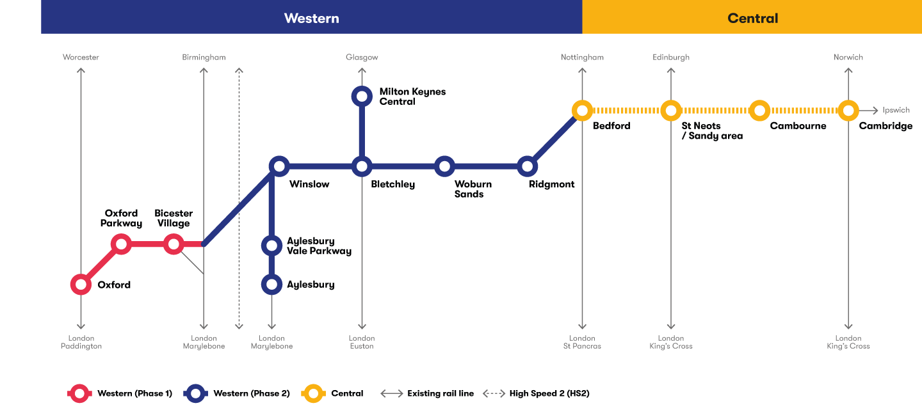

4.1 Values
EWR Co is looking for a supplier who can function as an extension of the existing EWR Co team – delivering work and behaviour that always reflects our values:

    - Being trusted – acting with honesty and integrity to inspire confidence

    - Being bold – innovating, creating and positively disrupting – making a difference, challenging ourselves and others – embracing lessons learned and pioneering best possible outcomes

    - Being open – connecting with our network to unlock insight and value for everyone - working collaboratively and openly - being transparent and acting unambiguously with external stakeholders

    - Having fun – enjoying what we do – embracing our own and others’ personalities, experiences and diversity of perspective

Information Strategy
EWR Co’s Asset Information Strategy is founded on the following tenets:

• Data is managed as an asset;

• Data is system agnostic;

• Asset Centric Model;

• Asset Ontology;

• Connected Data;

• Optimised Digital Engineering practices;

• Appropriate Process, Procedures and Governance;

• Encouragement of Open Source Information Technology Solutions.

All the principles are aligned with the ‘Gemini Principles’ and contribute to effective and economic whole life management of assets.

Requirements

EWR Co is open to novel ways to implement the requirements listed below and acknowledges that a suite of software tools may provide the most cost-effective solution. e.g. a prospective implementation might be envisaged to use three software components:
1) a Web based 3D GIS viewer for basic map viewing and analysis
2) desk-top client(s) for data creation, importing, editing and complex querying
3) specialist 3D tool for rendering and visualisation.

Business
Clause | Specification | Status
 | Cloud hosting and data processing within the UK or EU. | Mandatory
 | Web viewer(s) compatible with any HTML5 browser. | Highly Desirable
 | Support Single Sign-on from EWR Co SSO environment, via SAML. | Desirable
 | Licencing not based on a named-user basis. | Highly Desirable
 | Performance: The mapping platform should be capable of meeting performance targets.  • Average draw speed of base/context map <= l sec  • Average search results <= 2 sec | Desirable
 | The system should be capable of reporting its performance characteristics. | Desirable
 | Supplier certification to ISO9001 & ISO27001. | Mandatory
 | All staff with access to EWR Co data to have BPSS or CS security clearance. | Mandatory
 | Provide genuine value for money for the taxpayer. | Mandatory

Users
Clause | Specification | Status
 | Provide ‘Read-Only’ only access to EWR Co and Supply Chain partners. (max 100 users) | Mandatory
 | Provide ‘Edit’ access for up to 5 EWR Co users. | Mandatory
 | Enable a public facing Map Viewer to support the consultation process | Highly Desirable
 | Ability to save user workspaces, including layer visibility and symbology. | Highly Desirable

Data Management
Clause | Specification | Status
 | Support import and export of information in ‘Open Standards’ and interoperable formats. | Mandatory
 | Data Transformation Capability (ETL), to import 3D CAD Models and non-graphic data in an automated, or semi-automated, manner for mapping and visualisation purposes. (dwg, dgn and iFC file formats minimum requirement). | Mandatory
 | Ability to import data from third party hand-held data collection toolsets, using open formats. | Mandatory
 | Support industry standard interchange methods e.g. RESTful Web Service protocols and Web Map Services (WMS). | Highly Desirable
 | Enable data capture – GIS Desktop tools, web capture, mobile. | Mandatory
 | Provide management of external mapping datasets (e.g. OS data) | Desirable

Geo-spatial analysis
Clause | Specification | Status
 | Support Planning & Analysis (Environmental Surveys, Ground Investigation, Traffic & Logistics, Environmental Impact assessments, etc). | Mandatory
 | Support Land and Property management. | Mandatory
 | Support Stakeholder engagement (mailing lists, etc). | Mandatory
 | Ability to search data geo-spatially e.g. by point, line, polygon or buffer. | Mandatory
 | Ability to select data from text matching within attributes. | Mandatory
 | Production of automated clash analytics / geo-spatial intersections, that inform the development of risk mitigation plans. | Mandatory
 | Support Linear referencing. | Mandatory

Publication
Clause | Specification | Status
 | Production of high-quality public-facing dynamic and static maps, to support public engagement and consultation activities. | Mandatory
 | Publication of web services and data stores for collaboration. | Highly Desirable
 | Provide the ability to create standard templates including, but not limited to - title, legend, logo, date and scale. Where practical, template information should be automatically updated e.g. data, scale. | Mandatory

Visualisation
Clause | Specification | Status
 | Web viewer that supports 2D and 3D views and non-graphical information. | Mandatory
 | Creation of high-quality fly-throughs and viewpoints to allow stakeholders to gain insight of how the railway might look from their village/house, for visual impact assessment etc. | Highly Desirable
 | Support of dynamic 3D visualisation / VR / AR to support stakeholder engagement. | Desirable

Form of Proposal

Compliance to Requirements

(Pass/Fail)
Completion of separate Appendix A – Requirements.

Tenderers are requested to complete and confirm compliance.

Note: Tenderers are required to select either Yes or No to each of the requirements below and add comments to each requirement.

Mandatory requirements are a pass or fail - if you select no against a Mandatory requirement, you are confirming you cannot meet the minimum and therefore will not be able to participate in this RFQ

Appendix B - Written Technical Evaluation

(50% Points):
In line with Appendix B (Written Technical Evaluation), tenderers are requested to provide the following:

- Proposed methodology in relation to output development
- Stakeholder Engagement
- Utilisation of the Project Team

The total response document should be no greater than 9 pages in length, excluding appendices.

Commercial Evaluation

(50% Points)
Tenderer is to complete Appendix C – Commercial Evaluation.

A description of the software tools is to be provided, with comments and key assumptions to support the commercial submission.

Appendix B

Written Technical Evaluation
Written Proposal – 50 Points Available
Criteria | Description | Points Available
Ability to meet the requirements described in Section 5. | Please describe in detail the tool(s) intended to be delivered to deliver the requirements with evidence to support that they meet the detailed requirements in Section 5.  Diagrams and flow-charts should be used to substantiate your evidence. | 30
Evidence of providing similar tools to public sector bodies. | Provision of evidence of successful delivery of similar tools to the public sector.  Please provide a minimum of two examples. | 5
Evidence of innovation and value for the taxpayer. | Please provide evidence of how your solution provides innovation the delivery of Mapping and Visualisation and delivers the optimal value for the British taxpayer.  Please provide a minimum of two examples. | 5
Ability to deliver solutions in a timely and agile manner. | Please provide an indicative project plan along with evidence of how your solution has been deployed in a timely manner.  Please provide a minimum of two examples. | 10

Quality Criteria Scoring Methodology:

The scores for the quality element of Written Proposals and the entirety of the Presentation will be allocated in line with the following marking methodology:
Mark | Comment
20% | Failed to provide confidence that the proposal will meet the requirements. An unacceptable response with serious reservations.
40% | A poor response with reservations. The response lacks convincing detail with risk that the proposal will not be successful in meeting all the requirements.
60% | Meets the requirements – the response generally meets the requirements but lacks sufficient detail to warrant a higher mark.
80% | A good response that meets the requirements with good supporting evidence. Demonstrates good understanding.
100% | An excellent comprehensive response that meets the requirements. Indicates an excellent response with detailed supporting evidence and no weaknesses resulting in a high level of confidence.

Appendix C – Commercial

Scope
The anticipated contract term is 12 months, with the award in line with the Project Plan set out in Section 3.
The key elements of this tender are the provision of tools to enable:

- Management and analysis Environmental Survey information;

- Detailed public-facing static, interactive maps to support statutory and non-statutory consultations;

- 3 dimensional visualisations to support statutory and non-statutory consultations;

- Ad-hoc geo-spatial analysis;

Although the main elements of the contract are envisaged as a fixed price tender, being delivered by cloud-based system(s), there is scope for alternative proposals, especially where heavy duty information processing may be required.
Where elements are proposed that are not fixed price then a Rate Card should be supplied, along with an estimate of the required resources.

Project Management
The supplier shall provide a project implementation plan, within one week of contract award and appoint a nominated project manager for the implementation phase, and a contract manager for the operational phase. East West Railway’s ‘Head of Asset Management & Information’ or another nominated representative shall manage the implantation from the client’s perspective.

Appendix C – Commercials

Tenderer is to complete Appendix C – Commercial Evaluation.

The best (lowest) price receives the maximum score available in this section: the remaining bids will receive a score pro rata to the best price using the following calculation:

Lowest bid = maximum points of 50%

Lowest Bid x 50% (maximum points available)
Tenderers Bid

Contract

Framework Agreement

EWR Co. is inviting bids from Tenderers on the pre-tendered Government Procurement Service Framework. The details are as follows:

Framework ID: RM1557.11
Framework Agreement Title: G-Cloud 11
https://www.crowncommercial.gov.uk/agreements/RM1557.11

The Crown Commercial Service Framework call-off agreement will be utilised for this tender.
Tenderers must be registered on the framework to participate in this tender.
As part of tendering, each Tenderer has accepted the terms and conditions which make up the Call Off Contract. Tenderers cannot propose additional terms nor insert any of their standard terms of business.

