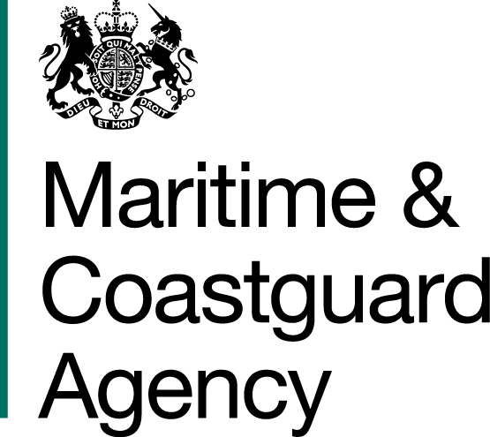

INVITATION TO TENDER – TCA 3/7/1120 CONTRACT FOR THE INSTALLATION OF A STANDBY GENERATOR AT THE HM COASTGUARD TECHNICAL TRAINING CENTRE (Daedalus)
- You are invited by the Secretary of State for Transport, to submit a tender for the above requirement.
- Please read all the documents listed in the Form of Tender. Should your tender be accepted these documents, your tender and any changes agreed in writing will form a binding contract between you and the Department.
- One original and one copy (so marked) of your tender and proposals, including any covering letter, are required.
- Tenders must be delivered BY 11.00 HOURS ON Friday 4th October 2019.
- To ensure that all tenderers have access to the same information you can only obtain further information about contractual issues and Technical Information from the Procurement Team. All requests must be submitted in writing as set out in the Instructions for Submission of Tenders, no later than 5pm on 27th September 2019.

Yours faithfully,

Kathy Monk
Senior Procurement Officer
Maritime and Coastguard Agency

