

Request for Quotation

LIFE18NAT/UK/000039 – LIFE Recreation ReMEDIES: Reducing and Mitigating Erosion and Disturbance Impacts affecting the Seabed

# Synthesis Report of Project Actions & Monitoring within the Solent Maritime SAC



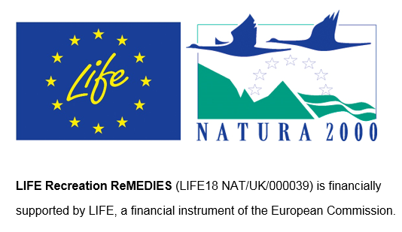

13th June 2024

Contents

Synthesis Report of Project Actions & Monitoring within the Solent Maritime SAC 1

Request for Quotation 1

Section 1: General Information 2

Glossary 2

Conditions applying to the RFQ 2

Acceptance of Quotations 3

Costs 3

Self-Declaration and Mandatory Requirements 3

Clarifications 3

Amendments 4

Conditions of Contract 4

Prices 5

Disclosure 5

Disclaimers 6

Protection of Personal Data 6

General Data Protection Regulations 2018 7

Equality, Diversity & Inclusion (EDI) 7

Sustainable Procurement 7

Conflicts of Interest 8

Section 2: The Invitation 9

Specification 9

Sustainability 22

Payment 22

Evaluation Methodology 23

Annex 1 Mandatory Requirements 28

Part 1 Potential Supplier Information 28

Part 2 Exclusion Grounds 29

Annex 2 Acceptance of Terms and Conditions 31

# Request for Quotation

### LIFE18NAT/UK/000039 - LIFE Recreation ReMEDIES: Reducing and Mitigating Erosion and Disturbance Impacts affecting the Seabed

### Synthesis Report of Project Actions & Monitoring within the Solent Maritime SAC

You are invited to submit a quotation for the requirement described in the specification, Section 2.

Please confirm by email, receipt of these documents and whether you intend to submit a quote or not.

Your response should be returned to the following email address by:

Email: [Caitlin.Napleton@naturalengland.org.uk](mailto:Caitlin.Napleton@naturalengland.org.uk)

Date: 11 July 2024

Time: 12 noon

Ensure you include the name of the quotation and ‘Final Submission’ in the subject field to make it clear that it is your response.

Contact Details and Timetable

Caitlin Napleton will be your contact for any questions linked to the content of the quote or the process. Please submit any clarification questions via email and note that, unless commercially sensitive, both the question and the response will be circulated to all tenderers.

|  |  |
| --- | --- |
| Action | Date |
| Date of issue of RFQ | 13 June 2024 |
| Deadline for clarification questions | 12 noon on 04 July 2024 |
| Deadline for receipt of Quotation | 12 noon on 12 July 2024 |
| Intended date of Contract Award | 19 July 2024 |
| Intended Contract Start Date | 22 July 2024 |
| Intended Delivery Date / Contract Duration | 22 July 2024 – 18 October 2024 |

Section 1: General Information

## Glossary

Unless the context otherwise requires, the following words and expressions used within this Request for Quotation shall have the following meanings (to be interpreted in the singular or plural as the context requires):

|  |  |
| --- | --- |
| Words/Expression | Meaning |
| “Authority” | Means Natural England who is the Contracting Authority |
| “Contract” | Means the contract to be entered into by the Authority and the successful supplier |
| “Response” | Means the information submitted by a supplier in response to the RFQ |
| “RFQ” | Means this Request for Quotation and all related documents published by the Authority and made available to suppliers |

## Conditions applying to the RFQ

You should examine your Response to the RFQ and related documents ensuring it is complete and in accordance with the stated instructions prior to submission.

Your Response must contain sufficient information to enable the Authority to evaluate it fairly and effectively. You should ensure that you have prepared your Response fully and accurately and that prices quoted are arithmetically correct for the units stated.

By submitting a Response, you, the supplier, are deemed to accept the terms and conditions provided in the RFQ. Confirmation of this is required in Annex 2.

Failure to comply with the instructions set out in the RFQ may result in the supplier’s exclusion from this quotation process.

## Acceptance of Quotations

By issuing this RFQ the Authority does not bind itself to accept any quotation and reserves the right not to award a contract to any supplier who submits a quotation.

## Costs

The Authority will not reimburse you for any costs and expenses which you incur preparing and submitting your quotation, even if the Authority amends or terminates the procurement process.

## Self-Declaration and Mandatory Requirements

The RFQ includes a self-declaration response (Annex 1) which covers basic information about the supplier, as well as any grounds for exclusion. If you do not comply with them, your quotation will not be evaluated.

Any mandatory requirements will be set out in Section 2, Specification of Requirements and, if you do not comply with them, your quotation will not be evaluated.

## Clarifications

Any request for clarification regarding the RFQ and supporting documentation must be submitted via email no later than the deadline for clarifications set out in the Timetable. The Authority shall be under no obligation to respond to queries raised after the clarification deadline.

The Authority will respond to all reasonable clarifications as soon as possible but cannot guarantee a minimum response time. The Authority will publish all clarifications and its responses to all suppliers via email unless deemed commercially sensitive.

If a supplier believes that a request for clarification is commercially sensitive, it should clearly state this when submitting the clarification request. However, if the Authority considers either that:

* the clarification and response are not commercially sensitive; and
* all suppliers may benefit from its disclosure,

then the Authority will notify the supplier (via email), and the supplier will have an opportunity to withdraw the request for clarification by sending a further message requesting the withdrawal of the clarification request. If not withdrawn by the supplier within 2 working days of the Authority’s notification, the Authority may publish the clarification request and its response to all suppliers and the Authority shall not be liable to the supplier for any consequences of such publication.

The Authority reserves the right to seek clarification of any aspect of a quotation and/or provide additional information during the evaluation phase to carry out a fair evaluation. Where the Authority seeks clarification on any aspect of the quotation, the supplier must respond within the timeframe requested by the Authority.

## Amendments

The Authority may amend the RFQ at any time prior to the deadline for receipt. If it amends the RFQ the Authority will notify you via email.

Suppliers may modify their quotation prior to the deadline for Responses. No Responses may be modified after the deadline for Responses.

Suppliers may withdraw their quotations at any time by submitting a notice via the email to the named contact.

## Conditions of Contract

The Authority’s Standard Good and Services Terms & Conditions (used for purchases under £50k) can be located on the [Natural England Website](https://www.gov.uk/government/organisations/natural-england/about/procurement) and will be applicable to any contract awarded as a result of this quotation process. The Authority will not accept any changes to these terms and conditions proposed by a supplier.

Suppliers should note that the quotation provided by the successful bidder will form part of the Contract.

## Prices

Prices must be submitted in £ sterling, exclusive of VAT.

## Disclosure

All Central Government Departments, their Executive Agencies and Non Departmental Public Bodies are subject to control and reporting within Government. In particular, they report to the Cabinet Office and HM Treasury for all expenditure. Further the Cabinet Office has a cross-Government role delivering overall Government policy on public procurement, including ensuring value for money and related aspects of good procurement practice. For these purposes, the Authority may disclose within Government any details contained in your quotation. The information will not be disclosed outside Government during the procurement.

In addition, the Authority is subject to the Freedom of Information Act 2000 and the Environmental Information Regulations 2004, which provide a public right of access to information held by public bodies. In accordance with these two statutes, the Authority may be required to disclose information contained in your quotation to any person who submits a request for information pursuant to those statutes.

Further to the Government’s transparency agenda, all UK Government organisations must advertise on Contract Finder in accordance with the following publication thresholds:

● Central Contracting Authority’s: £12,000

● Sub Central Contracting Authority’s and NHS Trusts: £30,000

For the purpose of this RFQ the Authority is classified as a Central Contracting Authority with a publication threshold of £12,000 inclusive of VAT.

If this opportunity is advertised via Contracts Finder, we are obliged to publish details of the awarded contract including who has won the contract, the contract value, and indicate whether the winning supplier is a small and medium-sized enterprise (“SMEs”) or voluntary organisation or charity. A copy of the contract must also be published with confidential information redacted.

By submitting a Response, you consent to these terms as part of the procurement.

## Disclaimers

Whilst the information in this RFQ and any supporting information referred to herein or provided to you by the Authority have been prepared in good faith the Authority does not warrant that this information is comprehensive or that it has been independently verified.

The Authority does not:

* make any representation or warranty (express or implied) as to the accuracy, reasonableness or completeness of the RFQ;
* accept any liability for the information contained in the RFQ or for the fairness, accuracy or completeness of that information; or
* accept any liability for any loss or damage (other than in respect of fraudulent misrepresentation or any other liability which cannot lawfully be excluded) arising as a result of reliance on such information or any subsequent communication.

Any supplier considering entering into contractual relationships with the Authority following receipt of the RFQ should make its own investigations and independent assessment of the Authority and its requirements for the goods and/or services and should seek its own professional financial and legal advice.

## Protection of Personal Data

In order to comply with the General Data Protection Regulations 2018 the supplier must agree to the following:

You must only process any personal data in strict accordance with instructions from the Authority.

* You must ensure that all the personal data that we disclose to you or you collect on our behalf under this agreement are kept confidential.
* You must take reasonable steps to ensure the reliability of employees who have access to personal data.
* Only employees who may be required to assist in meeting the obligations under this agreement may have access to the personal data.
* Any disclosure of personal data must be made in confidence and extend only so far as that which is specifically necessary for the purposes of this agreement.
* You must ensure that there are appropriate security measures in place to safeguard against any unauthorised access or unlawful processing or accidental loss, destruction or damage or disclosure of the personal data.
* On termination of this agreement, for whatever reason, the personal data must be returned to us promptly and safely, together with all copies in your possession or control.

## General Data Protection Regulations 2018

For the purposes of the Regulations the Authority is the data processor.

The personal information that we have asked you provide on individuals (data subjects) that will be working for you on this contract will be used in compiling the tender list and in assessing your offer. If you are unsuccessful the information will be held and destroyed within two years of the award of contracts. If you are awarded a contract it will be retained for the duration of the contract and destroyed within seven years of the contract’s expiry.

We may monitor the performance of the individuals during the execution of the contract, and the results of our monitoring, together with the information that you have provided, will be used in determining what work is allocated under the contract, and in any renewal of the contract or in the award of future contracts of a similar nature. The information will not be disclosed to anyone outside the Authority without the consent of the data subject, unless the Authority is required by law to make such disclosures.

## Equality, Diversity & Inclusion (EDI)

The Client is striving to create a diverse and inclusive working environment where every individual has equality of opportunity to progress and to apply their unique insights to making the UK a great place for living. The Service Provider is expected to respect this commitment in all dealings with Natural England staff and service users.

Suppliers are expected to;

* support Defra group to achieve its Public Sector Equality Duty as defined by the Equality Act 2010, and to support delivery of Defra group’s Equality & Diversity Strategy.
* meet the standards set out in the Government’s Supplier Code of Conduct
* work with Defra group to ensure equality, diversity and inclusion impacts are addressed (positive and negative) in the goods, services and works we procure, barriers are removed and opportunities realised.

## Sustainable Procurement

Addressing global sustainability impacts and realising additional community benefits within commercial activity is core to Defra group’s approach, working with its supply chain is key to achieving sustainable outcomes. In addition to supporting Defra group to meet its outcomes we look to understand and reduce negative sustainability impacts associated with our commercial activity and realise benefits.

The Client encourages its suppliers to share these values, work to address negative impacts and realise opportunities, measure performance and success.

Suppliers are expected to have an understanding of the Sustainable Development Goals, the interconnections between them and the relevance to the Goods, Services and works procured on the Client’s behalf.

## Conflicts of Interest

The concept of a conflict of interest includes but is not limited to any situation where an Involved Person or Relevant Body has directly or indirectly, a financial, economic or other personal interest which might be perceived to compromise their impartiality and independence in the context of the procurement procedure and/or affect the integrity of the contract award.

We expect suppliers to mitigate appropriately against any real or perceived conflict of interest through their work with government. A supplier with a position of influence gained through a contract should not use that position to unfairly disadvantage any other supplier or reduce the potential for future competition

Where the supplier is aware of any circumstances giving rise to a conflict of interest or has any indication that a conflict of interest exists or may arise you should inform the Authority of this as soon as possible (whether before or after they have submitted a quotation). Tenderers should remain alert to the possibility of conflicts of interest arising at all stages of the procurement and should update the Authority if any new circumstances or information arises, or there are any changes to information already provided to the Authority. Failure to do so, and/or to properly manage any conflicts of interest may result in a quotation being rejected.

Provided that it has been carried out in an open, fair and transparent manner, routine pre-market engagement carried out by the Authority should not represent a conflict of interest for the supplier.

Section 2: The Invitation

## Specification

1. **Background**
   1. **Background to Natural England**

Natural England (NE) is the government’s advisor on the natural environment. We provide practical advice, grounded in science, on how best to safeguard England’s natural wealth for the benefit of everyone.

NEs remit is to ensure sustainable stewardship of the land and sea so that people and nature can thrive. It is NEs responsibility to see that England’s rich natural environment can adapt and survive intact for future generations to enjoy.

Further information on the Authority can be found at: [Natural England](http://www.naturalengland.org.uk/)

* 1. **The ReMEDIES Project**

The LIFE Recreation ReMEDIES: ‘Reducing and Mitigating Erosion and Disturbance Impacts affecting the Seabed’ project (LIFE 18 NAT/UK/000039) runs from July 2019 - Oct 2024 and will provide the tools to deliver the conservation needed to move the relevant Annex 1 habitats towards Favourable condition in five Special Areas of Conservation (SACs) between Essex and Isles of Scilly. These habitats are intertidal/subtidal mud and intertidal/subtidal sand which support features such as seagrass. This will be achieved by restoration, demonstration and reducing recreational pressures. Promoting awareness, communications and inspiring better care of sensitive seabed habitats will be key. Natural England (lead partner) is working with the Marine Conservation Society, Ocean Conservation Trust, Plymouth City Council/Tamar Estuaries Consultative Forum, Royal Yachting Association and the Green Blue. The project is financially supported by LIFE, a financial instrument of the European Commission. More about the project can be seen at [www.saveourseabed.co.uk](http://www.saveourseabed.co.uk).

All five sites are SACs as designated under Directive 92/43/EEC on the Conservation of Natural Habitats and of Wild Fauna and Flora, and the Conservation of Habitats and Species Regulations 2017 (as amended) in England and Wales. Project actions were carried out where seagrass beds had been lost, fragmented, or degraded by historic loss from either wasting disease, or anthropogenic activity such as mooring, anchoring, trampling, and certain demersal fishing practices such as potting or bottom-set gill and tangle nets within the SACs.

* 1. **Background to the site**

One of the five sites of the ReMEDIES project is the Solent Maritime SAC (fig. 1).This Marine Protected Area (MPA) is a complex site encompassing a major estuarine system and has a tight cluster of small estuaries. It lies in one of the only major sheltered channels in Europe. The SAC includes extensive areas of mudflats and sandbanks, designated as intertidal mudflats and sandflats not covered by seawater at low tide (H1140) and intertidal sandbanks which are slightly covered by sea water all the time (H1110). These support sensitive seabed habitats, including seagrass which is recorded by the EUNIS habitat classification system (see Moss, 2008) as either: A2.61 Intertidal seagrass beds or A5.53 Subtidal seagrass beds

As a sub-feature of the SACs, Natural England has a statutory duty to report on the condition of the seagrass bed communities within these sites every six-years. In 2019, Natural England’s Condition Assessment of the Solent Maritime SAC recorded seagrass as Unfavourable/Unknown.

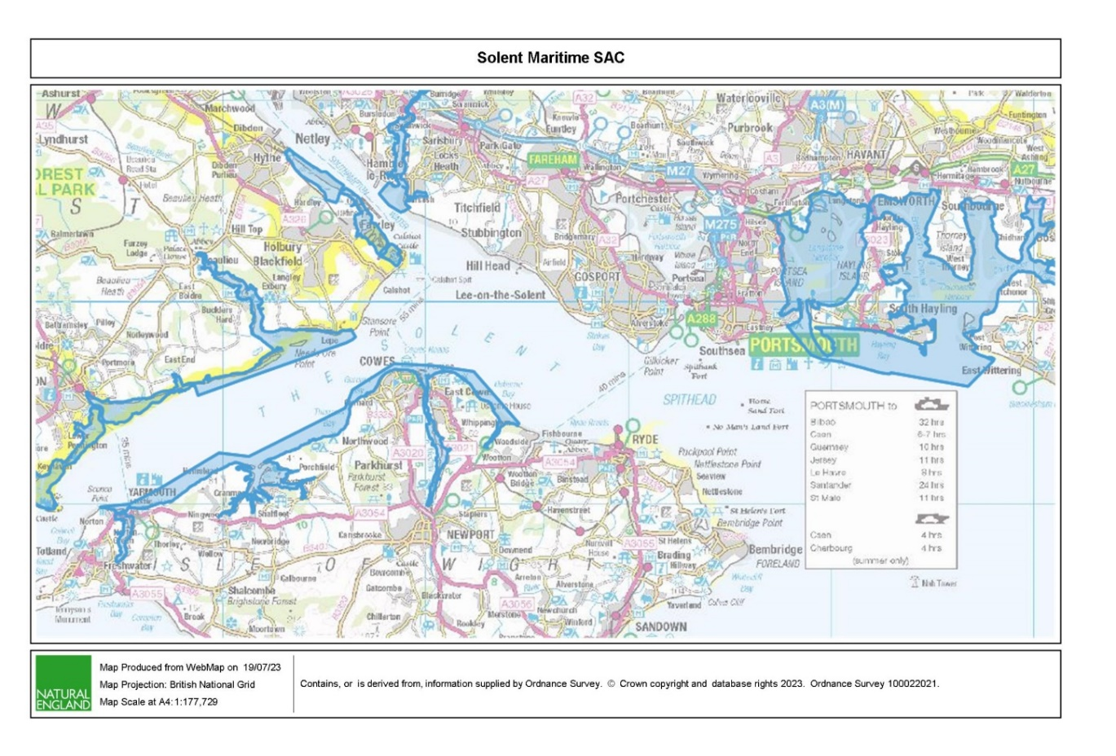

*Figure 1. Map of Solent Maritime Special Area of Conservation*

* 1. **Seagrass Conservation**

Seagrass beds occur in shallow sheltered marine environments, both subtidal and intertidal, with a wide but patchy distribution across England. Seagrass beds have been recorded as declining in extent and health nationally. This has been attributed, in part, to high levels of anthropogenic activity pressures, with some beds in unfavourable condition, including those within the Solent (Natural England, 2022).

Apart from being a functional habitat supporting marine biodiversity and connectivity between other marine habitats, including supporting commercial fish species, seagrass has a role as a blue carbon sink. Through photosynthesis, seagrass will transfer dissolved CO2 from seawater to plant matter, storing and sequestering the subsequent carbon by burial in substrates. Seagrass also traps detritus and other organic particulate matter, storing carbon transported from terrestrial and other marine habitats. From these processes, seagrass beds in the UK are estimated to have stored up to 11.5 megatonnes of carbon historically (Gregg *et al*., 2021), and area future ‘nature-based solution’ for carbon offsetting.

As a nature and environmental asset, the Government in its 25-Year Environmental Plan for ‘securing clean, healthy, productive, and biologically diverse seas and oceans’, has seagrass beds as a priority habitat. Natural England is therefore committed to support the increase of the scale and rate of implementation of estuarine and coastal restoration of seagrass.

1. **Overview of the ReMEDIES Project Activities within the Solent Maritime SAC**
   1. **Maps of Activities**

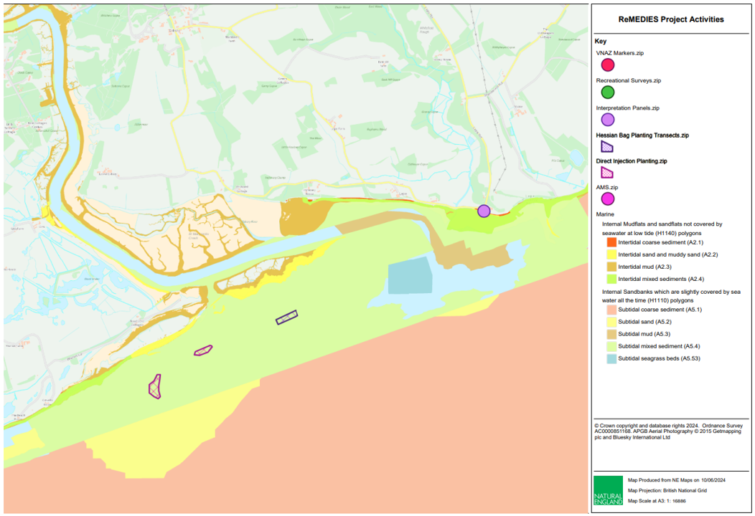

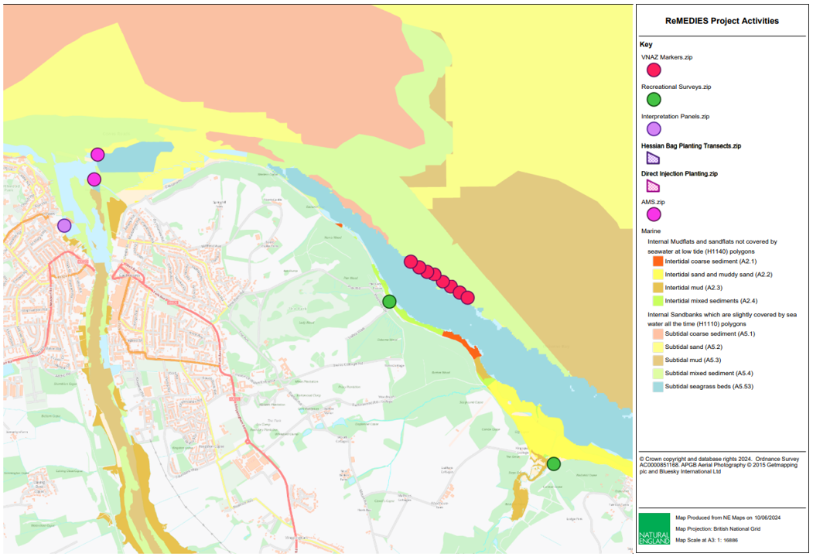

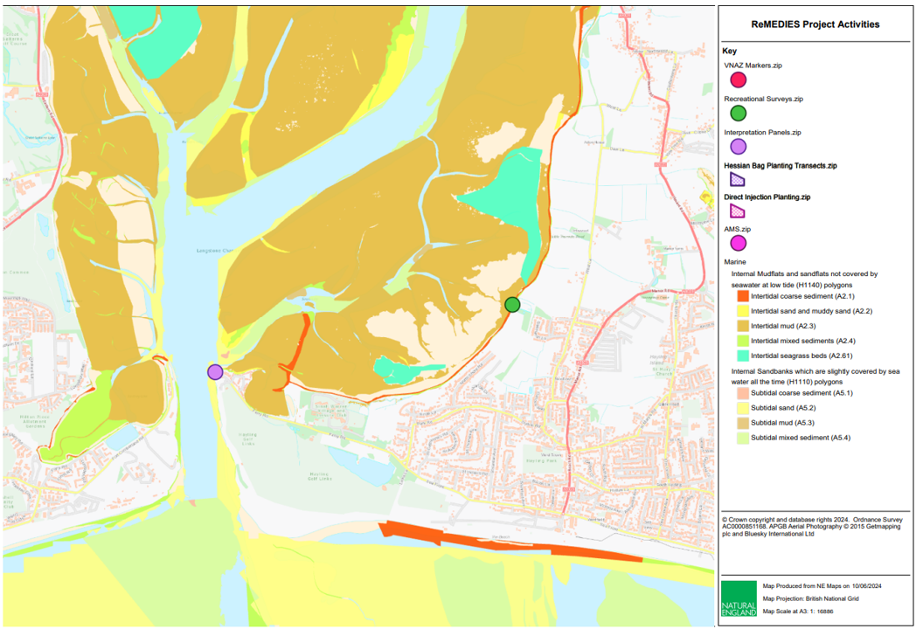

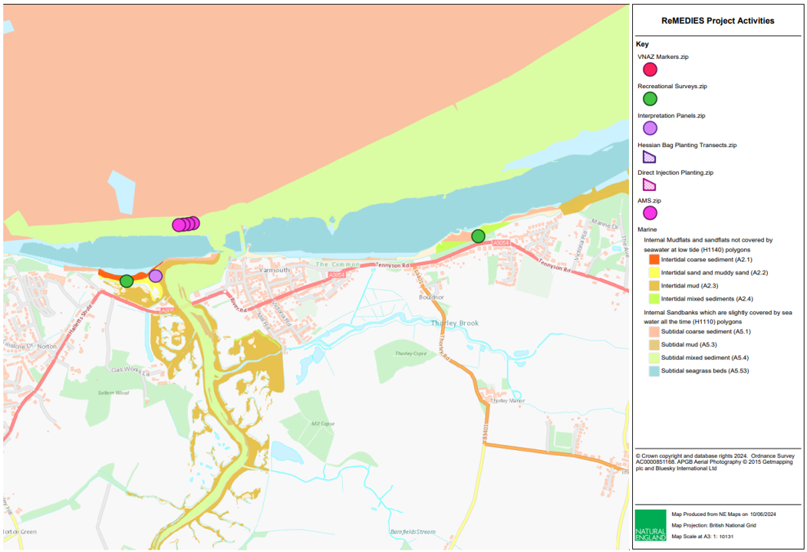

*Figures 2A-D. Maps of the Solent showing ReMEDIES project activities including VNAZ Markers, AMS, planting, recreational surveys and panels. Also shows the subfeatures of intertidal mudflats and sandflats not covered by seawater at low tide and intertidal sandbanks which are slightly covered by seawater all the time.*

* 1. **Monitoring**

Monitoring of seagrass has taken place throughout the project, beginning with baseline surveys in 2019 and 2020. These are being repeated currently to provide a comprehensive comparison of the seagrass quality and extent before and after intervention from the ReMEDIES project.

The data and reports from this are summarised in section 4.2. The method of these surveys includes diving, drop down video and echosounder.

As well as monitoring of seagrass, recreational activity surveys have been undertaken July-September 2021, 2022, and 2023, with plans to repeat this in 2024. These take place at Osborne Bay, Yarmouth Wast, Bouldnor, King’s Quay and the west of Hayling Island (figures 2B-D). The surveys monitor the activity inside and outside of seagrass for 1-hour periods.

* 1. **Active Restoration and Methods**

The focus of the restoration has been subtidal seagrass beds and the species *Zostera marina*, sometimes named common eelgrass, or as hereafter common seagrass. However, intertidal seagrass, *Zostera noltii*, or dwarf seagrass, is present as a conservation feature of the Solent Maritime SAC.

The proactive restoration took place in the Marine Management Organisation (MMO) licenced restoration area at the mouth of the Beaulieu River and used two key methods (figure 2A):

* Deployment of hessian bags containing seagrass seeds in March 2022 covering an area of 1 ha
* Direct injection of seagrass seeds into sediment by divers in November 2023 and April 2024 covering a total area of 1.5 ha

It was considered that this restoration would play a key role in moving sites toward Favourable Condition as it increases extent of seagrass and helps to rebuild connectivity between the beds in the area, improving their ability for sexual reproduction.

* 1. **Installation of Advanced Mooring Systems**

Advanced Mooring Systems (AMS) are designed to minimise the interaction of the mooring riser with the seabed, reducing the scour and abrasion impact that can be damaging to sensitive seabed habitats such as seagrass. This is done through several methods including using an elastic riser or subsurface buoys along the riser. See [Mooring - Save Our Seabed](https://saveourseabed.co.uk/protecting-our-seabed/recreational-boating/mooring/) for further information on AMS and their design.

In the Solent there are two sites of AMS:

Yarmouth Harbour (figure 2D): In 2019 and 2020, four stirling and one seaflex AMS were installed on one of the trot moorings in the Harbour. These were the first AMS in place in the Solent and their key role was as a demonstration and to raise confidence in the systems. The seaflex has since been removed to be used in a different project site.

Cowes Harbour (figure 2B): in 2023, two stirling moorings were installed in the harbour in areas of seagrass.

* 1. **Installation of a Voluntary No Anchor Zone**

Through the recreational activity surveys, Osborne Bay was identified as an area with higher-than-average recreational anchoring within seagrass. As a result, Voluntary No Anchor Zone (VNAZ) was installed to reduce the anchoring pressure. This consists of eight marker buoys using AMS designs to mark out the area of seagrass and highlight the VNAZ through signage (figure 2B).

* 1. **Community Engagement and Education**

Community engagement has been a key focus throughout the project. This has been undertaken through stands and talks at events such as the Southampton International Boat Show, Green Tech Boat Show, Noel Turner Science Festival and Beaulieu Family Conservation Awareness Day, and ongoing webinars. Webinars in particular have been used the length of the project in order to share sensitive seabed habitat information and best practice measures and were a key tool for community engagement during the COVID-19 pandemic.

As well as this, interpretation panels have been put in place at Cowes Yacht Haven, Norton Spit, Lepe Country Park and Hayling Island Ferry Terminal that share information on the importance of seagrass, where it is found in the Solent and some of the ongoing work to protect it (figures 2A-D).

1. **Aims and Objectives**
   1. **Aims**

Natural England wishes to commission a synthesis report of the activities of the LIFE Recreation ReMEDIES project and observed changes in seagrass throughout the lifetime of the project within the Solent Maritime SAC.

The tender should achieve the following aims:

* Summarise the actions taken throughout the ReMEDIES project to improve the condition of sensitive habitats such as seagrass within the Solent Maritime SAC
* Review the seagrass quality, extent and distribution across the ReMEDIES active sites of the Solent Maritime SAC based on reports and data from the ReMEDIES library
* Provide a recommendation for the condition of seagrass as a sub feature of the SAC
* Discuss the potential drivers of any changes observed through the data
  1. **Objectives**

The specific objectives of this contract are to, in collaboration with Natural England, produce a report synthesising the actions of the ReMEDIES project within the Solent Maritime SAC and the outputs of seagrass monitoring at active ReMEDIES sites within the SAC.

Under this specification tenderers must:

* Produce a written (word doc) report within the scope outlined. This should be completed on the [Natural England Report Template](https://publications.naturalengland.org.uk/publication/5790636781600768)
* Provide a method for how the tenderer’s recommendation for the condition of seagrass was established
* Analyse the projects actions, based on the literature, and any changes in seagrass through monitoring published by the ReMEDIES project, Natural England, and its project partners. Any analysis used should be repeatable and transparent. Any statistical modelling element in the analysis should completed in R programming language, and the associated scripts with their library packages used should be stated and provided to Natural England.
  1. **Supporting Information**

The tenderer will be provided with the full library of the reports carried out by Natural England and its partners throughout the ReMEDIES Project no later than 19th August 2024. There will also be the associated data for these reports provided, and together these will form the basis for meeting the outputs required. An initial library of reports is provided in section 4.2.

1. **Methods**
   1. **Planning & Reporting**

Before the synthesis is carried out the successful contractor will discuss any preparatory work with the Natural England project officer, including:

1. Clarification of roles, responsibilities and expectations
2. Acquisition and checking of sources of relevant information
3. Review existing information provided by Natural England
4. Ways of working and close collaboration with NE in developing a project plan and finalising methodologies
   1. **Natural England Reports & Data**

|  |  |  |  |  |
| --- | --- | --- | --- | --- |
| **Report/Dataset** | **Location** | **Method** | **Attribute** | **Date** |
| NE Dive Team Baseline Surveys | Osborne Bay, Beaulieu, Cowes, Yarmouth | Diving | Quality | 2021 |
| EA Baseline Surveys | Beaulieu, Yarmouth, Bouldnor | Drop down video | Extent and distribution | 2018 |
| HIWWT Intertidal Seagrass Baseline Surveys | Osborne Bay, Cowes, Bouldnor, Yarmouth | Walk over | Extent, distribution and quality | 2018 |
| EA Subtidal Seagrass Baseline Surveys | Osborne Bay | Drop down video | Extent and distribution | 2020 |
| Osborne Bay Seabed Data Analysis by Chris Cooling | Osborne Bay | Remote Operated Vehicle | Abundance | 2020 |
| Seasearch Dive Surveys | Solent Wide | Diving |  | 2019 - Current |
| Recreation Activity Surveys | Yarmouth West, Bouldnor, Osborne Bay, King’s Quay, West of Hayling Island | On shore | Frequency | 2021 - 2024 |
| HIWWT Video and Snorkelling surveys | Osborne Bay, Beaulieu, Cowes | Drop down video and snorkelling | Quality and Extent | 2024 |
| OCT Dive Surveys | Beaulieu | Dive | Restoration Success | 2024 |
| NE Dive Team Surveys | Beaulieu, Cowes, Osborne Bay, Yarmouth | Dive | Quality | 2024 |

* 1. **Data Outputs and Management**

All project outputs should be delivered to agreed deadlines.

Data must be interpreted, analysed and presented in light of the overarching aims stated above. Tenderers should pay particular consideration to the data and GIS required formats for information compatibility including MEDIN metadata standards and Marine Recorder provisions:

* + - 1. All sample data (e.g faunal analysis, PSA analysis) need to be entered into Marine Recorder and delivered with the final reports. Natural England will provide licence keys for Marine Recorder to the successful Contractor for use in this contract. A Snapshot file of the data should also be provided. <https://www.esdm.co.uk/marine-recorder>. Guidance ‘Marine Recorder Evidence for Contractors’ will be provided to the successful Contractor.
      2. All GIS datasets need to be provided in ESRI ArcGIS format compatible with ArcGIS9.3.1 and have attached metadata.
      3. Accompanying metadata for the data set must meet the MEDIN metadata discovery standard. Metadata derived as part of this project must be submitted to Natural England in an XML file which Natural England will archive through Data Archive Centres (DACs). Guidance ‘MEDIN Evidence for Contractors’ will be provided to the successful Contractor.
      4. Copies of the original data spreadsheets or databases are to be provided in the appropriate Microsoft Office format.
      5. Stills photographs to be provided in their raw format on CD/DVD or USB compliant external hard drives.
      6. Natural England will be provided with two bound hard copies and one electronic copy (on disc or USB) of the final report. The final report should contain:

1. Executive summary
2. Introduction
3. Methods
4. Results
5. Presentation of seagrass monitoring data
6. Recommendation for condition of seagrass as a sub feature of the Solent Maritime SAC
7. Catalogue of data provided
8. References
   1. **References**

Doggett, M. & Northen, K.O., (2024), Condition assessment monitoring for subtidal seagrass beds, Solent Maritime SAC June 2021, A report to Natural England by Marine Ecological Solutions Ltd

Kenworthy, J., (2021), LIFE Recreation ReMEDIES – River Medina and Osborne Bay, Isle of Wight Subtidal Seagrass Survey 2020. LIFE Recreation ReMEDIES Report, Environment Agency Report for Natural England, Natural England

Moss D., (2008), EUNIS habitat classification – a guide for users, European Topic Centre on biological diversity, 2008, European Environment Agency, available [HERE](https://www.eea.europa.eu/data-and-maps/data/eunis-habitat-classification/documentation/eunis-habitat-classification-users-guide-v2.pdf/file#:~:text=The%20EUNIS%20habitat%20classification%20is,at%20the%20first%20three%20levels.)

Natural England, (2022), Seagrass Natural Capital Assessment: The Solent Maritime SAC, Natural England Commissioned Report NECR421, <https://publications.naturalengland.org.uk/file/5068825065422848>

R Gregg, J. L. Elias, I Alonso, I.E. Crosher, P Muto & M.D. Morecroft, (2021), Carbon storage and sequestration by habitat: a review of the evidence (second edition), Natural England Research Report NERR094, Natural England, (2021), York

Unsworth, RKF., Butterworth, E., Freeman, AS., Fox, AD., & Priscott, (2021), The ecosystem service role of UK Seagrass meadows, Project Seagrass, May, 2021, Bridgend, Wales

1. **Outputs**
   1. **Timeline for Project Delivery**

|  |  |
| --- | --- |
| **Event** | **Date** |
| Contract Award Date | 19 July 2024 |
| Produce plan for synthesis report | 05 August 2024 |
| All report data provided by authority | 19 August 2024 |
| Draft report and associated products to be provided by | 11 October 2024 |
| Final report and full data output to be delivered | 18 October 2024 |

Any delays should be discussed with the Natural England project officer.

1. **Other**

In support of this contract Natural England will provide the successful Contractor with:

* Project support from dedicated project lead
* Opportunity to feedback and discuss progress and the project

The intellectual property rights and copyright for all products (including photographs) will lie with Natural England. All data will be made available by Natural England under the Open Government Licence at the end of the project via MESH and the MEDIN Data Archiving Centres.

As part of this contract the successful Contractor will provide a pre-survey planning meeting with Natural England.

## Sustainability

Natural England protects and improves the environment and is committed to reducing the sustainability impacts of its activities directly and through its supply chains. We expect the Contractor to share this commitment and adopt a sound, proactive sustainable approach in keeping with the 2-year environmental plan/our commitments compliant with all applicable legislation. This includes understanding and reducing direct and indirect sustainability impacts and realising opportunities, including but not restricted to; resilience to climate change, reducing greenhouse gas emissions, water use and quality, biosecurity, resource efficiency and waste, reducing the risk of pollution, biodiversity, modern slavery and equality, diversity & inclusion, negative community impacts.

As a delivery partner, the successful Contractor is expected to pursue sustainability in their operations, thereby ensuring the Contracting Authority is not contracting with a supplier whose operational outputs run contrary to the Contracting Authority’s objectives. The successful Contractor will need to approach the project with a focus on the entire life cycle of the project.

## Payment

The Authority will raise purchase orders to cover the cost of the services and will issue to the awarded supplier following contract award.

The Authority’s preference is for all invoices to be sent electronically, quoting a valid Purchase Order number. The cost will be broken down into 2 invoices, the first to be halfway through the contract and the second once all final deliverables are received.

It is anticipated that this contract will be awarded for a period 3 months to end no later than 18th October 2024. Prices will remain fixed for the duration of the contract award period. We may at our sole discretion extend this contract to include related or further work. Any extension shall be agreed in writing in advance of any work commencing and may be subject to further competition.

If successful, all invoices must include the following reference: LIFE Recreation ReMEDIES (LIFE18NAT/UK/000039).

*“Contractors shall make no financial investment in the project and, therefore, shall not benefit from any intellectual property rights arising from the project.”*

## Evaluation Methodology

We will award this contract in line with the most economically advantageous tender (MEAT) as set out in the following award criteria:

**Technical – 60%**

**Commercial – 40%**

Evaluation Criteria

Evaluation weightings are 60% technical and 40% commercial, the winning tenderer will be the highest scoring combined score.

|  |  |  |  |  |
| --- | --- | --- | --- | --- |
| **Award Criteria** | **Weighting** | **Evaluation Topic** | **Sub-Criteria** | **Question Scoring/Weighting (%)** |
| Complete quotation |  | Responses have been provided to all of the questions |  | Pass/Fail |
| Technical | 60% | Synthesis Report Proposal | Quality of Proposal and Synthesis Strategy | Q1 - 60% of technical score available |
| Experience and Capacity | Q2 – 40% of technical score available |
| GDPR | Q3 – Pass/Fail |
| Commercial | 40% | Whole life cost of the proposed Contract | Commercial Model | 100% of commercial score available |

**Technical (60%)**

Technical evaluations will be based on responses to specific questions covering key criteria which are outlined below. Scores for questions will be based on the following:

|  |  |  |
| --- | --- | --- |
| **Description** | **Score** | **Definition** |
| Very good | 100 | Addresses all the Authority’s requirements with all the relevant supporting information set out in the RFQ. There are no weaknesses and therefore the tender response gives the Authority complete confidence that all the requirements will be met to a high standard. |
| Good | 70 | Addresses all the Authority’s requirements with all the relevant supporting information set out in the RFQ. The response contains minor weaknesses and therefore the tender response gives the Authority confidence that all the requirements will be met to a good standard. |
| Moderate | 50 | Addresses most of the requirements with most of the relevant supporting information set out in the RFQ. The response contains moderate weaknesses and therefore the tender response gives the Authority confidence that most of the requirements will be met to a suitable standard. |
| Weak | 20 | Substantially addresses the requirements but not all and provides supporting information that is of limited or no relevance tor a methodology containing significant weaknesses and therefore raises concerns for the Authority that requirements may not all be met. |
| Unacceptable | 0 | No response or provides a response that gives the Authority no confidence that the requirement will be met. |

Technical evaluation is assessed using the evaluation topics and sub-criteria stated in the Evaluation Criteria section above.

Separate submissions for each technical question should be provided and will be evaluated in isolation. Tenderers should provide answers that meet the criteria of each technical question.

|  |  |
| --- | --- |
| Question | Detailed Evaluation Criteria |
| Q1 – Quality of Proposal and Synthesis Strategy | Your response will be marked against the quality of the proposal based on the synthesis strategy and method for the recommendation for condition.  Your response should:  1. Demonstrate a clear understanding of the nature of requirements  2. Have information in sufficient detail to allow a full appraisal of the suitability of the approach to deliver for the project  Please submit a document with the filename: “Q1_Your Organisation Name”.  Your response must not exceed a maximum of three sides of A4, font size 11. |
| Q2 – Experience and Capacity | Your response will be marked against the relevant experience and capacity to report on Marine Protected Areas and the condition of their features.  Your response should:  1. Provide experience related to the proposal  2. Demonstrate the work is achievable within the timeframe provided  3. Have information in sufficient detail to ensure a full appraisal of the ability to deliver for the project  Please submit a document with the filename: “Q2_Your Organisation Name”.  Your response must not exceed a maximum of two sides of A4, font size 11. |
| Q3 - GDPR | Please provide details of the technical facilities and measures (including systems and processes) you have in place, or will have in place by contract award, to ensure compliance with the General Data Protection Regulation and to ensure the protection of the rights of data subjects.  Your response should include, but should not be limited to facilities and measures:   * to ensure ongoing confidentiality, integrity, availability and resilience of processing systems and services; * to comply with the rights of data subjects in respect of receiving privacy information, and access, rectification, deletion and portability of personal data; * to ensure that any consent based processing meets standards of active, informed consent, and that such consents are recorded and auditable; * to ensure legal safeguards are in place to legitimise transfers of personal data outside the EU (if such transfers will take place); * to maintain records of personal data processing activities; and * to regularly test, assess and evaluate the effectiveness of the above measures.   Responses should not exceed three sides of A4, font size 11.  Please upload your response to this question with the filename: Q3_Your Organisation Name |

**Commercial (40%)**

The Contract is to be awarded as a fixed price which will be paid according to the completion of the deliverables in the Specification of Requirements.

Suppliers are required to submit a total cost to provide the deliverables stated in the Specification of Requirements. In addition to this the Commercial Response template must be completed to provide a breakdown of the whole life costs against ‘objectives’ used in the delivery of this requirement.

**Calculation Method**

The method for calculating the weighted scores is as follows:

* Commercial

Score = (Lowest Quotation Price / Supplier’s Quotation Price ) x 40%  
(Maximum available marks)

* Technical

Score = (Bidders Total Technical Score / Highest Technical Score ) x 60%  
(Maximum available marks)

The total score (weighted) (TWS) is then calculated by adding the total weighted commercial score (WC) to the total weighted technical score (WT):

WC + WT = TWS

**Information to be Returned**

Please note, the following information requested must be provided. Incomplete tender submissions may be discounted.

Please complete and return the following information:

* Completed Commercial Response template
* Separate response submissions for each technical question (in accordance with the response instructions above)
* Completed Mandatory Requirements (Annex 1)
* Completed Acceptance of Terms and Conditions (Annex 2)

**Award**

Once the evaluation of the Response(s) is complete all suppliers will be notified of the outcome via email.

The successful supplier will be issued the contract, incorporating their Response, for signature. The Authority will then counter sign.

# Annex 1 Mandatory Requirements

Part 1 Potential Supplier Information

Please answer the following self-declaration questions in full and include this Annex in your quotation response.

Part 1.1 Potential Supplier Information:

|  |  |  |
| --- | --- | --- |
| **Question no.** | **Question** | **Response** |
| 1.1(a) | Full name of the potential supplier submitting the information |  |
| 1.1(b) | Registered office address (if applicable) |  |
| 1.1(c) | Company registration number (if applicable) |  |
| 1.1(d) | Charity registration number (if applicable) |  |
| 1.1(e) | Head office DUNS number (if applicable) |  |
| 1.1(f) | Registered VAT number |  |
| 1.1(g) | Are you a Small, Medium or Micro Enterprise (SME)? | (Yes / No) |

Note: See EU definition of SME <https://ec.europa.eu/growth/smes/business-friendly-environment/sme-definition_en>

Part 1.2 Contact details and declaration

By submitting a quotation to this RFQ I declare that to the best of my knowledge the answers submitted and information contained in this document are correct and accurate.

I declare that, upon request and without delay you will provide the certificates or documentary evidence referred to in this document.

I understand that the information will be used in the selection process to assess my organisation’s suitability to be invited to participate further in this procurement.

I understand that the authority may reject this submission in its entirety if there is a failure to answer all the relevant questions fully, or if false/misleading information or content is provided in any section.

I am aware of the consequences of serious misrepresentation.

|  |  |  |
| --- | --- | --- |
| **Question no.** | **Question** | **Response** |
| 1.2(a) | Contact Name |  |
| 1.2(b) | Name of organisation |  |
| 1.2(c) | Role in organisation |  |
| 1.2(d) | Phone number |  |
| 1.2(e) | E-mail address |  |
| 1.2(f) | Postal address |  |
| 1.2(g) | Signature (electronic is acceptable) |  |
| 1.2(h) | Date |  |

Part 2 Exclusion Grounds

Part 2.1 Grounds for mandatory exclusion

|  |  |  |
| --- | --- | --- |
| **Question no.** | **Question** | **Response** |
| 2.1(a) | Please indicate if, within the past five years you, your organisation or any other person who has powers of representation, decision or control in the organisation have been convicted anywhere in the world of any of the offences within the summary below. | |
|  | Participation in a criminal organisation. | (Yes / No)  If yes please provide details at 2.1 (b) |
|  | Corruption | (Yes / No)  If yes please provide details at 2.1 (b) |
|  | Fraud. | (Yes / No)  If yes please provide details at 2.1 (b) |
|  | Terrorist offences or offences linked to terrorist activities | (Yes / No)  If yes please provide details at 2.1 (b) |
|  | Money laundering or terrorist financing | (Yes / No)  If yes please provide details at 2.1 (b) |
|  | Child labour and other forms of trafficking in human beings | (Yes / No)  If yes please provide details at 2.1 (b) |
| 2.1(b) | If you have answered yes to question 2.1(a), please provide further details.  Date of conviction, specify which of the grounds listed the conviction was for, and the reasons for conviction.  Identity of who has been convicted.  If the relevant documentation is available electronically please provide the web address, issuing authority, precise reference of the documents. |  |
| 2.1(c) | If you have answered Yes to any of the points above have measures been taken to demonstrate the reliability of the organisation despite the existence of a relevant ground for exclusion? (i.e. Self-Cleaning) | (Yes/No) |
| 2.1(d) | Has it been established, for your organisation by a judicial or administrative decision having final and binding effect in accordance with the legal provisions of any part of the United Kingdom or the legal provisions of the country in which the organisation is established (if outside the UK), that the organisation is in breach of obligations related to the payment of tax or social security contributions? | (Yes/No) |
| 2.1(e) | If you have answered yes to question 2.3(a), please provide further details. Please also confirm you have paid or have entered into a binding arrangement with a view to paying, the outstanding sum including where applicable any accrued interest and/or fines. |  |

Part 2.2 Grounds for discretionary exclusion

|  |  |  |
| --- | --- | --- |
| **Question no.** | **Question** | **Response** |
| 2.2(a) | The detailed grounds for discretionary exclusion of an organisation are set out on this [webpage](https://assets.publishing.service.gov.uk/government/uploads/system/uploads/attachment_data/file/956764/Annex_C_Exclusion_Grounds.pdf), which should be referred to before completing these questions. Please indicate if, within the past three years, anywhere in the world any of the following situations have applied to you, your organisation or any other person who has powers of representation, decision or control in the organisation | |
| 2.2(b) | Breach of environmental obligations? | (Yes / No)  If yes please provide details at 2.2 (f) |
| 2.2(c) | Breach of social obligations? | (Yes / No)  If yes please provide details at 2.2 (f) |
| 2.2(d) | Breach of labour law obligations? | (Yes / No)  If yes please provide details at 2.2 (f) |
| 2.2(e) | Shown significant or persistent deficiencies in the performance of a substantive requirement under a prior public contract, a prior contract with a contracting entity, or a prior concession contract, which led to early termination of that prior contract, damages or other comparable sanctions? | (Yes / No) If yes please provide details at 2.2 (f) |
| 2.2(f) | If you have answered Yes to any of the above, explain what measures been taken to demonstrate the reliability of the organisation despite the existence of a relevant ground for exclusion? (Self Cleaning) |  |

# Annex 2 Acceptance of Terms and Conditions

I/We accept in full the terms and conditions appended to this Request for Quote document.

Company ____________________________________________________

Signature ____________________________________________________

Print Name ____________________________________________________

Position ____________________________________________________

Date ____________________________________________________