ADVERTISEMENT FOR
BELOW-THRESHOLD PROCUREMENTS

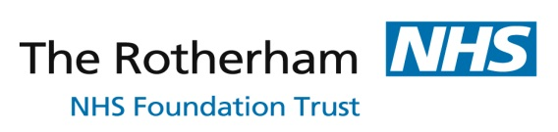
Provision of Hospital Funeral Services (Lot 1) and Contingency Transport and Storage of Deceased Patients (Lot 2)
Title

Reference number: | Itt_1093
Deadline Date: | 13th May 2016  Submission of tender response
This deadline is for: | 13th May 2016  Submission of tender response
Contract value: | Undisclosed
Location where the contract is to be carried out : | The Rotherham NHS Foundation Trust, Rotherham Hospital, Moorgate Road, Rotherham, S60 2UD (additional sites as per ITT schedule)
Is this suitable for smaller suppliers? | Yes
Name of the buying organisation: | The Rotherham NHS Foundation Trust
Description of the contract | The Rotherham NHS Foundation Trust wishes to retender its contract for the Provision of Hospital Funeral Services with an additional lot for Contingency Transport and Storage of Deceased Patients.  The successful bidder will deliver dignified, reliable, safe and value for money funeral services to deceased patients for whom the Trust is responsible in providing a funeral.
Documents | https://noecpc.bravosolution.co.uk
Classification of the contract | Funeral Services  All CPV codes can be viewed at http://simap.europa.eu.
ADDITIONAL INFORMATION
Contract type: | Contract
Is it a framework agreement? | No
Is this contract related to a programme of funding? | No
Contract will be awarded on the basis of: The most economically advantageous tender in terms of the criteria stated in the contract documents. | The Most Economically Advantageous Tender – as detailed in the tender documents.
Estimated length of contract: | 3 years with option to extend for 1 year plus 1 year
WHO TO CONTACT
Contact name: | Jo-Anne Turner  The Rotherham NHS Foundation Trust  120 Moorgate Road, Rotherham, S60 2TY  Via the E Tendering portal, as detailed in the tender documents.
Organisation name:

Address:

Email:
How to apply: | All tender documents can be accessed through the NOECPC e tendering portal at: https://noecpc.bravosolution.co.uk  It is free to register with the portal & they have a help desk should you need it.

