Micheldever Parish Council
Tender Document
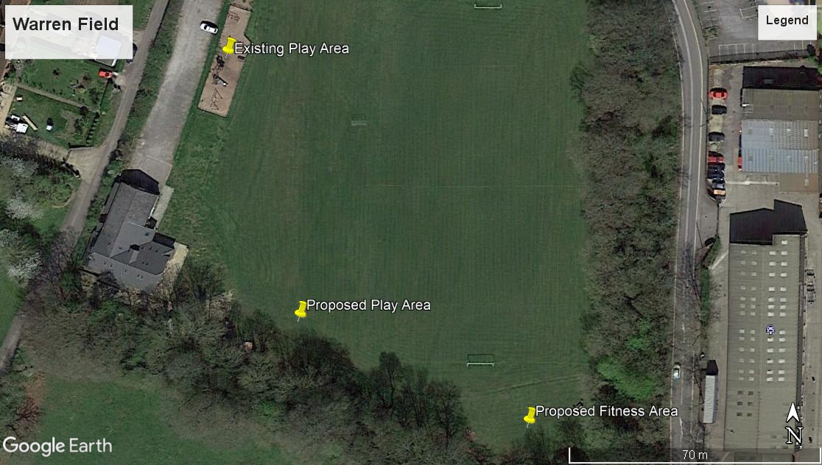
Lot 1: Provision to design and build a play area at Warren Field
- General Requirements
Micheldever Parish Council is seeking a suitably qualified company to design and build a play area to replace the existing facility at Warren Field Play Area, which is detailed in this document. The budget is £30,000.00 (ex vat).
The location of the site is Warren Hall, Micheldever, SO21 3AR.
Following the formal review of submissions, and a public consultation of the preferred design/s which may result in some revisions, the aim is to decide on the preferred supplier and place an order by the 17th December.
- Prices
All pricing should be exclusive of VAT and valid for 90 days from the due date of the response.
Prices will be fixed and firm for the duration of the contract.

- Non-Consideration of a Tender Response
The council has the right to refuse any or all submissions without tenderers being able to claim any compensation. All costs associated with the tender process and response is the responsibility of the suppliers that have been invited to participate.
The council may refuse a tender response if there has been any attempt to vary or alter the details within the document, or is not able to provide all the information required by the council to make a full evaluation.
Any offence or inappropriate actions by the supplier, including an offence under the Prevention of Corruption Act or the supplier directly canvasses any member of the council concerning the tender other than “appropriate” contact made to the individuals named within this document for the purposes of clarifying the requirements or raising any questions pertaining to the tender.
- CONTRACT CONDITIONS
The successful contractor will enter into a contract by way of a Purchase Order with Micheldever Parish Council.
The work is for the design, supply and installation of play equipment, surfacing, fencing and associated works which must all comply to current European Safety Standards mainly BS EN 1176 and BS EN 1177.
The successful contractor must provide evidence of Public Liability Insurance of no less than £5 Million and Employers Liability Insurance to the council within the tender response.
Confirmation of work hours, storage of materials, access to site, location of skips and a final Programme of Works and RAMS will need to be finalised and provided to the named consultant before work begins, most likely at the “Pre Start” meeting, along with a Construction Phase Plan.
During installation, the contractors needs to keep public and maintenance access points clear of equipment, and provide suitable HERAS fencing and safety notices around the construction site.
On completion of the project, any area that has been damaged during the installation such as the turf, surrounding pathways, existing play equipment and fencing must be returned to the original condition at the contractor’s expense. Reinstatement of the grassed area can be topsoil and seed.
- OVERVIEW OF PROJECT
Micheldever Parish Council has set aside a budget of £30,000.00 to redevelop the play area at Warren Field. As the existing car park is being extended into where the current play area is located, the objective is to create a durable, natural, challenging, and practical facility for children of all ages and abilities, while ensuring the area is enjoyable for the families of those using the play area all year round. It is proposed to use the existing fencing for the new area aimed at largely younger children (2-6) with either Junior equipment within this area or outside the fence depending on the design and advice from suppliers.
Existing play area below
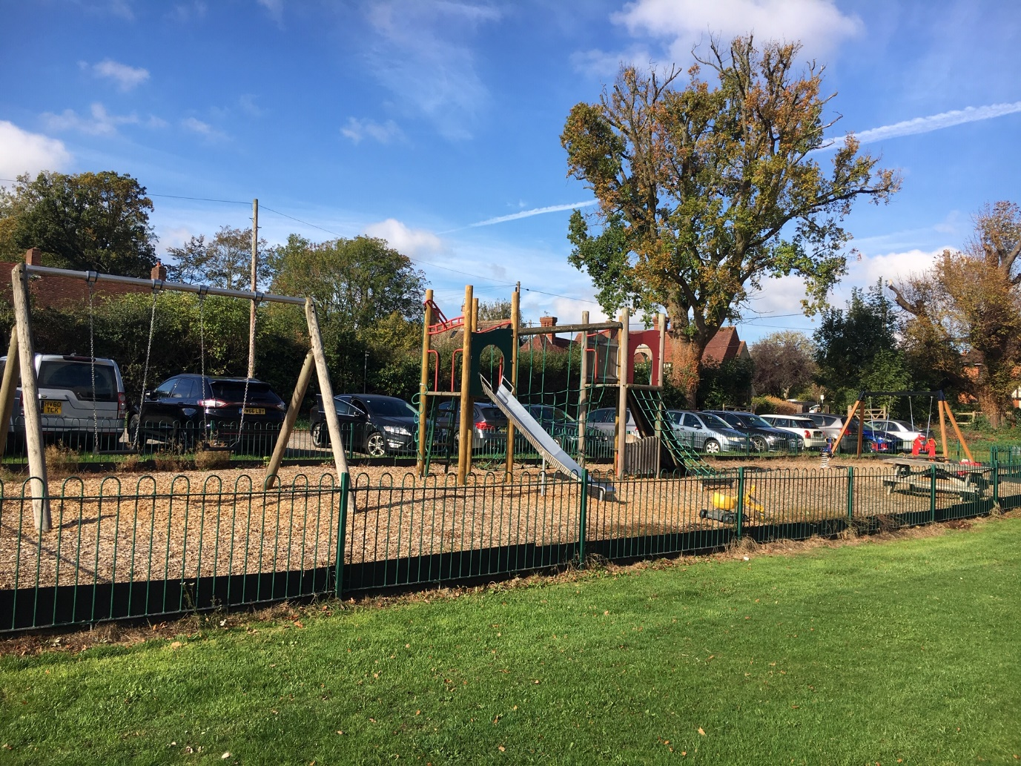
Materials
The council is seeking a fairly “Natural” look and feel to the play area that is sympathetic to the surrounding area and consistent throughout the play area. The design should incorporate wooden material with steel feet where possible using grass matting for the surfacing. It may not be mandatory to use steel feet if using a hardwood product however any details outlining the treatment or additional protection of the wood is encouraged.
Removals
The council would like some existing equipment to be relocated to the new area, primarily the toddler swing. The junior seats and chains can be reused if possible. The existing junior swing frame, climbing unit, springers and picnic bench can be disposed of. All bark will be removed by the council prior to work commencing.
Fencing
The existing fence is to be re-used (relocated) to the new site for the toddler and junior aged children. If possible, using the same length of fencing in a similar footprint would be preferable.
Furniture
The design needs to incorporate two new benches with back rests and one new Picnic Table. A new bin and play sign is also required.
Pathways
If the budget allows, it would be preferable to have a pathway from one end of the play area to the other, possibly connecting to the picnic bench to allow improved access. This can be a compacted type stone or similar that is in keeping with the equipment and surrounding area.
Play Equipment
Overall the design and choice of play equipment will be up to the supplier, however the items and suggestions which should be included are:
- Flat Seat Swing Frame (2 seats)
- Toddler Seat Swings (Existing Frame)
- Toddler Multi Play Unit
- Junior Multi Play Unit
- Timber Trail and or “Pick Up Sticks” frame
- Basket Swing
- New double springer and/or see saw
Surfacing
Grass Matting to be used under equipment only.
Post Installation Inspection
Please allow for a RPII inspection following the completion of the project, and any noted defects or medium to high risk reports need to be attended to and resolved before the open date noted on the table below.
- Time Table for Project

Action: | Date:
Tender Site Meeting – date and time to be confirmed – or suppliers can visit at their own convenience | 14th November 2018 (individual times if possible during day)
Final date for any clarification or questions on tender | 21st November 2018
Tender Response Due | 3rd December 2018
Final Design and Revisions (based on consultation of preferred design) | 15th December 2018
Award Date (Purchase Order) | 17th December 2018
Expected Start Date | 18th February 2019
Expected Completion Date including snagging and inspection report | 22nd March 2019

7. SCORING OF LOT 1
The table below will be used to score all the submissions in order to short list the responses to a preferred supplier.
Item | Detail | Score
Overall Design | Meeting the brief, design layout, aesthetics of equipment, varied challenge and suitability for different ages | 60%
Quality of Materials | Materials used, expected longevity, steel feet used, fixings and other considerations | 20%
Warranties | What is covered in the warranty, length of warranty for each type of material | 10%
Presentation | Quotation information, quality of the visuals, general information included and format of response | 10%

Lot 2: Provision to design and install a new outdoor fitness area at Warren Field
- General Requirements
Micheldever Parish Council is seeking a suitably qualified company to design and build an outdoor fitness area.
The location of the site is Warren Hall, Micheldever, SO21 3AR. The budget is £13,000.00 (ex vat).
- Prices – as per Lot 1
- Non-Consideration of a Tender Response – as per Lot 1
- CONTRACT CONDITIONS – as per Lot 1 however Outdoor Fitness Equipment must comply to European Safety Standards BS EN 16630.
- OVERVIEW OF PROJECT
The council is looking for a combination of moving and static fitness equipment that will encourage various ages and abilities to use the facility. The specific items will be up to the supplier, based on the budget available. At least one item should be inclusive, and all the equipment will be on grass matting.

A safety sign should be included with artwork and content to be agreed upon, and muted colours such as green used where possible.

A RPII inspection to be carried out and included in the quotation.

- TIME TABLE FOR PROJECT – As per Lot 1, however if this may be slightly varied depending on whether the same supplier is contracted to do both Lots, or separate contractors.

- SCORING OF LOT 2
The table below will be used to score all the submissions in order to short list the responses to a preferred supplier.
Item | Detail | Score
Overall Design | Selection of equipment, meeting the brief, variety for ability and ages, unique selling points | 60%
Warranties | What is covered in the warranty, length of warranty and how long the company has been operating (please state this) | 20%
Presentation | Quotation, quality of the visuals, general information included and format of response | 10%
Value Added | Any open days, training sessions or similar that is included within the proposal | 10%

SCORING SYSTEM (Both Lots)
8-10 | Superior | Exceptional demonstration of the relevant ability, understanding, experience, skills, resources & quality measures required to meet the projects aims or requirement. Response highly relevant with comparable contract value.
6-8 | Good | A comprehensive response submitted in terms of detail and relevance and clearly meets most of the project aims or requirement with no negative indications or inconsistencies.
4-6 | Adequate | Reasonable achievement of the requirements specified in the tender offer & presentation for that criterion. Some errors, risks, weaknesses or omissions, which can be corrected/overcome with minimum effort.
2-4 | Below Expectations | Minimal achievement of the requirements specified in the tender offer & presentation for that criterion. Several errors, risks, weaknesses or omissions, which are possible, but difficult to correct/overcome and make acceptable.
0-2 | Poor to deficient | Limited response provided, or a response that is inadequate, substantially irrelevant, inaccurate or misleading

- Reference Sites (Both Lots)
Please provide two suitable references that ideally are of similar value and requirements for this project. Please use the format below for each reference (one must be at least 3 years old and one must be within 12 months):
Name of Council/Client
Contact Name
Contact Telephone
Contact Email
Location of Installation
Value of Project
Description of Project
Date of Installation

- Format for Response (Both Lots)
Please provide 1 x A1 (or closest size) Hard Copy of any visuals / designs and 1 x A4 hard copy of any supporting material such as the quotation to the Parish Council, address shown below. Additionally, send an email ONLY to Michael Carter by the due date – electronic responses are not to be sent to the council.
The items should be clearly marked “Tender Response – to be opened only by nominated council staff”
Parish Council Address for delivery:
C/O Micheldever Parish Council
34 Bramble Hill
Chandlers Ford
Eastleigh, SO53 4TP
Attention: Jocelyn Jenkins –Clerk to the Council

- Contact for Tender
Micheldever Parish Council is using an independent consultant for all aspects of the Pre-Sales process (and Project Management) who will be the primary contact for this tender and installation.
Any questions relating to the tender and organising the time for a site visit should be directed to:
Michael Carter
Sports and Play Consulting Limited
07421 463099
michael@sportsandplayconsulting.co.uk

