Conversion of MAN 15T HX77
Support Vehicles to EPLS Mk-3 Variant
OSVP/0032

Contract Data Requirement Deliverable Plans

Annex K

V2

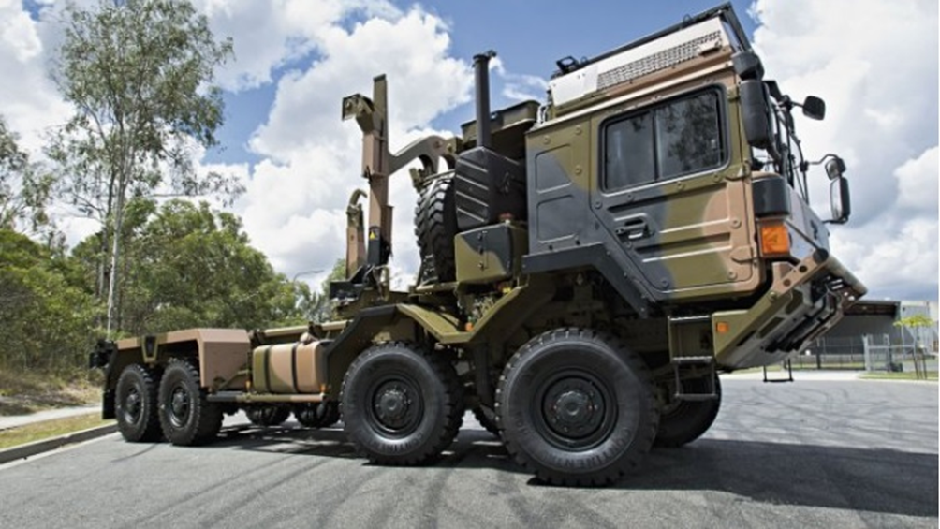
ANNEX K CDRs

Document | Comment
1. Integrated Support Plan [2.1] | See Contract Schedule, Annex B
a. Master Schedule & Milestones | See Contract Schedule, Annex B
2. ILS Progress Report [2.3.1] | Post CA required
3. Training Plan [4.8] | See Contract Schedule, Annex B
4. Packaging, Handling, Storage and Transportation (PHS&T)  Plan [4.10] | See Contract Schedule, Annex B
5. Disposal Plan [4.11] | See Contract Schedule, Annex B
6. Material Safety Data Sheets (MSDS) [DEFORM 68] | Prior to delivery of spares
7. Obsolescence Management Plan [4.15] | See Contract Schedule, Annex B
8. GPA Plan [4.14] | See Annex D
9. ILS Associated Meetings [2.3.2] | Post CA required
10. Quality Assurance Plan | Duplication, See CDR39
11. Risk Management Plan | See Risk & Opportunity Management Plan, CDR37
12. Configuration and Change Management Plan [8.9] | See Contract Schedule, Annex B
13. Supportability Case [2.9.1] | See Contract Schedule, Annex B
14. Supportability Case Reports [2.9.2] | Post CA required
15. Support Analysis (SA) Plan [3.1] | See Contract Schedule, Annex B
16. Reliability Centred Maintenance (RCM) Plan [3.6] | Included in R&M Plan, CDR 20
17. Reliability Centred Maintenance (RCM) Reports | Required Post CA as per RCM Plan
18. Level Of Repair Analysis (LORA) Plan [3.7] | Included in R&M Plan, CDR 20
19. Level Of Repair Analysis (LORA) Reports | Required Post CA as per LORA Plan CDR18
20. Reliability and Maintainability (R&M) Plan [4.2.1] | See Contract Schedule, Annex B
21. Reliability and Maintainability (R&M) Case Report | See Contract Schedule, Annex B
22. Maintenance Plan [4.3] | Included in R&M Plan CDR20
23. Ease of Maintenance Asses. Plan | Included in CDR22
24. Failure Modes Effects Criticality Analysis (FMECA) Plan [3.5] | Included in R&M Case, CDR20
25. FMECA Report | Not a contract deliverable
26. Logistics Test and Evaluation Plan (Log Demo) [5.2] | See Contract Schedule, Annex B
27. Logistic Info. Management Plan | Not a contract deliverable
28. Supply Support Plan & Schedule [4.4.2] | See Contract Schedule, Annex B
29. Initial Provisioning List | Not a contract deliverable
30. Initial Provisioning Ranging & Scaling | Not a contract deliverable
31. Facilities and Infrastructure Plan (F&I Plan) [4.6] | Submitted in Tender response
32. HFI [1.12] | See Contract Schedule, Annex B
33. Technical Documentation Management Plan [4.9] | See Contract Schedule, Annex B
34. Software Support Plan [4.13] | See Contract Schedule, Annex B
35. System Engineering Mgt. Plan | Not a contract deliverable
36. Project Management and Implementation Plan (PM&IP) [1.2.1] | See Contract Schedule, Annex B
37. Risk & Opportunity Management Plan [1.5] | See Contract Schedule, Annex B
38. Risk Register [1.6.1] | See Contract Schedule, Annex B
39. Quality Assurance Plan (QAP) [1.7] | See Contract Schedule, Annex B
40. Safety and Environmental Management Plan (S&EMP) [9.6] | See Contract Schedule, Annex B
41. Safety & Environmental Case Report [1.10] | See Contract Schedule, Annex B
42. Schedule Risk Analysis (SRA) [1.6.2] | Submitted in Tender Response
43. V&V Requirements Matrix | Not a contract deliverable
44. Legislation Compliance Matrix [9.1] | See Contract Schedule, Annex B
45. Maintenance Schedules, Drawings and Documentation  for AESP [4.9] | See Contract Schedule, Annex B, See CDR33
46. Security Management Plan [1.14] | See Contract Schedule, Annex B
47. 15T SV to EPLS Mk3 Conversion Manual | See Contract Schedule, Annex B

