AHDB TEMPLATE
REQUEST FOR QUOTE (RFQ)
Contract Title: | Provision of advertising spend information
Contract Reference: | CF/2017/16
Contract period: | 2 years
Date: | 26 April 2017

- Introduction
This document is an invitation to participate in a request for quotation. Submissions should be based on the information contained within this document and in the format outlined in section 4. Deadlines and submission instructions are contained in section 6.
- Background / Aims
AHDB (The Agriculture and Horticulture Development Board) would like to better understand how advertising affects both the image and sales of their sector related products and also assess their own activity. Therefore, there is a requirement for the provision of advertising spend information.

- Service Requirement
Reporting should be filtered by AHDB sectors, which are described below. If there is a regular report or publication already in place that meets this then AHDB will consider it, as an alternative to bespoke reporting.
Sector | Products Included | Further Requirements
Dairy | Milk, Yoghurt, Cheese, Butter and Ice Cream | Milk, yoghurt and cheese split out
Meat and Poultry | Beef, lamb, pork, chicken  Processed meats (sausages, bacon, ham)
Cereals | Breakfast cereals
Fruit and Vegetables | All fruit, vegetables and potatoes  Including fresh and frozen
Bread and Baked Goods | Bread  Bread alternatives (pitta bread, naan, thins)  Crumpets, croissants, pancakes  Biscuits and cakes

Reporting Requirement – Top-line
- Quarterly spending by AHDB sector (for definition see table)
- Annual spending by AHDB sector (for definition see table)
Reporting is to include charts and a data table showing actual expenditure and yoy % change, when compared to the same time period of the previous year.

Filtered Reporting Within Sector
- Quarterly expenditure of the top 10 spending brands and retailers for each AHDB sector: dairy, meat and poultry, cereals, fruit and vegetables, bread and baked goods
- Annual expenditure of the top 10 spending brands and retailers for each AHDB sector: dairy, meat and poultry, cereals, fruit and vegetables, bread and baked goods
- Within the dairy sector, split out: milk, yoghurt and cheese, then provide the same style of annual and quarterly reports
- Reporting is to include charts and a data table showing actual expenditure and yoy % change, when compared to the same time period of the previous year.
It is also desirable to have examples, including images, of advertising that was launched or has seen heavy investment through the most recent data period.
Advertising spend should be calculated from: cinema, internet, outdoor, press, radio, TV, direct mail and door drop

Examples of the Style of Reporting
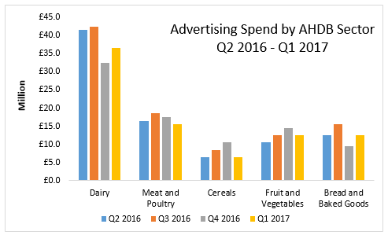
Topline ad-spend by sector

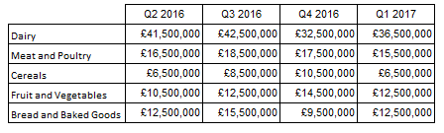

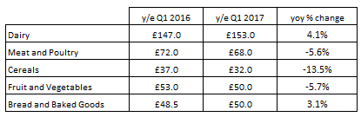
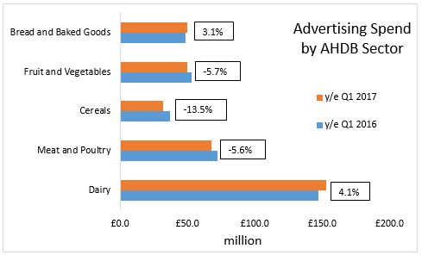

All Sectors
Dairy, meat and poultry, cereals, fruit and vegetables, bread and baked goods. This style of reporting should also be used for milk, cheese and yoghurt.

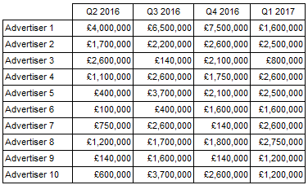
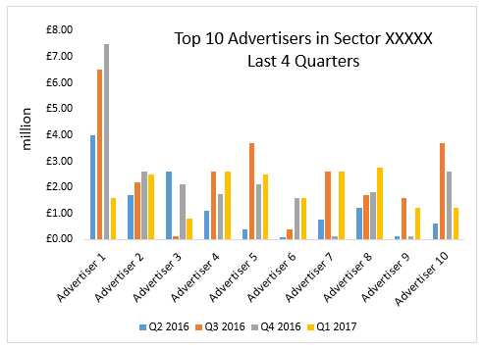

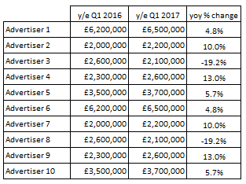

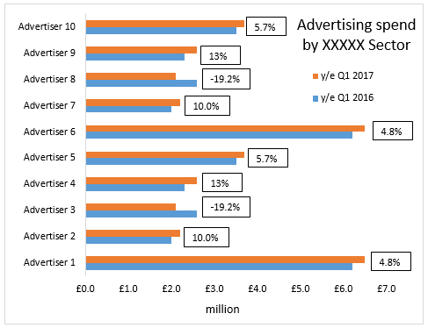

- Structure / Format of Submission
Maximum of 2 pages A4.
- Evaluation and Award of Contract

Evaluation of tenders will be on the following basis:-

 | Weighting (100%)
Quality:  Demonstrate full understanding of the brief  Clear description of data collection and approach taken  Clear description of deliverables - format and style of report | 60%
Price: | 40%

- Tender submissions

Quotes must be received by Noon: | 10 May 2017

Submission instructions:-

Electronically:

Email address: | Stewart.batchelor@ahdb.org.uk
Reference (entered as the subject): | CF/2017/16 Provision of advertising spend information

Submissions will remain unopened until after the closing date and time has passed.

- Timetable

 | Deadline
Mini-competition/RFQ circulated | 26 April 2017
Last date for suppliers to ask clarification questions  (suppliers are required to register their interest with AHDB in order to receive clarification information) | 5 May 2017
Deadline for receipt of submissions/quotes | 10 May 2017
Notification of intended award of contract | 16 May 2017
Contract commencement | 22 May 2017

Please note these timescales are approximate and may change.

- Additional Information

- Terms / Conditions of Participation

AHDB Terms and Conditions for the supply of goods and services shall apply to any contract awarded as a result of this request for quote.

If you have any questions relating to this tender please contact:-
Email address: | Stewart.batchelor@ahdb.org.uk
Stewart.batchelor@ahdb.org.uk | Provision of advertising spend information

