

Medicines Procurement and Supply Chain

NHS England

2nd Floor Rutland House

Runcorn

Cheshire WA7 2ES

**Project title: NHS National Framework for the supply of Ustekinumab 1 September 2024**

**CM/TNS/24/5711/01 - NHS Framework for the supply of Ustekinumab - London & South of England. Period of framework: 1 September 2024 to 31 August 2026 with an option or options to extend (at the Authority’s discretion) for a period or periods up to a total of 24 months.**

**CM/TNS/24/5711/02 – NHS Framework for the supply of Ustekinumab - North of England and Midlands & East. Period of framework: 1 September 2024 to 31 August 2025 with an option or options to extend (at the Authority’s discretion) for a period or periods up to a total of 24 months.**

Dear Sir/Madam,

We would like to bring the following information, pertinent to the specific medicines within this procurement to your attention.

This is a procurement for all brands of:

|  |
| --- |
| USTEKINUMAB SOLUTION FOR INJECTION VIAL 45MG/0.5ML |
| USTEKINUMAB SOLUTION FOR INJECTION PRE-FILLED SYRINGE 45MG/0.5ML |
| USTEKINUMAB SOLUTION FOR INJECTION PRE-FILLED PEN 45MG/0.5ML |
| USTEKINUMAB SOLUTION FOR INJECTION PRE-FILLED SYRINGE 90MG/1ML |
| USTEKINUMAB SOLUTION FOR INJECTION PRE-FILLED PEN 90MG/1ML |
| USTEKINUMAB INJECTION FOR INTRAVENOUS INFUSION VIAL 130MG |

The following list of products is being tendered for all uses except for use in the treatment of Ulcerative Colitis (unless or until there are any changes to licensed indications during the term of the framework).

MPSC will share the same explanation at the tender evaluation stage. If an award is made against these products, the above information will be communicated to Participating Authorities before the framework commencement date:

|  |
| --- |
| USTEKINUMAB (STEQUYMA) INJECTION FOR INTRAVENOUS INFUSION VIAL 130MG |
| USTEKINUMAB (STEQUYMA) SOLUTION FOR INJECTION PRE-FILLED SYRINGE 90MG/1ML |
| USTEKINUMAB (STEQUYMA) SOLUTION FOR INJECTION PRE-FILLED PEN 90MG/1ML |
| USTEKINUMAB (STEQUYMA) SOLUTION FOR INJECTION VIAL 45MG/0.5ML |
| USTEKINUMAB (STEQUYMA) SOLUTION FOR INJECTION PRE-FILLED SYRINGE 45MG/0.5ML |
| USTEKINUMAB (STEQUYMA) SOLUTION FOR INJECTION PRE-FILLED PEN 45MG/0.5ML |
| USTEKINUMAB (PYZCHIVA) INJECTION FOR INTRAVENOUS INFUSION VIAL 130MG |
| USTEKINUMAB (PYZCHIVA) SOLUTION FOR INJECTION PRE-FILLED SYRINGE 90MG/1ML |
| USTEKINUMAB (PYZCHIVA) SOLUTION FOR INJECTION PRE-FILLED PEN 90MG/1ML |
| USTEKINUMAB (PYZCHIVA) SOLUTION FOR INJECTION VIAL 45MG/0.5ML |
| USTEKINUMAB (PYZCHIVA) SOLUTION FOR INJECTION PRE-FILLED SYRINGE 45MG/0.5ML |
| USTEKINUMAB (PYZCHIVA) SOLUTION FOR INJECTION PRE-FILLED PEN 45MG/0.5ML |
| USTEKINUMAB (UZPROVO) INJECTION FOR INTRAVENOUS INFUSION VIAL 130MG |
| USTEKINUMAB (UZPROVO) SOLUTION FOR INJECTION PRE-FILLED SYRINGE 90MG/1ML |
| USTEKINUMAB (UZPROVO) SOLUTION FOR INJECTION PRE-FILLED PEN 90MG/1ML |
| USTEKINUMAB (UZPROVO) SOLUTION FOR INJECTION VIAL 45MG/0.5ML |
| USTEKINUMAB (UZPROVO) SOLUTION FOR INJECTION PRE-FILLED SYRINGE 45MG/0.5ML |
| USTEKINUMAB (UZPROVO) SOLUTION FOR INJECTION PRE-FILLED PEN 45MG/0.5ML |
| USTEKINUMAB (WEZENLA) INJECTION FOR INTRAVENOUS INFUSION VIAL 130MG |
| USTEKINUMAB (WEZENLA) SOLUTION FOR INJECTION PRE-FILLED SYRINGE 90MG/1ML |
| USTEKINUMAB (WEZENLA) SOLUTION FOR INJECTION PRE-FILLED PEN 90MG/1ML |
| USTEKINUMAB (WEZENLA) SOLUTION FOR INJECTION VIAL 45MG/0.5ML |
| USTEKINUMAB (WEZENLA) SOLUTION FOR INJECTION PRE-FILLED SYRINGE 45MG/0.5ML |
| USTEKINUMAB (WEZENLA) SOLUTION FOR INJECTION PRE-FILLED PEN 45MG/0.5ML |

Yours faithfully

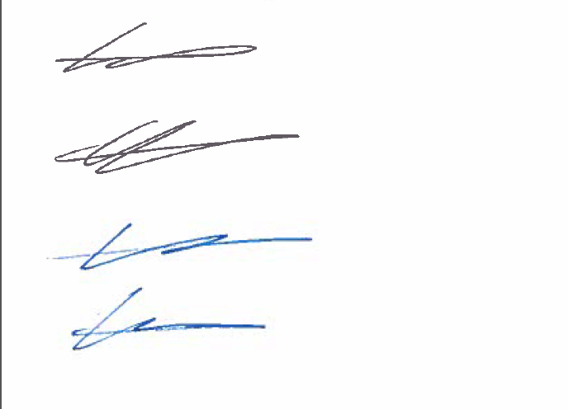

Katie Noonan

Operations Adviser and Developing Commercial Practitioner

Branded, Biosimilars and IV Fluids Procurement Support