Government-Funded Exploration License Competition
  - Expression of Interest
Reference Number: TRN010/03/2016

Deadline for applications: 1st April 2016 (17:00 GMT)

About the Oil and Gas Authority (OGA)
OGA is an executive agency, sponsored by the Department of Energy & Climate Change. OGA works with government and industry to make sure the UK gets the maximum economic benefit from its oil and gas reserves. OGA is responsible for regulating offshore and onshore oil and gas operations in the UK, including: licensing, exploration and production, fields and wells, infrastructure and carbon capture and storage (CCS) licensing.

Background
In the 2015/16 UK Budget, OGA was assigned funds to acquire seismic and other geoscience data in under-explored areas of the UK Continental Shelf in order to improve regional evaluations and stimulate future exploration activity by improving the fundamental geological understanding of these areas. Two areas were selected for surveying, in collaboration with industry, and the geophysical acquisition work was completed and data processed. The surveys cover the Rockall Trough and the Mid North Sea High (MNSH) areas with a total of up to 40,000 km of new and legacy seismic data (including a substantial set of Broadband 2D seismic data), supplemented by gravity and magnetic data. Final Processed and Raw data will be made available at the end of March 2016, including full-offset stacks, angle stacks, gathers, velocity data, navigation data, gravity data, magnetic data and well log data. A small charge will be made for data provided on physical media (i.e. field tapes). These data packages will be freely available for interpretation from 31st March 2016. More information on the surveys (including spatial data) is available from the OGA website: www.gov.uk/oga.

- Competition Summary
OGA has established this procurement competition to derive innovative geophysical and geological data analysis and/or products which the OGA would use to gain a better understanding of the two study areas. The work may also be used internally by OGA as part of the 29th Seaward Licensing Round process which is expected later this year subject to Strategic Environmental Assessment. The intellectual property of all work produced would be retained by OGA and applicants would be prohibited from selling any analysis or product relating to this process until licenses are awarded following closure of the 29th Seaward Licensing Round. After production licence award, applicants would be permitted to sell or otherwise distribute their products. Applicants could also opt to apply for production licenses through the Licensing Round process.
The competition would be structured as follows (indicative):
Phase 1 – Expression of interest and call for project plans
OGA is inviting applications for feasibility studies to generate studies, analyses and other products based on either the Rockall Trough and/or MNSH data, for which funding may be available.
Expression of Interest opens: 7 March 2016
Deadline for initial applications: 1st April 2016 (17:00 GMT)
Notification of feasibility funding awards: 8th April 2016
Phase 2 – Feasibility study
In this phase, applicants would be expected to carry out a detailed feasibility study, using the available seismic, gravity/magnetic and well data, plus any other relevant public domain data, and to carry out an initial analysis of that data. This may include (but is not limited to): an analysis of the petroleum plays from the perspective of source rock (presence, maturation and migration), reservoir (presence and quality) and seal (extent and effectiveness), structural interpretation , gravity/magnetics, seismic imaging, seismic processing, seismic inversion, tectonic/structural modelling or any other relevant specialism.
Whilst some applicants may choose to prepare a more generalist study, we would also strongly welcome specialist studies. Deliverables from this stage will include a report, plus supporting data, preferably in industry standard formats, together with a detailed project plan and costings. Applicants may be invited for a face to face interview.
Call for feasibility studies and project plans: 8th April 2016
Deadline for submission of feasibility study: 24th June 2016 (17:00 GMT)
Notification of winning entries: 11th July 2016
Phase 3 – Product development
A minimum of two feasibility studies (one for each geographical area) will be selected by an independent judging panel with the aim of supporting applicants to develop their initial work into a more comprehensive analysis or product, for which further funding may be available (assuming there is an acceptable proposal.)
The final projects delivered could, for example, provide structurally validated models for the areas, gravity and magnetic modelling, thermal history modelling, seismic/sequence stratigraphy, etc (supported by analysis of seismic, well data, cores and cuttings, seabed samples, seep data, gravity data, magnetic data).
Phase 3 product development begins : 11th July 2016
Final products delivered to OGA: 11th November 2016 (17:00 GMT)

Scope of Phase 1: Expression of Interest
Phase 1 is a pre-procurement stage expression of interest. OGA wishes to procure seismic analysis services in order to acquire final seismic interpretation products for two primary geographic regions, the Rockall Trough and the Mid North Sea High (MNSH/Central North Sea). At this stage, interested applicants are invited to provide a brief description of their proposed methodology, an outline of their proposed feasibility study and project plan. They should also provide a summary of their expertise and suitability and indicate the costs associated with carrying out this feasibility study and justification for the application of any funding.
The projects areas are broadly outlined on the following map.

Project 1: Rockall Trough

Project 2: Mid North Sea High (MNSH)

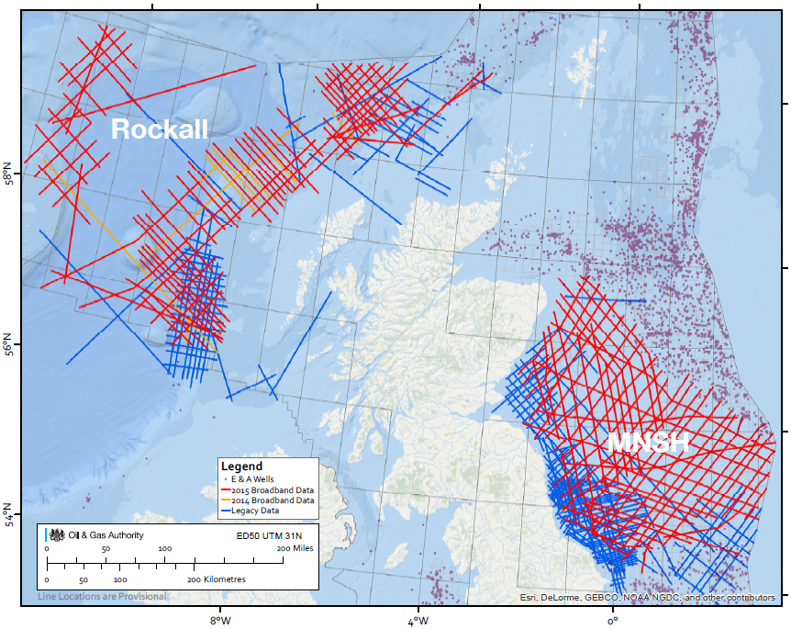

Eligibility
The competition is open to all registered companies, including individuals or teams affiliated to/applying on behalf of Higher Education Institutions. Companies and institutions which already have experience of seismic interpretation and access to hardware and software capable of the analysis of seismic and other geophysical datasets are encouraged to apply.

Funding
Phase 2:
Applicants submitting an expression of interest in Phase 1 are invited to apply for funding to carry out feasibility studies in Phase 2. The total funds available for Phase 2 will be a maximum of GBP 250,000 (Two Hundred and Fifty Thousand Pounds) inclusive. Applicants for funding must provide a detailed breakdown of cost associated with carrying out Phase 2 work. Applicants will be assessed by a judging panel. Funding will be allocated on a case-by-case basis for successful applicants but is likely to be in the region of £10,000 (Ten Thousand Pounds) to £30,000 (Thirty Thousand Pounds) for each applicant. Applicants will be judged on the basis of the quality of their project plans, experience and suitability.
Phase 3:
Applicants submitting their Phase 2 feasibility studies should also detail any further costs involved in developing their initial work into a final product and make any such application for further funding at this stage. The total funds available for Phase 3 for successful applicants will be in the region of £200,000 (Two Hundred Thousand Pounds) inclusive. This may be split into two awards of up to £100,000 (One Hundred Thousand Pounds); e.g. one for a Rockall Trough analysis and one for a MNSH analysis.
The OGA reserves the right to add funds to this budget at any time, which at the OGA’s discretion could be used to fund additional analysis or extend the period or scope of support for the successful applicants.
Cost and suitability will be a scrutinised and the assessment panel may make recommendations for amendments to requested costs if they are not fully justified.

Application Procedure
Phase 1 expressions of interest must be emailed to david.i.wilson@decc.gsi.gov.uk by 1st April 2016 (17:00 GMT). Applications will be received up to the time and date stated.
Please ensure your application is delivered not later than the appointed time on the appointed date. The OGA does not undertake to consider applications received after that time. The OGA requires applications to remain valid for a period of 60 days.
If you require further information concerning the application process email david.i.wilson@decc.gsi.gov.uk
The OGA reserves the right to amend the Phase 1 expression of interest at any time prior to the deadline for receipt of applications. Any such amendment will be numbered, dated and issued by 25th March 2016 17:00 GMT. Where amendments are significant, the OGA may at its discretion extend the deadline for receipt of applications.
The OGA reserves the right to withdraw this opportunity prior to award without notice and will not be liable for any costs incurred by applicants during any stage of the process. Applicants should also note that, in the event an application is considered to be fundamentally unacceptable on a key issue, regardless of its other merits, that application may be rejected. By issuing this invitation the OGA is not bound in any way and does not have to accept the lowest or any application and reserves the right to accept a portion of any application unless the applicant expressly stipulates otherwise in their application.

Information Required from Applicants
There is no set proforma for applications, but applicants are expected to provide a summary of the proposed project, project partner information and the finances requested.
The application should be a maximum of 10 sides A4, (excluding attachments, declarations, pricing schedule and CVs/Publication Lists), in minimum font size 11 point (Corbel or other sans serif typeface of equivalent size), with margins of at least 2cm.
Applications of expression of interest should consist of:
- Case for Support (up to 4 sides of A4) made up of:
- Previous Track Record (up to 2 sides of A4) which should include:
- A summary of recent industrial experience, knowledge exchange activity and/or research in the science or technology covered by the proposal;
- Specific expertise and facilities available to the applicant for the proposed work.
- A description of the proposed work (up to 5 sides of A4) which should include:
- How the proposal addresses the required aims of the competition;
- The project/area (Rockall or MNSH) you plan to apply against;
- Specific objectives for the project and rationale for why the work or product is needed, how the end-user (and therefore the economy or public good) will benefit from the work, and how the applicant will benefit from the interactions with end users;
- Feasibility study methodology and activities, including work programme with milestones and Gantt chart (activities of project partners should also be included);
- Deliverables – what are the anticipated deliverables from the project (Phase 2 feasibility study deliverables and Phase 3 end product if appropriate).
- Outline Data Management Plan (up to 1 side of A4). Please provide details of how you will manage, transfer and archive new data generated from the project. Please state the data sets you plan to use (note: a small charge will be made for data provided on physical media ie field tapes and, depending on demand, larger quantities of raw data may require a longer period of time to deliver).
- Justification of resources with itemised breakdown (up to 2 sides of A4).
- Price quotations/documentary evidence - full and detailed breakdown of associated costs of Phase 2 feasibility study (including options where appropriate) and state the amount of funding being applied for and how that would be allocated.
- The OGA would like applicants to demonstrate that the project(s) will be managed and carried out by individuals with relevant experience and capabilities. Your tender response should include a summary of key individuals and their relevant experience (CVs and, if relevant, publication lists, plus other information).

Evaluation Criteria/Assessment
The tender process will be conducted to ensure that bids are evaluated fairly and transparently, in accordance with agreed assessment criteria. Proposals will be assessed by an impartial assessment panel made up of relevant experienced persons. Membership of the panel may be subject to change in order to avoid any conflict of interest.
Proposals will be assessed against the following criteria:
EVALUATION CRITERIA AND SCORING
Criterion | Description | Weighting
01 | Technical quality of project plan and proposed scientific/technical study | 30%
02 | Presentation and quality of products | 30%
03 | Integration of database and techniques used | 15%
04 | Degree of innovation | 15%
05 | Suitability and experience of applicant(s) | 10%

Feedback to unsuccessful applicants will be available, on request, post-award.

Working arrangements
The successful applicant(s) will be expected to identify one named point of contact through whom all enquiries can be filtered. OGA reserves the right to use project deliverables and interim products for the purpose of promotion of the UK Continental Shelf’s resource potential.

