TIPTREE PARISH COUNCIL (‘the Council’) INVITES TENDERS FROM INTERESTED CONTRACTORS (‘The Contractor’)
FOR
Building of a new Parish Council Office including a refurbishment of the Disabled Toilet at the Former Public Conveniences, Church Road, Tiptree CO5 0AB (‘The former Public Convenience)

Before Commencement of Works:
(1) Contractor to provide written reference from 2 contracts for similar size project carried out by the contractor in the last 3 years verifying works completed on budget, on time and to a standard which was satisfactory to the buyer.
(2) Contractor to provide written risk assessments, methods statements, evidence of public liability insurance and other industry specific paperwork which is acceptable to the Council.
(3) Contractor to provide an expected start date and finish date with quote. Note that start date will not be before Sep 15th 2020, to enable the quotes to be received and award made to winning bid.

The Works:
(4) To assess the area to determine safe working requirements and to utilise, fencing/barriers, traffic management etc. as required to ensure the health and safety of staff and public.
(5) To scan the complete area using an ultrasonic cable avoidance tool to determine any potential hazards from underground services, noting and acting accordingly to the results.
(6) To ensure the removal of all asbestos material as determined by the Asbestos Survey.
(7) To deliver the building as per the specification stated in Colchester Borough Council Building Control Application 205060.
(8) To liaise with CBC Building control for any issues during the build.
(9). To maintain regular (at least weekly) contact with the Parish Clerk on the project, highlighting any issue which may delay the project end date.
(10) Contractor to note the need for shelving: Shelving to be provided as wall mounted (and painted) shelves prior to handover.
(11) Snagging: A thorough snagging check to be conducted with Parish Clerk and contractor prior to handover, ensuring the operation of all electrics and plumbing.
(12) To supply all materials, machinery, transport and manpower required to facilitate all of the above and to leave the site safe, clean and tidy each day.

Plans for the existing building and the work required are attached below:

Toilet Block Plan Layout:
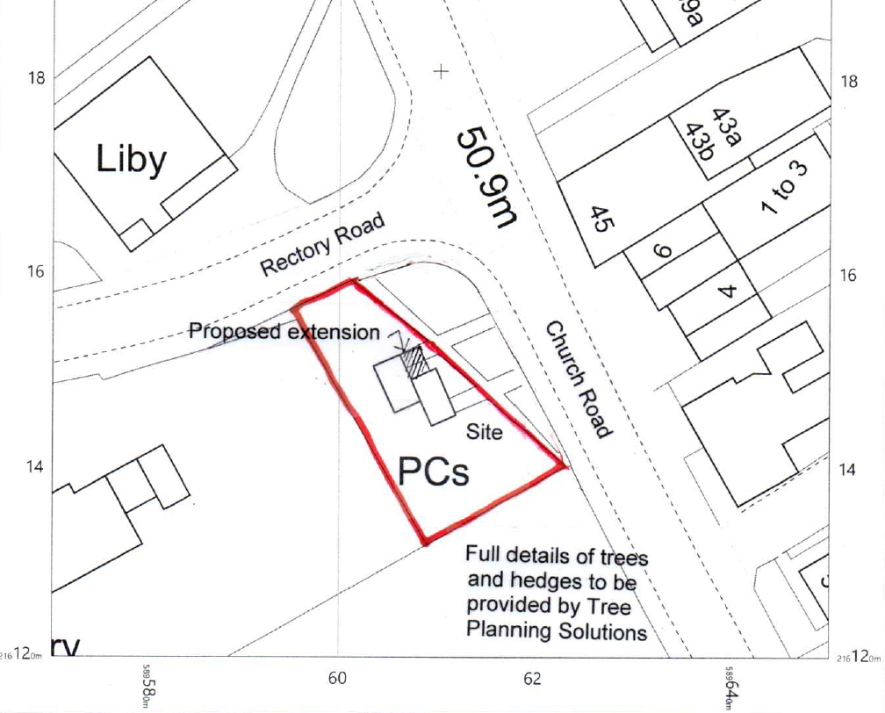

Existing Layout:
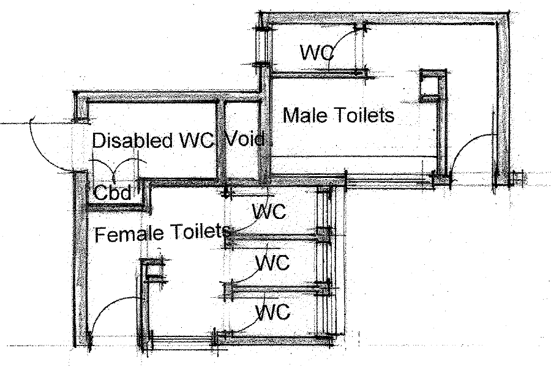

Existing Front Elevation:
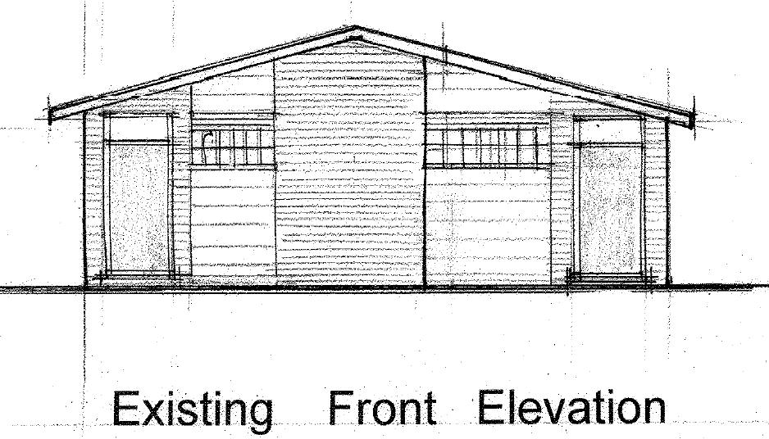

Proposed Layout of Ground Floor:
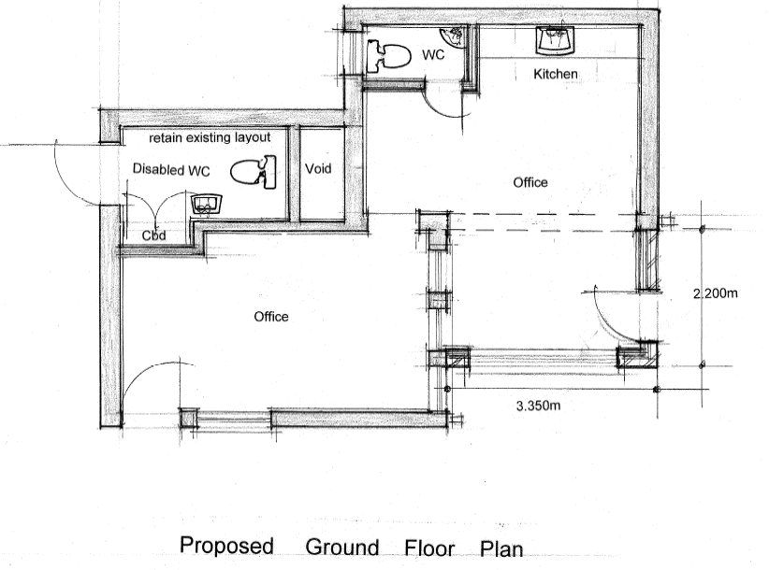

Proposed Elevation:
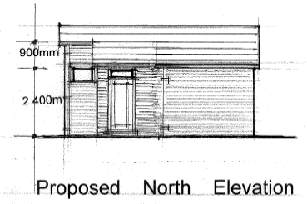

Electrical:

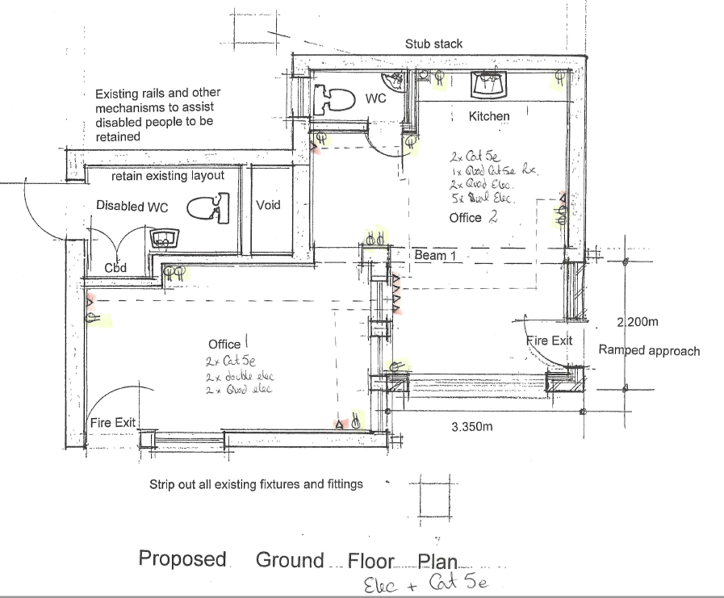
Note:
- All windows to have external shutters that can be locked into both closed and open position. Design of any type that will prevent out of hours stone throwing causing damage to windows will be acceptable.
- Loft space to be opened to a wider opening, and ladder assembly fitted.

Lighting Layout:
