**Invitation to Tender**

**MusicAbility Centre Phase 1**

**Ref: PZ-00095**

# About MusicAbility Foundation

Penzance-based charity MusicAbility Foundation strives to improve the lives of people in this beautiful but economically deprived area of the UK through music therapy, music education and participation. During the pandemic the Foundation was gifted a fine but rather run-down Grade 2 listed building in the centre of Penzance to create a music centre for health and well-being. MusicAbility is committed to creating flexible and inclusive musical opportunities for people of all ages, life-experience and abilities, and our services are frequently life-changing for the people we work with. On being gifted the building in June 2021 we created a dedicated music therapy room – the only fully equipped music therapy space west of Bristol. This has enabled us to meet the needs of individuals and families, working in close partnership with local schools, social care, and mental health services. We are now working towards renovating and extending the rest of the building to become a unique socially focussed music centre, offering expanded music therapy services and spaces for music teaching, rehearsal and events. The social impact of our project is significant – West Cornwall is rich in creativity but economically-deprived and quite isolated – our catchment includes young people in the most deprived 1½ % in the UK.

# Background and Context

The purchase of this system is part of a grant funded application process and therefore procurement will be subject to grant approval of the project. We will assess tenders received on a Most Economically Advantageous Tender.

The charity were fortunate to be bequeathed the Grade II listed property at 10 Parade Street. At the time it had a number of tenants in-situ, however these have gradually moved on. The building is in a general good state of repair with the exception of the rear extension corridor which has a little damp. The building has limited use at present providing a venue for music therapy sessions and a small amount of private hire. The Foundation want to refurbish the building into a music centre to provide facilities for music lessons, rehearsal, performance, therapy and community engagement. This application is to support Phase One of the project which will see the ground floor reconfigured and renovated to

improve accessibility and layout to meet the requirements identified through extensive consultation with the community and potential delivery organisations.

The refurbishment of the existing buildings includes

* Construction of a new entrance access ramp and steps to provide a level access
* New toilets to rear entrance area
* New fire compartmentation works to the protected corridor and between the Basement and the Ground Floor
* refurbished and new doors to upgrade fire and sound insulation
* New mechanical ventilation system to the principal ground floor rooms and basement
* New suspended ceilings and ceiling linings
* Refurbished windows and new secondary glazing
* New decorations and finishes

# Tender requirements

The successful tenderer will be expected to undertake the following activities as set out in the Schedule of Works and the following set of supporting documents which will form Enclosure 1:

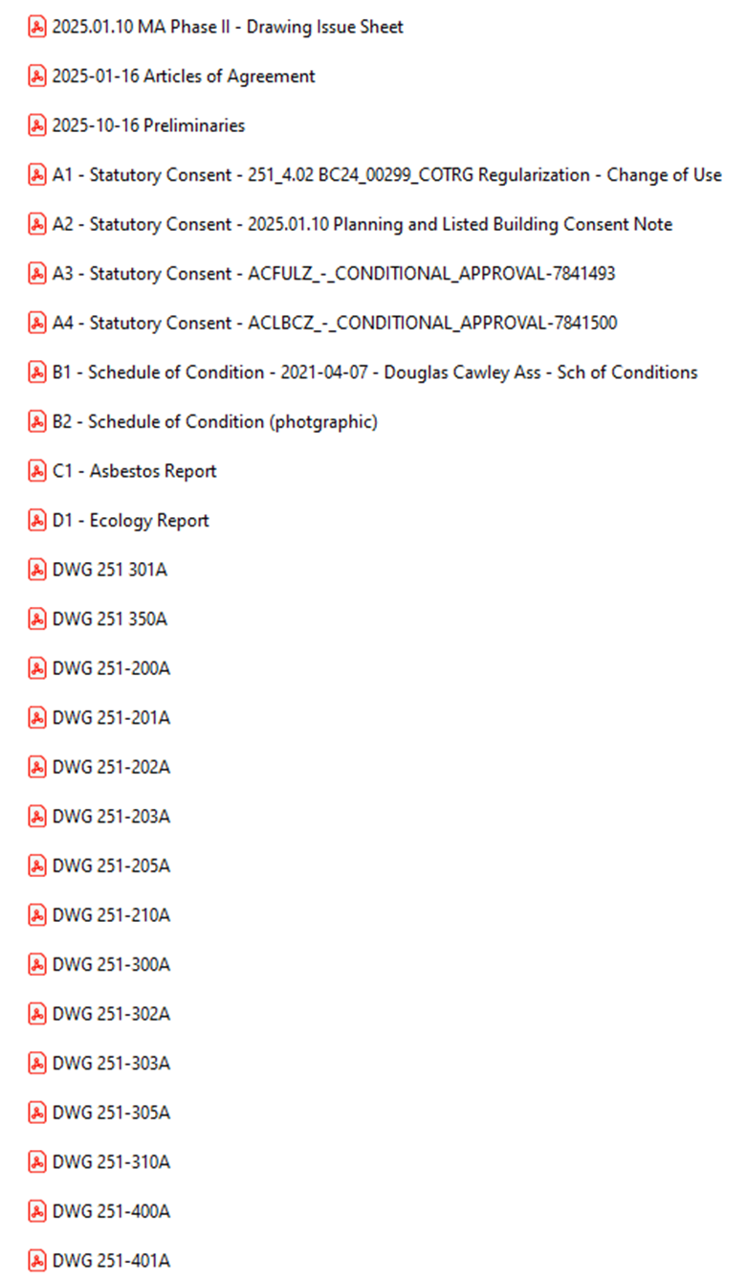

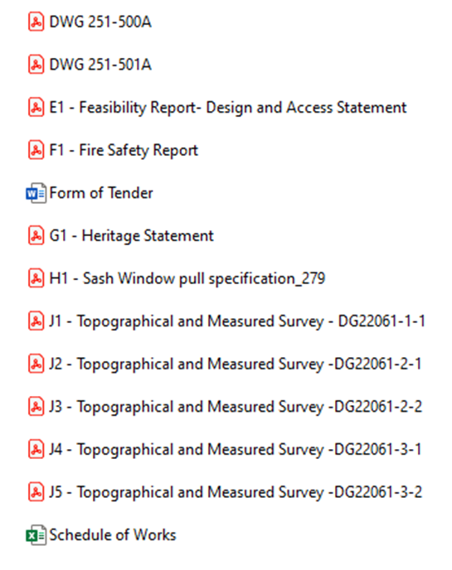

4**. Budget**

The total maximum budget available for this commission is £75,000 (exc VAT) but inclusive of all expenses.

The budget will be reviewed as part of the tender evaluation detailed in Section 10 and will reflect the degree to which there is a saving on the maximum budget

# 5. Tender and commission timetable

The timescale of the programme is in accordance with either a NEC Short Form/RIBA/JCT Minor Works (with Contractors Design to M&E portion) (to be agreed) form of contract but must complete no later than 31st October 2025. The timetable for submission of the Tender, completion of the programme are set out below:

|  |  |
| --- | --- |
| **Milestone** | **Date** |
| Date ITT available on Contracts Finder | 22th January 2025 |
| Site visit to be arranged by email with:  Tim Boulton, hello@musicabilityfoundation.uk | 23 January 2025 - 12 February 2025 |
| Last date for raising queries | 1700:13 February 2025 |
| Last date for clarifications to queries | 1700: 14 February 2025 |
| Deadline to return ITT | 1700:2 March 2025 5 |
| Evaluation of ITT | 3-6 March 2025 |
| Preferred Supplier notified | 10 March 2025 |
| Start of work | 24th March 2025 (subject to availability and relevant permissions being in place) |
| Completion of work | To be confirmed with client (maximum programme length 24 weeks) |

# 6. Tender submission requirements

Please include the following information in your Tender submission.

* 1. **Project Method Statement.**

This should include:

* The management organisation of the company to include who will be responsible for Health and Safety onsite and who will be the Project Manager. Provide the CVs of both of these members of staff (the CV should be a maximum of 1 page of A4).
* Programme of work that demonstrates how you will meet the proposed timetable and key milestones.
* Details of any design proposals
* Monthly valuation forecast
* Confirmation that the tenderer holds current valid insurance policies as set out below and, if successful, supporting documentation will be provided as evidence:

i. Professional Indemnity Insurance with a limit of indemnity of not less than one million (£1,000,000),

ii. Employers Liability Insurance with a limit of indemnity of not less than five million (£5,000,000)

iii. Public Liability Insurance with a limit of indemnity of not less than five million (£5,000,000).

* Conflict of interest statement
  1. **Details of 2 similar projects of value and size.**

Each example should be no more than 2 sides of A4 not including any photographs, but these can only have titles and no text. Links to websites will not be viewed.

* 1. **Environment and Sustainability.**

The funders of this project require a strong focus on environmental sustainability and equality and diversity. Please provide information that demonstrate that there will be a system in place to monitor, maintain and deliver to the standard of quality required for the project including sustainability and accessibility.

1. Attitude to collaborative problem solving within a defined team structure.
2. Anticipate and note the likely challenges and how they would be accommodated
3. How you will reduce energy and fuel consumption in the provision of the contract
4. How you will re-use resources
5. How you will increase recycling levels and reduce the amount of waste
6. How you will use environmentally friendly and ethically sourced goods
7. How you will contribute to reducing the carbon footprint
8. How you will contribute to pollution reduction

**6.4 Budget.** Completed Form of Tender and costed SOW.

**7. Sub-contracting**

Tenderers should note that a consortia can submit a tender but the sub-contracting of aspects of this commission after appointment will only be allowed by prior agreement with MusicAbility Foundation.

**8. Conflicts of Interest**

Tenderers must provide a clear statement with regard to potential conflicts of interests. Therefore, **please confirm within your tender submission** whether, to the best of your knowledge, there is any conflict of interest between your organisation and MusicAbility Foundation or its programme team that is likely to influence the outcome of this procurement either directly or indirectly through financial, economic or other personal interest which might be perceived to compromise the impartiality and independence of any party in the context of this procurement procedure.

Receipt of this statement will permit MusicAbility Foundation to ensure that, in the event of a conflict of interest being notified or noticed, appropriate steps are taken to ensure that the evaluation of any submission will be undertaken by an independent and impartial panel.

# 9. Tender clarifications

Any clarification queries arising from this Invitation to Tender which may have a bearing on the offer should be raised by email to:

[derekjackson@kohaarchitects.com](mailto:will@afinabc.com)

in accordance with the Tender and Commission Timetable in section 5.

Responses to clarifications will be anonymised and uploaded by MusicAbility Foundation to Contracts Finder and will be viewable to all tenderers.

No representation by way of explanation or otherwise to persons or corporations tendering or desirous of tendering as to the meaning of the tender, contract or other tender documents or as to any other matter or thing to be done under the proposed contract shall bind MusicAbility Foundation unless such representation is in writing and duly signed by a Director/Partner of the tenderer. All such correspondence shall be returned with the Tender Documents and shall form part of the contract.

# 10. Tender evaluation methodology

Each Tender will be checked for completeness and compliance with all requirements of the ITT. Tenders will be evaluated to determine the most economically advantageous offer taking into consideration the award criteria.

**Tender returns will be assessed on the basis of the following tender award criteria**

|  |  |
| --- | --- |
| Ref 6.1 Project Method Statement | 20 |
| Acceptable Project Method Statement including confirmation of the requirements detailed at 6.1 |  |
| Ref 6.2 | 20 |
| Provide two examples of previous projects which you feel demonstrate your ability to deliver this type of project. (maximum 2 pages of A4 per example). |  |
| Ref 6.3 | 20 |
| Details of your proposed system to monitor, maintain and deliver to the standard of quality required for the project including sustainability and accessibility. |  |
| Ref 6.4 Budget | 40 |
| A **fixed fee** for this work (exc VAT) including travel and other expenses  The lowest bid will be awarded the full 40 marks. Other bids will be awarded a mark that is proportionate to the level of their bid in comparison to the lowest bid i.e. Marks awarded = 40 x lowest bid / bid |  |

11**. Assessment of the Tender**

The reviewer will award the marks depending upon their assessment of the applicant’s tender submission using the following scoring to assess the response:

|  |  |  |
| --- | --- | --- |
| **Scoring Matrix for Award Criteria** | | |
| Score | Judgement | Interpretation |
| 100% | Excellent | Exceptional demonstration of the relevant ability, understanding, experience, skills, resource and/or quality measures required to provide the goods/works/services. Full evidence provided where required to support the response. |
| 80% | Good | Above average demonstration of the relevant ability, understanding, experience, skills, resource and/or quality measures required to provide the goods/works/services. Majority evidence provided to support the response. |
| 60% | Acceptable | Demonstration of the relevant ability, understanding, experience, skills, resource and/or quality measures required to provide the goods/works/services, with some evidence to support the response. |
| 40% | Minor Reservations | Some minor reservations of the relevant ability, understanding, experience, skills, resource and/or quality measures required to provide the goods/works/services, with little or no evidence to support the response. |
| 20% | Serious Reservations | Considerable reservations of the relevant ability, understanding, experience, skills, resource and/or quality measures required to provide the goods/works/services, with little or no evidence to support the response. |
| 0% | Unacceptable | Does not comply and/or insufficient information provided to demonstrate that there is the ability, understanding, experience, skills, resource and/or quality measures required to provide the goods/works/services, with little or no evidence to support the response. |

During the tender assessment period, MusicAbility Foundation reserves the right to seek clarification in writing from the tenderers, to assist it in its consideration of the tender. Tenders will be evaluated to determine the most economically advantageous offer taking into consideration the award criteria weightings in the table above.

MusicAbility Foundation is not bound to accept the lowest price or any tender. MusicAbility Foundation will not reimburse any expense incurred in preparing tender responses. Any contract award will be conditional on the Contract being approved in accordance with MusicAbility Foundation’s internal procedures and MusicAbility Foundation being able to proceed.

12**. Tender Award**

Any contract awarded as a result of this tender process will be in accordance JCT Minor Works with Contractors Design (to M&E portion).

# 13. Tender returns

Tenders are to be returned by email.

Tenders are to be returned in accordance with Section 5

Latest date to be returned: As per Section 5

Latest time to be returned: 17:00

Emailed tenders should be sent electronically to

[info@juliakerrison.com](mailto:karenhwhalley@gmail.com)

with the following message clearly noted in the Subject box;

MusicAbility Centre Phase 1

**Tenderers are advised to request an acknowledgement of receipt of their email.**

# 14. Disclaimer

The issue of this documentation does not commit MusicAbility Foundation to award any contract pursuant to the tender process or enter into a contractual relationship with any provider of the service. Nothing in the documentation or in any other communications made between MusicAbility Foundation or its agents and any other party, or any part thereof, shall be taken as constituting a contract, agreement or representation between MusicAbility Foundation and any other party (save for a formal award of contract made in writing by MusicAbility Foundation or on behalf of MusicAbility Foundation).

Tenderers must obtain for themselves, at their own responsibility and expense, all information necessary for the preparation of their tender responses. Information supplied to the tenderers by MusicAbility Foundation or any information contained in MusicAbility Foundation’s publications is supplied only for general guidance in the preparation of the tender response. Tenderers must satisfy themselves by their own investigations as to the accuracy of any such information and no responsibility is accepted by MusicAbility Foundation for any loss or damage of whatever kind and howsoever caused arising from the use by tenderers of such information.

MusicAbility Foundation reserves the right to vary or change all or any part of the basis of the procedures for the procurement process at any time or not to proceed with the proposed procurement at all.

Cancellation of the procurement process (at any time) under any circumstances will not render MusicAbility Foundation liable for any costs or expenses incurred by tenderers during the procurement process.

# 15. Enclosures

Drawing Set