

Innovation Centre
St. Cross Business Park
Newport, I.W
PO305WB
Phone: 01983 527496
E-mail: ben@bvdesigns.co.uk
Web: bvdesigns.co.uk

INVITATION TO TENDER

Contract/ Reference - PROPOSED CONVERSION OF FORMER TOILETS TO LIBRARY AT BUILDING ADJACENT FALCON CROSS HALL, SHANKLIN & EXTENSION TO CREATE TOWN OFFICE

Shanklin Town Council Invites tenders for PROPOSED CONVERSION OF FORMER TOILETS TO LIBRARY AT BUILDING ADJACENT FALCON CROSS HALL, SHANKLIN & EXTENSION TO CREATE TOWN OFFICE

Contractors are advised that the proposed works will be split into 2 phases;
Phase 1 – Conversion of former toilets to Library and associated works.
Phase 2 – Proposed extension forming Town Council Office

Phase 2 of the works is applicable for this invitation.

The works are to be carried out in accordance with the attached drawings and are to be of a high standard and fit for habitation.
All works must be undertaken in accordance with current Building Regulations and local By-laws

An optional pre-tender meeting MAY be held at the discretion of the client
The contractor is responsible for familiarizing themselves with all aspects of the works to be undertaken and site conditions prior to submitting their tender.

Tenders need to be received by Ben Vernon of Ben Vernon Designs Ltd in an official envelope which will be provided on request. Tenders not received in sealed envelopes will be destroyed,;
Contact – Ben Vernon
Innovation Centre
St. Cross Business Park
Newport, I.W
PO305WB
Phone: 01983 527496
E-mail: ben@bvdesigns.co.uk

Tenders need to be received by 15;00 on or before Tuessday 10th March.
Any tenders received outside of this time will be destroyed.

Direct All enquiries to ;

Ben Vernon
Innovation Centre
St. Cross Business Park
Newport, I.W
PO305WB
Phone: 01983 527496
E-mail: ben@bvdesigns.co.uk

Sincerely
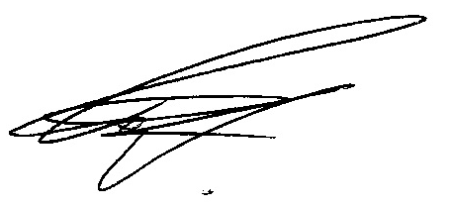
Ben Vernon

