

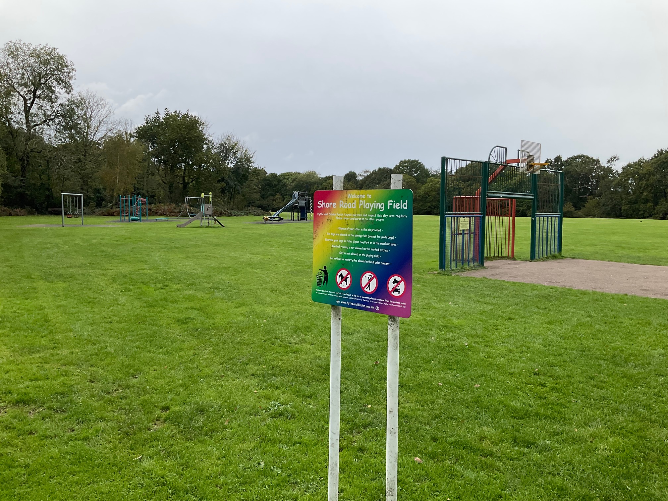

Shore Road

Recreation Ground

New Play Area 2024

Play should be at the heart of children’s everyday lives and experiences throughout childhood. We want children to enjoy a healthy balance of structured and unstructured play in their leisure time.

Shore Road,

Hythe,

Southampton

# 

# Introduction

Hythe and Dibden Parish Council installed the existing play area on Shore Road Recreation Ground off Shore Road, Hythe SO45 6DB, over a number of years with the latest equipment installed in 2016. The facility is extremely popular with the community and as a result the Parish Council has committed to provide an extensive refurbishment.

Experienced play area installers are invited to tender for the contract.

Hythe and Dibden Parish Council will be seeking the views on submitted designs from the community prior to accepting a tender.

Tenders are thus invited for the refurbishment of the existing play area on Shore Road Recreation Ground.

Please refer to the ‘site information’ section of this tender for the background information for the site.

All prices to be **net, excluding VAT**.

A map of the location is available on request.

Please register your intention to submit a tender by sending an email to:

[marcus.kendall@hytheanddibden.gov.uk](mailto:marcus.kendall@hytheanddibden.gov.uk) to include all contact details. This will enable us to inform you of any alterations or additions to the specification.

Companies must be registered with the API (Association of Play Industries) to tender for this contract.

Please supply copies of current certificates for accreditations for the above membership plus details of any other relevant accreditations.

All interested companies will be required to complete the Tenderer Questionnaire. Failure to complete all necessary paperwork will result in your tender being excluded from the process.

A timescale for commencing this project will be agreed between Hythe and Dibden Parish Council and the chosen contractor following the award of the contract. Ideally this install will not take place during school holidays.

**The objectives of this scheme are to**

1. Reuse or replace all existing play equipment, safety surfacing, seating and litter bins.
2. To provide a play area that is inline with the Parish Council’s commitment to Carbon Zero

3. Improve and provide a safe area for younger users of the area

4. Install a modern, high quality play facility that will be an asset to the local area

5. Provide a safe and welcoming environment for young people in the area aged 1 -12 years old

Full details of the contract are outlined below

## Project Information

**NAME OF PROJECT** Shore Road Recreation Ground Play Area

**PROJECT BUDGET** £70,000

**LOCATION OF PARK** Shore Road Recreation Ground, Shore Road, Hythe, Hampshire SO45 6DB – What 3 words - ///animal.adults.lofts

**NAME/ADDRESS OF OWNER** Hythe and Dibden Parish Council, The Grove, 25

St Johns Street, Hythe, Southampton, SO45 6BZ

**Grounds and Building Manager** Marcus Kendall [marcus.kendall@hytheanddibden.gov.uk](mailto:marcus.kendall@hytheanddibden.gov.uk)

IMPORTANT: A site visit is essential to assess access, gain detailed measurements and access points to the site.

To arrange a site, visit please contact Marcus Kendall telephone number 02380841411 or preferably by email [marcus.kendall@hytheanddibden.gov.uk](mailto:marcus.kendall@hytheanddibden.gov.uk)

The existing play area is one of the most popular locations within the parish for families to visit and designs should take these issues into account to avoid additional maintenance costs in the future.

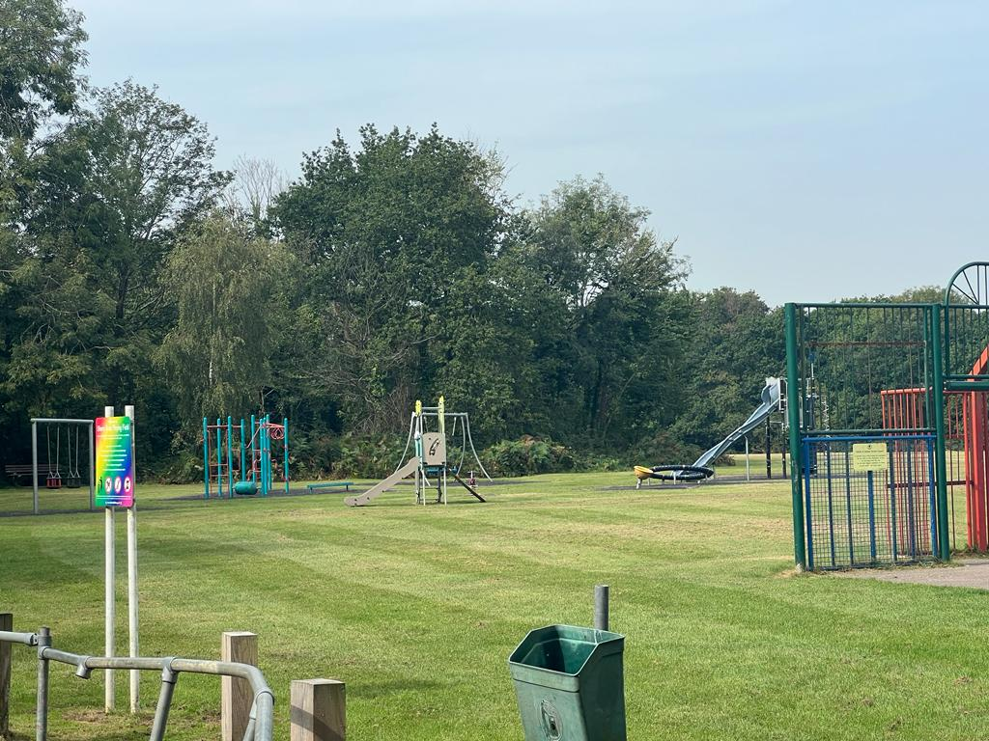Please note, the site is adjacent to very busy football pitches (home to the local youth football club) and an informal open space used daily for recreational purposes by many people. All access for materials etc. will require detailed risk assessments and management.

1. **STATEMENT OF INTENT**

1.1 Hythe & Dibden Parish Council wishes to employ a Principal Contractor to carry out the supply and installation of a play area with an age range of 1 -12years old as set out in this specification document

1.2 To clarify, the Council will tender the works in accordance with the authority’s existing tendering regulations.

1.3 Tenderers are required to submit a fixed price lump sum tender on the Form of Tender provided in this document.

1.4 Tenders should be returned in a **sealed envelope bearing no company identification and marked TENDER FOR Shore Road Recreation Ground** to the Clerk to the Council, The Grove, 25 St John’s Street, Hythe, Southampton, SO45 6BZ by **8th February 2024 (noon)**.

1.5 Hythe and Dibden Parish Council does not bind itself to accept any tender. The Council reserves the right to delete any items from the tender should the tender exceed the budget. No payment will be made in respect of any expense incurred by the tenderers in submitting a tender.

1.6 Tenderers should liaise with Marcus Kendall, Hythe and Dibden Parish Council, The Grove, 25 St John’s Street, Hythe, Southampton, Hampshire, SO45 6BZ, Tel 02380 841411, **during the tender period** regarding any queries or concerns on the content of this specification.

1.7 Given the nature of the works, the Construction (Design and Management) Regulations 2015 do not apply.

**2.0 PROJECT PARTICULARS**

2.1 The play area will be installed within the existing curtilage of the current play area and will not extended beyond its boundary.

2.2 The open space is situated on the edge of Hythe.

2.3 The contractor is to verify all of the above descriptive elements in preparation of his tender. These are given as guidance only.

2.4 **Description of the Works**

## 2.4.1 The Design Brief

a) The Contractor should visit the site at their own expense to satisfy themselves as to any conditions on site that may affect in any manner whatsoever the execution of the works detailed hereafter.

b) Supply and install new play equipment, safety surfacing, fencing and furniture suitable for children aged from 1 years of age up to 12 years of age.

The design of the play area must include equipment which complies with the full identified age range. You will be required to show how your chosen play equipment accommodates this age range.

The play area layout should encourage younger children to play at a distance from the equipment aimed at children at the older end of the age range.

The successful tenderer will need to show the inclusive play value of their design. A fully inclusive playground promotes the social model of disability where barriers to play are designed out. It enables self-esteem and builds confidence as well as encouraging independence.

All equipment must be predominantly constructed from sustainable raw materials/ recycled materials – unless otherwise specified or agreed with Hythe and Dibden Parish Council.

All equipment should be designed for extra strength and vandal resistance.

c) **Fencing, Gates, Seating, Signs and Bins**

There is currently no fencing around this play area, however, Council has expressed its wish to fence the play area. It is excepted that the budget will not allow for all of the area to be fenced and as such the equipment aimed at the younger users should be fenced at the very least. All fence should be compliant to BS EN 1176 Playground and have a least two BS EN 1176 compliant hydraulic self-closing gates. The gates and fence should be of two different colours so that the gates can easily be recognised. Due to the size of the play area no maintenance access gates will be required. Any damage to existing, fencing, tarmac or paved surfacing caused by installation works will need to be repaired to an acceptable standard.

To supply and install in a suitable position a picnic bench.

To supply and install in a suitable position, litter bins. The litter bins should be fitted with anti-seagull flaps. The bins should be of an adequate size for the area and also encourage recycling. Please check what products can be recycled locally before installing.

The Parish Council will erect its own information signage; however, it is recommended that the chosen contractor erects temporary signage whilst the work is taking place, showing the finished project and contact details of project lead.

d) Surfacing

Supply safety surfacing beneath play equipment to the highest industry standards which complies with European Safety Standards.

Any footways must be constructed to the industry standards.

2.4.2 The works are comprised of the design, supply and installation of a play area suitable for all, with an age range of 1- 12 years old, which comply with the relevant safety standards. Two single gates are required to be supplied and installed. The two single gates should be 1.2m in height, should be Hydraulic Self Closing Gates, manufactured to comply with BS EN 1176 for playground equipment and should be Yellow in colour. Supply and installation of suitable picnic bench and litter collection bins.

2.4.3 The removal of all the vegetation, existing play equipment, repairs or alterations to the existing featuresshould be allowed for as part of the tender price, however this is subject to final confirmation by the Parish Council.

**2.5 Specification**

**This project will focus on the provision of new play activities to replace the existing ones and the Contractor is to design and create a play area in accordance with the following general specification.**

## 2.5.1 Community Aspirations and Community Involvement Through Consultation

The play area needs to meet the needs of children from toddler age through to pre-teenage years. The existing play park is used by all ages of children alike and the community would like the new play features to link sympathetically with the surrounding area.

The contractor can decide to use any of the existing play equipment and refurbish it. However they must provide reassurances to the condition and expected lifespan of any “refurbished” equipment.

It is important that we involve the local community in creating the final design. We would therefore need to have some form of consultation and documentation included in the project.

Those contractors who have submitted an indication to tender by the 8th February will be invited to attend one of the open day events in February, at which they will receive feedback regarding their design from members of the public and based upon that feedback, may wish to alter their design before submitting the final design and drawings, along with the tender documents the following week.

This play area does require an element of fencing to provide security for younger users and it will be up to the contractor on how they decide that it is best to provide this i.e. to fence only parts of the play area or fence the whole play area. Appropriate safety surfacing, seating and provision of litter bins should be incorporated into the design.

Any design should incorporate best practice around ‘Safer by Design’.

## Overall Requirements

We would like to see a site that is innovative and which encourages and enables physically active play, and which is attractive to children from toddlers through to pre-teenage (12 years old). The site should be appealing and accessible for children with additional needs. Play activities should be open-access, with children free to independently move between them.

There is also a need for the new design to be a welcoming and restful place for parents with younger children to meet and socialise.

We ask you to consider these nine key expectations within your design: -

1. The site is ‘bespoke’

2. Accessible to children with additional needs

3. Provides a wide range of play opportunities

4. Builds in opportunities to experience risk and challenge

5. Meets community needs

6. Allows children of different ages to play together

7. Makes use of natural elements / sustainable raw materials/ ensures the lowest possible CO2e emission factor. Has the least impact on the environment, from production to end of life

8. Sustainable and easy and affordable to maintain

9. Allows for change and evolution

2.5.3 **Play Features**

Play features provided should offer challenges to all children, regardless of their capabilities, initiative and skills.

Where possible, play activities for children with additional needs should be integrated with other activities.

The play area should be designed to minimise the degree of assistance a child with additional needs may require, with special adaptations only where necessary and without fostering an atmosphere of separateness.

Play area features should be easily maintained; spare parts should be readily accessible and affordable.

**2.5.4 Safer Surfaces**

The site layout and safer surfaces should be designed with regard to anticipated high levels of site use and abuse and with respect to the maintenance and revenue implications, to sustain and prolong the life of the play area. Certification and specification of surfacing must be included.

Supply of safety surfacing beneath the play equipment should be to the highest industry standards which complies with European Safety Standards.

Any footways must be constructed to the industry standards.

**2.5.5 Maintenance and aftercare**

A full schedule of maintenance requirements is to be provided once the play area is completed. This should include a breakdown of items, specifications, and maintenance requirements to assist with the future site management and maintenance.

Copies of all relevant warranties and guarantees should be provided with the application.

The works will be subject to an independent Post Installation Inspection (PII) arranged and paid for by the contractor, before the project is signed off. The contractor shall undertake any remedial issues identified as part of the PII report, as part of the existing project cost. The play area must not be opened for public use until the PII has been signed off to the satisfaction of the Grounds and Building Manager.

**2.6 Location of Project.**

The existing play area is one of the most popular locations within the parish for families to visit and designs should take these issues in to account to avoid additional maintenance costs in the future.

Please note, the site is adjacent to a prize-winning football pitches and informal open spaces used daily for recreational purposes by many people. All access of materials etc. will require detailed risk assessments and management.

The area can be accessed from Frost Lane Only. There is a dedicated parking area for the play area.

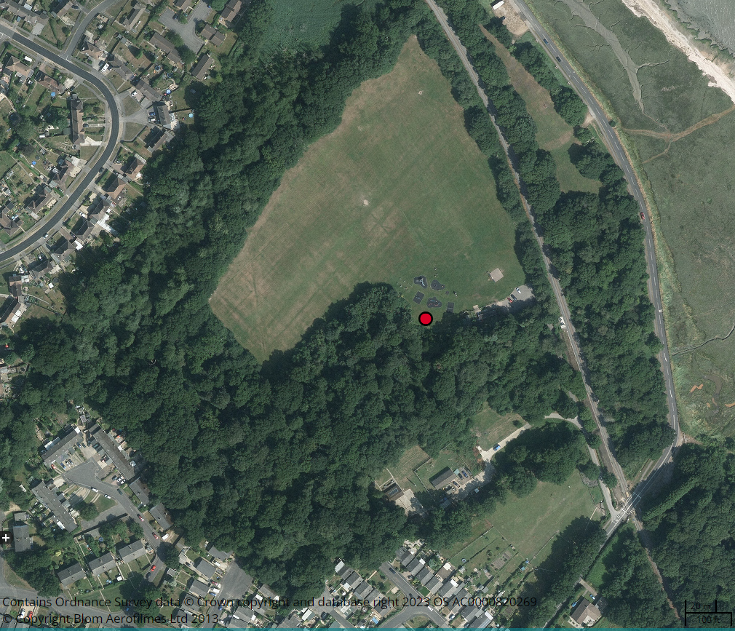

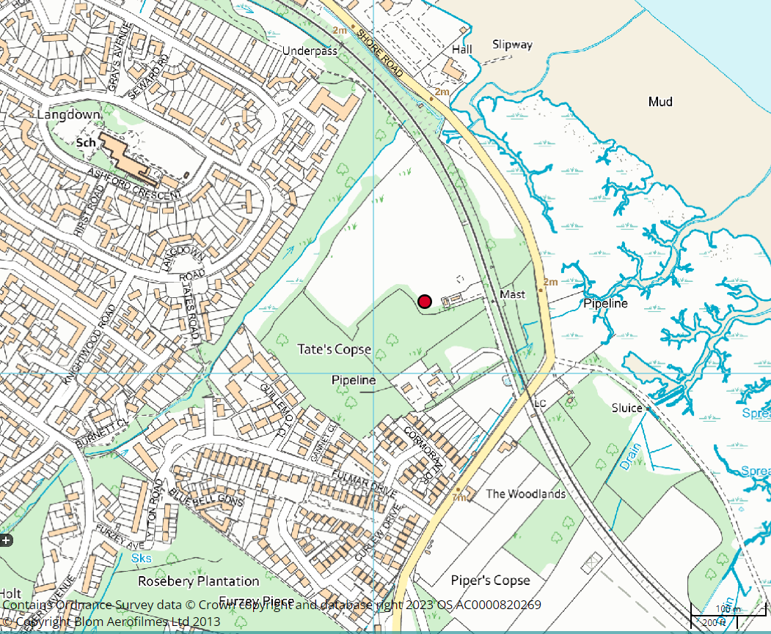

**3.0 TIMETABLE**

3.1 **Anticipated Pre-Contract Programme**

|  |  |
| --- | --- |
| ***Indications of interest received from contractors which should include estimated costs, timeline of project, A2 designs and design brief and green credentials of the project and company.*** | ***Received no later than 12.00 noon -8th February 2024*** |
| ***Interviews / Presentations / Presentation of designs to the Council by Contractors If required*** | ***Week commencing 12th February*** |
|  |  |
| ***Public consultation on designs including an event day that the contractors should attend.*** | ***20th February*** |
| ***Final Tender closing date (12:00 noon)***  ***Incorporating any design changes*** | ***5th March 2024*** |
| ***Award contract (following tender being present to Amenities Committee and to Full Council)*** | ***After 28th March*** |
| ***Works on site can begin anytime after*** | ***3rd April 2024*** |
| ***Completion of contract delivery*** | ***30th July 2024*** |
| ***Launch Event*** | ***TBC*** |

**3.2 Tender Submission Programme**

Tenderers should provide, together with their priced tender an indicative programme for the completion of works on site, taking account of the above and any access restrictions and permissions as set out under the Limitation of Working Hours.

**4.0 PRELIMINARIES**

4**.1 Generally**

The Contractor shall be deemed to have allowed in his price for the cost of complying with all the requirements of these Preliminaries and Schedule of Works. These preliminary particulars provisions shall form part of the contract between the Council and Contractor.

**4.2 Nature and Location of the Project**

4.2.1 The site is known as Shore Road Recreation Ground, Shore Road, Southampton, SO45 6DB

4.2.2 A skip can be located upon the public open space subject to weather and ground conditions. Monitoring of ground conditions will be undertaken by a Council Officer. If parking / site set up in this location is not practical, contractors will be required to use the area for “drop-off only” and park vehicles in the closest public car park.

4.2.3 The works are of an improvement nature generally.

**4.3 Access to the Site**

Access to the site is via a single field gate from the carpark area off Frost Lane. The width of which should be checked by the contactor to ensure that their vehicles can safely access the site.

**4.4 Access around Site**

Access to the site for the Contractor will be limited to the specified works area only. There are no welfare services on the site and therefore the contractor will have to provide external welfare facilities for the duration of the works.

**4.5 Nuisance.**

4.5.1 The Contractor shall carry out the works without causing nuisance at any time. Any complaints arising from the works may result in the immediate suspension of activities until suitable measures are established to prevent a reoccurrence and in this event no claim for additional costs will be entertained.

4.5.2 The Contractor is to be aware of that there is a public right of way across the open space and this should be maintained at all times.

**4.6 Control of Noise and Pollution**

4.6.1 The Contractor shall comply with all statutory requirements for noise abatement and the control of pollution and take all necessary precautions to prevent nuisance from water, smoke, dust, rubbish and other causes.

4.6.2 The Contractor shall at all times comply with the recommendations of BS 5228 Code of Practice for Noise Control on Construction Sites.

4.6.3 The Contractor shall use the best possible means to minimise noise and shall select appropriate plant and provide acoustic shields or barriers where necessary. All equipment shall be maintained in first class condition. The Contractor shall frequently and regularly monitor noise levels around the site and maintain records of noise levels. The Contractor shall ensure that any construction noise does not cause nuisance to any users of the building, adjacent buildings or roads etc. outside the site boundary.

4.6.4 Radios are permitted however the volume level should be kept at a reasonable level as not to cause a nuisance to other users of the area.

**4.7 Site Tidiness**

The Contractor shall keep the site tidy at all times. Any skips must be removed from site immediately once they are full. Any stockpile of rubbish is to be stored in a tidy and organised manor, without causing obstruction for the works to proceed, until it can be removed from site.

**4.8 Construction Design & Management Regulations 2015**

The CDM Regulations 2015 do not apply.

**4.9 Principal Contractor**

Clarification of duties not applicable, as the CDM Regulations 2015 do not apply.

**4.10 Other Legislation**

**4.11 Health and Safety Plan**

The Contractor will need to supply the Parish Council with a copy of their site risk assessment, method statement and a copy of their public liability insurance, seven working days before the start of the project.

**4.12 Personnel**

The Contractor shall ensure suitably qualified personnel are responsible for preparing, implementing, and monitoring the Method Statements and Risk Assessments for the duration of the construction phase of the project.

**4.13 Hazards or Health and Safety Generally**

4.13.1 The Contractor shall advise the Parish Council immediately of any deficiencies in the Method Statements of Risk Assessments, or unforeseen hazards to Health and Safety which may become apparent as the project proceeds.

4.13.2 The ground is not known to contain asbestos. The contractor is advised to have satisfied himself of the extent and location of all asbestos containing materials and removal of where applicable in order to safely undertake the works. The contractor is to allow for all costs associated with protecting from and working with the materials within his tender.

4.13.3 It is not known if there are any underground services on the Shore Road Recreation Ground, the contractor is advised to have satisfied himself of the extent and location of all underground services in order to safely undertake the works. The contractor is to allow for all costs associated with protecting from and working with the materials within his tender.

4.13.4 The Contractor shall take all precautions as are necessary to protect the Health and Safety of all persons employed by him and shall comply with all the requirements of any Acts, Regulations, orders or directions pertaining to the health and safety of employed persons, the employees of the Council and all other persons.

b) The Contractor shall take due note of the Council’s Health & Safety Policy statement. The Contractor’s own statement and safe working practices shall be to no less of a standard than that of the Council. The Grounds and Buildings Manager reserves the right to instruct the Contractor to revise their submission in such areas as it may be considered which fall short of the Council’s existing standards.

c) The Contractor shall allow the Grounds and Buildings Manager or their representatives and the Council’s own Safety Officer such access as may be required to buildings, locations, vehicles or operations used in relation to this contract.

d) The Contractor shall notify the Grounds and Buildings Manager of any accident to any of his employees or member of the public happening during the duration of this contract and which causes the injured person to be absent from work for more than three working days.

e) The Contractor shall advise the Grounds and Buildings Manager immediately of any notifiable occurrences as defined in the Reporting of Injuries, Diseases and Dangerous Occurrences Regulation (1985).

f) A method statement of works and a risk assessment must be submitted and agreed with the Grounds and Buildings Manager or their nominated representative prior to work commencing on site.

e) The successful contractor will need to show the following.

* A copy of your certificate of public liability insurance must also be submitted along with your submission.
* A copy of your company’s Health and Safety policy must be submitted along with your submission. (where it applies)
* A copy of your company’s API (Association of Play Industries) certification.

4.13.5 A project co-ordinator or single point of contact must be nominated by the successful tenderer who should be readily contactable to deal with any queries and problems that may arise. This point of contact must be available from the date the contract is awarded until satisfactory completion of the project

**4.14 Sub-Contractors**

4.14.1 The Contractor shall take all necessary measures to satisfy himself that all sub-contractors, whether appointed by him directly or not, are competent and have allocated sufficient resources to comply with the health and safety requirements of the project.

4.14.2 Notwithstanding the usual requirements of the Principal Contractor under the CDM Regulations 2015, the Contractor shall be bound to abide by and implement all other Regulations, Byelaws or other legislation relevant to the Health, Safety and Welfare of all persons on or about the works or likely to be affected by the execution of the works.

**4.15 Contract Documents**

The Contract Documents shall consist of this Specification, the Conditions of Contract, the Tender and the Letter of Acceptance, together with any other particular documents so listed and referred to in the aforementioned documents.

**4.16 Pricing Notes**

4.16.1 The Contractor shall supply and do everything necessary for the proper execution and completion of the work that may be reasonably inferred from the Contract Documents whether described in detail or not, without any extra payment in respect thereof.

4.16.2 The Contractor shall in preparing his tender sum determine the actual extent of the works as mentioned or otherwise described necessary to complete the works scheduled and described within. Where quantities are not provided the Contractor is responsible for establishing the full quantity and extent to satisfactorily complete the works described.

4.16.3 Any deviations, ambiguities or possible miss-quantifying within the specification are to be highlighted to the Parish Council with clarification requested. The Contractor shall not deviate from the proposed specification unless by prior written agreement from the Parish Council.

**4.17 Materials, Goods and Workmanship, etc.**

4.17.1 The goods or materials supplied or used in the execution of this Contract, where not specified otherwise, shall not be of a lower standard than that is in accordance with the appropriate Specification, if any, issued by the British Standard Institute and current at the time of tender.

4.17.2 The Contractor shall, upon the request of the Parish Council furnish him with samples of the materials and goods of equal standard with those to be incorporated in the works and execute reasonably sized specimens of work if so desired by the Parish Council.

4.17.3 Workmanship shall not be inferior to the standard laid down in the latest ‘British and European Standard Codes of Practice’.

**4.18 Tenders**

The closing date for submitting final completed tenders is ***12.00 noon - 8th February 2024***

**4.19 Acceptance of Tenders**

Hythe and Dibden Parish Council does not bind themselves to accept the lowest or any particular tender.

**4.20 Discrepancies**

The Contractor is to read all the Contract Documentation as defined. Any discrepancies, errors or omissions must be drawn to the attention of the Parish Council by the Contractor prior to any work being carried out. All work carried out by the Contractor which is found to be wrong or defective arising out of a discrepancy as aforesaid, and which has not been referred to the Parish Council by the Contractor, will be put right to the entire satisfaction of the Parish Council at the cost of the Contractor.

**4.21 Protection of Public and Private Services**

4.21.1 The Contractor shall also uphold, maintain and protect all pipes, duct, drains, sewers, services, overhead cables, etc. during the execution of the works and make good any damage or pay any costs of charges in connection therewith. If any damage is caused the Contractor shall notify the Parish Council immediately.

4.21.1 The Contractor shall also indemnify the Employer against all charges and costs in respect of damage to public and private services.

**4.22 Schedule of Condition**

Photographs of the external areas / access routes that are to be used by the Contractor during the works should be taken by the Contractor prior to the works and agreed jointly between the Parish Council and Contractor before commencing any work and on completion of the works. The Contractor will be required to reinstate any damage to the condition in the Photographic Schedule.

**4.23 Items of Convenience in Pricing**

The Contractor shall allow for the following:

1. All Plant, tools and vehicles required to safely execute the contract works
2. All access equipment
3. Safety, health and welfare of work people
4. Transport for work people
5. Disbursement arising from the employment of work people
6. Safeguarding the works, material and plant against damage and theft

**4.24 Lighting and Power for the Works**

The Contractor will make his own provision for electrical supply required for them to complete the works. Contractor to confirm during tender site visit.

**4.25 Water for the Works**

The Contractor will make their own provision for water supply required for them to complete the works. Contractor to confirm during tender site visit.

**4.26 Telephone**

Contractors are to make their own arrangement in respect of telephone facilities and pay for all calls and communication costs pertinent to the project.

**4.27 Notification of Accidents and Dangerous Occurrences Regulations 1980**

The Contractor is to note that in accordance with the above regulations it is his responsibility to report notifiable accidents during the progress of the Contract Works.

**4.28 Safety**

The attention of the Contractor is drawn to the fact that the site is outside of a residential area.

The contractor shall supply and secure the play area, in accordance with H&S guidelines, for the duration of the work with Heras fencing.

This fencing will remain on site and securing the play area until the Parish Council is satisfied that the project is completed.

**4.29 Limitation of Working Hours**

Works are permitted to be carried out during normal working hours, 0800 and 1700 Monday to Friday. Out of hours’ work may be permitted by the Parish Council, subject to the nature of works. Noisy works will generally not be permitted at weekends.

**4.30 Work Outside Normal Working Hours**

If the contactor needs to work outside of the normal work hours then, the contractor shall give the Parish Council at least 48 hours written notice of his intention to carry out work at nights, weekends or any other time outside normal site working hours, after first obtaining Local Authority by-law relaxation, if necessary. The Contractor should not assume that such permission shall be granted and is advised to plan any noisy or disturbance works carefully.

**4.31 Electrical Interference**

N/A

**4.32 Protection of Public and Private Services**

The Contractor shall inform the Parish Council before commencing site operations and ascertain the location of all services, drains or sewers or confirm that there are none within the vicinity of the works other than those plotted on the survey drawings.

**4.33 Storage of Materials On-Site**

Due to limitations in space Contractors will not be permitted to store materials on-site besides those for immediate incorporation within the works.

**4.34 Curing time**

The Contractor should not leave site until they are assured that the posts etc. are set and the concrete used has cured.

**4.35 Removing Rubbish**

4.35.1 Allow for clearing away all rubbish as it accumulates and for carrying out the works in a clean and orderly manner.

4.35.2 Where a skip is required on site, this must be secured. Contractors are advised to consider removal of all rubbish by van per day.

4.35.3 All rubbish and excess spoil is to be removed from site by the contractor at the end of the construction works, to include reinstatement as agreed with the Grounds and Buildings Manager, to grass areas and existing surfaces.

**4.36 Supervision**

The Contractor shall employ on site, during all permitted working hours, a designated and competent Supervisor who shall be experienced in carrying out works of a similar nature and shall not be discharged or transferred from the works without the written consent of the Parish Council. The name of the supervisor is to be advised to the Parish Council to works commencing on site.

**4.37 Damage Arising from the Works**

The Contractor will be held responsible for and shall make good any damage whatsoever if caused by his work to adjoining buildings, gates, paths, roadways, walls, fences, gardens, trees, etc. caused by the work and shall leave all sound and perfect on completion to the satisfaction of the Parish Council.

**4.38 Temporary Works**

4.38.1 The Contractor shall agree the positions and types of his temporary works with the Parish Council before putting the work in hand.

4.38.2 The Contractor shall maintain, alter and adapt and move temporary works as from time to time may be necessary.

**4.39 Site security**

The Contractor shall keep all unauthorised persons from the working area and shall make good any damage done thereon and replace anything lost or stolen there from due to his failure to exercise adequate control.

**4.40 Welfare Facilities**

The Contractor will provide external welfare facilities for the duration of the works.

**4.41 Safety, Health and Welfare**

The Contractor will be required to provide his own welfare provisions and will be required to provide health and safety provisions suitable for the nature and extent of the works.

**4.42 Construction Industry Scheme (CIS)**

The Contractor Industry Scheme (CIS) standards do not apply to these works.

**4.43 Site Records**

Take all necessary records of the works progress. These records as a minimum shall record the following.

1. Site diary with details of personnel attendance.

2. Requests for information or further instruction in respect of work.

3. Receipt of drawings, instructions, verbal instructions and written confirmation, as required.

**4.44 Approval of Drawings, Marking Holes etc.**

Where the Contractor is required to provide drawings for approval, he shall give at least five working days for such approval, if required.

**4.45 Site deliveries and Site Cleanliness**

The Shore Road Recreation Ground is used as a route by members of the public to and from the local schools and the village. It is also a popular location for people to exercise and for relaxation. The timing of deliveries should be arranged, to avoid the busiest times of the day.

The Contractor will be responsible for ensuring that all hard surfaces are kept free of litter, debris, mud and glass, etc., whilst undertaking works associated with this Contract. All arisings shall be picked up and removed from the site, approach roads and entrance ways and disposed of at the end of each working day and upon completion as directed.

Sweeping shall be carried out by hand or by approved mechanical sweeper or sucker. Damage to grassed areas should be minimised and repaired.

**4.46 Protection**

The Contractor will be responsible for the protection of his work at all times.

**4.47 Site Meetings**

The Contractor shall be required to attend such meetings as the Grounds and Buildings Manager or their nominated representative may require for the administration and successful completion of this Contract.

## 4.47.1 Community Liaison

A key element of this project is the involvement of the local community. When requested by the Grounds and Buildings Manager or their nominated representative, the Contractor shall be required to work in partnership with the Council to enable supervised site visits by the community. The Grounds and Buildings Manager will give the Contractor adequate notice of such requirements.

All works relating to such events will be carried out in accordance with the conditions, specifications and general regulations contained within this document, due regard being given to health and safety regulations and the health and safety of park users. At all times, the Contractor is required to answer simple enquiries as they arise and to treat members of the public courteously and with respect.

**4.48 Unloading, etc.**

Unloading, distributing and lifting the Contractor's materials and plant shall be the responsibility of the Contractor and is deemed to be included in the Contract Sum.

**4.49 Day Work**

N/A

**4.50 Restrictions by Police and Local Authorities**

The Contractor is to comply with any restrictions that may be imposed by the Police or the Local Authority with regard to the site and the construction of the work and in particular with regard to noise and fire protection during the course of the works and with regard to access to and from the site, loading, unloading or waiting in or from the surrounding streets and the construction, positioning and all other matters affecting any fans, barricades, walkways, gantries and the like on the street frontages.

**4.51 Master Programme**

4.51.1The Contractor is to provide **as part of his tender submission** a draft programme of the works clearly considering and including the key dates and restrictions on working hours contained within this document.

4.51.2 The Contractor is to prepare before commencing work and satisfy the Parish Council of its adequacy, a detailed master programme for the execution of the works, this should include any Sub-contractor's trades if required. One copy of the programme is to be sent to the Parish Council and one copy is to be displayed on the site. The progress of the work as executed is to be indicated weekly on the site copy of the programme.

4.51.3 The Contractor is to update or redraft the master programme as and when necessary or as deemed necessary and as instructed by the Parish Council and should any circumstances arise which affect the progress of any sections of the works and distribute copies as before at no further cost.

**4.52 Change of Scope' Items**

Where an item is agreed to be ' a change of scope', costs, whenever possible, must be agreed before the work is carried out. If this is not possible due to the time scale, a budget cost must be submitted followed by the agreed final cost within one week. Any effect on the programme due to such changes must be notified immediately.

**4.53 Workmanship and Materials**

4.53.1 The completed works must be fit for the purpose intended and ready for immediate use, subject to an independent safety inspection.

4.53.2 All materials, products and workmanship are to be suitable for the purposes of the works stated in or reasonably to be inferred from the Contract Documents and in accordance with good building practice including the relevant provisions of current Specification or Code of Practice issued by the British Standards Institution or BS EN harmonised Codes and Standards.

4.53.3 All proprietary materials to be used in strict accordance with their manufacturer's instructions.

4.53.4 Materials shall be EC marked as appropriate.

**4.54 Samples**

Allow for submitting samples, test certificates of materials and for setting up sample panels of materials and colours as required by the Parish Council.

**4.55 Payment**

A Stage payment schedule can be discussed with the selected contractor.

Payment for the completed play area refurbishment works will be made to the Contractor on satisfactory completion of works and following receipt by the Parish Council of a satisfactory RoSPA Post Installation Report.

This report should be commissioned, paid for and supplied to Hythe and Dibden Council by the Contractor before the play area is released back to the Parish Council.

______________________________________________________________________

**FORM OF TENDER** – **Works: Installation of a new play area Ewart Recreation Ground**

I/We, the undersigned, having examined the conditions of this Contract and hereby undertake to execute and complete the above works, all in accordance with the conditions of this contract and specification for the FIRM PRICE OF:

£

AND IN WRITING

…………………………………………………………………………………………………….

I/We offer to execute the complete work within..........................weeks from start date on site.

I/We undertake to start on site within ........................................ weeks of receipt of an order.

I/We agree that this offer shall remain open for consideration for a period of 60 days

.................................................................................................................................

FOR AND ON BEHALF OF:

...................................................................................................................................

ADDRESS:

...................................................................................................................................................

...................................................................................................................................................

……………………………………………………………………………………………………………

DATE: .....................................

AUTHORISED SIGNATURE:.................................................................................

I/We agree have read and understood the requirements of the Council Instructions for Tendering.

Your tender is to be sent in a **sealed envelope bearing no company identification and marked Ewart Recreation Ground Play Area to** The Clerk to the Council, The Grove, 25 St John’s Street, Hythe, Southampton, SO45 6BZ ***Received no later than 12.00 noon -8th February 2024***