

**ILMINSTER TOWN COUNCIL**

**FEE QUOTATION REQUEST**

**Public Toilet and Kiosk Block**

**Rebuild / Repair / Refurbishment**

Miss Joy Norris - Town Clerk

Ilminster Town Council

Council Offices

North Street

Ilminster

Somerset

TA19 0DG

01460 52149

town.council@ilminster.gov.uk

7 September 2016

**ILMINSTER TOWN COUNCIL**

**INSTRUCTIONS FOR SUBMITTING QUOTATIONS**

1. Contractors will be held to have fully informed and satisfied themselves by their own independent observations and enquiries, including where appropriate site visits and inspection of drawings, as to the nature, extent and practicability of the works and where appropriate the positions relevant thereto of buildings, structures, the means of access to the works and all other points which can in any way affect the prices inserted in the Form of Quotation.

2. Where the drawings are issued with documents, quotations will be based on them.

3. Where a quotation requires entry by the contractor they must be completed in ink or typescript and signed by the contractor.

4. All contract documents, including drawings, whether a quotation is submitted or not, remain the property of Ilminster Town Council and shall be treated as private and confidential.

5. Quotations shall remain open for acceptance for a period of **90 days** after the latest date for submission.

6. The Council will not be responsible for or pay any expenses or losses, which the contractor may incur in the preparation of their quotation.

7. Quotations are to be returned to: Miss Joy Norris, Town Clerk, Ilminster Town Council, Council Offices, North Street, Ilminster, Somerset TA19 0DG.

**QUOTATIONS TO BE RECEIVED BY NO LATER THAN NOON ON 28 September 2016**

**SPECIFICATION**

**General Information**

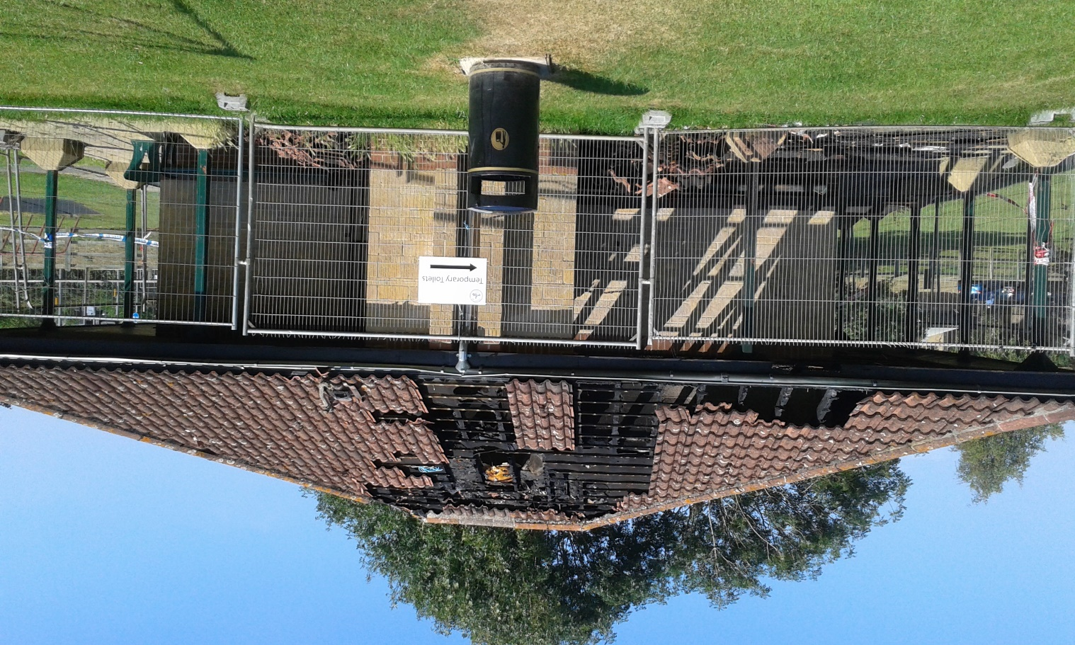The public toilet block on the Wharf Lane Recreation Ground in Ilminster was badly damaged by fire at the beginning of July 2016. The fire was the result of a stolen motorbike being abandoned adjacent to the building. The insurance company has accepted the claim and appointed a loss adjuster; the building is insured for approx. £110,000

The building currently comprises, gents toilet, ladies / disabled toilet, storage room and kiosk (which sold ice creams, drinks and snacks). Whilst the Town Council now own and manage the building it did not originally build it, hence there are no plans or drawings available.

The toilets and kiosk are important facilities on the recreation ground and are situated next to a children’s play area.

As a minimum the Town Council wishes to re-instate the facilities to the level that existed before the fire, the Council is also willing, subject to budget, to consider improvements.

**Indicative Work Required for this Fee Proposal**

The following is **indicative** of the work to be undertaken and is not intended as an exhaustive list:

* liaison with the Town Clerk
* liaison with the Loss Adjuster via the Town Clerk
* structural survey of building as at present
* design appropriate roof structure
* apply for planning permission if required
* schedule of works and drawings for work needed (including estimated costs & drawings for both like for like replacement (for insurance) and any scheme which includes improvements)
* compile tender documents;
* assess tender documents;
* project manage the work.
* contract administration including CDM to include:
* assist with negotiating, agreeing and preparing contracts
* assist and advise on the selection of contractors
* issue payment certificates
* agree variations with builders
* advise on cost matters
* agree final account with builder(s)
* issuing the final certificate
* obtain all necessary permits and licences
* keep the construction on schedule and within budget
* set targets and timescales
* take actions to deal with the results of delays, bad weather or emergencies at the construction site
* agreeing commissioning and testing procedures
* collating and issuing schedules of defects
* supplying information to resolve disputes (if they arise)
* preparing and issuing progress reports, attending Council meetings if requested to do so
* seeking instructions from the clients regarding variations to contracts or the design
* liaise with the South Somerset District Council Planning and Building Regulations sections as required
* liaise with organisations such as utilities and services suppliers
* ensure compliance with any Planning Permission or Building Regulation Conditions
* co-ordinating site inspections
* to be the Construction, Design and Management (CDM) Co-Ordinator ensuring compliance with the Design and Management Regulations which are in force during the construction of the facility (including responsibility for the Risk Assessments and Method Statements)

The successful appointee **must** have:

* Professional membership Chartered Institute of Building or the Royal Institute of Chartered Surveyors

The successful appointee should have:

* Previous experience of similar type and scale of work
* Previous experience of working with Councils and an understanding of the decision making processes and constraints

**PROFESSIONAL BODY MEMBERSHIP**

Quotations should be accompanied by evidence that the contractor has membership of eitherthe Chartered Institute of Building or the Royal Institute of Chartered Surveyors

**INSURANCE**

The contractor shall maintain a comprehensive policy of public liability and employer’s liability insurance. In respect of its liability such insurance cover to be maintained and provide for a minimum of £5,000,000 (FIVE MILLION POUNDS). Cover in respect of death of personal injury due to negligence will be unlimited.

A copy of the contractors insurance should be provided with their quotation submission.

**PAYMENTS**

Payment to the contractor will be within 28 days of receipt of invoice subject to agreement of the account by the Council’s officer.

**REFERENCES**

Please provide names of 2 people/organisations for whom you have undertaken similar work (the details should be completed on the attached form)

**Contractor’s Name: …………………………………………………………………**

(in block letters)

**SHORT DESCRIPTION OF WORKS:-**

Public Toilet and Kiosk Block Rebuild / Repair / Refurbishment, fee proposal for professional services

**FORM OF QUOTATION**

To: Miss Joy Norris – Town Clerk Closing Date & Time: 28 September 2016 **12 noon**

Ilminster Town Council

Council Offices

North Street

Ilminster

Somerset

TA19 0DG

Having examined the specification for the above-mentioned works, we offer to carry out the whole of the said works in conformity with the said specification for the sum of

**£……………………….**

We can advise that once the Quotation is formally accepted we can anticipate being able to commence the work within **……………..** weeks and complete the works within **………………** weeks.

This quotation together with your written acceptance thereof, shall constitute a binding contract between us.

We understand that you are not bound to accept the lowest or any other quotation you may receive and that this quotation will remain open for acceptance for a period **90 days** from the latest date for receipt of quotations.

**Reference Contact 1:**

Contact Name: ……………………… Company Name: …………………………….

Address: ………………………………………………………………………………………

Phone No: ……………………… e-mail address: ………………………………………

**Reference Contact 2:**

Contact Name: ……………………… Company Name: …………………………….

Address: ………………………………………………………………………………………

Phone No: ……………………… e-mail address: ………………………………………

Yours faithfully

Signature: **………………………………..** Date: **…………………………………...**

Name : **…………………………** Company: **……………………………………**

Address: **…………………………………………………………………………………….**

**…………………………………………………………………………………….**

Tel No: **………………………** e-mail: **……………………………………………**