Invitation to Tender

**GT50 Gas Turbine Program – Mechanical Design**

# Background/Introduction

Dynamiq Engineering Limited (Dynamiq) is a specialist engineering company providing advanced finite element analysis (FEA) and product development. We provide affordable access to world-class mechanical, structural and fluid engineering services to companies of all sizes in any sector of the industry.

Founded in 2005, Dynamiq has grown into an agile and internationally respected company, routinely covering a broad spectrum of projects. Project scales vary from those taking just a few hours to complex long-term design, simulation or full product development engagements.

Dynamiq wants to develop a small gas turbine for a general aviation application and seeks a Tenderer that has experience in the mechanical design of rotorcraft gas turbine engine systems, detailed heat transfer and lifing methods and control system development to support our washed component development team. Ultimately the engine will be incorporated into a new helicopter design.

Dynamiq will compare tenders received on a compliance basis only.

# Project Specifications

The simple-cycle, single-shaft engine comprises a single-stage centrifugal compressor, combustor and 2-stage uncooled axial turbine and is electronically controlled. In addition to the compressor, the turbine provides power to the helicopter main rotor via a reduction gearbox and clutch arrangement.

**The contract will require a close working collaboration between Dynamiq Engineering, the turbomachinery team and the successful tender of this contract. In order to achieve this it will be necessary for the successful tender to supply the appropriate member of staff to work at Dynamiq’s premises.**

## Engine Systems Preliminary Design

# The work is anticipated to be in three stages. Initially, the preliminary design will be provided to size and generate draft component models, such as required for preliminary structural, rotordynamic and thermal analysis.

# The second stage is for the development of detailed design of the components outside of the hot running gas-path along with the supporting engine systems, system as the lubrication system, fuel system, tertiary airflow systems and control system.

# The third stage will be the detail concept development of these components involving, structural, thermal, and lifing calculations and optimisation of the designs.

# Figure 1 below outlines the detailed interface between the tendered work package, with the components shown in RED being handled by the hot running gas path team and those shown in blue being the core engine components that require detailed concept design along with the supporting engine systems.

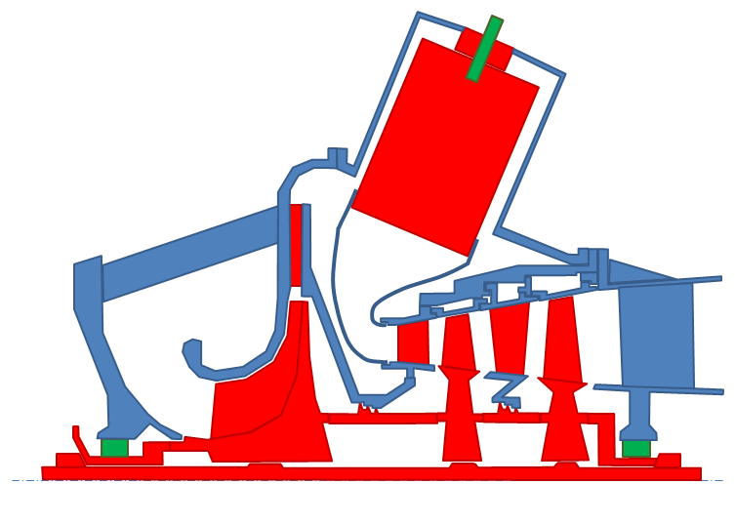

Figure 1 Sketch of the likely engine layout

### RED – Gas Path Components (Out of Scope)

### Aerodynamic profile definition

### Concept level structural analysis

### Rotordynamic assessment

### Combustor design

### Appropriate material selection

### Bearings

### Fuel nozzle

### All of 2.1.9-2.1.20 design elements shall be of a configuration typical to small gas turbine engines and of a type with a proven service record. The tender shall be sufficiently capable and knowledgeable to demonstrate this to be the case and provide their solution in the Compliancy Matrix at Annex 1.

### All engine casings & mounting points

### Engine Rotor Bearings & Installation.

### Engine Reduction gearbox

### Engine clutch system

### Engine inlet barrier filter & silencer

### Engine inlet de-icing system

### Engine outlet silencer

### Engine exhaust system

### Engine lubrication system

### Engine electrical system (including starter/generator)

### Engine control & instrumentation system (including torque sensor)

### Rotor shaft mechanical design.

### Engine Build Cost Estimate

### The tenderer will be able to demonstrate ‘expert’ levels of competence with complex non-linear ANSYS analysis and multi-physics simulations in addition to ‘expertise’ in practical implementation of advanced control systems. Provide appropriate member of staff’s CV as supporting evidence.

### The tenderer will have extensive recent experience of new product development in a related field, including experimental development and ‘design for development’. Please provide a minimum of 3 case studies to evidence this capability.

## ENGINE PERFORMANCE AND CONFIGURATION

### Summary of engine performance requirements

### The Helicopter will be powered by a single-shaft gas turbine engine operating at constant speed. The engine/transmission system will include an electronically controlled clutch system to enable the engine to be started without the rotor engaged

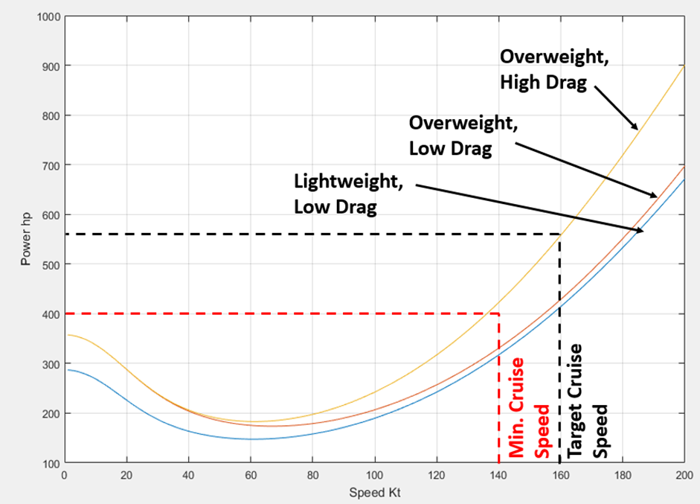

Figure 2 – Estimated Power Requirements (Various Weight/Drag Scenarios)

The aircraft must be able to hover out-of-ground effect at 10,000ft on an ISA+15°C day and must be able to cruise at 140kts.

With these considerations, the forward flight speed is the limiting factor, requiring the greatest power. Therefore, in order to reach the desired forward flight speed, the nominal design point for the engine shall be 400hp, between SL and 10,000ft pressure altitude on an ISA +15°C day

Given that helicopters operate at constant rotor speed, it is vital that the engine has sufficient torque margin available at the design point to avoid inadvertent engine damage or loss of rotor RPM in critical flight regimes due to pilots over-torqueing the engine. Therefore, the engine shall provide the following margins:

### Engine Duty Cycle

#### Nominal Design Point (Max Continuous): 100% TQ, 400hp

### 5 Minute Rating (Take-Off Power): 110% TQ, 440hp

### 30s Rating (Emergency): 125% TQ, 500hp

### A Typical Duty Cycle for the Engine Shall be:

### Normal Power 100% 45mins/hr

### 5 Min Rating 110% 12 mins/hr

### 30s Rating 125% 3 mins/hr

### Engine Service Life minimum 5,000hrs

### Engine Start/Stop Cycles minimum 20,000

### Fuel Consumption Requirement

### The following brake specific fuel consumption are required (with the 300-400hp range values being critical as the cruise point will be circa 350hp subject to drag and aircraft weight targets being met):

**Power Band BSFC**

Below 200hp Not controlled

200-300hp 0.6lb/hp.hr

300-400hp 0.5-0.55lb/hp.hr

Above 400hp <0.65lb/hp.hr

### Engine Certification Requirements

### The tenderer shall be responsible for developing a design that is compliant with the requirements of EASA CS-E and CFR FAR-33 (or equivalent). The tenderer shall be capable for being a named post-holder within a CAA Approved design organisation. Please provide relevant CV to evidence this capability

### Weight

### The engine design shall weigh no more than 75kg. This weight constraint is key to the design.

## Engine Casing Requirements

### The tender shall design an engine case of conventional gas turbine configuration, that provide for all of the engine mounting points, blade containment and engine services access.

### The engine casing shall be lightweight and provide for easy maintenance of all maintainable components and systems.

### The engine casing shall include all necessary heat shield and cooling passages for safe operation.

### The design shall be compliant with EASA CS-E and FAR-33 or equivalent.

### The engine shall have an integrated drive clutch, sprag clutch and integrate fully with the main rotor gearbox.

### The design of the main rotor gearbox of the aircraft is not yet set and the tenderer will work with the aircraft team on-site at Dynamiq Engineering to develop the most efficient integration of the engine with the main rotor gearbox and cabin suspension system

### The tenderer shall provide 3D CAD designs, full structural and thermal analysis calculations in ANSYS, and life calculations for both creep and fatigue.

## Engine Rotor Bearings and Installation

### The tenderer shall be responsible for working with the turbomachinery team to select the required bearings and develop an appropriate installation

### The installation shall allow for cooling, lubrication, maintenance and the required rotordynamic performance.

### The tenderer shall be responsible for the integrity of the bearing installation from and airworthiness and product liability perspective. In the event of a non-compliance the tenderer is liable for design corrections. Should you be awarded the contract you will need to provide the relevant insurance certificate with a minimum of £1 Million.

### The design shall meet the requirements of CS-E and FAR-33 or equivalent. In the event of a non-compliance the tenderer is liable for design corrections.

### The tenderer shall provide 3D CAD designs, full structural and thermal analysis calculations in ANSYS, and life calculations for both creep and fatigue.

## Engine Reduction Gearbox

### The speed of the gas turbine shaft has not yet been finalised but will be circa 50,000rpm. The main rotor speed will be 410rpm, therefore a reduction gearbox is required. The main rotor gearbox, generally is required to provide an engine input, and a main and tail rotor output at 410rpm for the main rotor and circa 5,000rpm for the tail rotor.

### In order to minimise the risk of a gear failure in the main rotor gearbox the high-speed gearing required by the engine is generally housed in an engine reduction gearbox, upstream of the sprag clutch (with allows rotor to continue to rotation after an engine failure). The tenderer shall work with the Dynamiq aircraft design team to establish the optimum layout of the drivetrain and consider whether the engine reduction gearbox can be combined with the main rotor gearbox, to reduce weight and complexity.

### The tenderer shall develop an engine reduction gearbox (integrated with MR gearbox or engine) which provides the necessary speed reduction from the high-speed turbine output shaft to the MR gearbox input.

### The reduction gearbox shall provide the necessary drive arrangements for the starter/generator, oil system, tertiary air systems and a spare PTO off-take.

### The tenderer shall provide 3D CAD designs, full structural and thermal analysis calculations in ANSYS, and life calculations for both creep and fatigue.

## Engine Clutch System

### The proposed engine is a single shaft design and therefore requires a clutch mechanism to disengage the main rotor and engine for starting and shutdown. The tenderer shall design a gas-turbine to helicopter rotor clutch system.

### The clutch system shall be electrically actuated and controlled and shall provide smooth connection and disconnection of the main rotor, without undue noise.

### The clutch system shall fail-safe to a fully engaged position.

### The clutch system shall meet the requirements of CS-27 and CS-E and FAR-27/FAR-33 or equivalent

### The clutch system shall include a cockpit annunciation system to indicate its state.

### The clutch shall be lightweight and of a proven design configuration for the application.

### If the engine and reduction gearbox are integrated into the MR gearbox module then the tenderer shall also provide the sprag clutch design as part of the clutch design assembly.

### The tenderer shall provide 3D CAD designs, full structural and thermal analysis calculations in ANSYS, and life calculations for both creep and fatigue.

## Inlet Barrier Filter and Silencer

### The engine shall be equipped with a conventional inlet barrier filter and/or particle separator to prevent the ingestion of particles into the engine.

### The filter shall be of conventional design with a proven safety record in this class of aircraft.

### The pressure drop for the inlet filter shall be defined by the turbomachinery team during the design process.

#### The inlet shall be designed to include an inlet silencer to reduce the engine noise emission from the inlet and compressor by 40dB.

### The system shall be compliant with the requirements of EASA CS-E or equivalent

### The tenderer shall provide 3D CAD designs, full structural and thermal analysis calculations in ANSYS, and life calculations for fatigue.

## Engine inlet de-icing system

### The tenderer shall design a conventional inlet anti-icing system of a similar configuration to those shown to be reliable in previously in helicopter engine installations.

### The system shall not reduce engine performance below the required level set out in the specification.

### The system shall be compliant with the requirements of EASA CS-E or equivalent

### The tenderer shall provide 3D CAD designs, full structural and thermal analysis calculations in ANSYS, and life calculations for fatigue.

## Engine Outlet Silencer

### The engine shall be equipped with a conventional outlet silencer.

### The pressure drop for the silencer shall be defined by the turbomachinery team during the design process.

### The system shall be compliant with the requirements of EASA CS-E or equivalent

### The outlet silencer shall be designed to reduce the engine noise emission from the unsilenced exhaust by 40dB.

### The tenderer shall provide 3D CAD designs, full structural and thermal analysis calculations in ANSYS, and life calculations for creep, fatigue and hot corrosion.

## Engine Exhaust System

### The engine shall be equipped with an exhaust duct designed to minimise overall momentum drag and flow separation on the fuselage around the exhaust outlet.

### The exhaust shall divert hot exhaust gases away from sensitive parts of the airframe and rotor systems.

### The exhaust shall be of simple low-cost design.

### The exhaust system shall be compliant with the requirements of EASA CS-E or equivalent

### The tenderer shall provide 3D CAD designs, full structural and thermal analysis calculations in ANSYS, and life calculations for creep, fatigue and hot corrosion.

## Engine Lubrication System

### The tenderer shall design a simple engine lubrication system to provide lubrication and cooling the all necessary parts of the engine.

### The lubrication system shall be redundantly designed and fail safe.

### The lubrication system shall be compliant with the requirements of EASA CS-E or equivalent

### The tenderer shall provide 3D CAD designs, full structural and thermal analysis calculations in ANSYS, and life calculations for creep and fatigue.

## Engine Electrical System (Including Starter/Generator)

### The engine shall be equipped with an electrical system including a starter-generator and associated controls and instrumentation.

### The electrical system shall have the required level of redundancy.

### The tenderer shall design a conventional electrical system to include a starter motor, generator and electrically driven oil pumps and any other accessories deemed necessary but should have limited impact on the effort required to deliver this element.

### The electrical system shall be compliant with the requirements of EASA CS-E or equivalent

### The tenderer shall provide electrical schematics, 3D CAD designs, full structural and thermal analysis calculations in ANSYS, and life calculations for creep and fatigue.

## Engine Control and Instrumentation System

### The engine shall be equipped with a dual-redundant electronic control system.

### The control system shall provide automatic control of engine starting, shutdown ancillary systems and speed/load control.

### The control system shall provide robust control against both over and under speed conditions.

### The control system will have agreed policy’s and responses to over-torque conditions. These shall be agreed with the Dynamiq team during the design process.

### The control system shall be designed to provide all necessary speed, temperature, pressure and torque measurements necessary for safe operation.

### The tenderer shall design the control and an instrumentation necessary to deliver these functions. The factors which depend partially of the requirements of the airframe team shall be designed in co-operation with the Dynamiq Engineering team. Please allow 5 visits to our premises.

### The control system shall be compliant with the requirements of EASA CS-E or equivalent

### The tenderer shall provide schematics, logic flow-charts, software source code, 3D CAD designs, full structural and thermal analysis calculations in ANSYS, and life calculations for creep and fatigue for relevant elements.

## Rotor Shaft Mechanical Design

### The design of the engine shaft shall be designed by the tenderer.

### The mechanical design shall include responsibility for the structural dynamics of the system, lubrication passageways and structural integrity.

### The tenderer will be responsible for the mechanical interfaces between the key rotating elements of the engine.

### The tenderer will be responsible for the sealing of key leakage paths.

### The tenderer will be responsible for holding the required tip clearance tolerances between the rotating elements of the engine and the casings.

### The shaft design shall be compliant with the requirements of EASA CS-E or equivalent

### The tenderer shall provide schematics, logic flow-charts, software source code, 3D CAD designs, full structural and thermal analysis calculations in ANSYS, and life calculations for creep and fatigue for relevant elements.

## Deliverables

|  |  |  |
| --- | --- | --- |
| Deliverable | Description | Timescale |
| D1 | 3D CAD Model in CATIA V6 on full engine design |  |
| D2 | Engine Calculation Technical File |  |
| D3 | Preliminary GA Drawings |  |
| D4 | Engine Build Cost Estimate |  |
| D5 | All native analysis files (ANSYS Native Format including source geometry files & definitions) |  |

## Pre-Existing IPR

## The Tenderer is to clearly identify any pre-existing IPR that they may wish to use in their response. Any existing IPR must be provided on a free and unfettered use for the application within this scope of supply

## IPR

## All IPR arising from this contract will be vested in Dynamiq Engineering Limited

## Timescales

## It is anticipated that the contact will start no later than 3 July 2019 and completion is by 13 September 2019

**Please ensure that you have completed *Annex 1 Compliancy Matrix* as part of your tender response. Failure to do so will render your response non-compliant.**

# ITT Timetable

The anticipated timetable for submission of the tender and commission milestones are set out below:

|  |  |
| --- | --- |
| Activity | Date |
| Date ITT available on Contracts Finder | 14 June |
| Last date for raising queries | 21 June |
| Last date for clarifications to queries | 24June |
| Deadline to return ITT | 28 June |
| Evaluation of ITT | 1 July |
| Award of Contract | This is subject to successfully obtaining grant funding and will normally be no later than 30 days from contract evaluation |

# Conflicts of Interest

Please provide a statement with regards to a conflict of interest for this procurement through the provision of either:-

A Declaration that to your knowledge there is no conflict of interest between *{enter your company name here}*and Dynamiq Engineering Limited that is likely to influence the outcome of this procurement either directly or indirectly through financial, economic or other personal interest which might be perceived to compromise their impartiality and independence in the contexts of this procurement procedure.

Or

A Declaration that there is a likely conflict of interest between {enter your company name here} and Dynamiq Engineering Company that is likely to influence the outcome of this procurement either directly or indirectly through financial, economic or other personal interest which might be perceived to compromise their impartiality and independence in the contexts of this procurement procedure, please provide details of this connection.

This will permit Dynamiq Engineering Company that in the event of a conflict of interest, appropriate steps are taken to ensure that the evaluation of any submission will be undertaken by an independent and impartial party.

**Exclusion**

Dynamiq Engineering Company shall exclude applicants from participation in this procurement procedure where they have established or are otherwise aware that the applicant, to include administrative, management or supervisory staff that have powers of representation, decision or control of the applicants company, has been the subject of a conviction by final judgment of one of the following reasons:-

Participation in a criminal organisation

Corruption

Fraud

Terrorist offences or offences linked to terrorist activities

Money laundering or terrorist financing

Child labour and other forms of trafficking in human beings

# Consortium or sub-contracting

Where a consortium or sub-contracting approach is proposed, all information requested should be given in respect of the proposed prime contractor or consortium leader. Relevant information should also be provided in respect of consortium members or sub-contractors who will play a significant ( greater than 25%) role in the delivery of the services under any ensuing Contract.

# Tender Application Requirements

Please provide paper copies of your application which should include:

1. Confirmation that **you the Tenderer** are able to meet the requirements outlined in the brief above.
2. **Dated** your response, used our company’s full postal address (albeit you submission might be by email) and included the **Reference: ‘GT50 Gas Turbine Program – Mechanical Design Tender Response’**
3. Details of who to **contact** in your company in relation to this tender is to be entered at Annex A
4. Company registration Number and VAT number (if appropriate) is to be entered at Annex A
5. Total cost of providing the goods/services requested Section 2 as detailed in Annex A

# Tender Scoring Criteria

The tender will be scored only on their compliance to the specification set out in section 2 and awarded to the lowest compliant tender.

# Tender Returns

Tenders may be returned by email or post, or by delivery in person.

Tenders are to be returned by:-

Latest date to be returned: 28 June 2019

Latest time to be returned: 4.00pm

If submitting by **email,** tenders should be sent electronically to [jasonhill@dynamiq-eng.co.uk](mailto:jasonhill@dynamiq-eng.co.uk) with the following message **clearly noted in the Subject box; ‘GT50 Gas Turbine Program Mechanical Design Tender Response’**

Tenderers are advised to request an acknowledgement of receipt when submitting by email.

If submitting by post or in person, the Tender must be enclosed in a sealed envelope, only marked as follows:-

Tender - Strictly Confidential – ‘ **GT50 Gas Turbine Program Mechanical Design Tender Response**’

Contract Reference Number:

Addressed to:

Dr J Hill

Venture Point

Wheelhouse Road

Rugeley

WS15 1UZ

The envelope should not give any indication to the Tenderer’s identity. Marking by the carrier will not disqualify the tender.

If delivery **by hand** please obtain an official Receipt at point of delivery

# Clarification

There will not be any negotiations of any of the substantive terms of the Tender Documents. Only clarification queries will be answered. Any clarification queries arising from the Tender Documents which may have a bearing on the offer should be raised as soon as possible in writing. The deadline for clarification questions is 21 June 2019. All e-mailed queries should be sent to:-

Name: Dr J Hill

E-mail: jasonhill@dynamiq-eng.co.uk

No representation by way of explanation or otherwise to persons or corporations tendering or desirous of tendering as to the meaning of the tender, Contract or other Tender Documents or as to any other matter or thing to be done under the proposed contract shall bind us unless such representation is in writing and duly signed by Dr J Hill of Dynamiq Engineering Limited. All such correspondence shall be returned with the Tender Documents and shall form part of the Contract.

Tenderers must provide a single point of contact in their organisation for all contact between the Tenderer and Dynamiq Engineering Limited.

Responses to any queries will be shared through Contracts Finder website

# Disclaimer

The issue of this documentation does not commit Dynamiq Engineering Limited. to award any contract pursuant to the bid process or enter into a contractual relationship with any provider of the service. Nothing in the documentation or in any other communications made between Dynamiq Engineering Limited. or its agents and any other party, or any part thereof, shall be taken as constituting a contract, agreement or representation between Dynamiq Engineering Limited. and any other party (save for a formal award of contract made in writing by or on behalf of Dynamiq Engineering Limited.

Bidders must obtain for themselves, at their own responsibility and expense, all information necessary for the preparation of their tender responses. Information supplied to bidders by Dynamiq Engineering Limited. or any information contained in Dynamiq Engineering Limited’s publications are supplied only for general guidance in the preparation of the tender response. Bidders must satisfy themselves by their own investigations as to the accuracy of any such information and no responsibility is accepted by Dynamiq Engineering Limited. for any loss or damage of whatever kind and howsoever caused arising from the use by bidders of such information.

Bidders shall be responsible for their own costs and expenses in connection with or arising out of their response. Dynamiq Engineering Limited reserves the right to vary or change all or any part of the basis of the procedures for the procurement process at any time or not to proceed with the proposed procurement at all.

Cancellation of the procurement process (at any time) under any circumstances will not render Dynamiq Engineering Limited. liable for any costs or expenses incurred by bidders during the procurement process.