**ARMYHQ2/00276 PROVISION OF NATIONAL ROADSIDE REPAIR & RECOVERY**

**REPAIR / RECOVERY FLOWCHARTS – COURSE OF ACTION**

**UK ONLY**

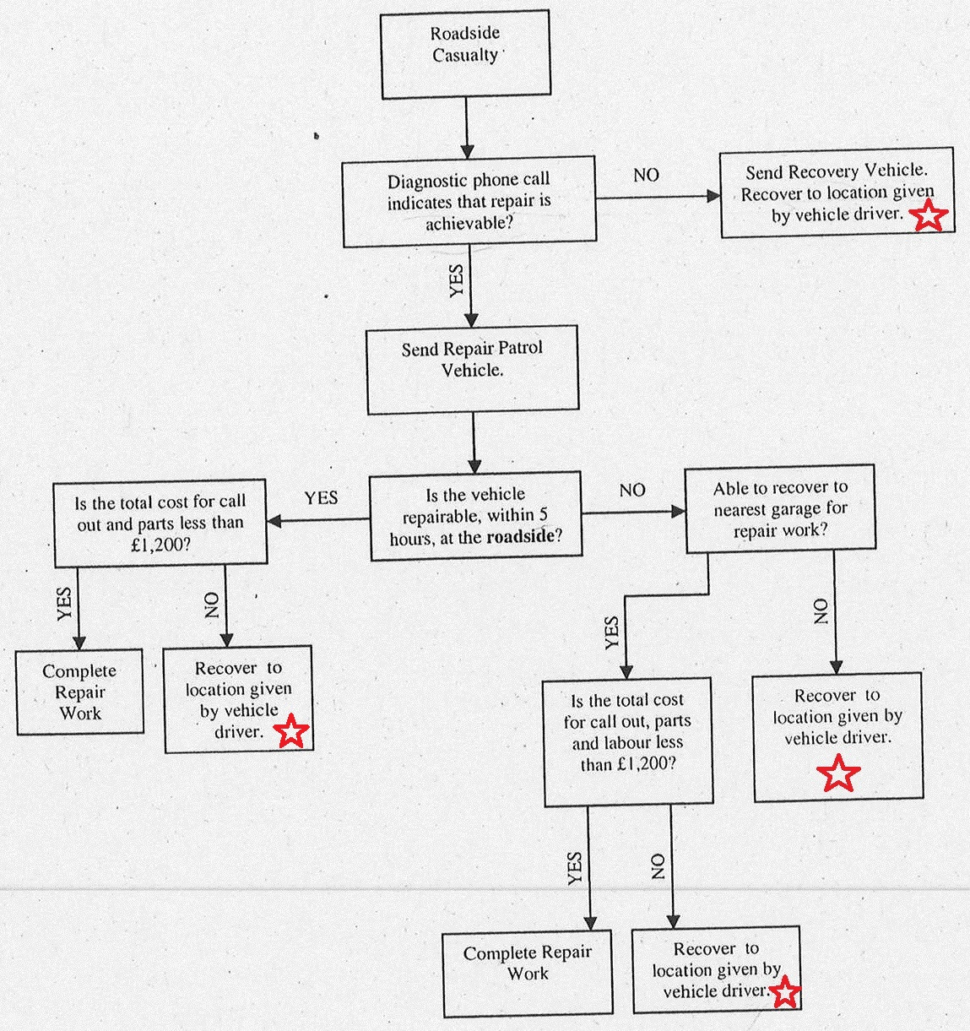

End of Contractor’s responsibility

**GERMANY ONLY**

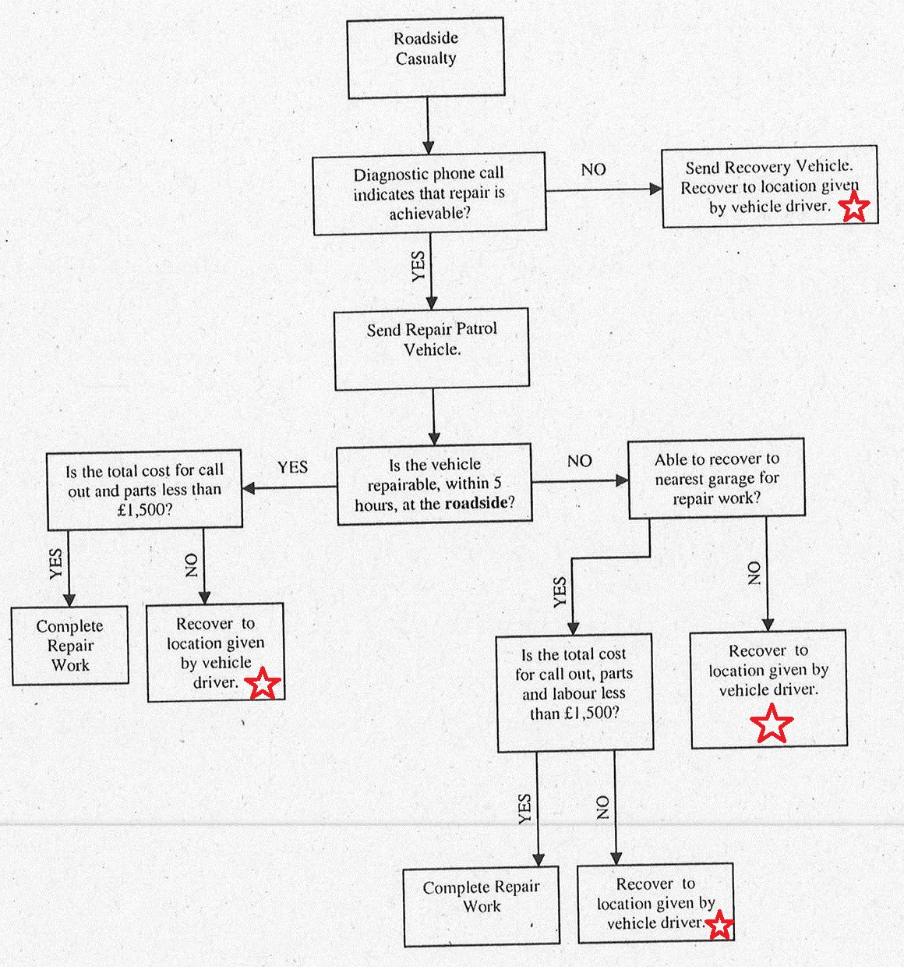

End of Contractor’s responsibility

**REMAINDER OF MAINLAND EUROPE**

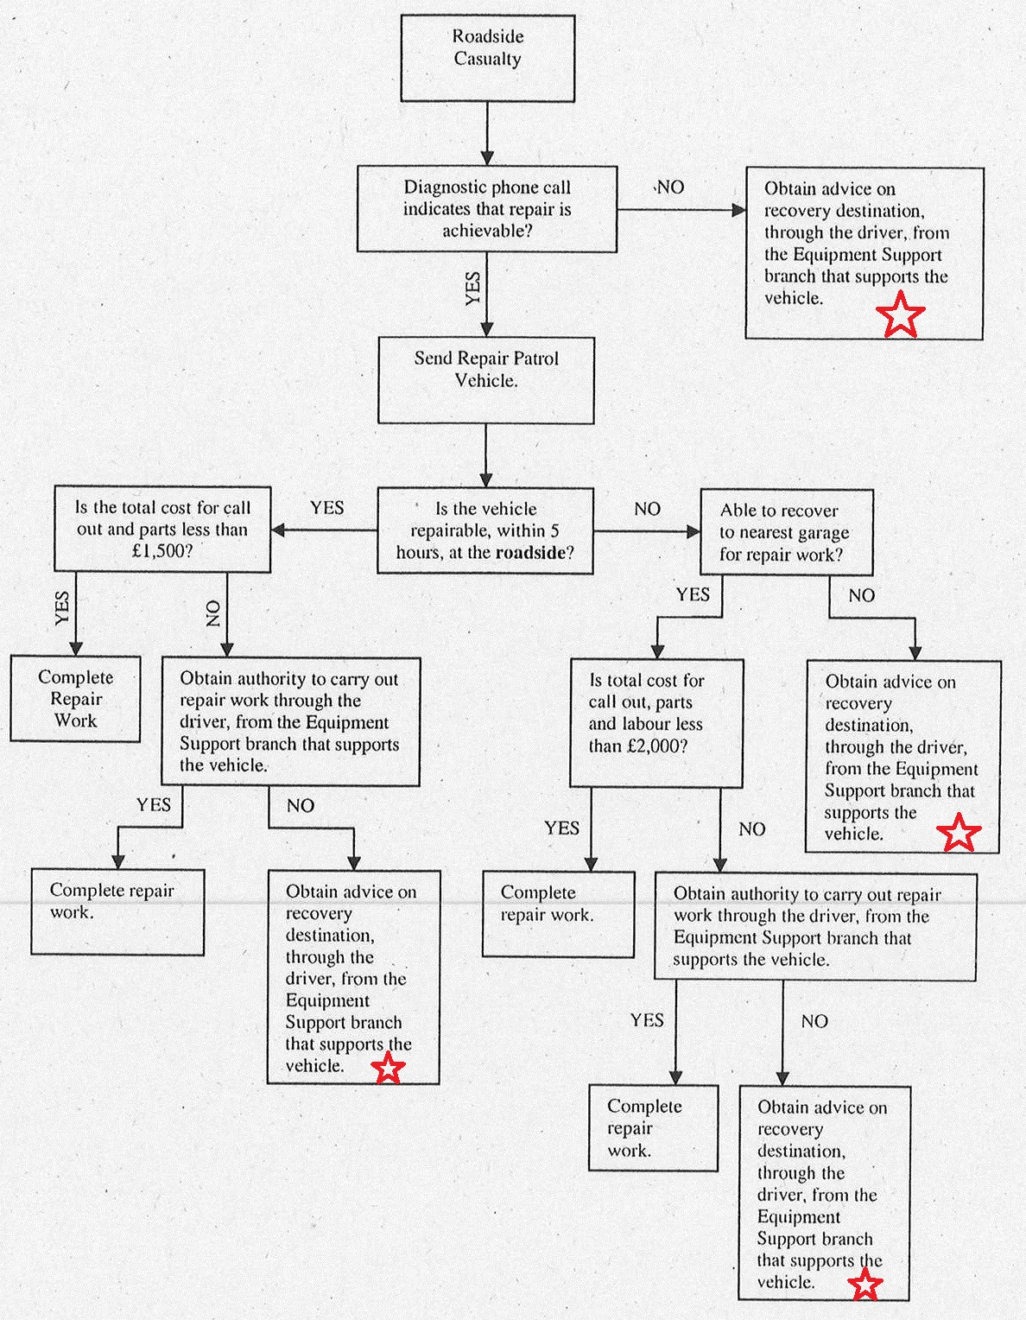

End of Contractor’s responsibility