Prior Information Notice:
Community Inclusion Service in Inner City and East Bristol Locality Partnership, part of Bristol, North Somerset and South Gloucestershire Integrated Care Board (BNSSG ICB)
Inner City and East (ICE) Bristol Locality Partnership (LP) – part of Bristol, North Somerset and South Gloucestershire Integrated Care Board (BNSSG ICB) – is considering an opportunity to provide a two-year contract (with the option to extend for one further year), to establish and run a new Community Inclusion Service. The service will support those people in the ICE Bristol locality, who are amongst the most marginalised to access and benefit from mainstream mental health and wellbeing services. The service will be a crucial component of a new Community Mental Health (CMH) Programme in the ICE Locality. The contract value would be estimated to be approximately £370k per annum, or £1.1m over the full three year period.

With this in mind, we are undertaking a market engagement exercise to help shape the final specification and to better understand potential interest in delivering this service, prior to formally offering the opportunity to the market.

We are looking for an organisation, partnership or alliance of providers, that can demonstrate:

- an ability to work with people from the communities described below
- a commitment to addressing health inequalities
- ability to deliver community mental health or wellbeing services
- a commitment to building a place-based approach to service delivery using the assets and actors within communities
- a commitment to co-production
- the capability to collaborate with mental health providers to support the wider transformation of services both in the Inner City and East locality and across the BNSSG ICB

The successful organisation, partnership or alliance of providers would need to deliver the full range of services outlined in the specification (once finalised) from 1st July 2023.

Based on health and population data the initial focus of this service will be on the following communities:

- African-Caribbean
- Somali
- South Asian
- Eastern European
- Refugees and Asylum Seekers
- LBGTQ+

This list was created using Joint Strategic Needs Analysis (JSNA) data from Bristol City Council, Population Health Management (PHM) data from the BNSSG ICB, and from many conversations with those who currently deliver mental health services, along with General Practice and people from the faith and grassroots organisations of Inner City and East Bristol.

It is not an exhaustive list; it should be read as a guide to where the initial focus of the service should be, not as an exclusion of other marginalised communities.

See Appendix C for more information.

The Community Inclusion Service will:

- support people from these communities to access, engage with and benefit from the full range of mental health services that may be available to them, as well as community-based wellbeing activities
- support people to address issues, such as debt, housing, and work
- ensure the person receives personalised care that is culturally appropriate throughout their engagement with services
- use a relational approach that will enable the person to build trust with the worker, with the service, and with wider mental health services

We anticipate the service will do this through the employment of Community Link Workers (provisional name). The Community Link Workers will act as ‘key workers’ who coordinate the care of the person and, where required, advocate on their behalf including as part of the multi-agency, multi-practitioner Integrated Personalised Care Teams (also known as Integrated Mental Health Teams). Broadly, we would expect these link workers will have a clear focus on a particular community (e.g., Somali) and a strong understanding of the communities they serve, acknowledging that people are never defined by any single category (for example, a person using the service may well be Eastern European and also identify as gay).

A draft job description of the Community Inclusion Service Link Worker role can be found at Appendix A for indicative purposes. The proposed make-up of the Integrated Personalised Care Team can be found at Appendix B.

The service will provide support for people from the minoritized communities identified above that, broadly, fall into one of the following categories:

- Category 1: People who are not known to formal mental health services but may frequent the Emergency Department, call 111 on a regular basis, and possibly frequently use general practice for non-mental health related issues. They may also seek support from family, community and faith groups.
- Category 2: People who receive support for their mental health from GPs, but who are too complex to be supported by primary care and social prescribing link workers alone.
- Category 3: People who have been triaged and/or assessed by AWP and who do not meet the threshold for secondary mental health care but would benefit from a culturally-appropriate service to support their engagement with other mental health services, general practice and/or community-based wellbeing activities
- Category 4: People who are receiving support for their mental health under secondary mental health care arrangements (excluding forensics) and would benefit from additional, culturally-appropriate support to strengthen engagement with secondary care mental health services as well as community-based positive activities
- Category 5: People who are moving towards discharge from secondary care services (excluding forensics) back into the community and would benefit from a culturally-appropriate service to support their continued engagement with non-secondary care mental health services as well as community-based wellbeing activities
- Category 6: Carers of people who are experiencing mental health issues, including those carers whose loved ones are not engaging with mental health services.

The service will work towards ensuring that workers from the team involved in the person’s care understand the cultural context for that individual and that services are accessible and responsive to that individual’s cultural needs. The service will also provide peer support for people, through the employment of peer support workers.

Providers will need to demonstrate an ability to work collaboratively and dynamically – proactively integrating with the other providers including VCSE, mental health and community providers and the local authority to advance the Partnership’s over-riding ambition to reduce health inequalities and improve mental health provision for marginalised people in the Inner City and East Locality.

We will be offering an opportunity for interested parties, individually or collectively, to meet with us as part of our market engagement process. At this meeting, we will describe in greater detail the scope and provisional structure of the service and offer an opportunity to ask questions; discuss the feasibility of the high-level delivery model; understand what organisations can provide themselves and what they will need support with; and gather information to support us to develop the final service specification. We will be in touch to ask you if you would like to participate in such a session once we have received your expression of interest.

If you wish to express an interest (either in bidding for any future opportunity or in attending an engagement meeting), please do so by email to Mark Stanbrook, Lead Senior Procurement Manager at mstanbrook@nhs.net (and cc’ing stevie.crawford2@nhs.net) by no later than 5pm on the 23rd September 2022.

Appendix A – Job Description (draft) of the Community Link Worker
DRAFT Job Description: Community Link Worker (provisional name)
Purpose
The Community Link Worker will be support people who are experiencing poor mental health to receive personalised care and support to improve their mental health and wellbeing. The CLW will be part of an Integrated Personalised Care Team (see Figure 1) under the Inner City and East Bristol Community Mental Health Programme and will advocate for the person to ensure they receive care that is both holistic and culturally-appropriate.
Key Functions
- Act as key worker for the person and ensure their care and support is personalised and co-ordinated across clinicians and other key workers or organisations

- Build trusting relationships with individuals, holding hope that their mental health and quality of life can improve

- Co-produce with the person (and, if appropriate, carers and loved ones) a personalised care and support plan (PCSP) that includes shared decision making, supported self-management tools, personal holistic budgets (small budgets for the individual to follow through on actions from their PCSP) and engagement with positive activities in their community

- Support the person to address core issues that are affecting their mental health, such as debt, housing and benefits

- Key tools include motivational interviewing techniques, active listening, and modelling healthy relationships rooted in kindness and with clear and consistent boundaries

- Support people to take an active role in their health and wellbeing

- Hold the cultural understanding and, if appropriate, language skills of some of ICE’s most marginalised communities

- Challenge assumptions and mental models of the wider team and workforce

- To be up to date on the offer and capacity of community based positive activities available for people, such as arts, physical activities, and nature-based activities

- To work to a trauma-informed approach, recognising the impact of adversity on the individual

- To work as part of an Integrated Personalised Care Team (IPCT) offering and receiving support and feedback to and from other team members.

- Engage with regular practice supervision, peer support and supervision, as well as any other training and coaching that supports the development of the Core IPCT.

Appendix B: Integrated Personalised Care Team (IPCT) – Core and Enhanced

Figure 1 Figure 2
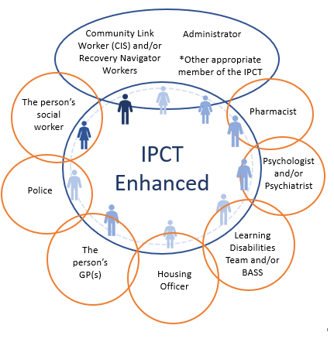
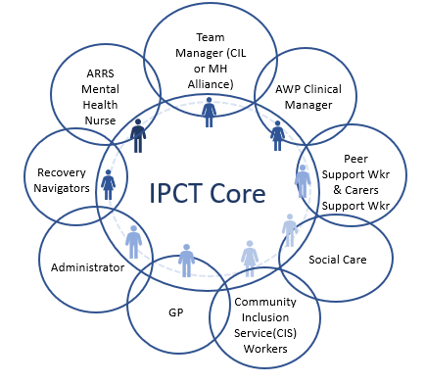

Appendix C – Data on Cohorts

This draft JD is for indicative purposes only.

