|  |  |
| --- | --- |
|  |  |
| SFA_BLK_AW |  |

**Specification and Guidance Document for Higher Apprenticeships & Degree Expansion 2016**

**ITT 30102**

**June 2016**

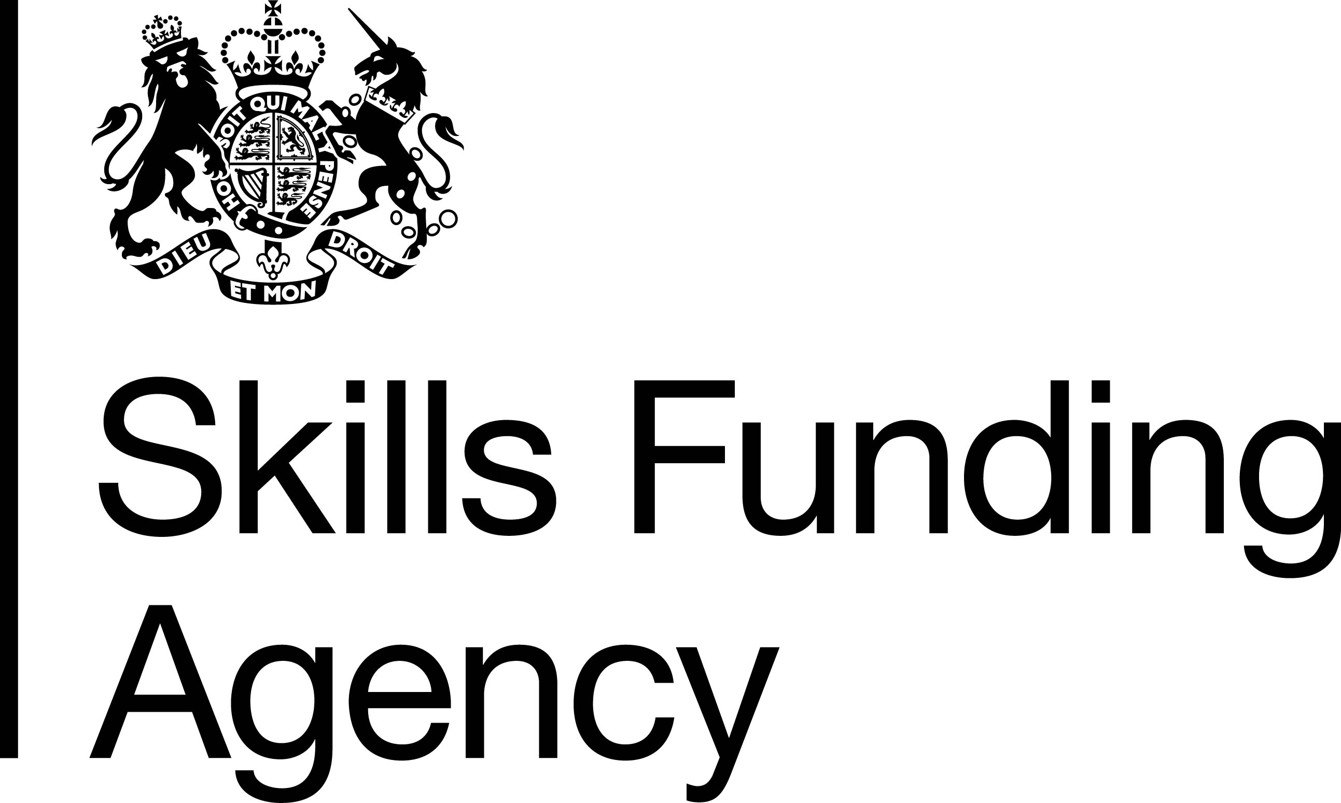

|  |
| --- |
| **HIGHER AND DEGREE APPRENTICESHIP EXPANSION 2016 to 2017** |
| Service Requirements |
| 1. **Scope of this procurement**     1. This £20m procurement is to select organisations to deliver higher and degree apprenticeships at levels 4-7 inclusive in England. The minimum application requirement is for ten 10 apprenticeships starts or £50,000 in the 2016 to 2017 funding year:         1. This funding can only be used for delivery of training and assessment of higher and degree apprenticeships at level 4-7 inclusive which are published with a funding rate (apprenticeship frameworks) or as ‘approved for delivery’ with a funding cap (apprenticeship standards) see ‘**Sources of Information’** below.       2. The only apprenticeships eligible for funding from this procurement are new apprenticeships, which start on or after 1 September 2016. Apprenticeships which started before 1 September 2016 are not eligible for this funding.       3. Candidates may include bids for the delivery of standards published, which are ‘in development’ but not yet ‘approved for delivery’ see ‘**Sources of Information’** below. To be eligible for inclusion these must be likely to be published as ‘approved for delivery’ on or before 1 September 2016. Successful candidates are able to deliver other published higher and degree apprenticeships in the event of this publication not taking place.       4. This funding cannot not be used for any other costs outside the costs of direct delivery of training and assessment. The costs of curriculum development or capital purchases are explicitly ineligible for this fund.       5. This funding can only be spent on eligible apprentices, employers and provision which complies with the Skills Funding Agency published Funding Rules – see ‘**Sources of Information’** below.      * 1. The invitation to tender (ITT) is open to training providers delivering higher and further education who may or may not be currently on the SFA Register of Training Providers (ROTO) and who do not currently have a SFA Adult Skills Budget (ASB) funding agreement to deliver apprenticeships apprenticeship in the 2016 to 2017 funding year.   2. The full value of this funding may not be allocated in this procurement round. A subsequent procurement round may be run for a higher apprenticeship starts from 1 January 2017 but this is subject to available 19+ age group and 16-18 age group apprenticeship budget.   3. The SFA reserves the right to set a maximum volume for individual funding awards. This will depend on the volume of eligible applications and on the SFA judgement of evidence supplied on employer demand and applicant capacity and capability information submitted in the application.   4. Candidates must have started delivery of the apprenticeships in their application by 1st January 2017 or apply to the SFA to return the funding allocated.   **Background**   * 1. This procurement will, by the end of the 2016 to 2017 funding year :   + increase the number of Higher and Further Education Institutions (HEI/FEI) and HE/FE training providers delivering higher and degree apprenticeships in England   + award funding for this delivery for the 2016 to 2017 funding year (1 August 2016 to 31 March 2017   + increase the number of HEIs with direct accountability for higher and degree apprenticeship delivery   + create a larger delivery network of higher and further education to deliver the longer term expansion of higher apprenticeships, particularly apprenticeship and degree apprenticeship standards   + deliver approximately 3000 higher and degree apprenticeship starts   1. This will enable the SFA to expand the higher and degree apprenticeship provider network to encompass the full range of apprenticeship standards available by January 2017 and support government ambition to increase degree apprenticeships and meet 3m apprenticeships starts by 2020.   2. If you are successful in this application you will be awarded funding to cover what is needed to deliver the apprenticeship activity that take place in 2016 to 2017.   3. Successful candidates who remain eligible for funding will have access to funding for delivery in future years. This will include funding for apprentices who start in the funding year 2016 to 2017 and progress to years 2 and 3 of their apprenticeship, and for new apprenticeship starts in 2017 to 2018 and beyond. This funding will awarded as part of a future year’s allocation or funding arrangements.   4. With the introduction of the apprenticeship levy from April 2016, funding arrangements for apprenticeships will change. Advice on how this affects apprenticeship providers including successful candidates will be provided by the SFA later in 2016 as part of the transition arrangements. All apprenticeships which commence by 31 March 2017 will continue to be funded by the SFA and will remain on the funding and payment model in place at the date their apprenticeship started.  1. **Candidate requirements**     1. To participate in this procurement candidates must:         1. Hold the appropriate approval and authority to deliver the provision for the apprenticeships at the time of submitting their ITT. This **must** include relevant authority from 15 August 2016 to 31 July 2017 to deliver and award all learning aims and qualifications for the standard or framework specified in the application. This will include, as needed, and for example, authority to deliver from the awarding body, issuing organisation, professional body, degree awarding body, and hold specific course designation for the provision applied for. This list is not exclusive and candidates must take care to ensure that all authorities required by the apprenticeship are current, and that authority cover extends from 15 August 2016 to 31 July 2017. SFA will seek confirmation of specific course designation from the Higher Education Funding Council for England.       2. Where a candidate is funded by the Higher Education Funding Council for England  (HEFCE) be designated as having no material issues through the annual HEFCE review of financial risk assessment or the specific course designation. SFA will seek confirmation of this from HEFCE.       3. Be operating successfully under formal recognised quality arrangements for delivery of education and skills in higher or further education, for example, Ofsted for Further Education Institutions and QAA for Higher Education Institutions, awarding body and professional body membership.    2. By the date when the contract is issued by the S FA must be listed (or approved and awaiting listing) on the Register of Training Providers and for HE providers be listed on the Register of Higher Education Providers and hold specific course designation for the provision applied for.    3. Applications are welcomed from organisations working with subcontractors or other partners but only one organisation may make an application. Should their application be successful, this lead organisation only will hold the funding agreement with the SFA, and will be fully accountable for delivery of the provision set out in their funding agreement and for full compliance with the SFA Funding Rules. All other partners must be named and their roles explained in the application.      1. **Application Requirements**     1. Candidates must specify in their response to the ITT :         1. the higher and degree apprenticeships they intend to deliver from 1 September and 31 March 2017       2. the planned starts volumes and funding values for delivery of each apprenticeship, divided into two separate apprentice age groups; 16-18 and 19+.       3. planned start volumes and the date of first start       4. the financial value requested for these apprenticeship starts comprising:       * ***government contribution costs only*** relating to the delivery of these apprenticeships for the funding year (i.e. not government contribution for the entire length of the apprenticeship, which will be allocated over several funding years) or employer contribution which must be paid by the employer       * ***government incentive payments for apprenticeship standards*** relating to the delivery of these apprenticeships for the funding year (i.e. not all incentive payments will be due on this funding year dependant on the apprentice start dates. The remaining incentives will be allocated in the following funding year)       1. It is likely that all candidates will require funding for some 16-18 year old apprentices so inclusion of at least a small indicative value is advised. Allocation of budget for 16-18 year old apprenticeships is subject to budget availability.    2. The SFA accepts that the apprenticeships listed, their respective volumes and financial value and the ages of apprentices contained in the application is an estimate at point of submission, and this may change over the year. Successful candidates must make all efforts to meet the trajectory in their application but it is acceptable to follow local demand and change the specific higher and apprenticeship provision delivered secured through accordingly.    3. Candidates however must not:        1. Breach the overall budget value or the separate budgets allocated for the 16-18 and 19+ age groups.       2. If additional funding is required, you must follow the advice in the performance management rules and apply to vire provision or request growth.       3. Successful candidates also cannot deliver apprenticeship provision at levels below level 4. 2. Candidates must provide evidence of their current delivery, track record, readiness to deliver and delivery experience **see ‘evaluation’** section below. This will include experience in some or all of either the occupation supported by the apprenticeship, the sector in which the occupation sits, or delivery of the qualifications or skills provision included in the apprenticeship applied for. Candidates must also confirm and provide evidence that they have the formal authority to deliver the provision applied for, and meet the eligibility requirements to receive funding from the SFA.   ***It is strongly recommended that you attend a procurement briefing workshop to ensure that you understand the application content and in particular how to calculate the level of funding needed.*** |
| Geography / area of delivery |
| 1. **Geographic scope**     1. This procurement is for higher and degree apprenticeships delivered in England only.    2. Employers, apprentices and apprenticeship provision delivered and funded through this application must meet the Skills Funding Agency eligibility criteria set out in the 2016 to 2017 Funding Rules - **see ‘Sources of information’** below. |
| **Funding and payments** |
| 1. **Calculating financial values in the bid**     1. You must include funding volumes in your bid, based on current published apprenticeship rates and funding caps, or the price you agree with employers; whichever is lower:       1. **Funding rates for apprenticeship frameworks** The list of regulated qualifications and apprenticeship frameworks eligible for public funding are set out in the Learning Aims search on the SFA ‘Hub’ and an explanation of funding rates apprenticeship frameworks is contained in the SFA Rates and Formula document ‘ See ‘**Sources of Information’** below for both .       2. **Funding caps for apprenticeship standards** available for delivery are published on the ‘approved for delivery’ you will need to refer to the funding model for each cap set out in the Funding Rules - see ‘**Sources of Information’** below.    2. Please review the advice on agreeing a price for **apprenticeship standards** contained in the 2016 to 2017 Funding Rules. The value of funding claimed in your application:       1. **must only include** the government contribution element of funding in an apprenticeship standard which will be drawn down from the Skills Funding Agency in the funding year 2016 to 2017. Do not include the employer contribution which will be paid direct by the employer       2. **must include** sufficient funding to cover the costs of training and assessment, and for any employer incentive payments likely to be due, but only those due in the funding year 2016 to 2017.      * 1. The provision that you include in your application must be eligible for funding as part of an apprenticeship. You must check that this is the case before making an application :       1. **For apprenticeship frameworks** the provision you are intending to deliver must be listed or about to be listed as eligible for inclusion in a framework before it can be funded. If provision is not listed and does not have a funding rate you must apply first to the apprenticeship framework issuing organisation to request that your provision is added. The Issuing Authority can be found on the Apprenticeship Frameworks Online website - see ‘**Sources of Information’** below. Then you must wait for a funding rate to be provided by the SFA. This is done automatically once provision is listed by the issuing organisation. If you to apply for a funding rate you must apply to the SFA via our Service Desk [servicedesk@sfa.bis.gov.uk](mailto:servicedesk@sfa.bis.gov.uk).      2. **For apprenticeship standards** you must deliver all the mandatory provision set out in the published assessment plan and ensure that your provision meets the requirements of the assessment plan and the end point assessment published on .GOV.UK, and the SFA Funding Rules. See ‘**Sources of Information’** below for both. Funding cap maximum government contribution values are published for a standard on the ‘approved for delivery’ table. See ‘**Sources of Information’** below. If you wish to include a published standard that does not yet have a published assessment plan i.e. one ‘in development’ it must be likely to be published by 1 September 2016 to include it in your application. You must then estimate this cost and the cost of any incentives, but note that until the funding cap is set, you cannot deliver any apprenticeships and they may ultimately not be funded at the level you estimate.      3. Awards will firstly be made to organisations who have submitted tenders for starts in degree apprenticeship standards and apprenticeship standards. Organisations offering the highest proportion of degree apprenticeship standards will be given priority. Awards will only be made to organisations submitting applications exclusively for apprenticeship frameworks if there is sufficient available funding.  1. **Funding and payments models**    1. Providers will be paid according to mainstream Skills Funding Agency processes. This differs depending on whether you are a private provider or an HE/FE Institution, and whether you deliver apprenticeship standards or frameworks. |
| **Performance Management** |
| 1. The SFA will monitor the funding agreements let through this specification and will intervene to address issues of under-performance. Performance management will follow the Skills Funding Agency performance management process. This funding may be directed away from under-performing contracts to areas of high demand in order to maximise the impact of the funding. The Agency therefore reserves the right to decrease or increase a bidder’s contract value through the performance management process. 2. The number of funding agreements awarded will be subject to budget. The Skills Funding Agency reserves the right to award individual contracts level below those applied for in the procurement application. |
| **Sources of information and definition of terms** |
| **Sources of information:**   * Apprenticeship standards ‘approved for delivery’ with their funding cap and the link to the published standard and its assessment plan <https://www.gov.uk/government/publications/apprenticeship-standards-ready-for-delivery> * Apprenticeship Standards ‘in development’ but not ‘approved for delivery’ <https://www.gov.uk/government/publications/apprenticeship-standards-in-development> * List of apprenticeship frameworks available for delivery <https://www.gov.uk/government/publications/apprenticeship-frameworks-live-list> * Skills Funding Agency Funding Rules 2016 to 2017 <https://www.gov.uk/guidance/sfa-funding-rules> * Skills Funding Agency Performance Management Rules 2015 to 2016 (to note: 2016 to 2017 will be published in June 2016)  <https://www.gov.uk/government/publications/sfa-performance-management-rules> * Skills Funding Agency Funding Rates and Formula 2016 to 2007   <https://www.gov.uk/government/uploads/system/uploads/attachment_data/file/510260/Funding_rates_and_formula_2016_to_2017_v2.pdf>   * List of apprenticeship frameworks, their issuing authority and the content approved for delivery <http://www.afo.sscalliance.org/> * The SFA ‘ Hub’ - see the Learning Aims tab <https://hub.imservices.org.uk/Pages/default.aspx> * General guide to higher and degree apprenticeships <https://www.gov.uk/government/publications/higher-and-degree-apprenticeships> |