KING EDWARD MINE MUSEUM
CAFÉ AGREEMENT
BRIEF
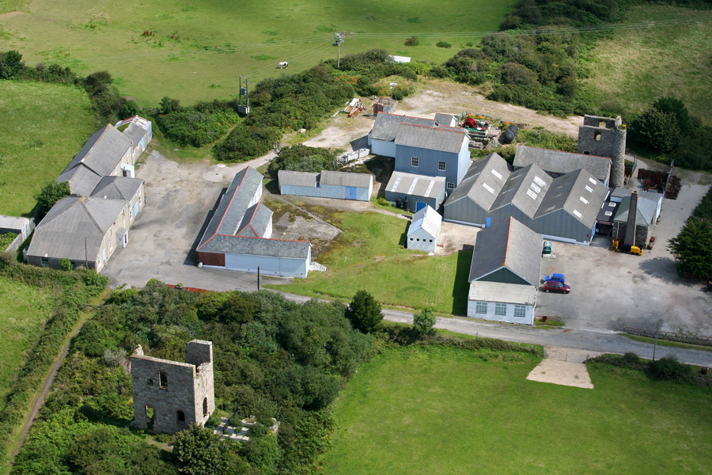
Introduction
King Edward Mine (KEM) is situated on the outskirts of Camborne, near the villages of Troon and Beacon, towards the western end of the Great Flat Lode valley. It is the oldest complete 19th/early 20th century mine site left in the world and a key element of the Cornish Mining World Heritage Site in recognition of the very important role that the mine played as Camborne School of Mines’ training mine for nearly 100 years.
King Edward Mine is owned by Cornwall Council and leased to King Edward Mine Ltd (KEM Ltd), a not-for-profit company and charity. KEM Ltd was set up in 1987 to preserve the mine and to open it as a museum, which they achieved in 2001. Following Camborne School of Mine’s relocation to Pool, Cornwall Council acquired the site in 2009 and has worked in partnership with KEM Ltd to realise a vision for KEM that will safeguard its long-term future and ensure that the site can be enjoyed by one and all.
Awards from the Heritage Lottery Fund and the Architectural Heritage Fund’s Buildings at Risk Challenge Fund, with match funding from Cornwall Council, will now see the conservation of the core buildings at King Edward Mine, the creation of a new exhibition space and a reinvigorated programme of community events and activities to help grow use of the site by the local community and visitors. The project will also see the refurbishment of the Assay Office as a new café and ‘community hub’.
The café operation should add value to the visitor and community offer at King Edward Mine, achieve good feedback from all users and should include consideration of local sourcing of employment and products, as well as good environmental credentials, such as for recycling.
KEM Ltd wishes to offer the café as a concession and is looking for a business to come forward to run the café and help raise the profile of King Edward Mine Museum as a ‘gateway’ to the Great Flat Lode historic landscape. Our aim is to attract more leisure visitors from across Cornwall and beyond, and also for King Edward Mine to be used as a social hub for the surrounding communities.
King Edward Mine – the Site
The map below shows in red the 8.5 hectare site of King Edward Mine and its proximity to the villages of Beacon and Troon. The site is located 2km to the south of Camborne.
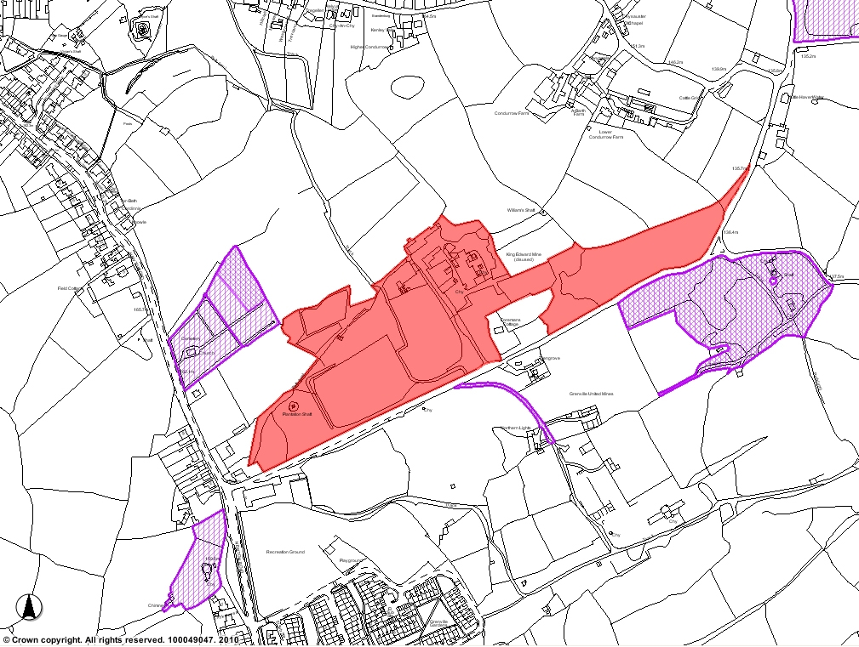
KEM
Troon
Beacon

The map below locates King Edward Mine on the Great Flat Lode mineral tramway multi-use trail; the trail runs to the back of the café yard and we intend to install signage from the trail to the café. Also on the map are other heritage attractions in the local area.
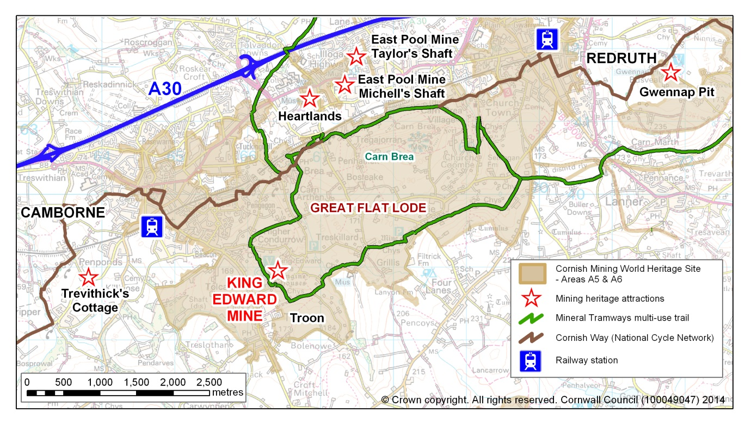
Current Visitor Profile
With relatively few marketing resources prior to this project, KEM has nevertheless shown a steady increase in visitor numbers, outperforming national visitor figures. This project provides a significant uplift in marketing budget and through the appointment of a Site Officer, additional staff time, to invest in raising the profile of the site with the aim of achieving increases in visitor numbers and spend.
The current visitor profile for the site can be described as follows:
Retired | 38%
Independent adult | 33%
Family with children | 32%
Special interest / recreational group | 12%
Young person (16-24yrs) | 5%
School / college group | 1%

In line with national trends for industrial heritage, the majority of visitors to KEM come from Cornwall (72%) and over half of these come from the local area, Camborne, Pool and Redruth (38%); overseas visitors were 4%. Most of this data comes from the free annual Open Day held at the end of April, which may have produced an over-estimate of the number of local visitors, but it is likely that at least 50% of the visitors to the museum are from the local area.
The marketing strategy anticipates that the site could see the following visitor increase:
Users | 2015/16 | 2016/17 | 2017/18 | 2018/19 | 2019/2020 | 2020/21 | 2021/22 | 2022/23 | 2023/24
 | 5,500 | 10,435 | 13,386 | 15,367 | 17,743 | 18,622 | 19,492 | 20,326 | 21,199
Increase | (current) | 90% | 28% | 15% | 15% | 5% | 5% | 4% | 4%

King Edward Mine Redevelopment: Workspaces & Museum
In 2013, Cornwall Council secured a grant of £1,126,248 from the ERDF Convergence Programme to conserve and bring back into economic use two redundant buildings at King Edward Mine. The Count House and Carpenters’ Shop are being converted to provide 9 high quality workspaces for the knowledge economy and creative industries sector businesses. The Carpenters’ Shop was completed in May 2015 and currently has 2 of the 3 units let; the Count House will not be completed until the middle of September 2015, but already has one tenant lined up and more publicity is now being carried out to attract further tenants for this building.
In December 2014, Cornwall Council secured an additional grant of £1,121,400 from the Heritage Lottery Fund to conserve all the core museum buildings and to invest in a programme of events and activities for the community and also employ two part-time staff to support the operation of the museum. In addition, with match funding of £200,000 from the Architectural Heritage Fund’s Buildings at Risk Challenge Fund, the Assay Office will be converted into a café to serve the museum visitors, the businesses occupying the workspaces and the local community.
It is anticipated that the capital works to be undertaken in the museum redevelopment project, including the creation of the new café, will be completed by June 2016.
Assay Office Café
The café will provide approximately 32 covers inside and some tables outside to the rear, facing the picturesque South Condurrow Stamps Engine House yard and the direction of the Great Flat Lode mineral tramway. The café will be housed within the conserved Assay Office building, which is divided into 4 rooms, and a modern extension at the rear where the kitchen will also be located.
The café will be fully accessible, including the toilet facilities. The front (North) elevation of the building will be conserved to match the original appearance. The central bay of the building is probably the oldest element (1865), with bays added to either side at the end of the 19th century. Within the Assay Office central bay, two hearths survive, although the chimneys serving them have been lost. This is the one area of the café that KEM Ltd will be installing some interpretation for the public so that people can understand the original function of the building.
The Great Flat Lode mineral tramway multi-use trail crosses the site a few hundred yards away from the rear extension of the café.

The extension is to form a serviced timber pod/box to house the kitchen and associated facilities. The materials and finishes to the new kitchen and extension are proposed as being natural and self-finished wherever possible to minimise ongoing maintenance and decoration.
The café will have underfloor heating throughout the building, with heating provided by a ground source heat pump system which is to be installed in the Events Field car parking area adjacent. The Events Field will also be resurfaced to maximise its potential use as a site for a variety of outdoor events and shows, as well as use as overflow car parking for the café and museum.
In terms of services, the café will have electricity, gas, water, foul and surface water drainage, telephone and data services. It is likely that Cornwall Council will be bringing Superfast Broadband to the King Edward Mine site, potentially also fibre optic; it will be the responsibility of the tenant to arrange a contract with a provider.
The images below are computer mock-ups of what the café will look like, provided by pdp Green Consulting, the project architects:
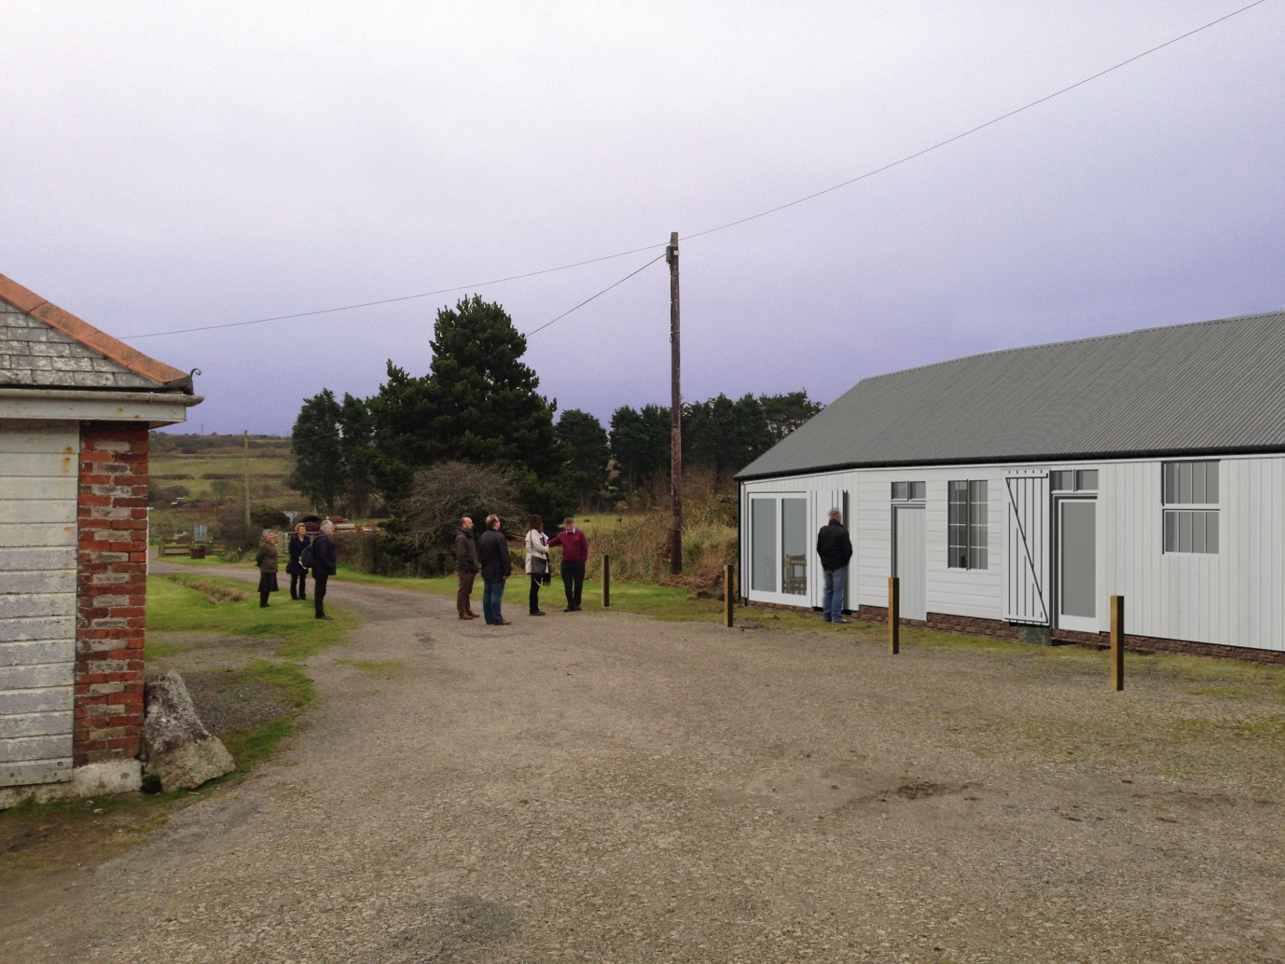
Front of café, see from work units
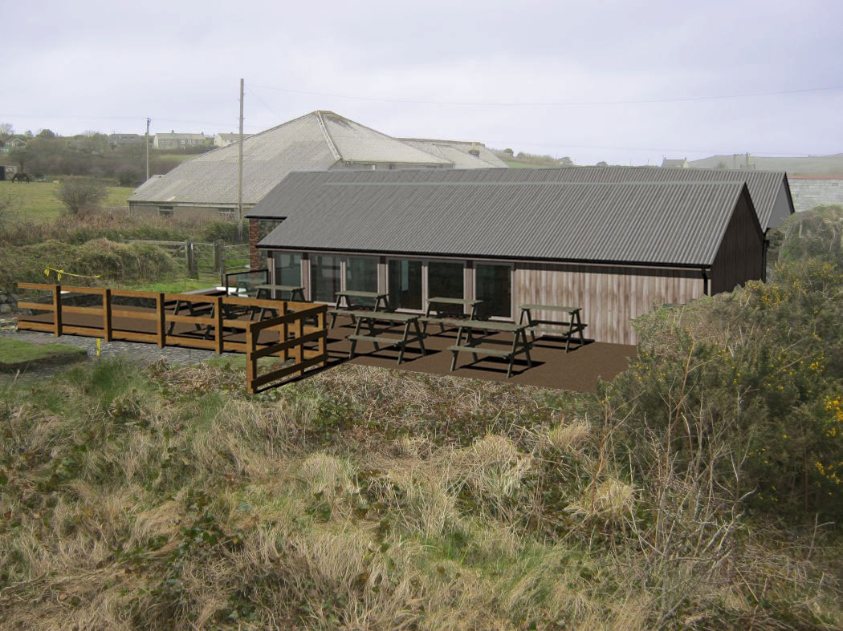
This rear view of the café and the extension that will house the kitchen and additional seating, it also shows an archaeology project in progress which has been expanded since this photograph was taken. This will become a feature of the ‘café yard’ and will have low level fencing and interpretation provided by KEM Ltd.
The café is 53.6 sqm, with the kitchen 15 sqm, suitable for three kitchen staff. There is a basic budget for equipping the kitchen with such things as a cooker, sink, etc. More detail on this is expected imminently once the Main Contractor (building company) has been chosen early in September. The tenant may be given the opportunity to help finalise the specification for the kitchen and selection of the tables, chairs and other furniture and fittings.
Aspiration
King Edward Mine currently achieves a high satisfaction rating by its visitors, with 87% rating their visit as ‘Excellent’ and a further 13% as ‘Good’. The main feedback from visitors during the year and from the consultation events we have held has been the need to preserve the heritage of the site and the quality of the visitor experience, to provide a café and to provide more for children and families to do.
Responding to this, the project aims to increase visitor numbers from 5,500 per annum to 10,000 per annum by 2018 through investment in publicity, free activities for children and families, and vitally, opening the café and promoting King Edward Mine as the gateway to Great Flat Lode for leisure visitors. The new café will greatly enhance the visitor experience and the ability of the site to attract new leisure audiences.
Consultation during the project development phase evidenced that King Edward Mine is much appreciated by the local community and that they are very enthusiastic about the opening of a café. The area has few community facilities and no cafes in the neighbouring villages, nor on this section of the Great Flat Lode mineral tramway. The community are also keen to see the café as a community resource, suggesting that it might also host social events. The configuration of the café lends itself in the winter months for use as a space for meetings and training events.
KEM is on the Great Flat Lode trail which itself is part of the Mineral Tramways, a 60km network of cycle trails and walks through Cornwall’s industrial landscape. Nearest cafes directly on the cycle route are at Portreath (6m away), Bissoe (8m away) and Stithians (4m away). All are reasonably busy and offer cycle hire. Feedback from cyclists is that KEM will be a good location to start and finish cycling from – free car parking, toilets and café and adjacent to the cycle route.
Café operation
Central to improving the overall offer at King Edward Mine will be the café and it is expected that a well-run, well promoted and competitively priced café will attract casual visitors to the site, support the use of KEM as a gateway to cycling and walking on the Great Flat Lode mineral tramways and host a range of social and community events for the surrounding villages.
As a minimum, we will require the tenant to provide a café facility during the period that KEM Museum is open to the public; this is generally from the end of April to the end of September (see KEM website for 2015 opening dates: www.kingedwardmine.co.uk ).
However, scope is included for use during the winter months with the underfloor heating. There is therefore potential for the tenant to continue to operate the café during the winter, particularly if they build up a good level of use by the local community and out of season visitors, such as those coming to Cornwall to continue to use the trails for walking and cycling. Other permitted uses during the winter months could also include such activities as hosting meetings, training events, etc., subject to any Planning constraints.
Agreement Terms
Interested parties are invited to offer a rental fee for the café agreement.
KEM Ltd will be awarding the 5 year café agreement on the basis of both the rental fee offered from the café tenant and a persuasive business plan demonstrating how the prospective tenant would develop the viability of the café and contribute towards raising the number of visitors to King Edward Mine.
KEM Ltd. will consider a phased rental basis for the first 3 years but will expect the tenant to demonstrate adequate investment in establishing the café (such as marketing and special events) in these first few years in their business plan.
The rent will be reviewed at the end of the 3rd year and at the end of the 5th year prior to renewal, should both landlord and tenant wish to renew the agreement.

KING EDWARD MINE CAFÉ AGREEMENT
APPLICATION
Return deadline for applications: Friday 13 November, by 3pm
It is the intention of King Edward Mine Ltd, that this procurement will follow a clear, structured and transparent process at all times and that all Applicants are treated equally. All applications received by the Return Date will be checked for compliance with the submission requirements. Applicants are asked to respond to all of the questions in the application and it is the Applicant’s responsibility to ensure that the response to each question is entire and can be assessed as such.
Failure to comply with the above requirements or any other requirement detailed in this form may lead to an application being considered to be non-compliant and King Edward Mine Ltd reserves the right not to carry out any further evaluation and may eliminate the Applicant from the procurement.
The issue of this application form in no way commits King Edward Mine Ltd to award any contract pursuant to the procurement process, nor does it constitute an offer to enter into a contractual relationship.
Sub-contracting and Consortia
Where an Applicant intends to participate in sub-contracting or a consortia for the purposes of this procurement, the Applicant shall identify whether and which subcontracting or consortium arrangements apply in the case of their application and precisely which entity they propose to be the Lead Organisation. The Lead Organisation will be required to enter into a contract with King Edward Mine Ltd and take all legal responsibility for the obligations under the contract.
The term ‘Relevant Organisation’ in this application form refers to all consortium members and significant sub-contractors (where applicable). The Lead Organisation is either the lead member of the consortium or the lead contractor.
Each Relevant Organisation is required to confirm that they will comply with the Lead Organisation’s policies, procedures and responses given within this application.

APPLICATION INFORMATION TABLE

Applicants must complete and return the various requirements set out in this document in order to submit a compliant application.

Applicants must supply – 3 x paper copies and 1 x master electronic version on CD. The application must be sealed in a plain envelope using the Return Label. The envelope or parcel shall not bear any name or any other mark (e.g. postal or franking devices on envelope) by which the applicant can be identified.

Applications to be returned to: | Kevin Baker  King Edward Mine Ltd  King Edward Mine Museum  Newton Moor  Troon  Camborne  Cornwall  TR14 9HW
Application clarification contact: | Tamsin Daniel  tamsin.daniel@cornwall.gov.uk  01872 224753
Site Visit and opportunity for Q&A | Monday 19 October 2015, 2pm  (Applicants must confirm their attendance/non-attendance by Wednesday 14 October)
Application Return Deadline | Friday 13 November 2015, by 3pm
Application review & interviews | 16/11/2015 – 4/12/2015
Decision date | 11/12/2015
Contract award | 30/01/2015
Café capital works completed | 30 June 2016
Café ready for occupation | 1 July 2016

- Applicant Details
NOTE TO APPLICANT (for consortium or where there will be significant subcontractors): only the Lead Organisation is required to complete this section.
1.1 | Full Registered Company and Trading Name and address of the applying Lead Organisation / Applicant  (Note: all documentation, e.g. Health & Safety and insurances, subsequently supplied must relate to this Lead Organisation / Applicant)
1.2 | Registered Office (if different from above)
1.3 | Company and/or Charity Registration Number
1.4 | If a Registered Company, please state if you are Limited by Shares, Limited by Guarantee or an Unlimited Company
1.5 | Date of Formation or Registration
1.6 | VAT Registration Number
1.7 | Is your organisation
(a) | A sole trader? | Yes / No
(b) | A partnership? | Yes / No
(c) | A private limited company? | Yes / No
(d) | A public limited company? | Yes / No
(e) | A local authority Direct Services Organisation? | Yes / No
(f) | A charity trading as a company?  Or, if not state number of trustess | Yes / No  …………..
(g) | If other, please specify below | Yes / No
1.8 | If your organisation is a subsidiary of another company or a member of a group of companies, please give the name, registered office address and registration number of the ultimate holding / parent company and all subsidiaries, and provide details of the group structure and relationships
1.9 | Please indicate which box below applies:
 | The applicant is tendering with the intention of providing the Services required directly without the use of third parties |  | Yes / No
OR | The applicant is tendering in the role of Lead Organisation and intends to use third parties to provide some or all of the Services required |  | Yes / No
OR | The Applicant is tendering in the role of Lead Organisation and intends to enter into a partnership or consortium for the provision of the Services required |  | Yes / No

- Financial Matters
NOTE TO APPLICANT: this section must be completed and the responses given will be scored and will be awarded a pass or fail mark overall dependant on the score awarded to the Applicant.
2.1 | Is your company currently trading and if so,  for how many years have you been trading  and what has been your average annual  turnover? | Yes / NO  …………….  £………….. pa
2.2 | Does your organisation / company have any outstanding claims or litigation against it?  If yes, please provide the extent of the percentage of those claims as against the profits of the last financial year (or part year if full year not applicable) | Yes / NO  % -------------
2.3 | Only to be completed by EXISTING TRADING ORGANISATIONS (i.e. Trading for 2 years or longer)  The Applicant shall provide the following financial information for the last two years of trading:  If the accounts you are submitting are for a year ended more than 10 months ago, please enclose a copy statement signed by the Director responsible for financial affairs, setting out the organisation’s turnover and net profit since the latest accounts, and any known significant changes in the balance sheet of the organisation.  Please note: if the organisation is a subsidiary, the financial information is required for both the subsidiary and the ultimate parent organisation. Where a consortium or association is proposed, the financial information is required for each relevant organisation.
 | - Two consecutive years of full audited or unaudited accounts as appropriate for the size of your organisation (to include Director’s and Auditor’s / Accountant’s Reports and Notes to the Accounts) | Attached  Yes / No
 | - If applicable, provide a separate statement of the organisation’s turnover within the accounts that relates directly to the supply of these services, supplies or works for the past two years | Attached  Yes / No
2.4 | Only to be completed by NEWLY FORMED ORGANISATIONS (i.e. trading for less than 2 years)  The Applicant shall provide the following financial information: if at section (d) below the accounts your are submitting are for a year ended more than 10 months ago, please enclose a copy statement signed by the Director responsible for financial affairs, setting out the organisation’s turnover and net profit since the latest accounts, and any known significant changes in the balance sheet of the organisation.  Please note: if the organisation is a subsidiary, the financial information is required for both the subsidiary and the ultimate parent organisation. Where a consortium or association is proposed, the financial information is required for each relevant organisation.
 | - Provide a five year business plan, including a five year cash flow forecast highlighting future turnover | Attached  Yes / No
 | - Provide evidence of external funding arrangements included in the business plan, such as signed bank letter outlining the terms of any loan, overdraft and/or credit facility position | Attached  Yes / No
 | - If applicable provide a separate statement of the organisation’s turnover within the business plan that relates directly to the supply of this service | Attached  Yes / No
 | - Audited or unaudited full accounts as appropriate for the size of your organisation (to include Director’s and Auditor’s / Accountant’s Reports and Notes to the Accounts | Attached  Yes / No

- Health & Safety

3.1 | Please provide evidence that your organisation has access to competent health and safety advice and certification | Attached  Yes / No
3.2 | Please provide a statement below on how you will ensure that all staff have the appropriate health and safety training and certification.

- Insurances
NOTE TO APPLICANT: only the Lead Organisation is required to answer this section.
4.1 | If your organisation’s tender is successful, adequate insurance cover will be required. The minimum levels are indicated below. Please complete the table below with the relevant information and confirm that the details entered are correct. If you do not currently have the required level of insurance, please indicate in the box provided below that you will have the cover required should you be awarded the Contract.  If the policy held is in the aggregate, the remaining cover must exceed the minimum requirements shown.
(a) | Employers Liability (minimum £2m)
 | Insurer
 | Policy Number
 | Amount of cover £
 | Deductibles £
 | Renewal Date
(b) | Public Liability (minimum £2m)
 | Insurer
 | Policy Number
 | Amount of cover £
 | Deductibles £
 | Renewal Date
We confirm that the details of insurance provided above are correct: |  | Yes / No
We confirm that we will have the insurance required above if we are awarded the Contract: |  | Yes / No

- Legal Matters and Disputes
NOTE TO APPLICANT: this section must be completed and will be evaluated as a whole on a Pass or Fail basis.
KEM Ltd will evaluate the Applicant’s response below and should the applicant answer ‘yes’ to any of the questions (a) to (h) KEM Ltd will decide, taking into account the applicants response to section 5.2, whether the detail in the answer constitutes an acceptable risk.
If the Applicants response to section 5.2 demonstrates that the steps taken by the Applicant mitigates this risk to KEM Ltd's satisfaction the applicant will pass.
If an Applicant (including the Lead Organisation and all Relevant Organisations) answers "No" to all of sections (a) to (h) the Applicant will pass.
The Lead Organisation and the Relevant Organisations must answer all questions in this section.
5.1 | In respect of similar services as that being applied for, has your organisation, or any of its proposed partners, in the last three years:
(a) | Been prosecuted or had any Court judgements awarded against it in the last three years? If yes, please provide details including details of any unresolved disputes, outstanding claims or litigation? | Yes / No
(b) | Had penalties, default notices or liquidated damages awarded against it? | Yes / No
(c) | Had a contract terminated or not had a contract renewed due to a failure to perform? | Yes / No
(d) | Been prosecuted for breaking any UK or EU, or equivalent national legislation relating to the environment? | Yes / No
(e) | Had any notice served upon it by an environmental regulator or authority? | Yes / No
(f) | Had any finding of unlawful discrimination been made against your organisation by any court of law or industrial or employment tribunal? | Yes / No
(g) | Has your organisation been the subject of a formal investigation on grounds of alleged unlawful discrimination? | Yes / No
(h) | Been convicted for failure to prevent corruption or bribery under Section 7 of the Bribery Act 2010? | Yes / No
5.2 | If the answer to any of the questions (a) to (h) above is ‘yes’, please provide full details and the steps you took as a consequence of that finding / investigation below.

- Ability and References
NOTE TO APPLICANT: This section must be completed and will be scored. References for services of a similar nature to this Application will be considered preferable.
KEM Ltd may elect to contact any of the given organisations for a reference at any stage of the procurement. Your permission to do so will be assumed unless you explicitly state any objections.
6.1 | Please provide reference details from three organisations and/or individuals who have knowledge your ability to provide a service similar to what is required in this Application
(1) | Referee name
 | Address
 | Contact name
 | Telephone number
 | Email address
 | Description of services undertaken
 | Start and finish date of services undertaken
 | Annual value of contract if applicable (£)
(2) | Referee name
 | Address
 | Contact name
 | Telephone number
 | Email address
 | Description of services undertaken
 | Start and finish date of services undertaken
 | Annual value of contract if applicable (£)
(3) | Referee name
 | Address
 | Contact name
 | Telephone number
 | Email address
 | Description of services undertaken
 | Start and finish date of services undertaken
 | Annual value of contract if applicable (£)

- Business Plan
Please provide, as a separate document in hard copy and on CD, your proposed business plan for the cafe. The business plan should include information on the following:
- The rental fee that you propose for Years 1 to 5

- Your vision for the café, including:
  - Why you are interested in this opportunity
  - How you have taken into consideration the seasonality of KEM as a visitor attraction – you may wish to think about whether you would want to use the building for other purposes during the winter or if you just want to open seasonally
  - Whether you would wish to make use of any of the other facilities at KEM, such as the Events Field

- How you will manage the café, including:
  - staffing arrangements
  - opening times

- Your marketing plan, including:
  - who you think your target audiences will be and how you will reach them
  - how you see your ‘brand’ developing
  - how you will help KEM to increase visitor numbers to the site and become used as the ‘gateway’ to exploring the Great Flat Lode historic landscape

- A flavour of your menu, including:
  - pricing
  - where you may source ingredients from

- Anticipated income and expenditure for the 5 years

- What you think the main risks will be for establishing the café and how you will mitigate against these

- How you will measure your success – what standards will you be setting yourself?

- Any other information to support your tender

- Declarations
WHEN YOU HAVE COMPLETED THIS APPLICATION, PLEASE READ AND SIGN THE SECTION BELOW. This section must be completed by the Applicant (including Lead Organisation and any Relevant Organisations).
Where the Tenderer is a company, the Tender must be signed by a duly authorised representative of that company. Where the Tenderer is a consortium, the Tender must be signed by the lead authorised representative of the consortium, which organisation shall be responsible for the performance of the Contract. In the case of a partnership, all the partners should sign or, alternatively, one only may sign, in which case he/she must have and should state that he has authority to sign on behalf of the other partner(s). The names of all the partners should be given in full together with the trading name of the partnership. In the case of the sole trader, he/she should sign and give his/her name in full together with the name under which he/she is trading.
We, the undersigned, having examined the tenancy agreement and specification for the café operation do hereby Tender and undertake to provide the service in accordance with this brief and our business plan. We hereby certify that:
We fully accept the terms and conditions as contained in the lease and associated documentation within this brief.
This is a bona fide Application intended to be competitive.
The amounts set out in our Application have not been calculated by agreement or arrangement with any person other than KEM Ltd and we have not fixed or adjusted the amount of the Application by, or under, or in accordance with, any agreement or arrangement with any other person.
We have not done and we undertake that we will not do at any time before the hour and date specified for the return of this Application any of the following acts:
Communicated to any person, other than that person calling for these Applications, or adjusted in accordance with any agreement or arrangement with any other person, until after the closing date for the submission of Applications, and in any event not without the consent of KEM Ltd, except where the disclosure, in confidence, of the approximate amount of the Application was necessary to obtain insurance premium quotations required for the preparation of the Application.
We have not and will not enter into any agreement or arrangement with any other person so that he shall refrain from making an Application.
We have not, and will not, offer or pay, or give, or agree to pay, or give any sum of money or valuable consideration, directly or indirectly, to any person for doing, or having done, or causing, or having caused to be done in relation to any other Application, or proposed Application, for the said work any act, or thing of the sort described above.
The insertion by us of any conditions qualifying this Application, or any unauthorised alteration to any of the Application documents shall not affect the Contract and may cause the Application to be rejected.
This Application shall remain open to be accepted or not by KEM Ltd and shall not be withdrawn for a period of 90 days from the Return Date for the receipt of Tenders.
We accept that before executing the lease substantially in the form set out in this document, the formal acceptance of this Application in writing by KEM Ltd or such parts as may be specified, together with the documents attached hereto shall comprise a binding contract between us and KEM Ltd.
We have read and understood the lease and state that, if appointed, we fully accept and agree to be bound by the terms and conditions of KEM Ltd’s for King Edward Mine Museum Redevelopment – Appointment of Café Lease.
We agree with KEM Ltd in legally binding terms to comply with the provisions of confidentiality set out in this document.
To the best of my /our knowledge and belief, no person or persons who is a Cornwall Councillor, officer, servant or agent of KEM Ltd or Cornwall Council has any direct or indirect interest in or connection with the Applicant.
We have not, and will not, canvass or solicit any Member, officer or employee or agent of KEM Ltd or Cornwall Council in connection with the preparation, submission, evaluation and award of this lease or award or proposed award of the lease and that to the best of my knowledge and belief, no person employed by us or acting on our behalf has done or will do such an act.
We further undertake and it shall be a condition of the lease, that:
We agree not at any time to divulge or allow to be divulged to any person any information, confidential or otherwise, relating to information passed to me regarding this procurement.
We understand you are not bound to accept the highest Application or any of the Applications you may receive and you will not pay any expenses incurred by us in connection with the preparation and submission of this document.
We acknowledge that in the event the procurement process is terminated or amended by KEM Ltd then we will not be eligible for any bid costs, expenditure work or effort incurred.
We agree that KEM Ltd may disclose the leasee's information/documentation (submitted to KEM Ltd during this procurement) to Cornwall Council and project funders such as the Heritage Lottery Fund and Architectural Heritage Fund, as well as any future auditor.
In this declaration the word "person" includes any persons and any body or association, corporate or unincorporated; and "any agreement or arrangement" includes any such transaction, formal or informal, and whether legally binding or not.
If this offer is accepted, we will execute such documents in the form of the lease within 14 days of being called on to do so.
We warrant that we have all requisite authority to sign this Application.
Signature

Name

Status

Duly authorised to sign Tenders and give such certificates for and on behalf of;
Name of company, partners or consortium
Address of company, partners or consortium

RETURN LABEL FOR ENVELOPES

TENDER SUBMISSION

Return Date: 13.11.2015

Return Time: 15:00 (3.00 pm)

For KEM Ltd Use only

Received by:

Date/Time:

Kevin Baker
King Edward Mine Ltd
King Edward Mine Museum
Newton Moor
Troon
Camborne
Cornwall
TR14 9HW

King Edward Mine Museum Redevelopment: CAFE
PROPOSED NEW LEASE
CAFE PREMISES AT KING EDWARD MINE,
TROON, CAMBORNE, CORNWALL, TR14 9DP
(Subject to Contract and Member Approval)

LANDLORD: | King Edward Mine Ltd
LANDLORD’S ADDRESS:  CONTACT:  TEL:  EMAIL: | King Edward Mine Museum  Troon  Camborne  Cornwall  TR14 9DP  Mr K Baker  01209  kemproject@outlook.com
TENANT:
TENANT CONTACT:
TEL:
EMAIL:
LANDLORD’S SOLICITOR:  CONTACT:  TEL:  EMAIL: | To be confirmed
TENANT’S SOLICITOR:  CONTACT:  TEL:  EMAIL: | To be confirmed
DEMISED PREMISES: | Café Premises at King Edward Mine, Troon, Camborne  (Shown edged red on the attached plan)  Staff and customer parking will be available within the overflow car park. A Lease plan will identify this area.
PERMITTED USE: | A3 (Café/Restaurant) under the Town and Country (Use Classes) Order 1987, as amended. The Tenant to provide catering at a standard approved by the Landlord.
TRADING HOURS: | At a minimum, the Tenant to open the Premises between the hours of 10:30 and 16:30 on all days that the site is open to the public.
TERM: | 5 years, commencement date to be agreed, aiming for early June 2016
RENT: | The annual rent to be proposed below by the applicant under the tender application. All rents to be paid quarterly in advance by standing order.  Year 1 –  Year 2 –  Year 3 -
RENT REVIEW: | The rent to be reviewed on the third anniversary based on the higher of the passing rent or 7.5% of the tenant’s turnover in the third year.
SERVICE CHARGE | A service charge will be payable by the Tenant and will be charged quarterly in arrears. The service charge will be in respect to all services benefitted from which are in common with other occupants within the King Edward Mine site.  The services will include, but are not limited to, electricity and heating, gas, telecommunications, building insurance, maintenance of all common areas, annual charges associated with the maintenance of the fire alarm system, security alarm and CCTV, the recovery of rent and costs associated with the management of the Building and any other service consumed in relation to the Premises.
OUTGOINGS: | The Tenant will be responsible for the payment of Uniform Business Rates and any other Statutory Charges which might arise during the term of the tenancy.  The Tenant to obtain rubbish and, if required, recycling receptacles and arrange the collection of all items stored within, at their own cost.
INSURANCE: | The Tenant will be responsible for their own contents, employer’s and public liability insurance.
REPAIR AND MAINTENANCE: | The Tenant is to be responsible for the internal repair, decoration and maintenance within the Premises and the external seating area/s.  The Tenant to obtain landlord approval and, where necessary, Listed Building Consent prior to carrying out any works.  The Tenant to maintain, repair and service all items provided by the Landlord at Lease commencement, as itemised within the attached Inventory, throughout the term of the Lease. Where any items are beyond repair, the Tenant to replace with an appropriate replacement, to be agreed with the Landlord.
ASSIGNMENT & SUBLETTING: | The tenant is not permitted to assign or sublet the Lease.
SECURITY OF TENURE: | The security of tenure provisions of the Landlord and Tenant Act 1954 will be excluded.
PROFESSIONAL FEES: | Each party to bear their own respective costs incurred in the transaction.
DEPOSIT: | A deposit of £500 to be paid by the Tenant upon completion of the Lease. This will be returned in full upon expiry of the Lease on the basis that all rent and service charge payments are up to date and that the Premises are returned to the Landlord in a good and tenantable repair
CONDITIONS: | i. Subject to all Landlord’s Contractor’s services being in place in readiness for occupation.  ii. Subject to references.  iii. Subject to contract

SPECIFICATION
The café will have the following installed:
COMMERCIAL CATERING FITTINGS, FURNISHINGS & EQUIPMENT
- Contractor design, supply and complete installation of kitchen as specification N12 and drawing 4310
  - Cupboards and storage units
  - Worktops
  - Purpose-made servery counter
  - Sinks with single drainers, taps, traps & wastes
  - Ovens
  - Hobs
  - Fire blanket system, heavy duty on mounting bracket
LIGHTING
- A new lighting installation will be provided to serve the building and emergency lighting. The lighting shall be fluorescent or other low energy install.
- Emergency lights shall be provided throughout and will have integral maintained battery packs to provide 3 hour back-up
- PIR switched lighting shall be fitted to the WC and lobby. Other lighting shall be dimmable where shown.
- External light fittings shall be weatherproof low energy and controlled via a time clock and manual override.
- Light switches to be MK Logic Plus units in white.
SERVICES
- Water: mains supply to building for kitchen and WC (sub-metered)
- Gas: mains supply to kitchen (sub-metered)
- Electricity: 3-Phase connection to distribution board for kitchen equipment (sub-metered)
- Telecommunications: BT ducted phone service with BT primary incoming board (fibre capable) to data communications cabinet, to house modem/router/switch and receive ether net cabling. Data outlet points (for phone/Ethernet connection) and Wireless Access Points (WAPs) throughout building as per drawings and linked back to data cabinet (Tenant to arrange own telecommunications contract)
FIRE ALARM SYSTEM
- Installed in accordance with BS 5839 and NICEIC standards. (Tenant to arrange own contract)

WC
- Fully accessible WC fitted with a proprietary call alarm kit comprising a wall mounted sounder and indicator unit located in the lobby. Within the WC a red ceiling mounted pull cord and wall mounted reset button will be located. Alarm to be C-TEC NC951 unit complete with control unit, reset point and sounder, ceiling pull cord, overdoor light and sounder and warning sticker.
- Baby change facility
OTHER
- Decentralised extractor fans installed in kitchen and WC
- Mirror in WC, safety glass to BS 6206

