**Tendring District Council**

**Specification**

**REPLACEMENT OF THEATRE SEATS**

**(DRESS CIRCLE)**

**Clacton-on-Sea, Essex**

**7th April 2022**

**Version 0.1**



**Our Vision**

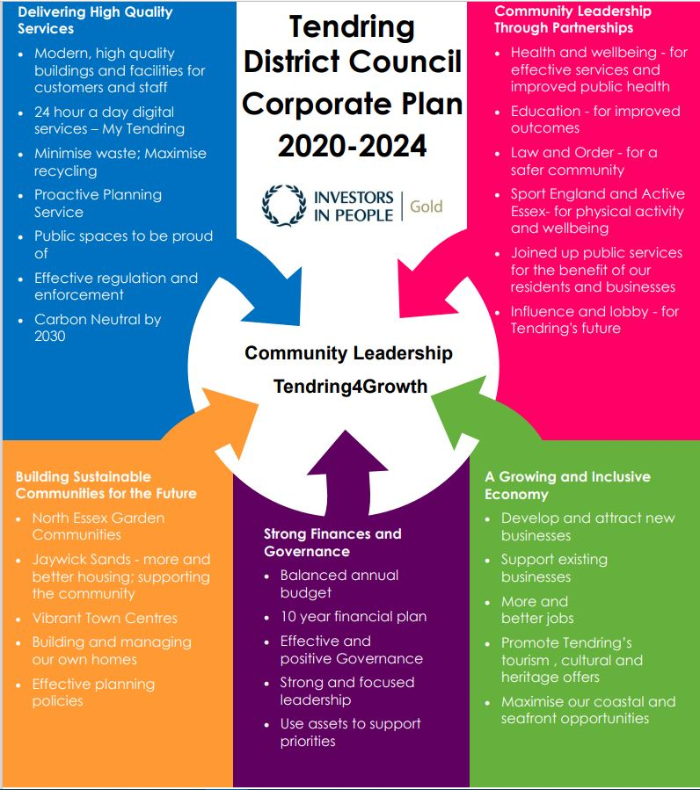***To put community leadership at the heart of everything we do through delivery of high quality, affordable services and working positively with others.***

**Our Values**

♦ Councillors and staff uphold **personal integrity, honesty,** and **respect** for others

♦ **Innovative, flexible, professional** staff **committed** to delivering excellence

♦ Recognising the diversity and equality of individuals

♦ Working **Collaboratively**

1. **Specification**

|  |
| --- |
| **Purpose**  Tendring District Council (TDC) oversees the running of the Princes Theatre (PT) and is looking to replace the Dress Circle seating sited within the main auditorium. These seats are to be in a fixed position and as such do not require moving or collapsing. The applicant will need to consider timescales carefully and work with the General Theatre Manager – Technical as this is a working venue that already has a full programme of events and activities.  Seats are to be replaced at the start of the contract and any additional parts to be called off of the contract for up to three years.  **Background Information:**  **Princes Theatre**  The Princes Theatre is a large Multi-Purpose venue that hosts a wide variety of shows and events both professional and amateur.  One of the main methods of ensuring the sustainability of the theatre is to ensure customer satisfaction and comfort.  **Quotation Specifications**  All work must be carried out to the highest standard. And each seat must have numbers attached from 1 – 22 as per the layout below.  **All costs must be identified in the quotation**  The colour and design of the seating should be such as to look similar to the remaining auditorium seating.  Any works that need to be carried out either by third party companies or the management of the theatre should also be detailed in the quotation i.e. the disposal of the old seating.  **Requirements**  Prepare a submission addressing the following issues:   1. **Quotations**   Detail the cost of providing the labour and material necessary to meet the specifications detailed below;  *The quotation is to be exclusive of V.A.T.*  *You are encouraged to provide costings for any additional design features you could provide, which may add value to the seating system. However, this should be shown as* ***additional costs,*** *so each quote can be assessed on its own merit.*   1. **Costs** - Provide a breakdown of costs detailing each aspect of the service you are quoting for as detailed in the specifications below. 2. **Portfolio of previous works** – from similar projects requiring theatre style seating installations. 3. **Lead Times** – Works are to be completed in no more than 5 months from contract award commencement dates will be arranged by mutual agreement. A clearly stated breakdown detailing the time it will take from the commencement date to delivering the finished product, this is to include details of works requiring access to the building outside 9am-5pm Monday - Friday. *Please note there is no problem with working outside normal office hours if it ensures an expedient installation delivery date.* 4. **Liquidated Damages** – the provision of payment where there is a failure to complete the contract within the quoted lead times to cover any losses to the theatre incurred from such failure. 5. **Supplementary Information** – companies should supply:    * Any information you think that the Council should require to aid its decision-making process    * Any and all details of insurance to cover all aspects of the work to be carried out within the Town Hall. 6. **Final Selection** - The selection will be made based on 70% price of quote that meets the Quotation Specification and 30% comprising of compliance with the quotation specifications, lead times, optional extras, best aesthetic fit etc. Also, social value is now required and forms an integral part of the quotation (see below). The lowest tendered price will be awarded the full number of points available - if two or more bidders quote the same overall price each will be awarded the full number of points available. Other Bidders will be awarded points on a pro-rata basis of their bid compared to the lowest. |

1. **Timetable**

The proposed timetable for this employment for guidance:

|  |  |
| --- | --- |
| *Publish RFQ* | 07.04.2022 |
| *Clarifications* | 20.04.2022 |
| *RFQ Submission deadline* | 29.04.2022 |
| *Evaluations* | 04.05.2022 |
| *Award notification* | 06.05.2022 |
| *Contract start* | TBC between the supplier and Theatre |
| *Contract end date* | TBC between the supplier and Theatre |

1. **Payment**

Payment to contractors will be made on receipt of invoice AFTER the completion of each works and in accordance with the council’s procurement and payment policies.

1. **Evaluation Criteria**

The RFQ will be evaluated on passing the mandatory requirements, and a submission weighting of 30% Quality (Section A) and 70% Price (Section B).

**SECTION A – QUALITY – 30% Weighting**

**You must pass the Mandatory questions below to be considered for this RFQ.**

|  |  |  |
| --- | --- | --- |
| **Regulatory Requirements** | **Evaluation Criteria** | **Page Limit** |
| It is essential that all installations fully comply with *The Furniture and Furnishings (Fire Safety) Regulations 1988 (amended 1989, 1993)* as well as, but not exclusively;  BS EN 1021-1:2006 (Cigarette)  BS EN 1021-2:2006 (Match)  BS 5852:2004 Section 4 Ignition Source 5  BS 7176:2007 Medium Heat  And have a Safety, Strength and Durability that meets BS EN 12727:2016  RAMS will be required prior to work commencement and may form part of evaluation if requested. | Please demonstrate and evidence that all installations will fully comply with the regulatory requirements | 2x Pages of A4. |
| **Dress Circle Seating**  It is necessary that all parties entering a submission will be required to come and measure the area to ensure that whatever seating is proposed there will be sufficient space to ensure all walkways, steps and spaces are within emergency evacuation policies, procedures and law including but not exclusively the Fire Safety Act 2021. A guarantee is also required that the seating your are proposing will not in any way harm the existing structure and will not negatively affect its safety. | **Client Contacts – Site Visit**  To arrange site visit, please contact;  Kai Aberdeen  General Theatre Manager – Technical  [kaberdeen@tendringdc.gov.uk](mailto:kaberdeen@tendringdc.gov.uk)  01255 686652 |  |

**Quality Technical Questions**

**Scores will be awarded on a 0-5 basis and then weighted in accordance with the table below.**

**If on any question you score below 3, this will classify as a failed score and a failed bid overall.**

**Scoring Methodology Table A:**

|  |  |
| --- | --- |
|  | **Unacceptable Response** The response is not relevant to the question, or the question has simply not been answered. Where the question has been answered, the response raises major concerns about understanding or approach which are potentially highly detrimental to satisfactory service delivery or Contract performance. The submission failed to cover any of all areas that should have been addressed within the response |
| **1** | **Poor Response** The response suggests significant shortcomings of understanding or approach which is likely to impact on service delivery or Contract performance. The submission failed to cover a number of all areas that should have been addressed within the response |
| **2** | **Fair Response** The response suggests minor shortcomings of understanding or approach which may impact to a limited extent on service delivery or Contract performance. The submission partially covered all areas that should have been addressed within the response |
| **3** | **Satisfactory Response** The response raises no concerns about understanding or approach to service delivery or Contract performance.  The submission covered all areas that should have been addressed within the response |
| **4** | **Good Response** The response raises no concerns about understanding or approach to service delivery or Contract performance. The response also demonstrates how relevant added value will be provided.  The submission covered all areas that should have been addressed within the response to a high standard |
| **5** | **Excellent Response**  The response raises no concerns about understanding or approach to service delivery or Contract performance. The response demonstrates how relevant added value will be provided including examples of the application of good practice, demonstration of how the study could be consider other perspectives not considered by the client or explores innovative ways to address climate change and net zero targets  The submission covered all areas that should have been addressed within the response to a high standard and demonstrated a commitment to go above and beyond requirements |

**The following parameters are shown as a guide to the scoring:**

The total score for each Technical Question statement scored will not exceed 5 and will carry equal weight. There are mandatory minimum assessments set out below; failure to reach these scores in anyone may result in a failure mark and the consultant will be excluded before price evaluation takes place.

|  |  |
| --- | --- |
| Questions 1-3 | Mandatory Minimum |
| Q1 – Technical Question 1 | Score 3 – Satisfactory Response |
| Q2 – Technical Question 2 | Score 3 – Satisfactory Response |
| Q3 – Technical Question 3 | Score 3 – Satisfactory Response |

|  |  |  |  |
| --- | --- | --- | --- |
| **Technical Evaluation**  **30%** | **Question** | **Evaluation Criteria** | **Weighting and Page Limit** |
| **1.** | Please give full details of lead times from award to delivery/installation. | A clear breakdown of time scales from the beginning of the project to completion. | 10%  Up to 1x A4 page  Scoring methodology: Table A (please see pg 3) |
| **2.** | Please provide a small portfolio of work you have completed of a similar specification. | Please include pictures references and a brief description of the work undertaken. | 10%  Up to 2x A4 pages  Scoring methodology: Table A (please see pg 3) |
| **3.** | What is the average product lifetime and what is the span of the warranty? | Please detail approximate life expectancy and what are the terms of the manufacturers / installers warranty. | 10%  Up to 1x A4 page  Scoring methodology: Table A (please see pg 3) |

**SECTION B – PRICING – 70% Weighting**

A pricing matrix spreadsheet has been included as part of the RFQ documentation issued (Appendix E).

This pricing matrix spreadsheet is separated into two elements:

Removal, Supply and Fit - 80% Weighting and Additional Prices - 20% Weighting,

which creates the overall 100% price.

The Additional Prices are to be called off of the contract for three years, from the contract start date – three years. The contract start date is subject to discussion and confirmation with the awarded bidder. The prices that are input in the Additional Prices are fixed for the term of the contract.

Please complete the spreadsheet as per the instructions stated within the document and return the completed spreadsheet as part of your RFQ submission.

All prices should be exempt of VAT and include any additional costs.

For more information, please refer to the Tendring RFQ – Appendix A.

**Images for reference:**

Current Seating Current Fixing To Base

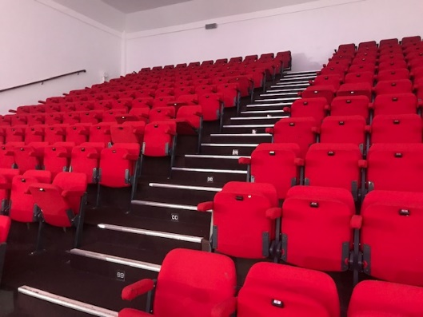

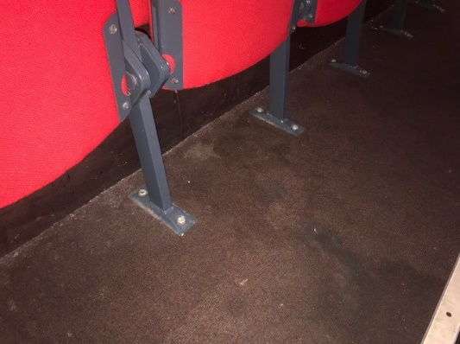

**Fixed Seating**

*Please find below details of what seating is required, where it is required and amounts.*

*Please note; it is required that all seats are numbered as per the layout below.*

**DRESS CIRCLE**

|  |  |  |  |  |  |  |  |  |  |  |  |  |  |  |  |  |  |  |  |  |  |  |  |  |  |  |  |  |  |  |  |  |  |  |  |  |  |  |  |  |  |  |  |  |  |  |  |  |  |  |  |  |  |  |  |  |  |  |  |  |  |  |  |  |  |  |  |  |  |  |  |  |  |  |  |  |  |  |  |  |  |  |  |  |  |  |  |  |  |  |  |  |  |  |  |  |  |  |  |  |  |  |  |  |  |  |  |  |  |  |  |  |  |  |  |  |  |  |  |  |  |  |  |  |  |  |  |  |  |  |  |  |  |  |  |  |  |  |  |  |  |  |  |  |  |  |  |  |  |  |  |  |  |  |  |  |  |  |  |  |  |  |  |  |  |  |  |  |  |  |  |  |  |  |  |  |  |  |  |  |  |  |  |  |  |  |  |  |  |  |  |  |  |  |  |  |  |  |  |  |  |  |  |  |  |  |  |  |  |  |  |  |  |  |  |  |  |  |  |  |  |  |  |  |  |  |  |  |  |  |  |  |  |  |  |  |  |  |  |  |  |  |  |  |  |  |  |  |  |  |  |  |  |  |  |  |  |  |  |  |  |  |  |  |  |  |  |  |  |  |  |  |  |  |  |  |  |
| --- | --- | --- | --- | --- | --- | --- | --- | --- | --- | --- | --- | --- | --- | --- | --- | --- | --- | --- | --- | --- | --- | --- | --- | --- | --- | --- | --- | --- | --- | --- | --- | --- | --- | --- | --- | --- | --- | --- | --- | --- | --- | --- | --- | --- | --- | --- | --- | --- | --- | --- | --- | --- | --- | --- | --- | --- | --- | --- | --- | --- | --- | --- | --- | --- | --- | --- | --- | --- | --- | --- | --- | --- | --- | --- | --- | --- | --- | --- | --- | --- | --- | --- | --- | --- | --- | --- | --- | --- | --- | --- | --- | --- | --- | --- | --- | --- | --- | --- | --- | --- | --- | --- | --- | --- | --- | --- | --- | --- | --- | --- | --- | --- | --- | --- | --- | --- | --- | --- | --- | --- | --- | --- | --- | --- | --- | --- | --- | --- | --- | --- | --- | --- | --- | --- | --- | --- | --- | --- | --- | --- | --- | --- | --- | --- | --- | --- | --- | --- | --- | --- | --- | --- | --- | --- | --- | --- | --- | --- | --- | --- | --- | --- | --- | --- | --- | --- | --- | --- | --- | --- | --- | --- | --- | --- | --- | --- | --- | --- | --- | --- | --- | --- | --- | --- | --- | --- | --- | --- | --- | --- | --- | --- | --- | --- | --- | --- | --- | --- | --- | --- | --- | --- | --- | --- | --- | --- | --- | --- | --- | --- | --- | --- | --- | --- | --- | --- | --- | --- | --- | --- | --- | --- | --- | --- | --- | --- | --- | --- | --- | --- | --- | --- | --- | --- | --- | --- | --- | --- | --- | --- | --- | --- | --- | --- | --- | --- | --- | --- | --- | --- | --- | --- | --- | --- | --- | --- | --- | --- | --- | --- | --- | --- | --- | --- | --- | --- | --- | --- | --- | --- | --- | --- | --- | --- | --- | --- | --- |
|  | 242 x Fixed seating (please quote)   |  |  |  |  |  |  |  |  |  |  |  |  |  |  |  |  |  |  |  |  |  |  |  | | --- | --- | --- | --- | --- | --- | --- | --- | --- | --- | --- | --- | --- | --- | --- | --- | --- | --- | --- | --- | --- | --- | --- | | **1** | **2** | **3** | **4** | **5** | **6** | **7** | **8** | **9** | **10** | **11** | **AA** | **12** | **13** | **14** | **15** | **16** | **17** | **18** | **19** | **20** | **21** | **22** | | **1** | **2** | **3** | **4** | **5** | **6** | **7** | **8** | **9** | **10** | **11** | **BB** | **12** | **13** | **14** | **15** | **16** | **17** | **18** | **19** | **20** | **21** | **22** | | **1** | **2** | **3** | **4** | **5** | **6** | **7** | **8** | **9** | **10** | **11** | **CC** | **12** | **13** | **14** | **15** | **16** | **17** | **18** | **19** | **20** | **21** | **22** | | **1** | **2** | **3** | **4** | **5** | **6** | **7** | **8** | **9** | **10** | **11** | **DD** | **12** | **13** | **14** | **15** | **16** | **17** | **18** | **19** | **20** | **21** | **22** | | **1** | **2** | **3** | **4** | **5** | **6** | **7** | **8** | **9** | **10** | **11** | **EE** | **12** | **13** | **14** | **15** | **16** | **17** | **18** | **19** | **20** | **21** | **22** | | **1** | **2** | **3** | **4** | **5** | **6** | **7** | **8** | **9** | **10** | **11** | **FF** | **12** | **13** | **14** | **15** | **16** | **17** | **18** | **19** | **20** | **21** | **22** | | **1** | **2** | **3** | **4** | **5** | **6** | **7** | **8** | **9** | **10** | **11** | **GG** | **12** | **13** | **14** | **15** | **16** | **17** | **18** | **19** | **20** | **21** | **22** | | **1** | **2** | **3** | **4** | **5** | **6** | **7** | **8** | **9** | **10** | **11** | **HH** | **12** | **13** | **14** | **15** | **16** | **17** | **18** | **19** | **20** | **21** | **22** | | **1** | **2** | **3** | **4** | **5** | **6** | **7** | **8** | **9** | **10** | **11** | **II** | **12** | **13** | **14** | **15** | **16** | **17** | **18** | **19** | **20** | **21** | **22** | | **1** | **2** | **3** | **4** | **5** | **6** | **7** | **8** | **9** | **10** | **11** | **JJ** | **12** | **13** | **14** | **15** | **16** | **17** | **18** | **19** | **20** | **21** | **22** | | **1** | **2** | **3** | 4 | 5 | 6 | 7 | 8 | 9 | **10** | **11** | **KK** | **12** | **13** | **14** | **15** | **16** | **17** | **18** | **19** | **20** | **21** | **22** | | **1** | **2** | **3** | **4** | **5** | **6** | **7** | **8** | **9** | **10** | **11** | **LL** | **12** | **13** | **14** | **15** | **16** | **17** | **18** | **19** | **20** | **21** | **22** | |
|  | Existing seating that will remain (no quote required) |

**Optional Extras**

As mentioned above any suggestions and extra services that you feel will bring value to the project are greatly appreciated but should be clearly separated on the quotation as optional extras. Please also include the following as such.

* Fabric Side Drapes

Currently the side of the tiered seating is wooden it is desirable that these be replaced with lighter fabric drapes.

* Spare parts

Please give details of current costs of all replacement parts for proposed seating

* Service contract

Please give details of costs for an annual service contract detailing the seating **and** the retractable structure. In accordance with all current legislation including but not exclusively.

Provision and Use of Work Equipment Regulations 1998 (PUWER)

Certificate of Inspection

Emergency call out

Fixed terms over 3 & 5 years contracts

1. **The** **Authority’s Policies** **& Statements**

The bidder will need to adhere with the below policies and statements.

* Data Protection (please see Appendix D)
* Freedom of Information (please see Appendix F.

**Modern Slavery**

The bidder self-certifies that they are taking steps to ensure that there is no modern slavery or human trafficking (as defined in the Modern Slavery Act 2015) in their organisation or supply chain relating to the requested services/supplies requirements.

Here is a link to the Act: <http://www.legislation.gov.uk/ukpga/2015/30/contents/enacted>

**Health and Safety**

The bidder self-certifies that they adhere to the Health & Safety at work Act. Here is a link to the Act: <http://www.hse.gov.uk/legislation/hswa.htm>

**Environment**

The bidder confirms that they are aware of Tendring District Council’s Environmental Statement, and should they be successful, they are committed to working with the Council fulfil the vision outlined in the Statement.

<https://www.tendringdc.gov.uk/environment>

1. **E-procurement requirements**

Tendring District Council has a fully automated Purchase to Pay (P2P) system.

The successful bidder will be able to:

* View their orders online;
* Update their status;
* Notify delivery; and
* Submit and monitor the status of electronic invoices, once they have been submitted.

Orders will be sent electronically to the successful bidder’s central e-mail address from the contract start date.

The successful bidder will be expected to submit electronic invoices from the contract start date. On approval of the electronic invoice an automatic payment will be made via BACS, direct to the successful bidder’s bank account supported by an e-mailed remittance advice, in line with Tendring District Council’s contracted payment terms.

1. **Submission**

**Return of Submission**

Site Visit and Clarification Questions deadline is: **20/04/2022**.

For site visits please contact: [kaberdeen@tendringdc.gov.uk](mailto:kaberdeen@tendringdc.gov.uk)

For clarifications please contact: [rula.dymond@essex.gov.uk](mailto:rula.dymond@essex.gov.uk)

The deadline for your submission is **29/04/2022** and must be sent to our locked email address: [tenderbox5@tendringdc.gov.uk](mailto:tenderbox5@tendringdc.gov.uk) Submissions will only be accepted by this method and before the deadline.

Additional copies **MUST NOT** be submitted in hard copy to any other recipient or member of the Council, or email copied or forwarded to additional email recipients. This is likely to disqualify your submission and could nullify the tender exercise.

There is a receipt limit of 20 megabytes per email on the Council email system. We do not accept files from download sites. For large files you may like to send zip files up to 20Mb per email. here is a large file rejection automated notice set up which will alert you if this is the case.

We also have an automated delivery receipt on these secure email accounts. If you do not receive this response from the Procurement team it is likely that your submission has failed to reach our Server so please resend and failing that contact [procurement@tendringdc.gov.uk](mailto:procurement@tendringdc.gov.uk)

You are advised to allow enough time before the deadline for any delays or errors reaching our server or rejection for oversize etc.

The onus is on you, the responder, to ensure that emails are received by us before the deadline.

The Council does not bind itself to accept the lowest or any quotation/tender.