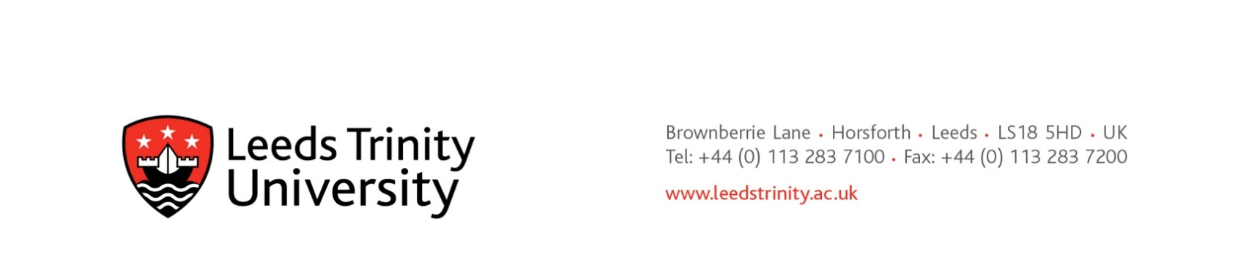

21st November 2024

Dear potential supplier

**Preliminary Market Consultation**

**Employee Assistance Programme and Occupational Health Services**

**PFB060LTU**

In respect of the above Leeds Trinity University seeks advice from independent experts/authorities/market participants with a view to developing the scope and specifications needed to plan and conduct its procurement procedures.

The primary objective of this consultation is to refresh our understanding of:

1. The size and characteristics of the supply market
2. The appropriate specification for the service, including service levels and KPIs.
3. The likely costs, and how these are constituted.

Our current understanding of appropriate EAP requirements is set out below. We will be interested to hear from providers that meet or exceed these requirements, or who are able to discuss aspects of the specification that are superfluous, inappropriate, or even omitted, with a view to improving the University offering.

The University particularly wishes to understand whether organisations being EAP providers, also provide Occupational Health Services. The University will be grateful to receive information from those organisations setting out the extent of their OH services.

For the avoidance of doubt, no call for competition has been made, and no contract award opportunity identified. All relevant information exchanged or resulting from this preliminary market consultation will be documented and may be communicated to other candidates and tenderers participating in any resultant procurement procedure.

Responses to this preliminary market consultation will be received until **5th December 2024.**

Please respond and address any queries by e-mail to [Mark Hayter](mailto:m.hayter@leedstrinity.ac.uk), Head of Procurement ([m.hayter@leedstrinity.ac.uk](mailto:m.hayter@leedstrinity.ac.uk))

We hope to hear from you soon.

With kind regards

[Mark Hayter](mailto:m.hayter@leedstrinity.ac.uk)

Head of Procurement

**Information about known requirements, standards, and output specification etc:**

Full Employee Assistance Programme (EAP) covering:

* **Legal**
* **Financial:**
  + signposting to relevant agencies.
  + Financial / debt counselling.
* **Mental Health care – to cover for conditions including:** 
  + Stress
  + Depression
  + Anxiety
  + post-traumatic stress disorder (PTSD)
  + addiction and substance misuse.
  + For stress (and other mental health difficulties) we require day one referral in event of colleague absence from work.
* **Work – including advice, information & support for:** 
  + Redundancy
  + Bullying/Harassment
  + Mediation
  + Team Conflict
  + Trauma/Critical Incidents
  + Stress Management
  + Sickness
  + Absence and attendance
  + Manager Coaching
  + Change Management
  + Diversity at Work
  + Employment legislation
  + Handling appraisals, grievances, and disciplinary hearings
* **Medical – Access to resources to support health, such as Menopause awareness and Wellbeing initiatives.**
* **EDI – to include:**
  + Specialist advice and support for Neurodivergent colleagues (with or without a formal diagnoses)
  + Discrimination
  + sexual harassment /violence
* **Family:**
  + Relationships
  + Bereavement
  + domestic violence
* **Consumer rights and advice**
* **Elder advice care including Dementia support / childcare advice.**
* **Carers’ support and signposting to relevant agencies**
* **Colleague Wellbeing mobile app.**

Provision to include, but not limited to:

* Telephone Support
* Face to Face Counselling Provision
* Online

Provision of Specialist Services to include but not limited to:

* Talking therapies including counselling and Cognitive Behavioural Therapy (CBT)
* Eye Movement Desensitisation and reprocessing (EMDR)
* Critical Incident Support
* Support for mood and personality disorders and instances of psychosis are desirable.

Web services, information and mediation are desirable.