Atamis Supplier Guide

Version 0.1

Contents

1. Overview 2
2. Help and support 2
3. Getting Started on the Portal 2
4. Logging off the application 5
5. Accessing contracts 5
5. Managing your contract 6
6. Managing your supplier certificates 8

Overview

Atamis is the Department of Health and Social Care Commercial system. It is available to Arms Length Body’s, NHS trusts and other organisations that wish to manage commercial activity.

This user guide provides the supplier user with a guide to register within the system and manage contract information.

The individual or team that are managing the contract is referred to as the “Customer” throughout the document.

Help and support

Contact the Atamis helpdesk by email at support-health@atamis.co.uk if you require technical support when accessing or using Atamis, include a description of the issue and screen prints of any issues where possible.

Getting Started on the Portal

Atamis can be accessed by any computer or mobile device through a web browser. The experience may vary by web browser. It is recommended that browsers that are still under maintenance by the provider are used to access Atamis.

Within your web browser, navigate to the portal:
https://health-family.force.com/s/Welcome and save the link as a favourite so you can access it easily in the future.

In order to use Atamis, each user in your organisation will need to register. Clicking on the “Register Here” button

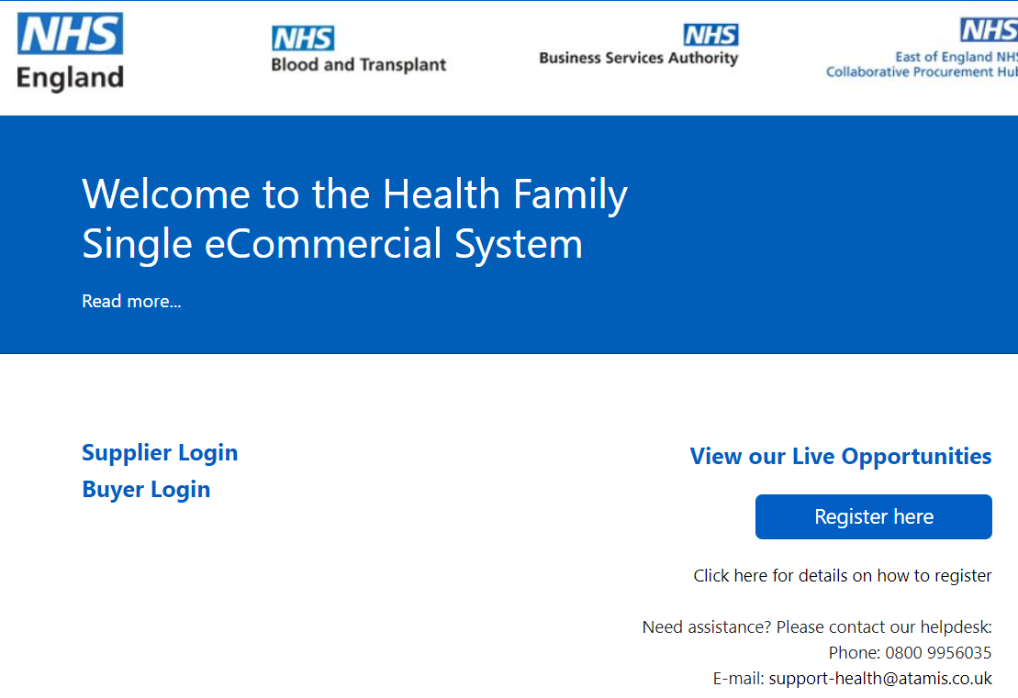

Review the user agreement and select the “Agree” button at the bottom.

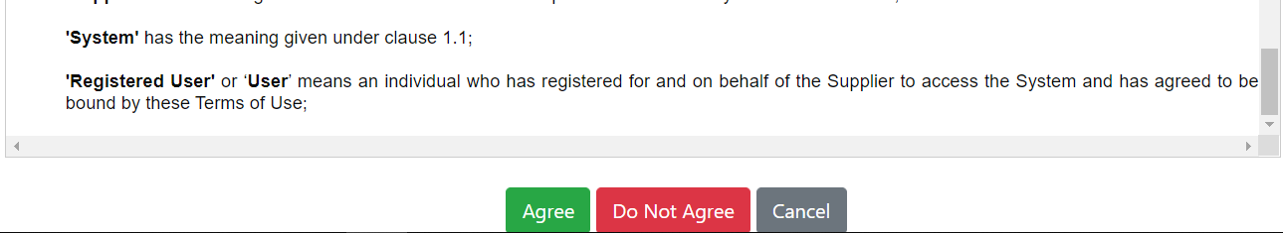

Complete the registration page with your company details and press submit.

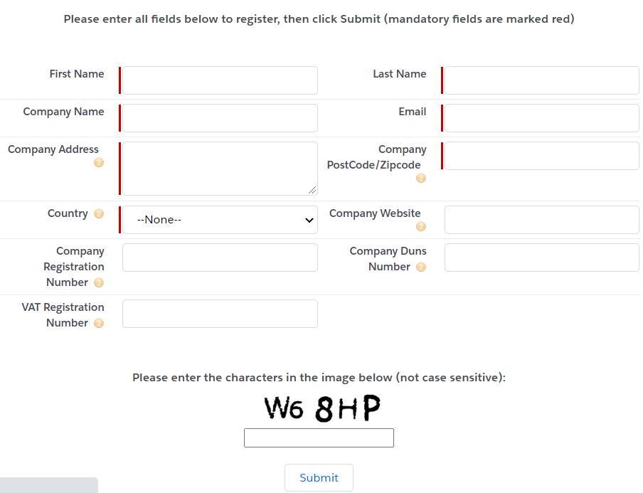

If another person in your organisation has already registered your organisation, you will receive this message. It is important that you press the “Request Merge” button so that you are added to the same organisation and so you can access your organisational data together as a team.

You will then receive a message that your request has been submitted.

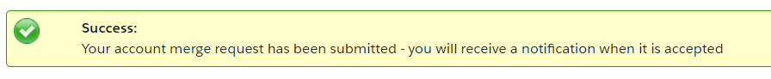

The person who registered the organisation will receive an email asking them to accept the request for account merge. They should follow the instructions within the email to accept or reject the request.

You will receive a Welcome email that enables you to login. Because the system runs on the Salesforce platform, the email will arrive from support@emea.salesforce.com with the subject “Welcome to Salesforce: Verify your account". If it has not arrived, please check your junk folder and if you find it there, mark emails from Salesforce as “Not Junk”. If you cannot find the email, please email support-health@atamis.co.uk and the team will arrange your access.
It is important that you select the “Verify” link within the email, DO NOT select the URL.
After you have logged in for the first time through the email, you can access the system through the “Supplier Login” tab.
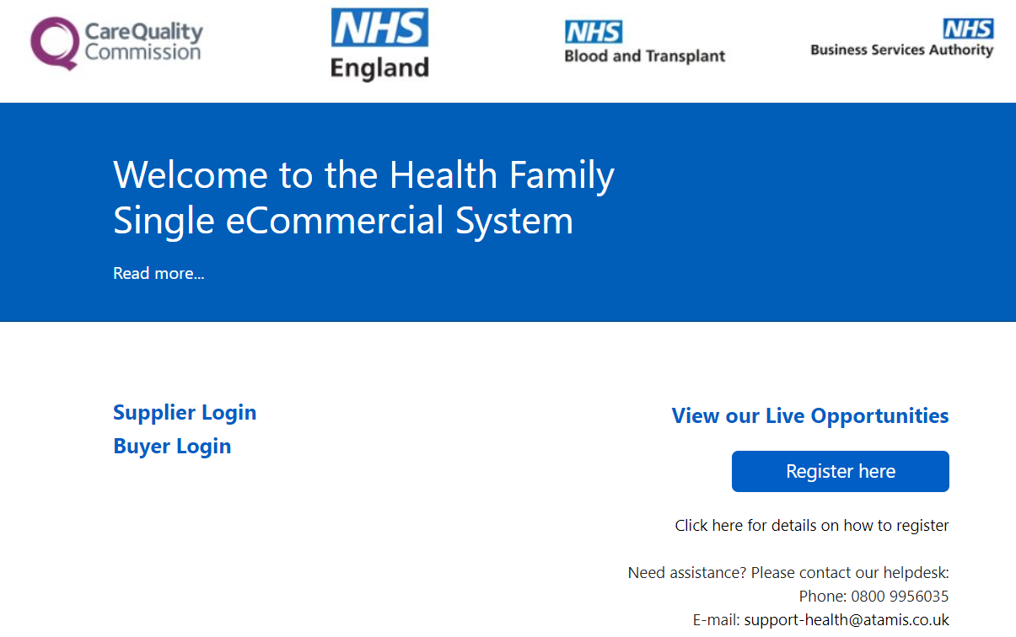

Your username is your email address. Your password will be as you set it within your welcome email. Click on the “remember me” link so the system remembers your username.
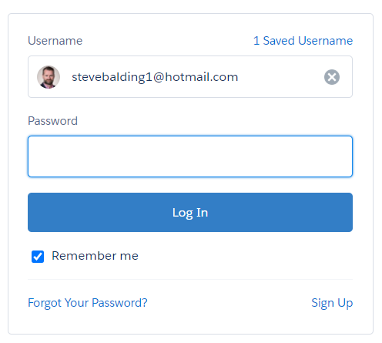

If you forget your password, or username you can reset it through the “Forgotten your login details” link within on the portal login screen.
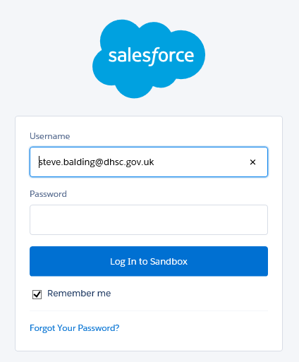

Logging off the application

You can log off the application at any time by right clicking your account in the top right 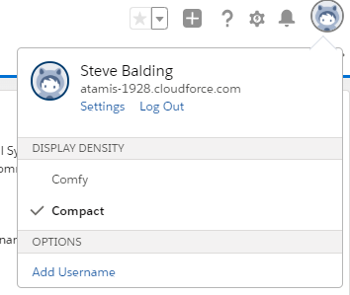

Accessing contracts

When you have registered, inform the person within the Health Family that is managing the contract. They will arrange for your supplier account to be connected to the contract and inform you when this is complete.

Once you have been advised that your account has been connected, login to the system and select “My Contracts” from the Atamis Supplier Dashboard
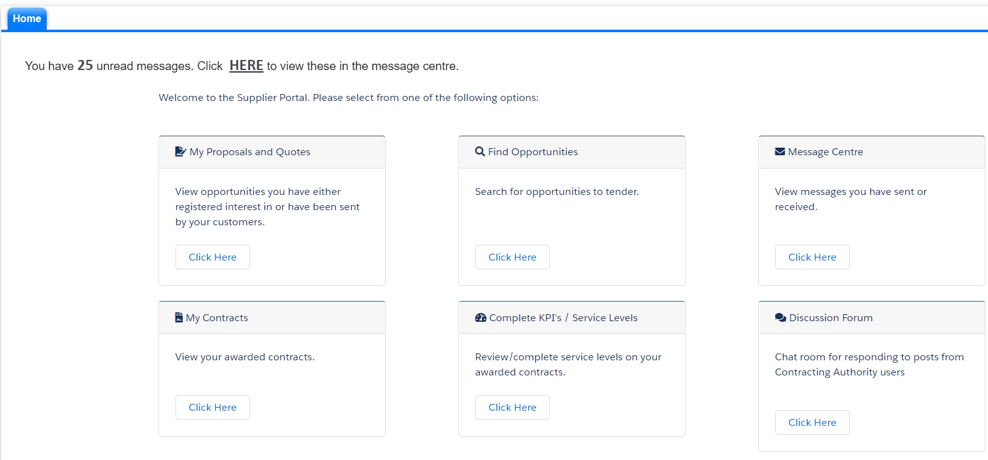

If the Customer team have connected your contract to your supplier record account, you will see the contract listed in your contract listing. Select the contract that you wish to access:
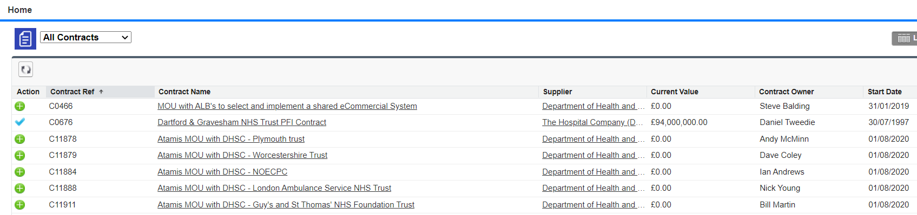

If no contract is listed, contract your Customer and they will arrange for your account to be connected to the contract.

Managing your contract

You can share messages and documents within the contract area.
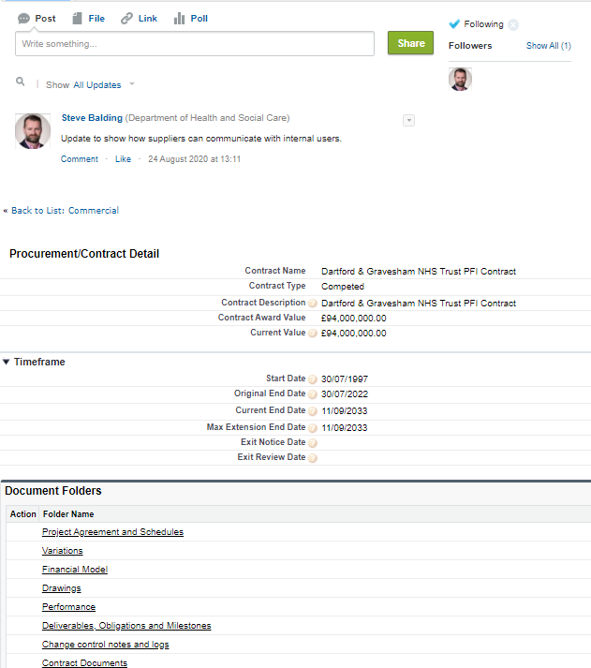

To send a message to the contact(s) select post and add a message.
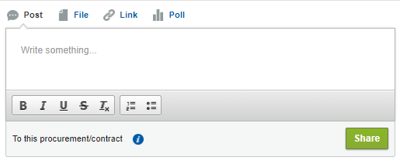

All individuals that are following the contract will receive an alert that a message has been added and can access it and respond to it. This will allow you to create a contract forum thread.
To access contract documents, click on any of the accessible folders:
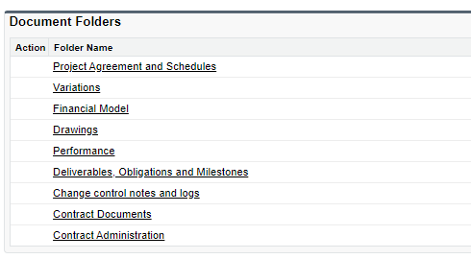
As you select a folder you can open documents within by pressing “View”. The system will usually provide a preview view that you can download if you wish. For large files, the preview option may not be available. Note that you can only Edit or Delete files that you have added.
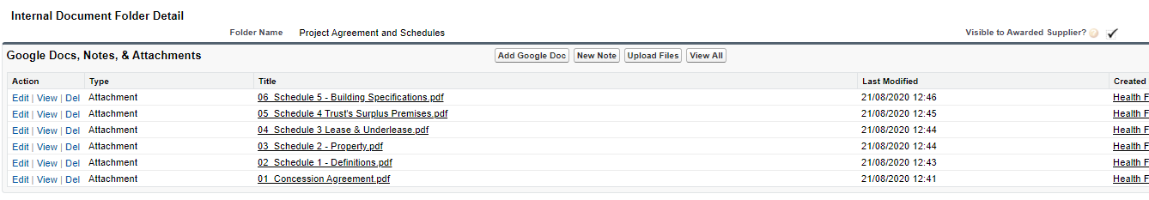

To add a file to a file, select the upload files button and upload a file from your computer.
Only you can delete files that you have added to the folder.

Managing your supplier certificates

You may be required to add current certifications such as insurance scheduled to system, so they can be reviewed by the Customer team. Select the “Company Details” tab.
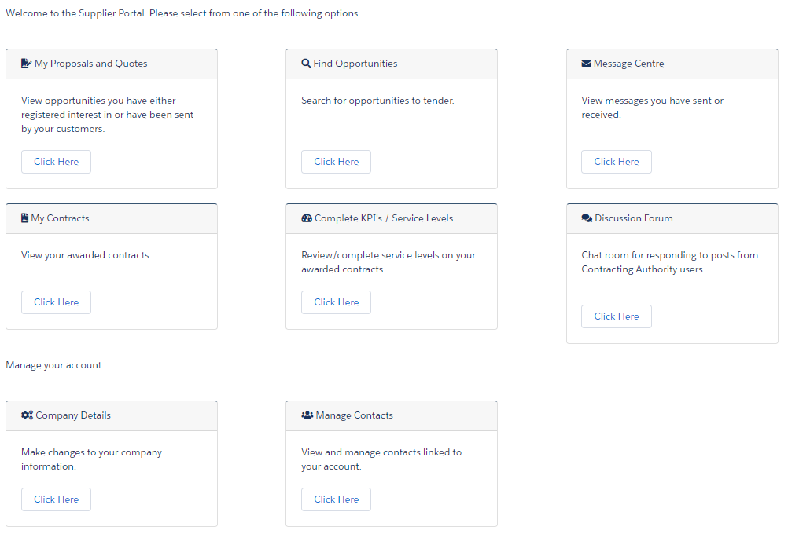

Hover over the “Supplier Certification” area and add new certifications as required.
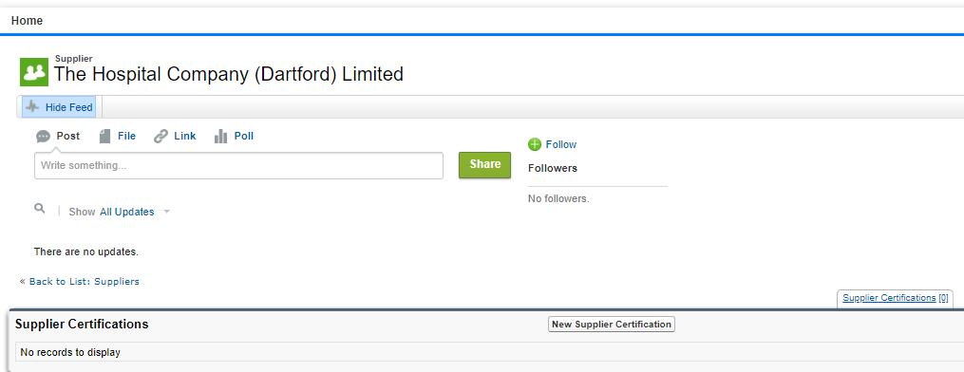

You can View, Edit and Delete (that you have added) certifications as required.

