Lot4 - Independent Mental Health Advocacy

DEFINITIONS AND INTERPRETATION

In this Specification the following expressions shall have the following meanings:

"Action Plan" | means a document created by the Quality and Improvement Service in conjunction with the Service Provider which details the actions to be taken by the Service Provider to remedy, resolve, rectify or improve any issues arising in respect of the quality of the delivery of the Services by the Service Provider;
"Best Practice" | means those standards, practices, methods and procedures of working that conform to Law and guidance issued by the CQC, the Social Care Institute of Excellence, any Relevant Authority and any Regulatory Body in relation to the subject matter of the Services;
"Business Day" | means a day (other than a Saturday or Sunday) on which banks are ordinarily open for business in the City of London;
"Community Directory" | means the Council's internet directory for services found at Cornwall Community Directory;
"Contract Review Meeting" | means the quarterly meeting to discuss out puts, outcomes with commissioners;
"Co-Production" | means working collectively with Stakeholders to design and develop the Services and care solutions (and "Co-Produced" and "Co-Produce" shall be interpreted accordingly);
"CQC" | means the Care Quality Commission and any replacement thereof or successor thereof;
“Dove tail” | means to cause something to fit exactly together, taken from the Care Act Guidance 2015
"Eligible Needs" | means the needs which the Local Authority has determined as eligible for funding pursuant to the guidance issued by the Secretary of State pursuant to section 7 of the Care Act 2014 guidance or such other guidance as is issued by the Secretary of State from time to time;
"Eligible Person" | means an individual whose needs meet the Eligibility Criteria and to whom the Local Authorities or NHS Kernow (Mental Health) is under a statutory duty to provide the Services;
"Invoicing Period" | Means in a monthly period in arears unless differently stipulated. commencing on the date of commencement of the Contract Agreement;
"Law" | means:  - any applicable Act of Parliament which has been issued, declared, passed or given effect;  - any Bill which has been presented before Parliament including for the avoidance of doubt the Care Bill [HL] 2013-14;  - any subordinate legislation within the meaning of Section 21(1) of the Interpretation Act 1978, including subordinate legislation under the 2000 Act (and to avoid doubt, the Care Standard Regulations made under the 2000 Act);  - any exercise of the Royal Prerogative;  - any enforceable community right within the meaning of Section 2 of the European Communities Act 1972; and  - any regulatory policy, binding guidance or binding industry code, judgment of a relevant court of Law, or directives or requirements of any Regulatory Body;
"Monitoring Workbook" | means the Monitoring Workbook that the Service Provider is required to complete and submit to the Council on a monthly and quarterly basis, the template for the workbook is set out in Appendix A;
"Out of Hours Services" | means the provision of Services which are commissioned by the Local Authorities or NHS Kernow (Mental Health) on weekdays between the times of 17.00 hours to 08.30 hours, weekends and public holidays;
"Outcomes"  “Outputs” | means the Outcomes identified in this Specification and the Outcomes that a Person wishes to meet following service provision;  means the Outputs identified in this Specification and the Outputs achieved through effective service delivery;
“Person” | means Service User, Patient, Carer, someone who is eligible for independent advocacy provision under statutory duties;
"Person Centred" | means constructing the provision of the Services based on what is important to the individual, utilising the individual's strengths to be independent, enabling effective communication and supporting the development of the individual;
"Personal Data" | has the same meaning as set out in the Data Protection Act 1998 as amended from time to time;
"Provider Performance Monitoring Form" or "PPMF" | means the Council's ASC24 form for recording complaints, issues, problems or concerns received by Adult Care Health and Wellbeing Quality and Improvement Team;
"Relevant Parties" | means a Service User's Carers, Representatives, health and social care professionals and all other individuals and organisations that provide assistance to or represent the wishes and/or best interests of Service Users;
"Representative" | means a Person who has been identified by a Service User as a Person who is able to:  - make decisions on his or her behalf; and/or  - represent his or her best interests to other parties,  in respect of their care;
"Sensitive Personal Data" | shall have the same meaning as set out in the Data Protection Act 1998 as amended from time to time;
"Service Provider" | means the counterparty to the Council in respect of the contract ;
"Services " | means those services set out in each Persons Outcomes plan, the delivery of which will meet the Person Outcomes;
"Social Care Values" | means the set of principles underlying the Council's Care at Home Commissioning Strategy which are pioneered by the voluntary and community sector in Cornwall and known as "Changing Lives" which can be found at www.cornwall.gov.uk/default.aspx?page=30592;
"Specification" | means this Specification - Working with Cornwall Council Education Health and Social Care, NHS Kernow (Mental Health), the Council of the Isles of Scilly;
"Staff" | means any individual or individuals directly involved by the Service Provider in respect of the provision of the Services to Service Users and such terms shall include the staff of any Sub-Contractor;
"Stakeholders" | means any Person which affects or is affected by the provision of the Services to a Service User;
"Sub-Contract" | means the form of the Contract entered into between the Service Provider and a Sub-Contractor relating to the provision of the Services;

THE SERVICES

SERVICE SPECIFICATION

Service Specification No.
Service | Lot 4 Independent Mental Health Advocacy (“IMHA”)
Commissioner Leads | Serena Collins
Provider Lead
Period | 01/04/16 – 31/03/19
Date of Review | 01/10/2016

1. Purpose

The following is the definition for Independent advocacy for commissioned Services within Cornwall and the Isles of Scilly. This definition has been agreed by the integrated independent advocacy group, 2015 and provides the baseline understanding for all Relevant Parties working within the contract.

Definition agreed for use by the integrated independent advocacy group 2015.

“Although many advocacy services are commissioned by public authorities they are required to function independently.
Independent advocacy promotes the exploration of options and choices with vulnerable children, young people and adults by assisting them to understand the information that is available to them.
It empowers those people to make sure that their views and wishes are heard and that they are treated fairly and equally.
Independent advocacy helps in navigating public services and in accessing the right support to achieve greater independence and wellbeing”.

The contracted advocacy Service Providers will work with Persons to:
- Express their views and wishes
- Explore choices and options
- Secure their rights
- Have their interests represented fairly and equally
- Access information and services
- Navigate public services

and the Service Providers will not:
- Make decisions or choices for people
- Provide a campaigning service
- Provide a befriending service
- Provide financial advice and advocacy
- Provide legal advice and advocacy
- Provide advice and guidance

The contracted advocacy Service Providers will work with Persons to offer support for the Person that will:

a. Promote self-esteem and confidence improving the wellbeing of the Person and their ability to self-advocate in the future.
b. Work in partnership to ensure joined up and seamless support across statutory, voluntary and independent services and maximise the opportunities for added value.
c. Be flexible and responsive to the Persons needs and Outcomes for them.
d. Ensure the advocacy Service is Person-Centred and able to meet the needs of the Person in relation to their own preferences, aspirations and Outcomes and in accordance with their presenting needs ensuring the Person is empowered to make their own decision and choices.
e. Ensure respect is maintained and promote the dignity of the Persons accessing independent advocacy Services

The following table details the Lots approach:
Lot 1 Information | Lot 2  Community | Lot 3  Community Mental Capacity | Lot 4  Wards and Crisis support
Triage service | Care planning  Inc. Cornwall Foundation Trust (CFT) social worker assessments | Independent Mental Capacity Advocates  (IMCA)  Independent Mental Capacity Advocates  Deprivation of Liberty  (IMCA DoLS) | For Persons detained under the relevant sections of the Mental Health Act (1983 as amended 2007)
Information  Signposting | Safeguarding both complex care management and adult protection | Paid Relevant Persons Representative (RPR)
NHS Complaints
1 Service Provider | 2 Service Providers | 1 Service Provider | 1 Service Provider

The requirement for Service Providers to be independent is paramount to meet statutory duties, but also to ensuring that they gain the trust of the Person and therefore achieve positive Outcomes for them.

Statutory duties for local authorities within the Care Act (2014) have expanded and dove tailed with current legislation including the Mental Capacity Act (2005) and the Mental Health Act (1983 as amended 2007). Therefore the Care Act (2014) does not supersede this legislation but increases duties on the local authorities to ensure all Persons who would experience substantial difficulty and who would have no other appropriate person to support them through NHS and Local Authority Services, have an independent advocate. This is from point of referral through to their assessment and their customer journey across adult social care and through into NHS Continuing Health Care (CHC).

There is an exception contained within the Care Act (2014) for the provision of an independent advocate where there is an appropriate person able to facilitate active involvement. This occurs when, as part of the care and support assessment or planning functions, it is likely that a Person will be placed in NHS- funded provision in a hospital for a period of twenty eight (28) days or more (including places like assessment and treatment units) or a care home for a period of eight (8) weeks or more. If it is deemed within the best interests of the Person to do so an independent advocate will be commissioned. This is due to the scale of the decision being made to provide support to the family; as often they can feel ignored and exhausted by the process of supporting a relative or friend alone.

  - Aims

‘The ultimate aim is for people’s wishes, feelings and needs to be at the heart of the assessment, care planning and review processes. This needs to be just as true for those who are subject of a safeguarding enquiry or safeguarding adult review (SAR)’. (Care and Support statutory guidance October 2014)

The Care Act (2014) states clearly the need for joint working across the NHS and adult social care to ensure assessments are not duplicated, the Person is actively supported in all processes and that decisions are clearly explained, recorded and shared so, if required, a Person can challenge if they feel decisions are unjust.

The requirement of the independent advocacy Services is to assist Cornwall Council and the Council of the Isles of Scilly in delivering statutory duties for independent advocacy provision, which provides necessary independent advocacy provision for NHS Kernow. This will result in Persons with Eligible Needs for the Services being empowered and experiencing improved quality of life, having the ability to live independently in their own homes or in the community for as long as possible and to have reduced, limited or no need for independent advocacy in the future.

The contracted advocacy Service Providers will:

- Provide commissioners with detailed performance indicators of the Outcomes that have been achieved for a Person and how a Persons facilitated support has contributed to their active involvement in the decision making process.

- Provide commissioners with data, information and expert knowledge to inform sustainable advocacy provision in the future.

- Promote understanding of the independent advocacy Services and recruit effectively to meet the statutory requirements of Cornwall’s population.

- Meet these aims through the provision of flexible, Person-Centred Services which enable Persons to be actively involved in their own care planning and decision making.

- Appropriately recruit, train and provide competent independent advocates to support Persons with substantial difficulties in being actively involved in their care where there is no other appropriate person to support them.

1.2 Strategic requirements from the independent advocacy Service delivery:
Through the provision of the independent advocacy Service the Service Providers will;
- Support the Person through partnership working, to achieve their individual Outcomes for independent living.
- Support Carers to remain in their caring role.
- Support the Local Authorities and NHS Kernow (Mental Health) in gathering information of the demands for independent advocacy and requirements of the local community.
- Support the Local Authorities and NHS Kernow (Mental Health) in independent advocacy engagement and stakeholder events.
- Support the Local Authorities and NHS Kernow (Mental Health) in the development of independent advocacy provision which includes offering opportunities for meaningful volunteering into paid employment where appropriate and retention of a skilled workforce to meet increases in demand for competent independent advocacy.

There is a commitment by all parties to develop the advocacy Service delivery in line with the strategic findings as the contract develops and ensure flexibility within the Services to achieve maximum benefits for the future delivery of independent advocacy.

Commissioned Service Providers must find innovative new methods to deliver independent advocacy to meet predicted increases in demand within the maximum budget stipulated for the length of the contract.

Expected changes within legislation will likely cause spikes within demand from 2017 which must be met within agreed contract values.

The potential need for an independent advocate currently may be raised throughout the care planning process, from the Person themselves, Carers, family or professionals.

The Care Act (2014) defines the four areas that Local Authorities must consider in making a judgement regarding substantial difficulty. A Persons eligibility for the advocacy Service might be found in any one of the four listed below.
- Understanding relevant information
- Retaining information
- Using or weighing the information as part of engaging
- Communicating their views, wishes and feelings

Due to the dove tailing with the Mental Capacity Act (2005) and that of the Mental Health Act (1983 as amended 2007), the use of substantial difficulty will be the eligibility criteria for initial access to the provision of advocacy Services.

Persons who lack capacity will receive non- instructed independent advocacy to enable best interest decisions to be made on their behalf by the appropriate decision maker through information gained and reported by the independent advocate.

Independent Mental Capacity Advocates (IMCA) will provide information to support care planning, safeguarding, accommodation changes and treatment by statutory organisations.

Independent Mental Health Advocates (IMHA) will provide information and support understanding of the Mental Health Act 1983 as amended 2007.

The Services will be generic, provided to all Persons who are eligible. This includes but not limited to people with learning disabilities, Asperger’s, Autism, dementia, mental health needs and acquired brain injury. Therefore Service Providers must be able to meet the individual needs from a wide spectrum of the community and have the necessary skills within their Staff to enable the Persons voice to be at the centre of decision making.

The Care Act also places a duty on local authorities to provide an independent advocate to facilitate the involvement in the transition assessment where the person in question would experience substantial difficulty in understanding the necessary information or in communicating their views, wishes and feelings – and if there is nobody else appropriate to act on their behalf. This duty applies for all young people or Carers who meet the criteria, regardless of whether they lack mental capacity as defined under the Mental Capacity Act.

This support will be provided within Children’s advocacy contracts however to assist in the transition process and to provide consistency of approach, advocates will work together through an agreed period of hand over from Children’s’ Services to that of adults independent advocacy.

1.3 Evidence Base, which has been used to inform the service Specification
Article 5 of the European convention of Human rights requires that each person has a right to liberty and security of person save those ‘detained’ by a procedure prescribed by Law.
Article 6 of the European convention of Human rights stipulates that everyone should have the right to a fair hearing.
Article 10 if the same convention highlights the rights of individuals to express themselves.
Care Act 2014
Care Act Guidance Oct 2014
Computer Misuse Act 1990
Data Protection Act 1998
Freedom of information Act 2000
Environmental Information Regulations 2004
Public sector equality duty (PSED) within the Equality Act 2010 stipulates the need to pay due regard to the need to eliminate discrimination, advance equality of opportunity and foster good relations between people who share a’ protected characteristic’.
Mental Capacity Act 2005
Mental Health Act 1983 as amended 2007
Mental Health Act Code of Practice 2015
Stronger Code: Better Care- Government response to the consultation on the Mental Health Act 1983 as amended 2007.
Department of Health briefing note in support of Winterbourne View Joint improvement programme. 2015
Social Care for Excellence Institute Commissioning advocacy (SCIE)
Advocacy Quality Performance Mark Edition 3 2014
Key competencies of an effective IMHA service Action for Advocacy

1.4 General Overview for independent advocacy provision
The funding for independent advocacy Services is through a pooled budget with Cornwall Council, NHS Kernow (Mental Health) and the Council of the Isles of Scilly. Therefore joint Contract Review meetings will take place quarterly with commissioners from all funding parties.

During the length of the contract, creating and testing of new models of delivery will take place to support better Outcomes for people accessing Services and improve value for money. Therefore Services are required to be flexible to develop aligned with local policy decisions making and changes in central government legislation.

Initially commissioners will be expecting Services to test a new model of delivery of independent advocacy within the Royal Cornwall Hospital Trust (RCHT) and West Cornwall Hospital. Using the data and learning from this, commissioners will explore the viability of provision of independent advocacy in Derriford Hospital and other smaller hospitals, over the course of the year.

Further development will continue in using One Stop Shop facilities to meet advocacy demand in a different way via an appointment based approach. Testing will begin based on the geographical areas with the highest numbers of referrals. This information will also inform the implementation of peer and community support within high advocacy demand areas.

Following central legislation independent advocacy Service Providers must actively engage with the local Crisis Care Concordat to ensure local action plans are instigated and reflect local policies. This will also require a flexible approach and delivery model.
Local crisis concordat

To provide necessary information for all parties in the development of advocacy Services for Persons who are marginalised and hard to engage. Service Providers will need to request details from Persons in respect to the nine (9) protected characteristics in the form of a questionnaire to Persons accessing support. These questionnaires under the Equality Act 2010 will be appropriately logged and securely stored by the contracted Service Providers. This information will be requested as appropriate within the Service delivery before a Person exits the service. These requests for personal information will only be made following the initial triage referral process.

In addition, contracted advocacy Service Providers (following the period of implementation) must attend quarterly meetings as part of an advocacy steering group, this is to advance implemented joint working agreements, ensure adherence by all relevant parties to joint working protocols across the four (4) Lots and as a group develop advocacy Services to ensure best value and better Outcomes for people accessing Services.

The four (4) Lots, although distinct in independent advocacy specialism, must work effectively together from the point of triage and therefore key to successful delivery will be co-produced practical protocols.

Contracted Service Providers must jointly agree during the implementation period and adhere to the following protocols prior to 1 April 2016:
- Information sharing protocol
- Transition protocol
- Discharge and Exit protocol

Agreed protocols between Service Providers will require final signed agreement by commissioners of the Service.
This joint working by contracted Service Providers will ensure Persons accessing advocacy Services have continuity of Service delivery, reduce the need to repeat their story and enable safe exit from the independent advocacy Service following agreed met Outcomes within any contracted Lot.

Many of the people who qualify for independent advocacy under the Care Act (2014) will also qualify for advocacy under the Mental Capacity Act (2005). Therefore the same advocate can provide support as an advocate under the Care Act and under the Mental Capacity Act. However under whichever legislation the advocate providing support is acting, they should meet the appropriate competency requirements for an advocate under that legislation.

The advocacy Service provision will benefit from the recruitment and active involvement of unpaid Staff/volunteers. To encourage the valuable participation of volunteers into the sector, the level of training and competency required needs to reflect the willingness of the volunteer and their wishes for the future.

Volunteers must have the necessary enhanced Disclosure and Barring Checks (DBS) before working within the Service and have the core levels of skills and training stipulated to support volunteers within the first 6 months of joining an organisation. Service Provider managers must take responsibility in ensuring a volunteers’ competency before undertaking visits with Persons accessing Services.

Core skills
- Excellent active listening, communication and people skills
- A good level of literacy and numeracy
- Good record keeping skills
- Openness to the views of others and to be non-judgemental
- Ability to maintain confidentiality
- Appropriately assertive
- Able to work in an empowering way

Core training requirements for all Staff:
- Safeguarding Level 2
- Mental Capacity Level 2
- Communication training
- Basic Advocacy training
- Care Act training
- Equality and diversity training
- Data protection and confidentiality training
- Freedom of information and information security training

- Level 2 independent advocacy within 12 months

Following a period of supervised induction and successful achievement of the above; volunteers can work independently with Persons but with the supervision and support from a paid independent advocate, who is competent and nationally qualified Level 3 or above. The paid independent advocate working with the Person and the volunteer has the responsibility for the progress and actions to meet the Persons Outcomes. Therefore will need to have oversight of the Persons Outcomes and planned activity will regular supervision and support for the volunteer.

Service Providers will be actively encouraged to support volunteers and, where appropriate for the volunteer, support training opportunities and increased skills into paid employment within the sector.

The contracted Service Providers must have a volunteer policy for suitable recruitment including the verification process of at least 2 references, plan for skill development of volunteers and a policy for exiting volunteers from the advocacy Service if required, due to being unsuitable for this unique role.

To ensure joint working and the meeting of both parties’ (organisation and volunteer) planned Outcomes, the following approaches are suggested to recruit and retain suitable volunteers.

- Volunteer signed agreement stipulating expectations of both sides;
- Volunteer handbook detailing contacts, policies and supervision;
- Volunteer confidentiality agreement;
- Volunteer induction;
- Volunteer development plan;
- Volunteer peer support;
- Volunteer regular supervision and yearly reflection of overall Outcomes.

Contracted Service Providers must comply with all legal requirements.

1.5 Expected Outcomes
Service Providers will demonstrate flexibility in the event of excessive emergency demand.
The Lot 4 Service will provide Independent Mental Health Advocacy (IMHA) Service that is accessible both through triage and direct from patients and professionals working with hospitals and treatment units.
IMHAs provide an additional safeguard for patients who are subject to the Act. (IMHAs do not replace any other advocacy and support services that are available to patients, but are intended to operate in conjunction with those services).
Patients are eligible for support from an IMHA if they are:

- detained under the Act (even if they are currently on leave of absence from hospital)
- conditionally discharged restricted patients
- subject to guardianship
- supervised community treatment (SCT) patients

Other patients (informal patients) are eligible if they are:

- being considered for a treatment to which section 57 applies (a section 57 treatment)
- under 18 and being considered for electro-convulsive therapy or any other treatment to which section 58A applies (a section 58a treatment)

The Service Provider will adhere to the following broad principles:
- Ascertaining the views, feelings, wishes, beliefs and values of the person, using whichever communication method is preferred by the client and ensuring that those views are communicated to, and considered by, the decision-maker.
- Non-instructed advocacy. Asking questions on behalf of the person and representing them. Making sure that the person’s rights are upheld and that they are kept involved and at the centre of the decision-making process.
- Investigating the circumstances. Gathering and evaluating information from relevant professionals and people who know the person well. Carrying out any necessary research pertaining to the decision.
- Prepare a report for the authorised person and may include submissions about the person and the act or decision proposed.
- Auditing the decision-making process. Checking that the decision-maker is acting in accordance with the Act and that the decision is in the person’s best interests. Challenging the decision if necessary.

IMHAs will safeguard Persons rights, which encompass both mental health policy and Law together with their rights as citizens.

The Lot 4 Service will work jointly with Lot 1, Lot 2 and Lot 3 Service Providers and information, advice and guidance Service Providers where appropriate, to ensure effective use of resources, collaborative working and successful progressive Outcomes for Persons accessing independent advocacy provision.

Using the Adult Social Care Outcomes Framework 2014-15 the following domains will be achieved by the Service.

Domain 1: Enhancing quality of life for people with care and support needs:
- Persons report that they are actively involved in their care planning, managing their own support as much as they wish, so they are in control of what, how and when support is delivered to match their needs.
- Persons report they feel their wellbeing, quality of life and ability to self-manage has improved.
- Persons report that their voices have been heard and acted upon which has increased confidence and ability to self-advocate.
- Persons report they feel able to be independent following additional initial support and have exited the service safely.

Domain 2: Delaying and reducing the need for care and support:
- Persons report that they have knowledge of and are aware of their choices and options in the delivery of care and support including community networks and volunteer organisations.
- Carers report that they feel appropriately supported in their caring role.

Domain 3: Ensuring that people have a positive experience of care and support:
- Persons report the Service has increased their understanding of the processes within adult social care and are now able to navigate care and support services.
- Persons report that they are overall satisfied overall with the independent advocacy service provided and their Outcomes have been met.
- Persons report that they feel respected as equal partners throughout the care process.

Domain 4: Safeguarding adults whose circumstances make them vulnerable and protecting them from avoidable harm.
- Persons report that they feel safe from harm, treated with dignity and respect.
- Persons report that they felt previously excluded from services and following independent advocacy support they now feel socially included within their community.
- Person’s report that they feel supported to plan ahead and have freedom to manage risks the way that they wish.

NHS Outcomes Framework 2015:
Domain 1
- Prevent people from dying prematurely
Domain 2
- Enhancing quality of life for people with long term conditions.
Domain 3
- Helping people to recover from episodes of ill health or following injury
Domain 4
- Ensuring people have a positive experience of care.
Domain 5
- Treating and caring for people in a safe environment and protecting them from harm.

All Service Providers must ensure opportunities for added value are maximised by offering in addition to the core Service, a choice of advocacy models as appropriate to circumstances from the chosen list below:

- Supported self-advocacy
- Group advocacy
- Peer advocacy
- Citizen advocacy

  - Service Description
To provide an IMHA Service to eligible Persons over the age of 16.
The legislation governing the compulsory treatment of certain people who have a mental disorder is the Mental Health Act 1983 (the 1983 Act). The main purpose of the Mental Health Act 2007 (the 2007 Act) is to amend the 1983 Act. It places a duty on the appropriate authority to make arrangements for help to be provided by independent mental health advocates (IMHA’s).
The IMHA must help the Person to obtain information about and to understand:
- The Person’s rights under the Act;
- The rights other people have in relation to them under the Act.
- The particular parts of the Act which apply to them (e.g. the basis on which they have been detained) and which therefore make them eligible for independent advocacy;
- Any conditions or restrictions to which the Person is subject by virtue of the Act;
- What (if any) medical treatment is given to the Person or is proposed or discussed in their case;
- Why it is given, proposed or discussed;
- The legal authority under which treatment is , or would be , given and
- The requirements of the Act which apply, or would apply, in connection with giving treatment to the Person;
- Help and support in obtaining information about and understanding any rights which may be exercised under the Act by on in relation to the Person;
- Help and support to the Person to exercise their rights, this can include representing them and speaking on their behalf. IMHA’s can accompany patients to tribunals and hospital managers hearing and can speak on their behalf in meetings.

IMHAs provide an additional safeguard for patients who are subject to the Act. (IMHAs do not replace any other advocacy and support services that are available to patients, but are intended to operate in conjunction with those services).
Patients are eligible for support from an IMHA if they are:

- detained under the Act (even if they are currently on leave of absence from hospital)
- conditionally discharged restricted patients
- subject to guardianship
- supervised community treatment (SCT) patients

Other patients (informal patients) are eligible if they are:

- being considered for a treatment to which section 57 applies (a section 57 treatment)
- under 18 and being considered for electro-convulsive therapy or any other treatment to which section 58A applies (a section 58a treatment)

IMHAs may also help qualifying patients to exercise their rights. This may include:
- supporting patients to access information and better understand what is happening to them
- supporting qualifying patients in exploring options, making better informed decisions and actively engaging with decisions that are being made
- supporting qualifying patients to articulate their own views
- speaking on the patients behalf and representing them

Non Instructed Advocacy
IMHAs will inevitably work with Persons who lack capacity to instruct or request an IMHA Service.
IMHA Services will therefore be required to have an understanding and practical working experience of non- instructed advocacy, which will include:
- A non- instructed advocacy policy
- An understanding of non-instructed advocacy approaches.
- A referral process for Person’s unable to instruct themselves.
- Prioritisation policy that includes those less able to instruct an advocate.
- Information and training available for third parties including professionals about non instructed advocacy.

In addition to referrals direct from Mental Health Professionals, referrals will be allocated by Lot 1 triage Service.
The responsibility of these referrals remains with triage Lot 1 until notification of acceptance from the allocated Lot 4 Service Provider.
The allocated Service Provider must acknowledge receipt of the referral from triage electronically within 2 hours before 4.30pm or if it is received later than this time the next business working day before 10am.
If no acknowledgment is received, triage must contact the allocated Service Provider to establish a reason for delay and if the delay is significant contact the Person to inform them. All delays in acceptance of referrals must be recorded for Contract Review meetings.

In addition, the allocated Service Provider must notify triage of any relevant additional information gained through working with a Person and notify when the Person has either been transferred to another Service or safely exited from the advocacy Service.

Triage will log all enquiries and referrals with a Person unique number this will remain the identification for that Person across the Services and must be used by all Service Providers working with that Person. This process will also be completed for all direct referrals to Lot 4. By using a unique Person number all information relating to that Person can be gathered from the various Service Providers back to triage following safe exit of provision. This is therefore working towards during the length of the contract, a centralised database of information accessible through appropriate permissions by all contracted advocacy Service Providers to provide holistic support and assisting in consistency for the Person.

The Lot 4 Service Provider must allocate a unique Person identification number to each referral made direct to Lot 4. This and the initial referral must be sent through to the Lot 1 Service Provider within 1 business working day of initial request for independent advocacy. Lot 4 Service Provider has a responsibility to inform Lot 1 on the either the transition into Lot 2, Lot 3 or safe exit from Lot 4 so Lot 1 is able to collate the necessary information on a central database.

Where signposting has been used the Service Provider must contact the Persons within 14 working days to establish if a Persons Outcomes have been met through this action. This process of checking on the effectiveness of signposting and information is to be used by all Lot Service Providers.

    - Access to Services
The Lot 4 Service Provider will accept statutory advocacy referrals only and will not:

- Make decisions or choices for the Person
- Be a campaigning service
- Offer befriending
- Provide financial advocacy
- Provide legal advocacy

Although there are clear links with information, advice and guidance (IAG) advocacy is not (IAG) and requires different skills and the ability to actively listen without giving opinions and advice.

Any referrals that do not comply with statutory requirements are to be considered inappropriate and support provided if appropriate to other resources within Health and Social Care or signposted to other organisations within the community.

Where Lot4 Service Provider receives a referral direct from a professional, or Person that is inappropriate for the IMHA Service but would be eligible for independent advocacy provision; the referrer needs to be notified that Lot 4 Service Provider has declined the referral but has past all information through to triage for allocation to other advocacy Services.

The Service is to be provided free of charge and available upon request and recognises that Persons mental capacity can fluctuate and will work with Persons accordingly.

The Service Provider must not provide an advocacy service for family and friends or others for whom there may reasonably be identified a conflict of interest.

  - Accessibility/acceptability
The Service must provide high quality independent advocacy that is appropriate to people’s needs including their disability, race, culture, religion, sexuality, age and gender. The Service must also recognise that Persons needs can change over time and respond accordingly.
The Service will be flexible in its approach and will ensure information is available in a variety of formats to support Persons accessing services.

To enable information to be widely available; the Service Provider will also develop a range of easy read downloadable materials and tools for informal advocates supporting people. This will include a variety of information on navigating services, links to other resources and information explaining the role of an advocate in supporting a Persons rights. Information to also be provided as to when support from contracted independence advocacy would be appropriate to support an informal advocate.

The Service will adhere to the Accessible Information Standard 2015. This legislation is explained in law under Section 250 of the Health and Social Care Act 2012.

2.3 Whole System Relationships
The independent advocacy Service can be referred to by Mental Health professionals within NHS Kernow, Cornwall Partnership Foundation Trust (CFT) social work staff, CFT mental health ward staff, Cornwall Council and all adults assessment Representatives, adult care staff for the Council of the Isles of Scilly, Royal Cornwall Hospital, West Cornwall Hospital, Joint Continuing Health Care assessments NHS Kernow (CHC), PCH.

2.4 Interdependencies
Interdependencies exist between the four (4) separate Lots Service Providers, and where appropriate to information, advice and guidance Service Providers. Therefore all contracted Service Providers must have a transparent proactive approach to ensure clarity of information sharing and clear communication.

2.5 Relevant Clinical Networks and Screening Programmes
N/A
2.6 Sub-contractors
Sub-Contracting is only applicable in working outside of Cornwall and the Isles of Scilly supporting ordinary residents of both areas.
3. Service Delivery

3.1 Lot 4 IMHA Service
The Service Provider must;
- Be independent and have its own constitution, code of practice and complaints procedure.
- Provide independent specialist advocacy Service, with offices and Staff based in Cornwall, to people who are eligible for receiving secondary mental health services from Cornwall adult mental health services as both formal and informal inpatients.
- Provide information in a variety of styles and formats to aid communication during a complex time within Persons life.
- Have a good working knowledge of the Mental Health Act 1983 as amended 2007 and accompanying Code of Practice in order to inform patients of their rights and discuss options.
- Have a good working knowledge of the Care Act 2014 for Persons with Eligible Needs to access other independent advocacy Services following safe exit from Lot 4 Service provision.
- Ensure Staff adhere to aspects of Section 130A, 130B, 130C and assist with adherence by health staff to 130D of the Mental Health Act 1983 as amended 2007.
- Have information about detention and supervised community treatment (SCT), consent to treatment, seeking a review of detention or SCT, informal hospital in-patients, those subject to guardianship, about Second Opinion Appointed Doctors (SOAD’s), awareness of the emergency applications for detention.
- Ensure latest legislation and practice guidance is shared with Staff through team meetings and supervision and that the Service is proactive in its approach to research and Best Practice.
- Ensure all Staff are competent and have a good practice understanding of the Mental Capacity Act 2005.
- Ensure all Staff are competent in the interface between Mental Health Act and the Mental Capacity Act and the work of IMCA advocates.
- Ensure all Staff are competent and have good practice understanding of Deprivation of Liberty Safeguards (DoLS) Code of Practice.
- Work closely with other agencies to support the needs of people with mental health problems.
- Ensure the raising of awareness of the role and referral process for IMHA services.
- Support the training of IMHAs and independent advocacy in general within the hospital induction programme and hospital staff team meetings.
- Provide a local timetable of when an IMHA will be available on each mental health ward. This will link with ward rounds and handovers sessions on wards. Work with the local mental health trust to establish the most efficient times to be available on the wards.
- Ensure as part of IMHA ongoing training updates are provided on relevant case law and aspects of community care law as well as refreshers on key legislation.
- Ensure accurate recording and collating of voluntary capacitated patients (informal patients) unable to access support through the IMHA service delivery to assist in policy shaping and commissioning intentions.
- Have a presence on wards and units which enables patients to be able to self-refer.
- Have information leaflets and posters clearly indicating contact details of the relevant service and methods of referral as well as availability both on the ward and outside these times.
- Proactively approach patients that are newly admitted onto the ward/unit.
- Ensure referrals under Section 2 of the Mental Health Act 1983 as amended 2007 are action in a timely way to support the right of appeal within 14 days.
- Attend, host patient group meetings and facilitate peer support and self- advocacy where appropriate.
- Ensure joint working with Lot 1 triage and notify within 1 business working day any direct referrals from both professionals and patients. This activity to be actioned following the agreed information sharing protocol and ensuring confidentiality of personal data on transfer between Lots.
- Have clear personal safety policies that are reviewed with Staff working on hospital wards and units.
- Work proactively with wards and units to ensure the safety of all individuals.
- Work with wards and units to ensure quiet confidential space is available for independent advocacy to take place with patients.
- Where signposting has been used the Service Provider must contact the Persons within 14 working days to establish if a Person’s outcomes have been met through this action.
- Provide and proactively manage a secure inbox on electronic mail for referrals and queries.
- Ensure that, when all telephone contact lines are in use, there is a managed answer phone service which will be checked throughout the day.
- Ensure confidentiality is maintained at all times, and where information is needed to be shared through consent, that strict protocols manage information securely.
- Provide evidenced feedback to commissioners and referring professionals of inappropriate referrals and provide learning opportunities outside of the organisation to improve the efficiency of the Service. Proactively identify areas/teams who may benefit from training.
- Promote and support the development of volunteers where appropriate to the Service to ensure value for money and additional social and community benefits through training opportunities and links to paid work.
- Ensure that Staff have time to complete necessary continuing professional development ( a minimum of 14 hours a year) and support Staff to remain within the advocacy Service through career pathways and opportunities for personal growth.
- Create a secure database system where all calls and queries to the Service can be logged securely with each Person being provided a unique identification number which must be used by all contract Service Providers to ensure accurate recording of the Person, through both transition and safe exit from the Service. Information and unique identification number to be passed onto Lot 1.
- Ensure there is a unique Person identification system for individual recording of work undertaken, records must be retained for monitoring and follow up purposes.
- Ensure Staff, both paid and unpaid complete Service Provider outcome monitoring tools with Persons entering and exiting the service e.g. outcome stars.
- Ensure signposting of Carers to relevant Carer support services.
- Provide joint support in the publicising of independent advocacy Services using a collaborative approach with contracted Service Providers .

The Service Provider Must;
- Ensure robust systems are in place to meet the legal requirements of the Data Protection Act and the safeguarding of personal data at all times.
- Ensure Staff are trained in regards to the Data Protection Act 1998, Computer Misuse Act 1990, confidentiality of sensitive personal data, safe transfer of information.
- Ensure there is a working policy, which is updated appropriately detailing the actions to be taken in the event of a data breach and that staff receive training and updates on the policy.
- Ensure commissioners are informed as soon as reasonably practical following a breach of security and also notified in writing within 3 working days.
- Ensure compliance with specific data retention requirements as detailed in Batchelor Retention Guidelines for both paper and electronic documents.
- Ensure all staff both paid and unpaid will have access to and apply Information Sharing guidance and protocols.
- All volunteers working within independent advocacy must be working towards the Level 2 national qualification for independent advocacy within 12 months of being recruited.
- Ensure compliance with the Data Protection Act, have clear policies for the control of data and adherence to the terms of this Contract.
- Ensure compliance with Cornwall Council’s Third Party Security Protocol at all times appendix B.
- Have agreed data sharing protocols with partner agencies where applicable.
- Have a record management policy, which ensures as a minimum adherence to Data protection Act, confidentiality and regular audit of records.
- Ensure Service User information is kept electronically on a secure database.
- Have a data management system that will record the source, classification and flow of referrals, the time spent on each matter, outcomes achieved and customer feedback.
- Ensure compliance with the Council information governance strategy as stipulated within the contract.

The Service Provider Must;

- Provide the Services in compliance with:
- the Human Rights Act 1998 and the principles enforced by the European Convention on Human Rights 1950;
- the Equality Act 2010;
- the Mental Capacity Act 2005;
- the Mental Health Act 2007;
- the Health and Safety at Work Act 1974;
- the Disability Discrimination Act 1995;
- all legislation relating to the safeguarding of adults; and
- all other legislation which is applicable to the provision of the Services;

- Ensure compliance with all legislation in regards to health and safety, including, but not limited to, The Health and Safety at Work Act 1974;
- Ensure there are health and safety policies and procedures set out in this Specification are in place and that all Staff understand and adhere to these policies and procedures at all times;
- Ensure there is a current signed and dated Health and Safety policy. ensure that Staff are appropriately supported and trained, including continued professional development and refresher updates and that these are recorded in Staff's training records;
- Ensure that individual risk assessments are in place for each Person which contain measures to control risks. This requires a balanced decision to be made between the needs, freedom and dignity of the individual and their safety. By completing risk assessments in this way, Persons can develop and fully participate in daily activities;
- Ensure Health and Safety training records are in place for all Staff and that these are recorded accurately and kept up to date.
- Ensure there is a mechanism in place for accurate reporting of risks to the Council and other appropriate parties.
- Ensure Staff has access to risk assessments and that include but not limited to risks regarding lone working, violence and aggression.
- Ensure there is a lone working policy in operation when working on the wards and in mental health units
- Ensure all Staff comply with the health and safety policies and procedures when working on the ward and mental health units.
- Ensure adequate staffing levels must be in place to meet the requirements of the service. This must include arrangements for the employment / engagement of an appropriate number of suitably qualified / experienced advocates with adequate management and administrative support.

The Service Provider Must

- Ensure and maintain a written recruitment and selection policy which complies with all legal and good practice requirements. The Service Provider must demonstrate that at all times they are following safe recruitment practices, and must ensure that they robustly examine the competence, experience, qualifications and attitudes of potential staff and workers.
- Ensure employment of only such individuals as are skilled, suitably experienced and competent, due account being given to:
  - Disclosure and Barring Service (DBS) checks (previously CRB checks)
  - Two references, (including the most recent employer). Verification must be undertaken by the Service Provider by speaking directly to the referee. These must be kept on the worker’s file and be available for inspection by the commissioner on request
  - Past employment record, exploring reasons for any gaps in employment history. Gaps must be documented
  - Levels of training (as evidenced with qualifications)
  - Levels of experience.
- Ensure DBS process is adhered to before Staff begin working within the Service and that all Staff are renewed every three (3) years or in line with any changes within legislation.
- Ensure arrangements for the induction, training, supervision, and support of all staff. Statutory independent advocates must possess or achieve a level three
- Ensure IMHA have the completed the necessary additional modules of the Level 3 advocacy qualification within twelve months of appointment.
- Ensure that there is a comprehensive range of policies and guidance to ensure safe and effective working practice including a lone working policy and protective equipment as appropriate i.e. mobile phone.
- Ensure there is efficient administration of the Service, ensuring prompt response to enquiries or referrals and timely delivery of all statutory reports within explicit quality standards.
- Ensure that there are arrangements for Staff to have access to support and specialist advice in respect of complex issues or legalities.
- Ensure their Staff are competent of all advocacy Services and the eligibility criteria for access to contracted advocacy Services.
- Ensure a wide knowledge of other Services within the community that can be signposted too and work affectively with the information, advice and guidance Service Providers where appropriate, based on need and outcomes of the Person.
- Promote self-advocacy and provide information tools in a variety of formats that can be accessed by people reducing the need for ongoing advocacy Services.
- Ensure compliance with any policy amendments or changes within competency required by Best Practice guidance within independent advocacy delivery.
- Ensure consideration of any comment or complaint, this should include a two stage complaint process which includes input from an independent professional at Stage 2.
- Ensure reasonable adjustments are made as stipulated in the Equality Act 2010 ensuring that all disabled people have equal access to information and advice services. Information is to be provided in different formats, utilising a variety of resources to ensure active involvement is possible.
- Ensure Staff members both paid and unpaid are aware of the preferred communication methods of Persons accessing Services and that Staff are appropriately trained and experienced to support Persons with a variety of needs.
- Ensure alternative methods of communication (such as Skype) are clearly explained and offered.
- Ensure access to interpreters is available to those who would benefit from this facility, including those with profound hearing impairments, and to keep this under review. Where appropriate, the cost of providing an interpreter may be met by Commissioners for a particular service;
- Ensure consistency of advocacy Staff members both paid and unpaid to enable effective communication.
- Ensure Staff members both paid and unpaid use language and expressions that are readily understandable and appropriate to the relevant Service User's communication need in wide ranging communication skills.
- Ensure Persons are supported to communicate at the speed and in the style they wish;
- Ensure both paid and unpaid Staff are competent within their role and work within their level of recognised competency.
- Ensure relevant and appropriate E learning modules are completed by Staff both paid and unpaid to assist in learning within workshop sessions.
- Ensure Managers of Staff are competent in providing supervision in independent advocacy and working towards level 4 qualifications.
- Ensure Managers of Staff both paid and unpaid are responsible for Staff competency when working as an independent advocate and ensure areas of concern in practice and knowledge are appropriately remedied through support, additional training and practical supervision.
- Ensure regular recorded supervision is undertaken both through observation and discussion by competent advocacy managers and that reflection of practice is actively encouraged.
- Ensure all Staff paid and unpaid understand and are competent in the requirements for independent advocacy contained within Care Act (2014) and Mental Capacity Act (2005), Mental Health Act (1983 as amended 2007) and in further guidance to ensure safe practice.
- Ensure joint working with Commissioners for Staff both paid and unpaid are given opportunities to achieve Care Act mandatory training, City and Guilds Level 3 independent advocacy.
- Ensure that there is a competent skilled paid advocate managing the Staff within the county at office business hours. This is to provide additional support to core Staff and provide additional expertise if required depending on the nature of the query.
- Ensure the six key principles detailed with in the Care Act regarding safeguarding are adhered to by all parties and promoted by the independent advocates:
- Empowerment
- Prevention
- Proportionality
- Protection
- Partnership
- Accountability

- Support Persons to understand safeguarding policies and processes including the expectations detailed within the Care Act 2014.
- Provide information and support to explore all options available with Person who can then exit the Service safely enabled to self-advocate where appropriate.
- Co-design with the contracted independent advocacy Service Providers independent advocate Staff support days; one (1) a quarter to be established within the first quarter. This will create a peer network across the Services, enabling the safe transfer of knowledge, peer review of cases and ensure clarity of roles and competency.
- Proactively work with commissioners to develop community peer group independent advocacy within high demand geographical areas.
- Signpost Persons to access peer and group support independent advocacy.
- Support commissioners in exploring options for utilising information technology to assist with meeting the needs of the different geographical communities.
- Enable access to records to the Council for monitoring arrangements.
- Ensure where demand for Service exceeds the Service capacity, the Service Provider will notify Commissioners and ensure a business continuity plan is put into place to remedy the issue quickly and effectively.
- Ensure compliance in embedding Equality and Diversity principles and the meeting of Public Sector Equality Duty.
- Provide representation when required to the Cornwall and Isles of Scilly Safeguarding Adults Board (SAB ).
- Assist commissioners in engaging and consulting with Persons who use the Service to evaluate the quality of the Service provided and to inform the future development and commissioning of services.
- Complete the supplied performance workbook as stipulated within appendix A.
- The workbook is to be returned no later than the 20 of each month with information for the previous month.
- Attend and be proactive in market partnership meetings and events to support the creation of solutions to growing independent advocacy demands.
- Ensure that Persons feedback regarding accessing the Service is collected, collated and utilised to improve the service.
- Provide opportunities for Persons that have used and exited the Service to be actively involved within the organisation.
- Ensure within the first year of contract award the successful completion and certification of the Advocacy Quality Performance Mark. Evidence of this will be necessary at contract review. The Service Provider will continue to work within the quality indicators of the Advocacy Quality Performance Mark and any subsequent advocacy quality standards.

3.2 Pathways

Referrals to independent advocacy Services will be through two access points either through triage through Lot 1 Service Provider or direct from Mental Health Practitioners through Lot 4 Service Provider. Where referrals are made direct from Mental Health practitioners the Lot 4 Service Provider must notify Lot 1 triage Service Provider of the referral to ensure all information is captured at a central point and that Persons do not transition unsafely from the Service.

Lot 4 Service Provider must allocate a unique Person identification number to each referral made direct to Lot 4. This and the initial referral must be sent through to the Lot 1 Service Provider within 1 business working day of initial request for independent advocacy. Lot 4 Service Provider has a responsibility to inform Lot 1 on the either the transition into Lot 2, Lot 3 or safe exit from Lot 4 so Lot 1 is able to collate the necessary information on a central database.

Lot 4 Service Provider must work collaboratively with the Lot 1 Service Provider in the development of a central database for all Persons accessing the Service which can be securely accessed by all contracted independent advocacy Service Providers.

IMHAs have a duty to respond to requests to visit a patient received from: Patients, Nearest Relatives, Responsible Clinicians, Approved Mental Health Professionals.

A qualifying patient may request the support of an IMHA at any time, may choose to end the support they are receiving at any time and does not have to accept support from an IMHA.

Before requesting an IMHA, professionals should wherever practicable, discuss the idea with the patient and give the patient the opportunity to decide for themselves whether or not to request an IMHAs help.

4. Referral, Access and Acceptance Criteria

  - Geographic coverage/boundaries
The ordinary residence principles will be applied for this commissioned service, both for Cornwall and the Isles of Scilly residents.
To ensure consistency and fairness to Persons deemed as ordinarily residents, provision outside of Cornwall may be necessary and therefore the Service Provider may choose to use Sub- Contracting arrangements.
The courts have considered the meaning of “ordinary residence” and the leading case is that of Shah v London Borough of Barnet (1983). In this case,

Lord Scarman stated that:
‘unless … it can be shown that the statutory framework or the legal context in which the words are used requires a different meaning I unhesitatingly subscribe to the view that “ordinarily resident” refers to a man’s abode in a particular place or country which he has adopted voluntarily and for settled purposes as part of the regular order of his life for the time being, whether of short or long duration.’

Where a Person lacks the capacity to decide where to live and uncertainties arise about their place of ordinary residence, the test in Shah will not assist since it requires the voluntary adoption of a place.

Therefore a best interest decision will need to be made following Care Act guidance to deem ordinary residence status.

A Person for whom NHS accommodation (including beds in private hospitals and treatment units where the placement is funded by NHS Kernow – Mental Health) is provided is to be treated as being ordinarily resident in the local authority where they were ordinarily resident before the NHS accommodation was provided. This means that where a Person, for example, goes into hospital, they are treated as ordinarily resident in the area where they were living before they went into hospital. This applies regardless of the length of stay in the hospital, and means that responsibility for the Persons care and support does not transfer to the area of the hospital, if this is different from the area in which the Person lived previously.

Where Persons with ordinary residence for either Cornwall or the Isles of Scilly are placed in other areas of the country, the Service Providers have an option to Sub-Contract to a local advocacy Service Provider within that geographical area taking responsibility for all arrangements and actions arising from Sub-Contracting activity; or provide the visit at the agreed contracts’ standard hourly rate.

There are approximately one hundred people at any given time, whose care and support is being provided out of Cornwall but have been assessed and placed by Cornwall Council, Isles of Scilly Council or NHS Kernow (Mental Health) in accommodation as listed below.

Accommodation types as listed in the Care Act 2014 as ordinary residence are:
- nursing homes/care homes – accommodation which includes either nursing care or personal care;
- supported living/extra care housing; this is either;
specialist or adapted accommodation: (this means accommodation which includes features that have been built in or changed to in order to meet the needs of adults with care and support needs. This may include safety systems and features which enable accessibility and navigation around the accommodation and minimise the risk of harm, as appropriate to the Person) or
- accommodation which is intended for occupation by adults with care and support needs, in which personal care is also available, usually from a different provider.
- Shared Lives schemes: accommodation which is provided together with care and support for an adult by a Shared Lives carer, approved by the scheme, in the Shared Lives carer’s home under the terms of an agreement between the adult, the scheme the Shared Lives carer and any local authority responsible for making the arrangement.

  - Location(s) of Service Delivery
All contracted advocacy Service Providers must have offices based in Cornwall which cover Cornwall and the Isles of Scilly.

The Service is to be based in Cornwall but will if appropriate be required to travel across to the Isles of Scilly.
Isles of Scilly expenses are detailed with in the contract. However all other methods of communication must be considered in the first instance in the provision of independent advocacy to provide value for money Services.

4.3 Service Information

The Service Provider must have a comprehensive marketing strategy which includes a website with clear information including the services offered, eligibility criteria, access arrangements, service standards, complaint arrangements, and support available to those with language or communication needs.

The Service Provider will ensure information about the Service is made available in forms reflecting the diversity of the local population. This may include but is not limited to other languages, easy read, large print, Braille, visual or audio and other formats accessible to people with communication and cognitive impairment. Information should be personalised to meet the needs of the Person. Information will be updated whenever there is a material change to the Service or its facilities. Information must be provided to the Community Directory for the Council on the Council’s web portal, NHS information website and that of the Isles of Scilly. Service Providers to ensure information is kept up to date and relevant to changes in local policy.

The Service Provider needs to work jointly with experts in the sensory loss to ensure all sensory loss needs can be met and that Staff are skilled in communicating in a variety of formats and working with Sign language interpreters where necessary.

The Service Provider will work with commissioners and information, advice and guidance providers in developing information links and ensuring consistency of information and ease for Persons assessing Services.

The Service Provider will actively work with commissioners to publicise Services through a variety of methods including GP surgeries, Public Health and Health and Social Care staff training.

  - Days/Hours of operation
The Service must be provided normal Business Working Days Monday to Friday 9am - 5pm excluding bank holidays. However a telephone answering facility and electronic mail must be available at all times stating actions to be taken in case of an emergency. All Out of Hours queries or referrals will be actioned as a matter of priority on the next available business working day.

Out for hours provision may be considered necessary by commissioners following local changes with NHS (Mental Health) Services to 7 day provision. However if Service is required outside of the usual Business Day this will be achieved through joint negotiations with commissioners and contracted Service Providers.

  - Exclusion Criteria of Persons accessing Services.

While Staff have a duty of care, in the event that a Person is violent or aggressive, or a member of Staff experiences physical or non-physical assault, Service Providers as responsible employers are entitled to withdraw their services from that Person and will inform commissioners as to the actions in writing. This is information will used to inform the cautionary contact list across commissioning organisations.

4.6 Safeguarding
The Service Provider will ensure the highest standards of protection for vulnerable people in line with CQC's standards and the Association of Directors of Adult Social Services' standards,
The Service Provider will share Best Practice in respect of prevention of abuse across the care sector;
The Service Provider will adhere to the Cornwall and the Council of the Isles of Scilly Safeguarding Adults Board's policies and procedures;
The Service Provider will have a Safeguarding Adults Policy which includes a clear statement of every Service User's right to live a life free from abuse. This will define abuse to include physical, financial, psychological, institutional and sexual abuse, neglect, discriminatory abuse, inhuman or degrading treatment through deliberate intent, negligence or ignorance and neglect. A copy of the Service Provider’s policy shall be available on request in a range of formats to all Service Users, Carers, Representatives and Representatives of the Council;
The Service Provider will ensure its Safeguarding Adults Policy is compliant with Cornwall and Isles of Scilly Safeguarding Adults Board's overarching multi-agency policy and provides clear process to make an alert either both in Cornwall and the Isles of Scilly.
The Service Provider will have a clear, well-publicised policy of zero-tolerance of abuse and neglect within its organisation;
The Service Provider will guarantee both paid and unpaid Staff receive ongoing training in safeguarding processes so they understand their role in safeguarding the wellbeing of Service Users. The Service Provider shall ensure that both paid and unpaid Staff apply and follow the Service Provider's safeguarding policies and procedures which must be compliant with Cornwall Council and Isles of Scilly Safeguarding Adults Board's procedures at all times;
The Service Provider will ensure safeguarding training is included in, but not be restricted to the Staff induction process, and that Staff receive regular refresher training courses. The training must be compliant with the Cornwall and Isles of Scilly Safeguarding Adults Board's Multi-Agency.
The Service Provider will have robust policies and procedures in place for responding to the suspicion or evidence of abuse or neglect, ensuring a robust whistle blowing policy is in place with evidence that this is regularly raised with Staff collectively at team meetings as well as during individual supervision so as to ensure the safety and protection of Service Users. The procedures must be fully compliant with the Cornwall and Isles of Scilly Safeguarding Adult Board's policies and procedures to safeguard vulnerable adults from abuse and neglect;
The Service Provider will guarantee that its Staff appropriately apply and follow the Service Provider's Safeguarding Policy at all times and remind them they will be expected to fully comply and co-operate with safeguarding alert and investigation processes;
The Service Provider will ensure that the Safeguarding Policy is accessible to all adults covered by it. The Service Provider will publicise its Safeguarding Policy to all Staff, Service Users, Carers and Representatives in ways which are appropriate and accessible;
The Service Provider will have a clear, accessible and well-publicised complaints procedure. This will include information about how to complain to the Council and to external bodies and shall be cross-referenced with the Service Provider’s Safeguarding Policy and relevant advocacy and advisory services and ensure these are well-publicised;
The Service Provider will have a procedure by which Staff can raise concerns and seek protection for whistle blowing in accordance with the Public Interest Disclosures Act 1998. This should be cross-referenced with the Service Provider's Safeguarding Policy.
The Service Provider will include Service Users as key partners in all aspects of safeguarding within their work;
The Service Provider will ensure compliance with the requirements of the Service Provider's Safeguarding Policy is audited and monitored;
The Service Provider will comply with the requirements of the Disclosure and Barring Service.
The Service Provider will ensure that both paid and unpaid Staff are aware of legislative requirements when working with or in a home where children are present.

- Applicable quality requirements

  - Outputs of Service delivery
Performance data workbooks will be contractually obliged to be sent as specified within templates for analysis by commissioners as to level of Service delivery and monetary value of demand.
Further outcome information will be required quarterly including random samples of case studies detailing Persons Outcomes through the use of agreed outcome monitoring tools.
See appendix A for full details.

An Action Plan will be requested by Commissioners for the Service and if appropriate the Cornwall Council Quality Service Improvement Team following concerns raised regarding either due to poor quality or value for money provision. Service Providers must put plans into place within the agreed timescale to rectify and resolve issues.

  - Outcomes to be achieved by Service delivery

- Enhancing quality of life for people with care and support needs.
- Delaying and reducing the need for care and support.
- Ensuring that people have a positive experience of care and support.
- Safeguarding adults whose circumstances make them vulnerable and protecting them from avoidable harm
- Preventing people from dying prematurely through signposting, clarity of information and support to explore options to meet outcomes.
- Ensuring quality of life for people with long term conditions

6. Continual Service Improvement Plan

The Commissioners and Service Provider will seek to agree a suitable plan and methods to continuously improve and work to ensure unmet need is both identified and addressed.

Appendix A Performance workbook to be completed

Appendix B Third Party Security Information Protocol

Appendix C Template Equality and Diversity key information

Appendix D Referral allocation template

Appendix E Provider Performance Monitoring Form

Appendix A

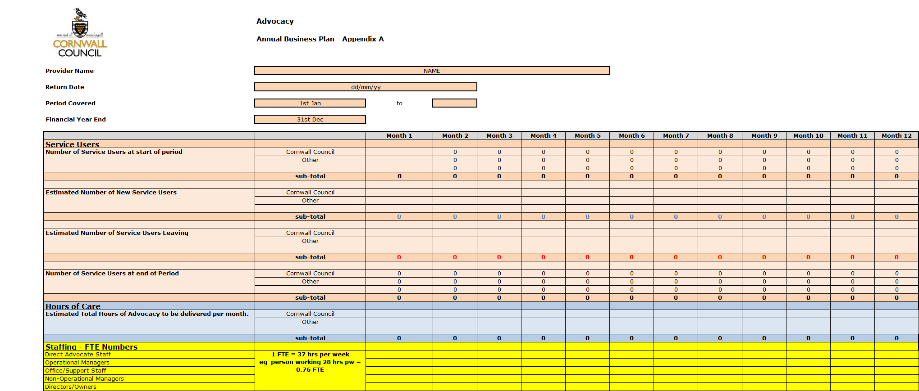

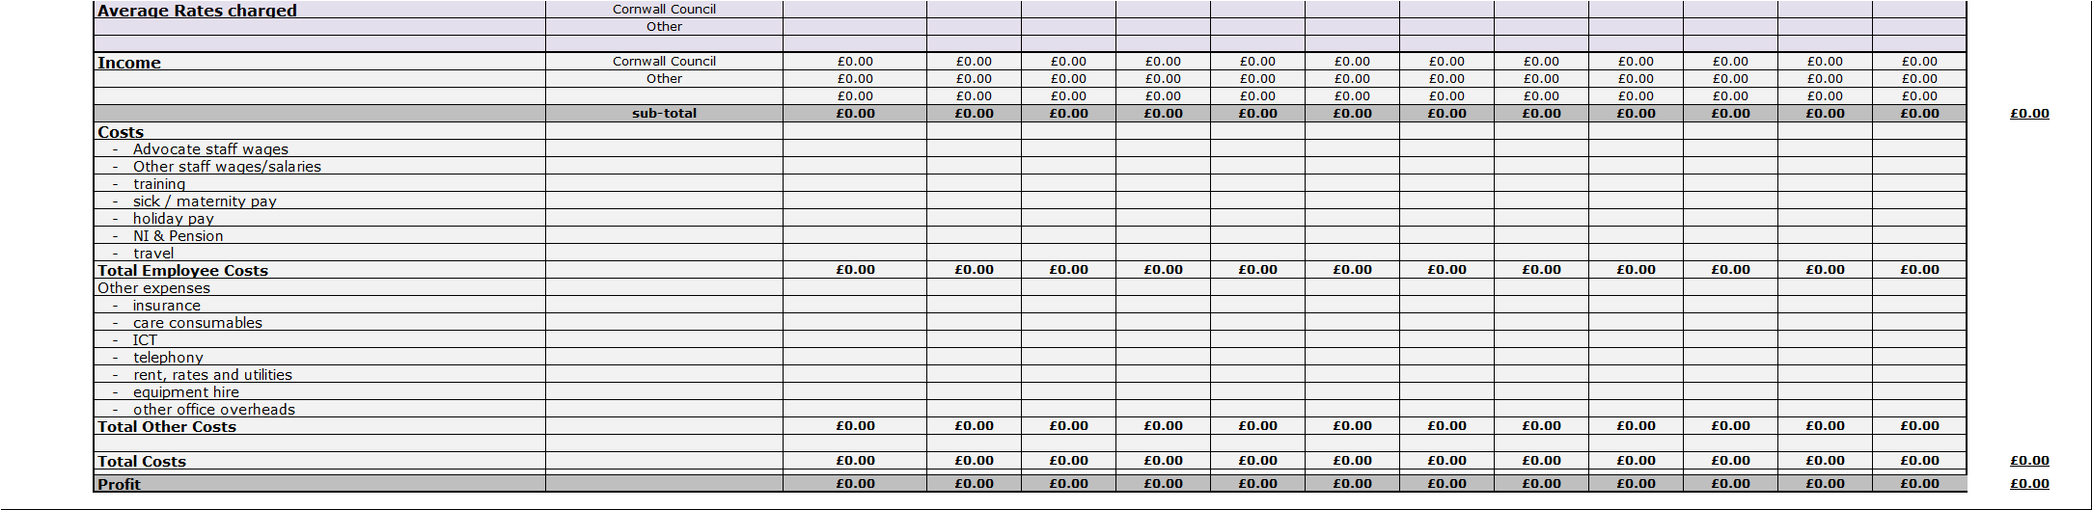

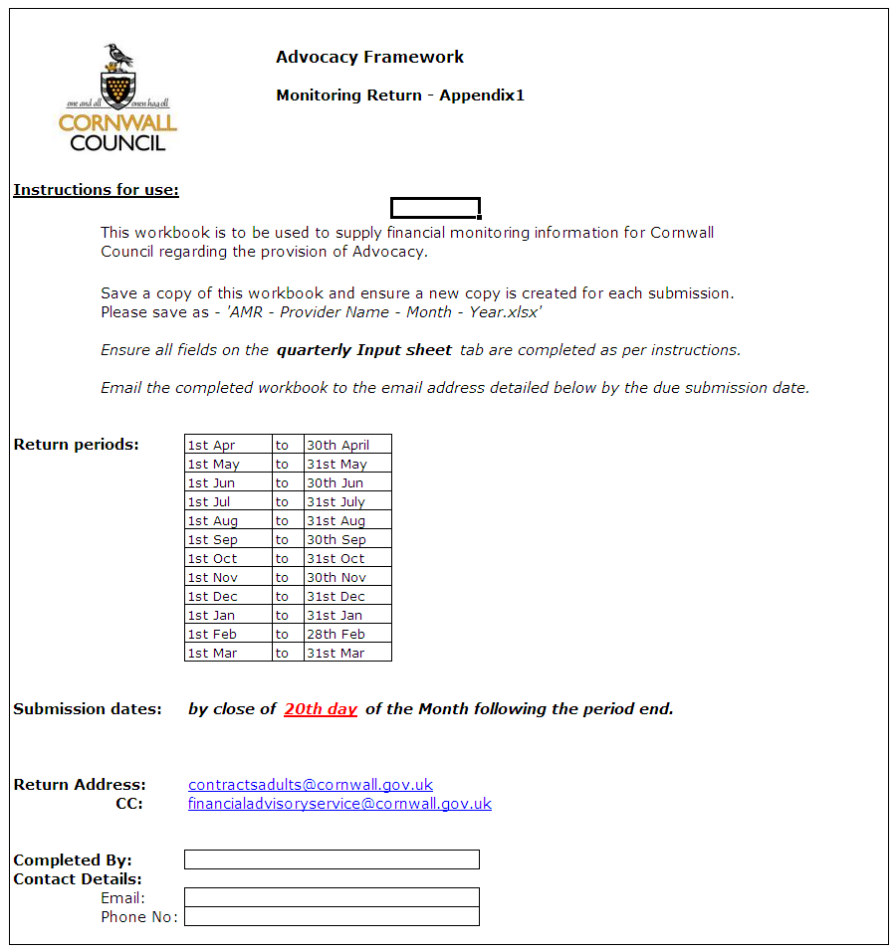

Monthly Monitoring Form
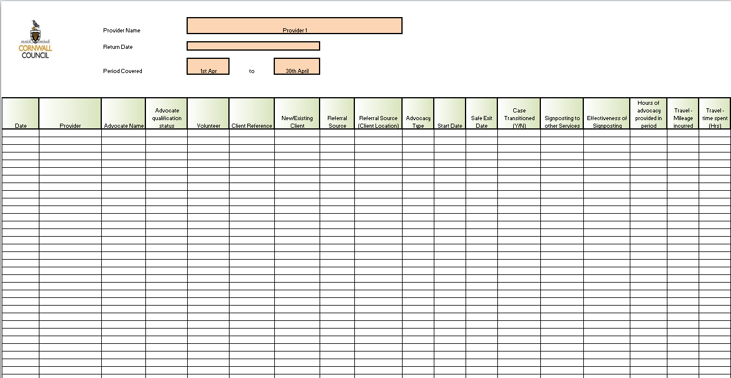

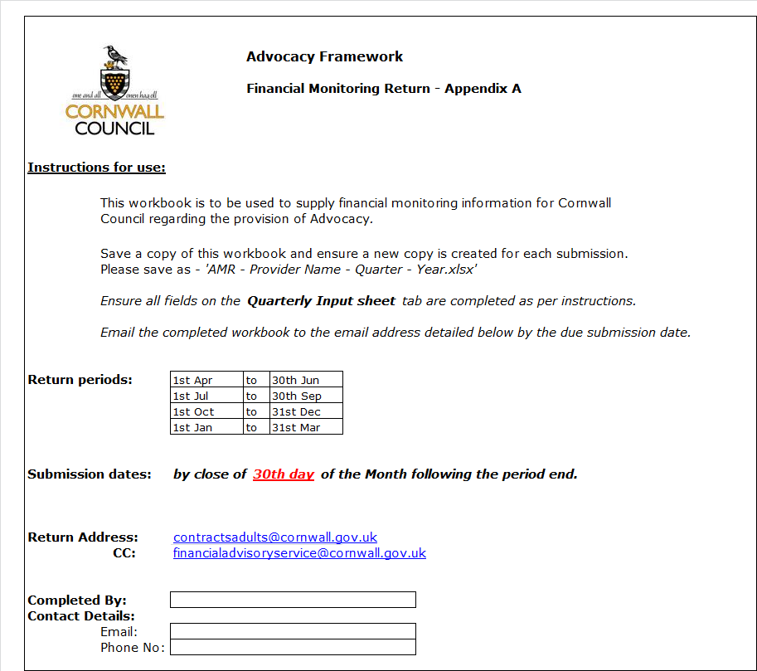
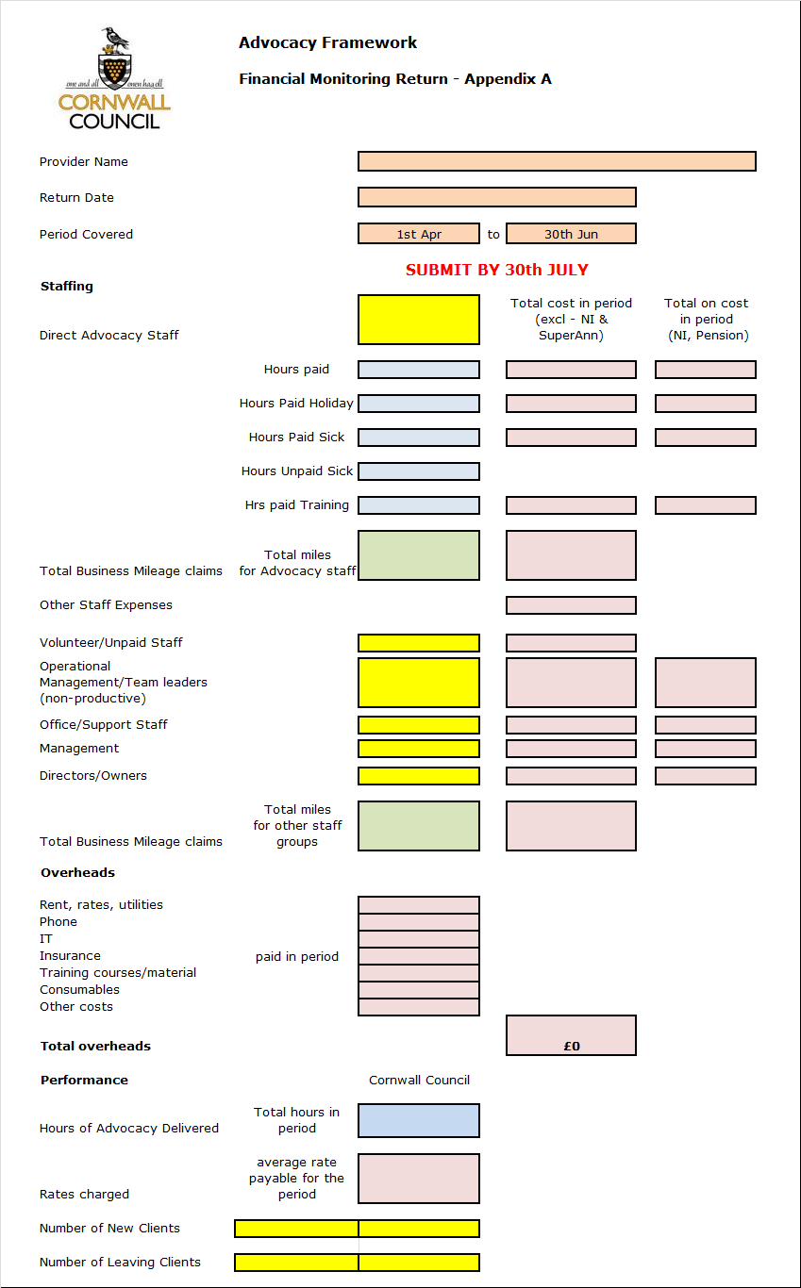

Quarterly Return: Financial Monitoring

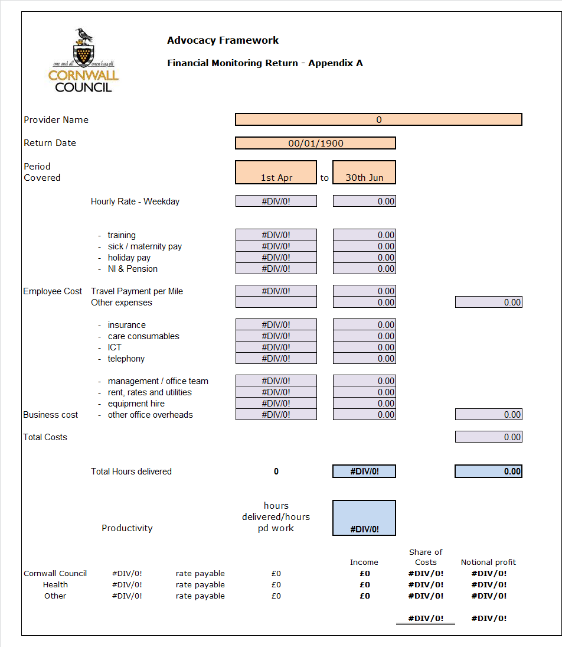

Appendix B
Appendix C Template for Equality and Diversity key information.
Template for use to obtain Equality and Diversity key information

Long Equal Opportunities Monitoring Form

Cornwall Council is committed to ensuring that our services, policies and practices are free from discrimination and prejudice and that they meet the needs of all the community. For us to check we are providing fair and effective services, we would be grateful if you would answer the questions below. You are under no obligation to provide the information requested, but it would help us greatly if you do.

Fair Processing Notice:
The information you provide will be treated in the strictest of confidence and may be passed on to other services within the Council, who will use it for the same purposes. The information you provide on this form will be processed in accordance with the requirements of the Data Protection Act 1998 and will not be passed onto any third party. At all times, it will be treated as confidential and used only for the purpose of Equality Monitoring. All personal information held by Cornwall Council is held safely in a secure environment. Thank you for your assistance.

About you:

- Please enter your postcode __________

- How do you describe your sex? Female Male

- Is your gender identity the same as the sex you were assigned at birth?

Yes No

- Which age group are you?

0 – 4 25 – 29 50 – 54 75 – 79
5 – 9 30 – 34 55 – 59 80 – 84
10 – 14 35 – 39 60 – 64 85 – 89
15 – 19 40 – 44 65 – 69 90 – 94
20 – 24 45 – 49 70 – 74 95+

- Do you consider yourself to have a disability? Yes No

If you have answered ‘yes’, please select the definition/s from the list below that best describes your impairment:

Physical or mobility impairment Sensory Impairment
Mental health condition Learning disability / difficulty
Long standing illness or health Other (please specify
condition (cancer, HIV, diabetes,
chronic heart disease or epilepsy ____________________________

Is there anything we can do or put in place which would make it easier for us to offer you an equal service? (For example documents in large print, hearing loop etc.).

______________________________________________________________________

Do you need someone to help you understand information? (For example someone to read documents with you or an interpreter).

______________________________________________________________________

- Do you give help or support to family members, friends, neighbours or others because of a long-term physical or mental health or disability, or problems related to old age (do not count anything you do as part of paid employment).

Yes No

- Do you consider your sexual orientation to be: Heterosexual/Straight

Lesbian/Gay woman Gay man Bisexual

- How do you describe you religion or belief (if any)?

Buddhist |  | Hindu |  | Jewish
Christian |  | Muslim |  | Sikh
Pagan |  | None
Other – please specify ________________________________________

- What is your legal marital or same-sex civil partnership status?

Never married and never registered a same sex civil partnership |  | In a registered same-sex civil partnership |  | Separated, but still legally in a same-sex civil partnership
Married |  | Divorced |  | Formerly in a same-sex civil partnership which is now legally dissolved
Separated, but still legally married |  | Widowed |  | Surviving partner from a same-sex civil partnership
- How do you describe your ethnic origin?

Please read through carefully before selecting the ethnic group that you feel most closely reflects your background.

White
English, Welsh, Scottish, Northern Irish, British  White Cornish |  | Irish  Other
Any other white background, please write below

Mixed
White & Asian  White & Black Caribbean |  | White & Black African  Mixed Cornish
Any other mixed background, please write below

Asian
Bangladeshi  Pakistani  Chinese |  | Indian  Asian Cornish
Any other Asian background, please write below

Black
African  Black Cornish |  | Caribbean
Any other Black background, please write below

Other
Gypsy/Roma |  | Traveller of Irish Heritage
Any other ethnic group, please write below

- It would help the Council to know of any barriers you have faced when dealing with us.

Appendix D Referral allocation system

Department of Health (October 2014). Care and Support Statutory guidance, issued under the Care Act 2014. Crown Copyright
Department of Health (2013) Adult Social Care Outcomes Framework 2014-15 .Crown copyright
Department of Health (2014) NHS Outcomes Framework 2015/16. Crown copyright
Advocacy Quality Performance Mark 3ed
You can delete ranges you will definitely not use, but please do not change the ranges specified.
Includes Church of England, Catholic, Protestant and all other Christian denominations.

