Request for quote for:

Design and build project – Edenbrook Country Park Boardwalk

Date opportunity posted | 2 October 2023
Dates for site visit | Week starting 16 October 2023
Last date for clarifications | 30 October 2023
Quotation return date | 12 noon, 13 November 2023
Estimated Contract Value | £40,000
Quotation shall be returned to | procurement@hart.gov.uk
With the subject line | HDC202307 Design and Build Edenbrook Country Park Boardwalk
Contact in case of queries | Sarah.leedham@hart.gov.uk

Introduction
  - The Council invites quotations for this opportunity in accordance with the terms and requirements of this document and any Schedules attached.
  - Document contents:
1 Introduction 1
2 Specification 2
3 Information for Bidders 6
2 Quotation response: Bidder details and declaration 10
3 Quotation response: Bidder submission 11
4 Terms and Conditions of Contract for Services 12

Specification
  - Key contract dates:
Site Visit | October 2023
Intended Start Date | November - December 2023
Duration | 2 weeks
Intended End Date | November - December 2023
Extension Details | To be agreed with the site ranger

  - Aim:
    - The Council is seeking a quote for the removal of a wooden boardwalk at Edenbrook Country Park and a design and build solution for its replacement within the specifications set out below.
    - The Council is seeking a competent contractor with proven experience in construction works on public open spaces, with an excellent track record delivering similar scale projects to deadlines and within budget.
  - Objectives:
The Council’s main objectives are:

- Removal of existing structure & disposal offsite at a licensed facility.

- Design & build solution fulfilling the following criteria -

- DDA compliant crossing required to replace function of the above. Width of structure must be 2 metres with a handrail on both sides along the complete structure.

- Handrail supports to be positioned on the outside of the 2m width to avoid reducing width space once in use.

- Edge of structure to be sited at least 50cm away from existing weir to allow for weir maintenance.

- Existing path at each end to be made up to the height of the structure and be DDA* compliant to form an easily accessible slope without a step to allow for a smooth transition from path to replacement structure. Path materials to match existing materials.

- Existing structure spans two separate voids, one over a section of pond with 4 posts in the pond and a second smaller section which spans a ditch. Contractor to provide design and build solution to replace current structure. If replacing existing posts currently positioned in the water these must be larger than the originals. Would consider a combination of structures and raised path between if this is a more cost-effective option.

- Surface of replacement structure must be non-slip to pedestrians. Wire mesh or similar is not permitted. Non-slip material integral to walking surface (e.g. as currently manufactured in decking boards) rather than exterior strips laid on top. Integral strips must be a natural colour such as tan.

- *DDA: Disability Discrimination Act

- Any timber used must be FSC (or similar) certified and grade ‘A’ and must be a timber that lasts a long time in wet environments such as green oak or Douglas fir.

- Access to work area via Pale Lane and access track beyond a height barrier and drop posts. Existing works compound next to bike track area can be used for storage of plant and materials at contractor's own risk.

- Work area to be secured with Heras fencing during operations. Ensure a safe working environment is maintained at all times, ensuring materials and machinery that are stored on site are kept secure and in a safe condition.

  - Timetable:
    - A site visit, accompanied by the site ranger, is required to understand the full scope of the work. Please email countryside@hart.gov.uk for the attention of Sarah Leedham to arrange a site visit, prior to submitting your bid.
    - Notification of start date from contractor to occur at least two weeks prior to start date of works on site.
    - The preferred start date would be in November to finish 14 days later, however this is flexible and weather dependent, as the site can be liable to flooding. The finish date is to occur before the end of February 2024.
  - Scope:
    - All costs, materials, labour, VAT and associated items to be included in the quote. Hart District Council will not be liable for any costs accrued in excess of the accepted quote.
  - Deliverables:
    - The successful bidder must:
- Submit an itemised quote
- Agree a start and finish date at least two weeks prior to the start date and provide copies of relevant insurance and RAMS.
- Agree access details with the site ranger and agree where materials will be delivered on site.
- Any permissions regarding placing structures in or near the water courses must be obtained by the contractor as part of the work.

- Owing to the nature of the site, work must be carried out outside of bird nesting season.

- Remove any temporary signage, barriers and fencing from site.

- Make good all damage to adjoining surfaces caused by the works, by access to the works by plant and machinery, by storage of materials and other causes within the contractor’s control.

- Compacted soil to be de-compacted and re-graded. Contaminated soil (for example accidental spillage of fuel) must be excavated and removed from site to an approved landfill site and replaced with uncontaminated subsoil and topsoil to match existing soil profile.

- Make good any damage to retained trees and other woody plants by pruning back damage to healthy growth in accordance with good arboricultural practice.

- Leave site clean and tidy. Remove all excess materials from site to the contractor’s store or to an approved tip, unless otherwise agreed in writing.

  - Monitoring arrangements:
    - The Council may monitor the performance of the Services by the Supplier.
    - Site ranger to view works with site foreman to ensure that the work has been completed to satisfaction. This is to take place ideally before any machinery and material are removed from site.
    - The site ranger will meet the contractor on site to discuss the planned works. Council staff may visit at any time during the works to inspect the site. Site access points are at Pipistrelle (w3w: class.swordfish.attaching via Edenbrook estate), Water Lilies (w3w: eats.startles.belief via Edenbrook Estate) and Pale Lane (w3w: respect.fame.factored).
    - Payment in full on completion of contract, when works have been signed off to client satisfaction and contractors have completely finished works on site.

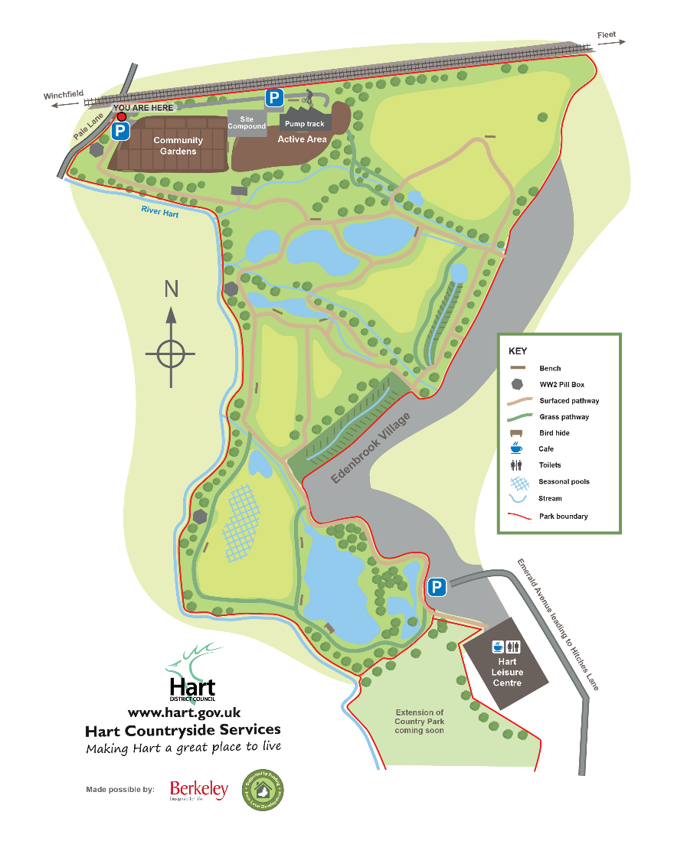
Pipistrelle entrance
Water Lilies entrance
Work site

Pale Lane entrance

Pipistrelle W3W class.swordfish.attaching



Water Lilies W3W eats.startles.belief

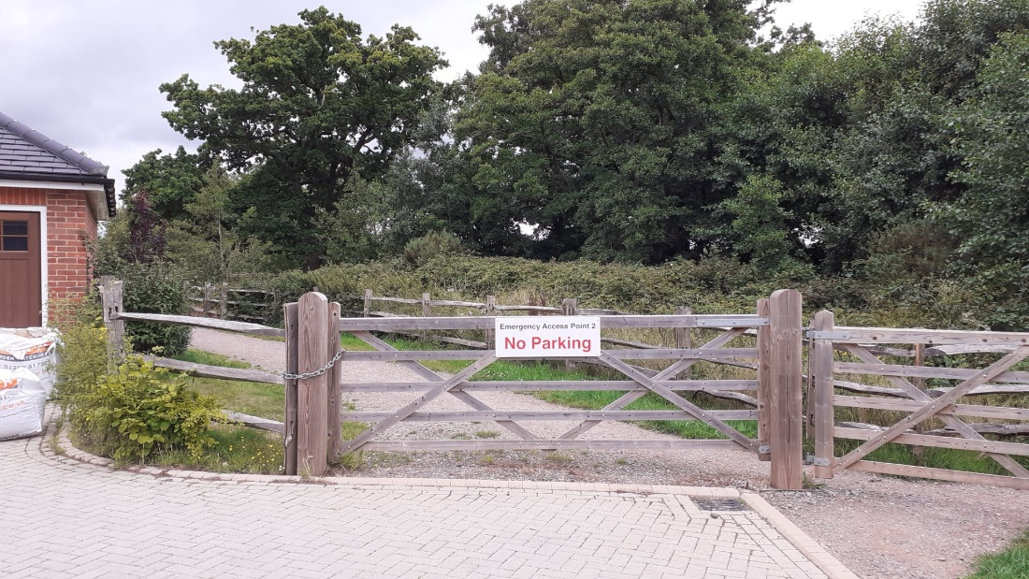

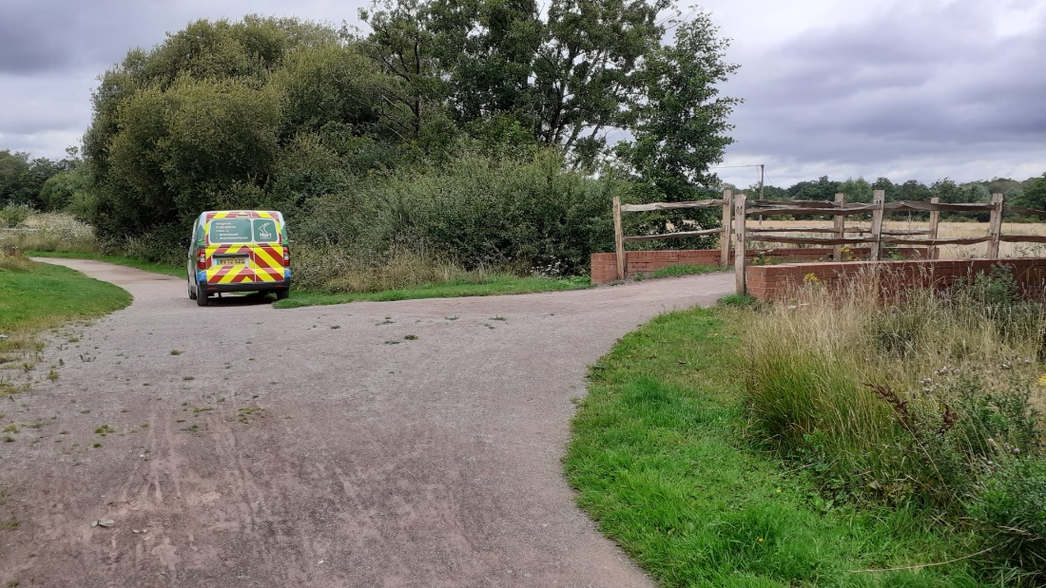

Information for Bidders
  - Photos and measurements of the current bridge and boardwalk to remove and replace can be seen in the Appendix.
  - All quotation response documents must be returned to the email address stated on page 1 by no later than the quotation return date also stated on page 1. Quotations received after this time will only be accepted in exceptional circumstances and at the council’s discretion.
  - If there appears to be an error or omission in a quotation the Council shall invite the Bidder to confirm the submitted price, including errors/omissions, or amend the submitted price to correct these errors/omissions. All amendments or confirmation of quotation must be confirmed in writing by the Bidder.
  - If the Council considers a query may have a material effect on quotation responses, all suppliers will be notified without delay via email.
  - The Council reserves the right to disregard any quotation where:
- in the opinion of the council, there is sufficient doubt as to the Bidder’s ability to perform the contract for the submitted price; or
- it does not fulfil a mandatory or pass / fail requirement; or
- it contains qualifications that conflict with the Request for Quotation instructions.
  - Quotations and supporting documents shall be in English and any contract subsequently entered into and its formation, interpretation and performance shall be subject to and in accordance with the laws of England and Wales.
  - All prices quoted shall, unless otherwise stated, include profit, transport, labour, materials, fuel and plant charges, insurance and all other expenses of every kind which under the conditions of Contract are borne by the Bidder. Prices quoted shall be in UK Sterling and exclusive of Value Added Tax. Value Added Tax shall be applied at the appropriate rate ruling at the date of any invoice.
  - Bidders must not take part in any publicity activities with any part of the media about the Contract or this opportunity without getting the Council’s written agreement first. This includes the Council’s agreement on the format and content of any publicity.
  - This opportunity is made available in good faith. The Council give no warranty as to the accuracy or completeness of the information contained in it. The Council also disclaim any liability for any inaccuracy or incompleteness. The Council reserve the right to cancel the Quotation process at any point.
  - The Council are not liable for any costs resulting from any cancellation of this Quotation process or for any other costs that Bidders may incur by Tendering for this Contract. Bidders must obtain at their own expense all the information that they need for the preparation of their Quotation.
  - Bidders will be deemed to fully understand the processes that the Council must follow under relevant legislation, and where the value of the opportunity is deemed to be above relevant thresholds, will adhere to the requirements set out in such legislation.
- CODE OF WORKING

  - All works to be carried out by contractor in line with Hart District Council’s Contractor Code of Conduct.

  - Invoice to be received following completion of works, unless a staged schedule of payment has been agreed in writing prior to commencing works.

  - Quotation is expected to be a fixed price, providing work is awarded within a reasonable time from the quotation deadline, unless there are unforeseeable additional expenses that are outside of the contractor’s control, such as weather delaying start dates or additional requirements from client (e.g. extended/reduced boardwalk lengths).

  - Contractor is expected to adhere to agreed start and finish dates, unless there are factors beyond contractor control, such as incremental weather and site conditions. Where there are contractor delays that could have been reasonably avoided by the contractor, any associated costs incurred will be the responsibility of the contractor to cover. Evaluation and award process.

- Evaluation and Award Process

  - The contract, if awarded, will be awarded, based on the following criteria:
Criteria |  |  | Score
Price (calculated as per 4.2): |  |  | 40%
Quality (which is scored on against the sub-criteria below): |  |  | 60%
 | Experience | 20%
 | Design and Method Statement | 35%
 | References / Case studies | 5%

  - The percent share will be given the maximum score available. Other scores will then be calculated as a proportion of this based on the formula below:
Lowest price
Price of next quote to be considered

  - The Price element of the evaluation will only be scored once the Quality criteria have been assessed.
  - The each section in the Quality criteria will be scored using the following template:
Exceptional demonstration by the supplier of the relevant ability, understanding, skills, facilities and quality measures required to provide the services with evidence to support the response, where appropriate. | 5
Good demonstration by the Supplier of the relevant ability, understanding, skills, facilities and quality measures required to provide the services with evidence to support the response, where appropriate. | 4
Satisfactory demonstration by the Supplier of the relevant ability, understanding, skills, facilities and quality measures required to provide the services with evidence to support the response, where appropriate. | 3
Contains minor shortcomings in the demonstration by the Supplier of the relevant ability, understanding, skills, facilities and quality measures required to provide the services with evidence to support the response, where appropriate and/or is inconsistent or in conflict with other proposals with little or no evidence to support the response. | 2
Satisfies the requirement but with considerable reservations of the supplier’s relevant ability, understanding, skills, facilities and quality measures required to provide the services, with little or no evidence to support the response. | 1
No response or irrelevant response provided. | 0

  - Any responses scoring less than 2 for any Quality criteria, may be considered to not meet the requirements, and therefore fail the evaluation and the quotation may be rejected. As per 4.3, the Price element will not be assessed in those circumstances.
  - Bidders will be notified via email as soon as possible of any decision made by the council during the quotation process, including notifying Bidders of the intended award.
  - As part of the notification of award process, Bidders will be provided with details of the points awarded for their submitted responses in line with the evaluation criteria above.
  - Bidders must not undertake work without first having received an Official Purchase Order as written notification that they have been awarded the contract and are required to start work.

Quotation response: Bidder details and declaration

  - Please complete the following and sign to confirm that your quotation is fully compliant with the Specification, and all Terms and Conditions as stated within this documentation.
Company Name:
Address:
Telephone:
E-mail:
Signed:
Print Name:
Position in Company:
Date:

Quotation response: Bidder submission

  - Please complete the following pricing schedule in full (values must be exclusive of VAT).
[Breakdown as needed] | £
[Breakdown as needed] | £
[Breakdown as needed] | £
Total cost for contract term | £

  - Please complete the following section which will be used to score the Quality criteria.
Experience – 20%
- Please tell us about any previous experience you have on similar projects

Design and Method Statement – 35%
- Please detail your method statement, including how you plan to carry out operations in a sympathetic way that is appropriate to site’s natural environment, outline RAMs or CEMP to be provided to include best practice standards (e.g. for refuelling and management of oil spills etc) – 15%
- Please detail the proposed design with detailed and scaled drawings. Please include detail of the proposed materials and their longevity – 15%
- Please detail how you will consider sustainability in your design, in the materials you use and your work practices – 5%

References / Case studies – 5%
- Please provide one or two case studies of previous work with links or photos attached

Terms and Conditions of Contract for Services

- Interpretation
  - In these terms and conditions:
“Agreement” | means the contract between (i) the Council and (ii) the Supplier constituted by the Supplier’s countersignature of the Award Letter and includes the Award Letter and Annexes;
“Award Letter” | means the letter from the Council to the Supplier printed above these terms and conditions;
“Charges” | means the charges for the Services as specified in the Award Letter;
“Confidential Information” | means all information, whether written or oral (however recorded), provided by the disclosing Party to the receiving Party and which (i) is known by the receiving Party to be confidential; (ii) is marked as or stated to be confidential; or (iii) ought reasonably to be considered by the receiving Party to be confidential;
“Council” | means Hart District Council, located at Hart District Council, Civic Offices, Harlington Way, Fleet, Hampshire GU51 4AE;
“DPA”  “Data Protection Legislation” | means the Data Protection Act 2018;  means the DPA, the EU Data Protection Directive 95/46/EC, the General Data Protection Regulation (GDPR) (EU) 2016/679 and all applicable laws and regulations relating to processing of personal data and privacy, including where applicable the guidance and codes of practice issued by the Information Commissioner;
“Expiry Date” | means the date for expiry of the Agreement as set out in the Award Letter;
“FOIA”  “Force majeure event” | means the Freedom of Information Act 2000 together with any guidance and/or codes of practice issued by the Information Commissioner or relevant government department in relation to such legislation;  means any circumstance not within a party’s reasonable control including, without limitation:  - acts of God, flood, drought, earthquake or other natural disaster;  - epidemic or pandemic;  - terrorist attack, civil war, civil commotion or riots, war, threat of or preparation for war, armed conflict, imposition of sanctions, embargo, or breaking off of diplomatic relations;  - nuclear, chemical or biological contamination or sonic boom;  - any law or any action taken by a government or public authority, including limitation imposing an export or import restriction, quota or prohibition;  - collapse of buildings, fire, explosion or accident; and  - any labour or trade dispute, strikes, industrial action or lockouts (other than in each case by the party seeking to rely on this clause, or companies in the same group as that party);  - non-performance by suppliers or sub-contractors (other than by companies in the same group as the party seeking to rely on this clause); and  - interruption or failure of utility service.
“Information” | has the meaning given under section 84 of the FOIA;
“Key Personnel” | means any persons specified as such in the Award Letter or otherwise notified as such by the Council to the Supplier in writing;
“Party” | means the Supplier or the Council (as appropriate) and “Parties” shall mean both of them;
“Personal Data” | means personal data (as defined in the Data Protection Legislation) which is processed by the Supplier or any Staff on behalf of the Council pursuant to or in connection with this Agreement;
“Purchase Order Number” | means the Council’s unique number relating to the supply of the Services;
“Request for Information” | has the meaning set out in the FOIA or the Environmental Information Regulations 2004 as relevant (where the meaning set out for the term “request” shall apply);
“Services” | means the services to be supplied by the Supplier to the Council under the Agreement;
“Specification” | means the specification for the Services (including as to quantity, description and quality) as specified in the Award Letter;
“Staff” | means all directors, officers, employees, agents, consultants and contractors of the Supplier and/or of any sub-contractor of the Supplier engaged in the performance of the Supplier’s obligations under the Agreement;
“Staff Vetting Procedures” | means vetting procedures that accord with good industry practice or, where requested by the Council, the Council’s procedures for the vetting of personnel as provided to the Supplier from time to time;
“Supplier” | means the person named as Supplier in the Award Letter;
“Term” | means the period from the start date of the Agreement set out in the Award Letter to the Expiry Date as such period may be extended in accordance with clause 4.2 or terminated in accordance with the terms and conditions of the Agreement;
“VAT” | means value added tax in accordance with the provisions of the Value Added Tax Act 1994; and
“Working Day” | means a day (other than a Saturday or Sunday) on which banks are open for business in the City of London.
  - In these terms and conditions, unless the context otherwise requires:
    - references to numbered clauses are references to the relevant clause in these terms and conditions;
    - any obligation on any Party not to do or omit to do anything shall include an obligation not to allow that thing to be done or omitted to be done;
    - the headings to the clauses of these terms and conditions are for information only and do not affect the interpretation of the Agreement;
    - any reference to an enactment includes reference to that enactment as amended or replaced from time to time and to any subordinate legislation or byelaw made under that enactment; and
    - the word ‘including’ shall be understood as meaning ‘including without limitation’.
- Basis of Agreement
  - The Award Letter constitutes an offer by the Council to purchase the Services subject to and in accordance with the terms and conditions of the Agreement.
  - The offer comprised in the Award Letter shall be deemed to be accepted by the Supplier on receipt by the Council of a copy of the Award Letter countersigned by the Supplier within 7 days of the date of the Award Letter.
- Supply of Services
  - In consideration of the Council’s agreement to pay the Charges, the Supplier shall supply the Services to the Council for the Term subject to and in accordance with the terms and conditions of the Agreement.
  - In supplying the Services, the Supplier shall:
    - co-operate with the Council in all matters relating to the Services and comply with all the Council’s instructions;
    - perform the Services with all reasonable care, skill and diligence in accordance with good industry practice in the Supplier’s industry, profession or trade;
    - use Staff who are suitably skilled and experienced to perform tasks assigned to them, and in sufficient number to ensure that the Supplier’s obligations are fulfilled in accordance with the Agreement;
    - ensure that the Services shall conform with all descriptions and specifications set out in the Specification;
    - comply with all applicable laws; and
    - provide all equipment, tools and vehicles and other items as are required to provide the Services.
  - The Council may by written notice to the Supplier at any time request a variation to the scope of the Services. In the event that the Supplier agrees to any variation to the scope of the Services, the Charges shall be subject to fair and reasonable adjustment to be agreed in writing between the Council and the Supplier.

- Term
  - The Agreement shall take effect on the date specified in Award Letter and shall expire on the Expiry Date, unless it is otherwise extended in accordance with clause 4.2 or terminated in accordance with the terms and conditions of the Agreement.
  - The Council may exercise an option to extend the Agreement for a period of 2 years, subject to the mutual agreement of the parties, by giving not less than 10 Working Days’ notice in writing to the Supplier prior to the Expiry Date. The terms and conditions of the Agreement shall apply throughout any such extended period.
- Charges, Payment and Recovery of Sums Due
  - The Charges for the Services shall be as set out in the Award Letter and shall be the full and exclusive remuneration of the Supplier in respect of the supply of the Services. Unless otherwise agreed in writing by the Council, the Charges shall include every cost and expense of the Supplier directly or indirectly incurred in connection with the performance of the Services.
  - All amounts stated are exclusive of VAT which shall be charged at the prevailing rate. The Council shall, following the receipt of a valid VAT invoice, pay to the Supplier a sum equal to the VAT chargeable in respect of the Services.
  - The Supplier shall invoice the Council as specified in the Agreement. Each invoice shall include such supporting information required by the Council to verify the accuracy of the invoice, including the relevant Purchase Order Number and a breakdown of the Services supplied in the invoice period.
  - In consideration of the supply of the Services by the Supplier, the Council shall pay the Supplier the invoiced amounts no later than 30 days after verifying that the invoice is valid and undisputed and includes a valid Purchase Order Number. The Council may, without prejudice to any other rights and remedies under the Agreement, withhold or reduce payments in the event of unsatisfactory performance.
  - If the Council fails to consider and verify an invoice in a timely fashion the invoice shall be regarded as valid and undisputed for the purpose of paragraph 5.4 after a reasonable time has passed.
  - If there is a dispute between the Parties as to the amount invoiced, the Council shall pay the undisputed amount. The Supplier shall not suspend the supply of the Services unless the Supplier is entitled to terminate the Agreement for the Council’s failure to pay undisputed sums in accordance with clause 17.4. Any disputed amounts shall be resolved through the dispute resolution procedure detailed in clause 20.
  - If a payment of an undisputed amount is not made by the Council by the due date, then the Council shall pay the Supplier interest at the interest rate specified in the Late Payment of Commercial Debts (Interest) Act 1998.
  - Where the Supplier enters into a sub-contract, the Supplier shall include in that sub-contract:
    - provisions having the same effects as clauses 5.3 to 5.7 of this Agreement; and
    - a provision requiring the counterparty to that sub-contract to include in any sub-contract which it awards provisions having the same effect as 5.3 to 5.8 of this Agreement.
    - In this clause 5.8, “sub-contract” means a contract between two or more suppliers, at any stage of remoteness from the Authority in a subcontracting chain, made wholly or substantially for the purpose of performing (or contributing to the performance of) the whole or any part of this Agreement.
  - If any sum of money is recoverable from or payable by the Supplier under the Agreement (including any sum which the Supplier is liable to pay to the Council in respect of any breach of the Agreement), that sum may be deducted unilaterally by the Council from any sum then due, or which may come due, to the Supplier under the Agreement or under any other agreement or contract with the Council. The Supplier shall not be entitled to assert any credit, set-off or counterclaim against the Council in order to justify withholding payment of any such amount in whole or in part.
- Premises and equipment
  - If necessary, the Council shall provide the Supplier with reasonable access at reasonable times to its premises for the purpose of supplying the Services. All equipment, tools and vehicles brought onto the Council’s premises by the Supplier or the Staff shall be at the Supplier’s risk.
  - If the Supplier supplies all or any of the Services at or from the Council’s premises, on completion of the Services or termination or expiry of the Agreement (whichever is the earlier) the Supplier shall vacate the Council’s premises, remove the Supplier’s plant, equipment and unused materials and all rubbish arising out of the provision of the Services and leave the Council’s premises in a clean, safe and tidy condition. The Supplier shall be solely responsible for making good any damage to the Council’s premises or any objects contained on the Council’s premises which is caused by the Supplier or any Staff, other than fair wear and tear.
  - If the Supplier supplies all or any of the Services at or from its premises or the premises of a third party, the Council may, during normal business hours and on reasonable notice, inspect and examine the manner in which the relevant Services are supplied at or from the relevant premises.
  - The Council shall be responsible for maintaining the security of its premises in accordance with its standard security requirements. While on the Council’s premises the Supplier shall, and shall procure that all Staff shall, comply with all the Council’s security requirements.
  - Where all or any of the Services are supplied from the Supplier’s premises, the Supplier shall, at its own cost, comply with all security requirements specified by the Council in writing.
  - Without prejudice to clause 3.2.6, any equipment provided by the Council for the purposes of the Agreement shall remain the property of the Council and shall be used by the Supplier and the Staff only for the purpose of carrying out the Agreement. Such equipment shall be returned promptly to the Council on expiry or termination of the Agreement.
  - The Supplier shall reimburse the Council for any loss or damage to the equipment (other than deterioration resulting from normal and proper use) caused by the Supplier or any Staff. Equipment supplied by the Council shall be deemed to be in a good condition when received by the Supplier or relevant Staff unless the Council is notified otherwise in writing within 5 Working Days.
- Staff and Key Personnel
  - If the Council reasonably believes that any of the Staff are unsuitable to undertake work in respect of the Agreement, it may, by giving written notice to the Supplier:
    - refuse admission to the relevant person(s) to the Council’s premises;
    - direct the Supplier to end the involvement in the provision of the Services of the relevant person(s); and/or
    - require that the Supplier replace any person removed under this clause with another suitably qualified person and procure that any security pass issued by the Council to the person removed is surrendered, and the Supplier shall comply with any such notice.
  - The Supplier shall:
    - ensure that all Staff are vetted in accordance with the Staff Vetting Procedures;
    - if requested, provide the Council with a list of the names and addresses (and any other relevant information) of all persons who may require admission to the Council’s premises in connection with the Agreement; and
    - procure that all Staff comply with any rules, regulations and requirements reasonably specified by the Council.
  - Any Key Personnel shall not be released from supplying the Services without the agreement of the Council, except by reason of long-term sickness, maternity leave, paternity leave, termination of employment or other extenuating circumstances.
  - Any replacements to the Key Personnel shall be subject to the prior written agreement of the Council (not to be unreasonably withheld). Such replacements shall be of at least equal status or of equivalent experience and skills to the Key Personnel being replaced and be suitable for the responsibilities of that person in relation to the Services.
- Assignment and sub-contracting
  - The Supplier shall not without the written consent of the Council assign, sub-contract, novate or in any way dispose of the benefit and/ or the burden of the Agreement or any part of the Agreement. The Council may, in the granting of such consent, provide for additional terms and conditions relating to such assignment, sub-contract, novation or disposal. The Supplier shall be responsible for the acts and omissions of its sub-contractors as though those acts and omissions were its own.
  - Where the Council has consented to the placing of sub-contracts, the Supplier shall, at the request of the Council, send copies of each sub-contract, to the Council as soon as is reasonably practicable.
  - The Council may assign, novate, or otherwise dispose of its rights and obligations under the Agreement without the consent of the Supplier provided that such assignment, novation or disposal shall not increase the burden of the Supplier’s obligations under the Agreement.

- Intellectual Property Rights
  - All intellectual property rights in any materials provided by the Council to the Supplier for the purposes of this Agreement shall remain the property of the Council but the Council hereby grants the Supplier a royalty-free, non-exclusive and non-transferable licence to use such materials as required until termination or expiry of the Agreement for the sole purpose of enabling the Supplier to perform its obligations under the Agreement.
  - All intellectual property rights in any materials created or developed by the Supplier pursuant to the Agreement or arising as a result of the provision of the Services shall vest in the Supplier. If, and to the extent, that any intellectual property rights in such materials vest in the Council by operation of law, the Council hereby assigns to the Supplier by way of a present assignment of future rights that shall take place immediately on the coming into existence of any such intellectual property rights all its intellectual property rights in such materials (with full title guarantee and free from all third party rights).
  - The Supplier hereby grants the Council:
      - a perpetual, royalty-free, irrevocable, non-exclusive licence (with a right to sub-license) to use all intellectual property rights in the materials created or developed pursuant to the Agreement and any intellectual property rights arising as a result of the provision of the Services; and
    - a perpetual, royalty-free, irrevocable and non-exclusive licence (with a right to sub-license) to use:
    - any intellectual property rights vested in or licensed to the Supplier on the date of the Agreement; and
    - any intellectual property rights created during the Term but which are neither created or developed pursuant to the Agreement nor arise as a result of the provision of the Services, including any modifications to or derivative versions of any such intellectual property rights, which the Council reasonably requires in order to exercise its rights and take the benefit of the Agreement including the Services provided.
  - The Supplier shall indemnify, and keep indemnified, the Council in full against all costs, expenses, damages and losses (whether direct or indirect), including any interest, penalties, and reasonable legal and other professional fees awarded against or incurred or paid by the Council as a result of or in connection with any claim made against the Council for actual or alleged infringement of a third party’s intellectual property arising out of, or in connection with, the supply or use of the Services, to the extent that the claim is attributable to the acts or omission of the Supplier or any Staff.
- Governance and Records
  - The Supplier shall:
    - attend progress meetings with the Council at the frequency and times specified by the Council and shall ensure that its representatives are suitably qualified to attend such meetings; and
    - submit progress reports to the Council at the times and in the format specified by the Council.
  - The Supplier shall keep and maintain until 6 years after the end of the Agreement, or as long a period as may be agreed between the Parties, full and accurate records of the Agreement including the Services supplied under it and all payments made by the Council. The Supplier shall on request afford the Council or the Council’s representatives such access to those records as may be reasonably requested by the Council in connection with the Agreement.
- Confidentiality, Transparency and Publicity
  - Subject to clause 11.2, each Party shall:
    - treat all Confidential Information it receives as confidential, safeguard it accordingly and not disclose it to any other person without the prior written permission of the disclosing Party; and
    - not use or exploit the disclosing Party’s Confidential Information in any way except for the purposes anticipated under the Agreement.
  - Notwithstanding clause 11.1, a Party may disclose Confidential Information which it receives from the other Party:
    - where disclosure is required by applicable law or by a court of competent jurisdiction;
    - to its auditors or for the purposes of regulatory requirements;
    - on a confidential basis, to its professional advisers;
    - to the Serious Fraud Office where the Party has reasonable grounds to believe that the other Party is involved in activity that may constitute a criminal offence under the Bribery Act 2010;
    - where the receiving Party is the Supplier, to the Staff on a need to know basis to enable performance of the Supplier’s obligations under the Agreement provided that the Supplier shall procure that any Staff to whom it discloses Confidential Information pursuant to this clause 11.2.5 shall observe the Supplier’s confidentiality obligations under the Agreement; and
    - where the receiving Party is the Council:
    - on a confidential basis to the employees, agents, consultants and contractors of the Council;
    - on a confidential basis to any company to which the Council transfers or proposes to transfer all or any part of its business;
    - to the extent that the Council (acting reasonably) deems disclosure necessary or appropriate in the course of carrying out its public functions; or
    - in accordance with clause 12; and for the purposes of the foregoing, references to disclosure on a confidential basis shall mean disclosure subject to a confidentiality agreement or arrangement containing terms no less stringent than those placed on the Council under this clause 11.
  - The Parties acknowledge that, except for any information which is exempt from disclosure in accordance with the provisions of the FOIA, the content of the Agreement is not Confidential Information and the Supplier hereby gives its consent for the Council to publish this Agreement in its entirety to the general public (but with any information that is exempt from disclosure in accordance with the FOIA redacted) including any changes to the Agreement agreed from time to time. The Council may consult with the Supplier to inform its decision regarding any redactions but shall have the final decision in its absolute discretion whether any of the content of the Agreement is exempt from disclosure in accordance with the provisions of the FOIA.
  - The Supplier shall not, and shall take reasonable steps to ensure that the Staff shall not, make any press announcement or publicise the Agreement or any part of the Agreement in any way, except with the prior written consent of the Council.
- Freedom of Information
  - The Supplier acknowledges that the Council is subject to the requirements of the FOIA and the Environmental Information Regulations 2004 and shall:
    - provide all necessary assistance and cooperation as reasonably requested by the Council to enable the Council to comply with its obligations under the FOIA and the Environmental Information Regulations 2004;
    - transfer to the Council all Requests for Information relating to this Agreement that it receives as soon as practicable and in any event within 2 Working Days of receipt;
    - provide the Council with a copy of all Information belonging to the Council requested in the Request for Information which is in its possession or control in the form that the Council requires within 5 Working Days (or such other period as the Council may reasonably specify) of the Council's request for such Information; and
    - not respond directly to a Request for Information unless authorised in writing to do so by the Council.
  - The Supplier acknowledges that the Council may be required under the FOIA and the Environmental Information Regulations 2004 to disclose Information concerning the Supplier or the Services (including commercially sensitive information) without consulting or obtaining consent from the Supplier. In these circumstances the Council shall, in accordance with any relevant guidance issued under the FOIA, take reasonable steps, where appropriate, to give the Supplier advance notice, or failing that, to draw the disclosure to the Supplier’s attention after any such disclosure.
  - Notwithstanding any other provision in the Agreement, the Council shall be responsible for determining in its absolute discretion whether any Information relating to the Supplier or the Services is exempt from disclosure in accordance with the FOIA and/or the Environmental Information Regulations 2004.
- Protection of Personal Data and Security of Data
  - The Supplier shall, and shall procure that all Staff shall, comply with any notification requirements under the DPA and both Parties shall duly observe all their obligations under the DPA which arise in connection with the Agreement.
  - The Parties acknowledge that for the purposes of the Data Protection Legislation, the Council is the Controller and the Supplier is the Data Processor.
  - Notwithstanding the general obligation in clause 13.1, where the Supplier is processing Personal Data for the Council as a data processor (as defined by the DPA) the Supplier shall:
    - process that Personal Data only on the documented written instructions of the Council unless the Supplier is required by Applicable Law to process Personal Data. Where the Supplier is relying on the laws of a member of the European Union or European Union law as the basis for processing Personal Data, the Supplier shall promptly notify the Council of this before performing the processing required by the Applicable Law unless the Applicable Law prohibits the Supplier from notifying the Council;
    - ensure that it has in place appropriate technical and organisational measures to ensure the security of the Personal Data (and to guard against unauthorised or unlawful processing of the Personal Data and against accidental loss or destruction of, or damage to, the Personal Data), as required under the Seventh Data Protection Principle in Schedule 1 to the DPA;
    - provide the Council with such information as the Council may reasonably request to satisfy itself that the Supplier is complying with its obligations under the DPA;
    - ensure that all personnel who have access to and/or process Personal Data are obliged to keep the Personal Data confidential.
    - The Supplier must promptly notify the Council of:
    - any breach of the security requirements of the Council as referred to in clause 13.; and

    - any request for personal data;
    - ensure that it does not knowingly or negligently do or omit to do anything which places the Council in breach of the Council’s obligations under the DPA or Data Protection Legislation;
    - maintain complete and accurate records and information to demonstrate its compliance with this clause 13 and immediately inform the Council, if in the opinion of the Supplier, an instruction infringes the Data Protection Legislation.
  - When handling Council data (whether or not Personal Data), the Supplier shall ensure the security of the data is maintained in line with the security requirements of the Council as notified to the Supplier from time to time.
  - If the Supplier appoints a third party processor of Personal Data under the Agreement, the Supplier must confirm that it has entered or will enter with the third party processor into a written agreement incorporating terms which are substantially similar to those set out in this clause 13 and in either case which the Supplier confirms that it will continue to reflect the requirements of the Data Protection Legislation. As between the Council and Supplier, the Supplier shall remain fully liable for all acts or omissions of any third party processor appointed by it pursuant to this. As between the Council and the Supplier, the Supplier shall remain fully liable for all acts or omissions of any third party processor appointed by it pursuant to this clause 13.
- Liability
  - The Supplier shall not be responsible for any injury, loss, damage, cost or expense suffered by the Council if and to the extent that it is caused by the negligence or wilful misconduct of the Council or by breach by the Council of its obligations under the Agreement.
  - Subject always to clauses 14.3 and 14.4:
    - the aggregate liability of the Supplier in respect of all defaults, claims, losses or damages howsoever caused, whether arising from breach of the Agreement, the supply or failure to supply of the Services, misrepresentation (whether tortuous or statutory), tort (including negligence), breach of statutory duty or otherwise shall in no event exceed a sum equal to 125% of the Charges paid or payable to the Supplier; and
    - except in the case of claims arising under clauses 9.4 and 19.3, in no event shall the Supplier be liable to the Council for any:
      - loss of profits;
      - loss of business;
      - loss of revenue;
      - loss of or damage to goodwill;
      - loss of savings (whether anticipated or otherwise); and/or
      - any indirect, special or consequential loss or damage.
  - Nothing in the Agreement shall be construed to limit or exclude either Party's liability for:
    - death or personal injury caused by its negligence or that of its Staff;
    - fraud or fraudulent misrepresentation by it or that of its Staff; or
    - any other matter which, by law, may not be excluded or limited.
  - The Supplier’s liability under the indemnity in clause 9.4 and 19.3 shall be unlimited.
- Insurance
Without prejudice to the Suppliers obligations contained in the Agreement, the Supplier shall take out and maintain Public Liability , Professional Liability and Employer’s Liability Insurances for sums not less than £5,000,000 and produce to the Council on demand, documentary proof of such insurances.
- Force Majeure
Neither Party shall have any liability under or be deemed to be in breach of the Agreement for any delays or failures in performance of the Agreement which result from a Force Majeure event . Each Party shall promptly notify the other Party in writing when such circumstances cause a delay or failure in performance and when they cease to do so. If such circumstances continue for a continuous period of more than two months, either Party may terminate the Agreement by written notice to the other Party.
- Termination
  - The Council may terminate the Agreement at any time by notice in writing to the Supplier to take effect on any date falling at least 1 month (or, if the Agreement is less than 3 months in duration, at least 10 Working Days) later than the date of service of the relevant notice.
  - Without prejudice to any other right or remedy it might have, the Council may terminate the Agreement by written notice to the Supplier with immediate effect if the Supplier:
    - (without prejudice to clause 17.2.5), is in material breach of any obligation under the Agreement which is not capable of remedy;
    - repeatedly breaches any of the terms and conditions of the Agreement in such a manner as to reasonably justify the opinion that its conduct is inconsistent with it having the intention or ability to give effect to the terms and conditions of the Agreement;
    - is in material breach of any obligation which is capable of remedy, and that breach is not remedied within 30 days of the Supplier receiving notice specifying the breach and requiring it to be remedied;
    - undergoes a change of control within the meaning of section 416 of the Income and Corporation Taxes Act 1988;
    - breaches any of the provisions of clauses 7.2, 11, 12, 13 and ;
    - becomes insolvent, or if an order is made or a resolution is passed for the winding up of the Supplier (other than voluntarily for the purpose of solvent amalgamation or reconstruction), or if an administrator or administrative receiver is appointed in respect of the whole or any part of the Supplier’s assets or business, or if the Supplier makes any composition with its creditors or takes or suffers any similar or analogous action (to any of the actions detailed in this clause 17.2.6) in consequence of debt in any jurisdiction; or
    - fails to comply with legal obligations in the fields of environmental, social or labour law.
  - The Supplier shall notify the Council as soon as practicable of any change of control as referred to in clause 17.2.4 or any potential such change of control.
  - The Supplier may terminate the Agreement by written notice to the Council if the Council has not paid any undisputed amounts within 90 days of them falling due.
  - Termination or expiry of the Agreement shall be without prejudice to the rights of either Party accrued prior to termination or expiry and shall not affect the continuing rights of the Parties under this clause and clauses 2, 3.2, 6.1, 6.2, 6.6, 6.7, 7, 9, 10.2, 11, 12, 13, 14, 17.6, 18.4, 19.3, 20and 21.7 or any other provision of the Agreement that either expressly or by implication has effect after termination.
  - Upon termination or expiry of the Agreement, the Supplier shall:
    - give all reasonable assistance to the Council and any incoming supplier of the Services; and
    - return all requested documents, information and data to the Council as soon as reasonably practicable.
- Compliance
  - The Supplier shall promptly notify the Council of any health and safety hazards which may arise in connection with the performance of its obligations under the Agreement. The Council shall promptly notify the Supplier of any health and safety hazards which may exist or arise at the Council’s premises and which may affect the Supplier in the performance of its obligations under the Agreement.
  - The Supplier shall:
    - comply with all the Council’s health and safety measures while on the Council’s premises; and
    - notify the Council immediately in the event of any incident occurring in the performance of its obligations under the Agreement on the Council’s premises where that incident causes any personal injury or damage to property which could give rise to personal injury.
  - The Supplier shall:
    - perform its obligations under the Agreement in accordance with all applicable equality Law and the Council’s equality and diversity policy as provided to the Supplier from time to time; and
    - take all reasonable steps to secure the observance of clause .3.1 by all Staff.
  - The Supplier shall supply the Services in accordance with the Council’s environmental policy as provided to the Supplier from time to time.
  - The Supplier shall comply with, and shall ensure that its Staff shall comply with, the provisions of:
    - section 182 of the Finance Act 1989.
- Prevention of Fraud and Corruption
  - The Supplier shall not offer, give, or agree to give anything, to any person an inducement or reward for doing, refraining from doing, or for having done or refrained from doing, any act in relation to the obtaining or execution of the Agreement or for showing or refraining from showing favour or disfavour to any person in relation to the Agreement.
  - The Supplier shall take all reasonable steps, in accordance with good industry practice, to prevent fraud by the Staff and the Supplier (including its shareholders, members and directors) in connection with the Agreement and shall notify the Council immediately if it has reason to suspect that any fraud has occurred or is occurring or is likely to occur.
  - If the Supplier or the Staff engages in conduct prohibited by clause 19.1 or commits fraud in relation to the Agreement or any other contract with the Crown (including the Council) the Council may:
    - terminate the Agreement and recover from the Supplier the amount of any loss suffered by the Council resulting from the termination, including the cost reasonably incurred by the Council of making other arrangements for the supply of the Services and any additional expenditure incurred by the Council throughout the remainder of the Agreement; or
    - recover in full from the Supplier any other loss sustained by the Council in consequence of any breach of this clause.
- Dispute Resolution
  - The Parties shall attempt in good faith to negotiate a settlement to any dispute between them arising out of or in connection with the Agreement and such efforts shall involve the escalation of the dispute to an appropriately senior representative of each Party.
  - If the dispute cannot be resolved by the Parties within one month of being escalated as referred to in clause 20.1, the dispute may by agreement between the Parties be referred to a neutral adviser or mediator (the “Mediator”) chosen by agreement between the Parties. All negotiations connected with the dispute shall be conducted in confidence and without prejudice to the rights of the Parties in any further proceedings.
  - If the Parties fail to appoint a Mediator within one month, or fail to enter into a written agreement resolving the dispute within one month of the Mediator being appointed, either Party may exercise any remedy it has under applicable law.
- General
  - Each of the Parties represents and warrants to the other that it has full capacity and authority, and all necessary consents, licences and permissions to enter into and perform its obligations under the Agreement, and that the Agreement is executed by its duly authorised representative.
  - A person who is not a party to the Agreement shall have no right to enforce any of its provisions which, expressly or by implication, confer a benefit on him, without the prior written agreement of the Parties.
  - The Agreement cannot be varied except in writing signed by a duly authorised representative of both the Parties.
  - The Agreement contains the whole agreement between the Parties and supersedes and replaces any prior written or oral agreements, representations or understandings between them. The Parties confirm that they have not entered into the Agreement on the basis of any representation that is not expressly incorporated into the Agreement. Nothing in this clause shall exclude liability for fraud or fraudulent misrepresentation.
  - Any waiver or relaxation either partly, or wholly of any of the terms and conditions of the Agreement shall be valid only if it is communicated to the other Party in writing and expressly stated to be a waiver. A waiver of any right or remedy arising from a breach of contract shall not constitute a waiver of any right or remedy arising from any other breach of the Agreement.
  - The Agreement shall not constitute or imply any partnership, joint venture, agency, fiduciary relationship or other relationship between the Parties other than the contractual relationship expressly provided for in the Agreement. Neither Party shall have, nor represent that it has, any authority to make any commitments on the other Party’s behalf.
  - Except as otherwise expressly provided by the Agreement, all remedies available to either Party for breach of the Agreement (whether under the Agreement, statute or common law) are cumulative and may be exercised concurrently or separately, and the exercise of one remedy shall not be deemed an election of such remedy to the exclusion of other remedies.
  - If any provision of the Agreement is prohibited by law or judged by a court to be unlawful, void or unenforceable, the provision shall, to the extent required, be severed from the Agreement and rendered ineffective as far as possible without modifying the remaining provisions of the Agreement, and shall not in any way affect any other circumstances of or the validity or enforcement of the Agreement.
- Notices
  - Any notice to be given under the Agreement shall be in writing and may be served by personal delivery, first class recorded or, subject to clause 22.3, e-mail to the address of the relevant Party set out in the Award Letter, or such other address as that Party may from time to time notify to the other Party in accordance with this clause:
  - Notices served as above shall be deemed served on the Working Day of delivery provided delivery is before 5.00pm on a Working Day. Otherwise delivery shall be deemed to occur on the next Working Day. An email shall be deemed delivered when sent unless an error message is received.
  - Notices under clauses (Force Majeure) and 17 (Termination) may be served by email only if the original notice is then sent to the recipient by personal delivery or recorded delivery in the manner set out in clause 22.1.
- Governing Law and Jurisdiction
23.1 The validity, construction and performance of the Agreement, and all contractual and non-contractual matters arising out of it, shall be governed by English law and shall be subject to the exclusive jurisdiction of the English courts to which the Parties submit.

APPENDIX

Further site details
Existing boardwalk dimensions: 130cm x 2460cm
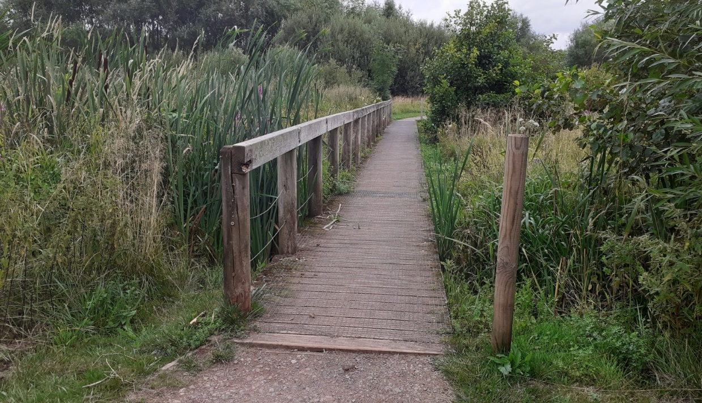

Existing boardwalk showing gap between existing structure and weir (see main document for details)


Gap between boardwalk and weir showing structure beneath
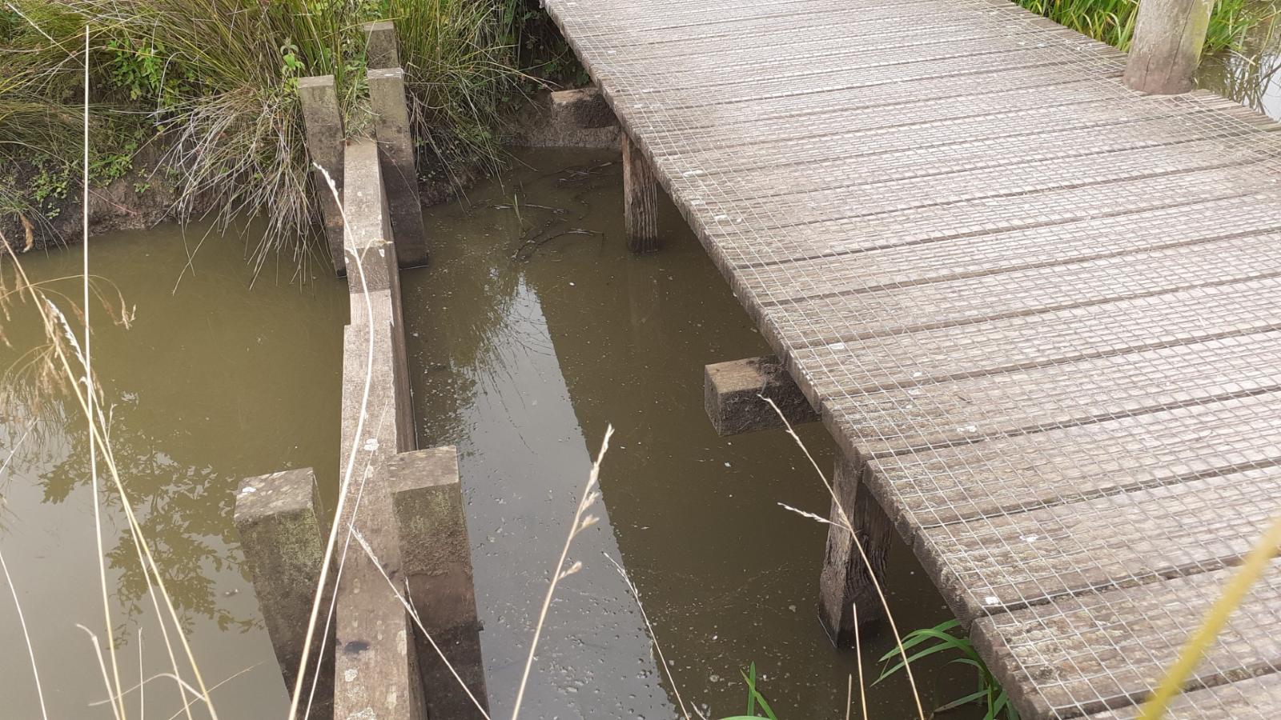

Seasonality and site peculiarities:
The site can be completely flooded during the autumn/winter months, reducing access and stopping any work from taking place.
The ground is wet at all times as the site runs between two ponds
Nesting season is between March and end August requiring any works to have been completed before 1st March.
Sensitive species include Grass Snake, Common Toad, Sedge Warbler and all wildfowl.
The site is a SANG meaning that it is a dog friendly area. This means that access to dog walkers and pedestrians is a priority and any path closures must be adequately signed, giving notice to the site ranger at least 2 weeks before commencing work.

Site visit:
Companies selected as possible candidates for the work will be invited to attend a site visit with the site ranger on a day to suit both parties.

