Invitation to Tender to Regenerate Children’s Play Area
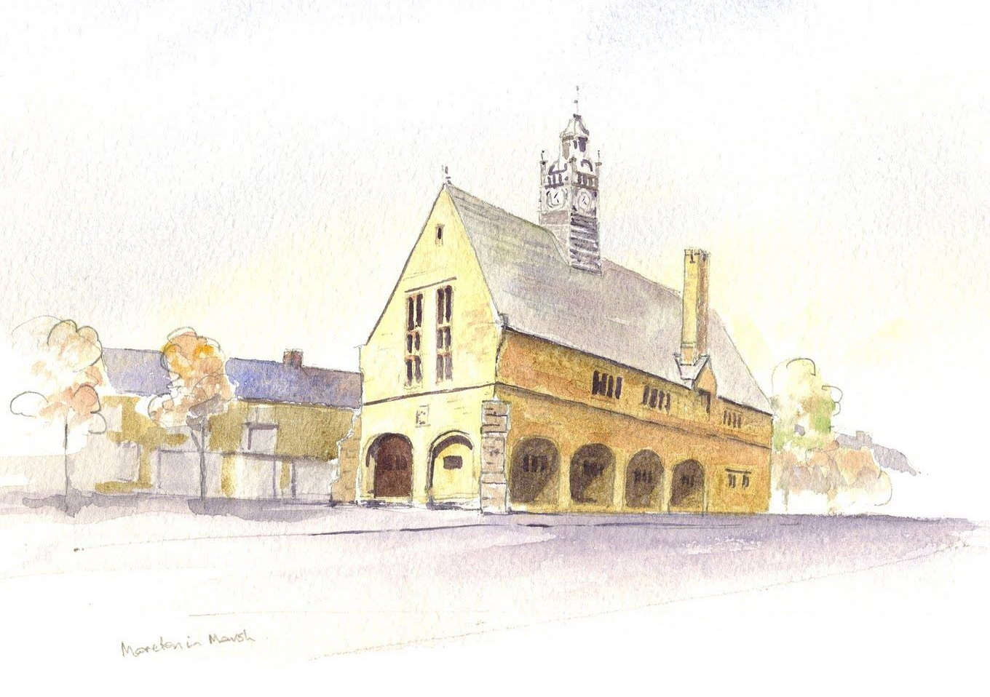
MORETON-IN-MARSH TOWN COUNCIL
QUEEN VICTORIA PLAY PARK

REGENERATION
SUMMER 2023

Contents

1 Background
2 Site Overview
3 Project Expectations
4 Project Detail
5 Pricing Breakdown
6 Completion Dates
7 Tender requirements
8 Reinstatements
9 Preparation of Quote
10 Submission deadline
11 Tender Validity
12 Technical information, maintenance, and spares
13 Guarantees and Warranties
14 Questions on tender submissions
15 Award of tender
16 Confidentiality
17 Location Map
18 Existing Play Equipment Position

Background
There are approximately 2500 homes within Moreton-in-Marsh with a thriving tourist economy. The residents and Moreton-in-Marsh Town Council (MiMTC) have tried for a number of years to provide an updated play area for the children within the town. The current play equipment is believed to be in excess of 15 years old and although it is still loved by the children and is still somewhat serviceable, some of the equipment no longer meets today’s high standards. Expectations are high and over the past few years, with the pandemic, financial constraints and further inflationary pressures MiMTC are now in a position where it has limited funds for the project. Due to our plight, MiMTC are looking for companies to provide highly innovative solutions to invigorate children’s imagination and it has to provide a more challenging and inclusive environment for play than is presently installed.

Site Overview
The site is located to the end of the central High Street thereby providing an excellent opportunity to engage visitors, tourists and residents alike.

The site is predominantly flat, although the access to the site is not. The play area itself is completely fenced with older bow top railings. The main access from the High Street is via a metal staircase and is not accessible for people with limited mobility or any wheeled vehicle, such as prams, pushchairs, wheelchairs, mobility carriage or cycle etc. Limited mobility and wheeled access is available at two other points, both of which are via connecting roads within a little walking distance. The road to the North has no delimited footpath and has fast moving traffic, where the road to the South West is off a quiet back street but is unknown to most visitors and tourists.
To the East, the High Street is approximately 4 Metres above the play area. The height of the adjacent High Street is one cause of concern for both residents and MiMTC due the possibility of falling vehicles as a consequence of a road accident therefore a safe “buffer zone” should be included into any design. To the South there is a brook, which during some wetter seasons overflows and subsequently floods the play area. The Western side of the park is the open space that constitutes the “Queen Victoria Gardens”.

Some older equipment has already been removed from the site due to issues of safety and maintenance, these being a roundabout and a cargo net style climbing frame.

There are no “services” onsite whatsoever and access by a works vehicle is over adjacent grassed areas.

Project Expectations
MiMTC are looking for companies to provide innovative solutions who are open to working alone or in partnership with others to provide the best solution. The project itself will be delivered in two phases after an initial review of the existing equipment with consideration of advice from RoSPA and any Interested Suppliers.

Phase-1
- Refurbishment of retained equipment
- Installation of peripheral play equipment
- Installation of safety surfaces

Phase-2
- Installation of a focal piece of play equipment
- Installation of safety surface.

MiMTC are looking for complete designs that incorporate both Phase-1 and Phase-2.

MiMTC have funds for Phase-1 of the project and will be assisting the community to raise funds for Phase-2.

The dynamic solution will need to be one that inspires people to help raise further funds for Phase-2 to complete the overall design. The design will also require some consideration as to how the solution can be provided. The solution may require to be broken down into smaller deliverable parts, but it may also be necessary to partner with other providers or installers to provide a highly creative solution whilst working within the site restrictions in place.

Project Detail
MiMTC overall project funds are presently approximately £120,000 Ex VAT. MiMTC believe it is appropriate to retain at least 10% of the existing project funds to use as an initiator to raising further funds with the community for the focal piece of equipment, safety surface and installation. To ensure MiMTC can spark the interest of the community, it is believed the focal equipment ideally should not cost more than £40-£50,000. Timescales are tight but MiMTC are hopeful that we can have the majority of the project in place for use within the summer of 2023.

- Available Phase-1 funding is up to £108,000 Ex VAT, MiMTC can use on peripheral equipment, surfaces, installation and regeneration.
- Available Phase-2 funding is up to £12,000 Ex VAT towards focal equipment.
- Further fund raising of additional Phase-2 project funds will be required to approximately £28,000 to £38,000 (depending upon design) for the focal piece of equipment, surfaces and installation.

The focal piece is expected to be funded in part by the community and as such the value of equipment and installation for the focal equipment do not form part of this tender value. The included design and costs requested for the focal piece of equipment are to establish the funding criteria, which when completed will provide the further funding for Phase-2. MiMTC cannot guarantee when the Phase-2 equipment specified will be purchased from any particular solution provider or that the equipment will be purchased at all if funding targets are not met.

MiMTC needs an inspirational, challenging, inclusive and accessible design for age groups 0-14 years; any equipment design must consider the probable flooding of the site.
All bearings must be fully sealed, ideally above potential water levels but must be fully serviceable.
Any serviceable parts must be accessible and serviceable within one working day.
Equipment must be protected against water damage and have a long anti-corrosion warranty.
Eco-friendly product is preferable, natural materials such as wood and hessian are not suitable.
Safety surfaces must be lawn mower friendly, ground level, porous and set in position, so as not to wash away with flood waters.
Pegged matting, bark and sand will not be considered.
No equipment should require the use of ground pits, such as ground trampolines.
Any equipment with tunnels must provide easy cleaning.
Where ever possible equipment should be inclusive to all users.
The manufactured shape of any equipment should ideally not retain water.
All surfaces must be “power wash” friendly.
Existing safety surfaces may need replacing around any retained equipment and should be costed accordingly.
Implement a safe “Buffer Zone” to the west to mitigate accidental vehicle interactions.

Everything to be installed must conform to the most current safety standards including BS-EN 1176 and BS-EN 1177. A safety inspection certificate for all new equipment and surfaces is required on completion.

There are some older, highly treasured, serviceable pieces of equipment that are still used by the children and consideration should be given to supplement the original equipment where possible. The supplier will be requested to advise on the viability of any existing equipment before removal is agreed.

The present play area can be extended further into Victoria Gardens if necessary, but MiMTC are aware that alteration to the play area fence will require further discussion due to the age and standard of the existing fence. Street furniture should be included; however innovation is sought in consideration of multi-use solutions.

MiMTC is looking for the most dynamic solution that is possible and it requires an understanding on how each company works and whether or not any company will consider a partnership with other companies.
MiMTC needs to know what the company’s expectations are:

Do you contract to 3rd party companies?
Do you work with individuals or community groups?
Do you prefer to be project leader?
Do you provide a solution as supply only? If so, are there condition variations?
How does your warranty work? Are there any unusual considerations for this project?
How long is your warranty? Is it affected by any 3rd party work?
With regards to the overall design, do you only use your own product?
Do you manufacture your product? If not, how and where are serviceable parts held?
The list above is not exhaustive and we welcome detailed insight of a company’s ethos for service and working with others in providing the ultimate solution.

Pricing Breakdown
As stated, MiMTC are looking for an imaginative design to inspire, but it needs the design to be costed for it to understand where partners could work together if deemed necessary.

The overall design with all specific elements should be identified.
The peripheral equipment design, supply and installation elements are to be identified.
The focal equipment supply and installation cost for additional funding purposes.
The safety surface supply and installation cost to suit each piece of equipment in the design.
An opinion on what should be kept and what requires replacement and associated refurbishment.

With each item above an installation/removal cost associated with each, including any health and safety and security requirements for the site and operatives.
MiMTC needs to understand how you prefer to work with 3rd parties or whether you will only consider supply and install of any or all of the equipment exclusively.

Before supplier selection, to gather feedback on the designs and to help promote the additional funding MiMTC will need to publish design details to the community. This will assist with the promotion of the initiation fund of £12,000 from MiMTC with a hope and desire to reach any funding target before the completion of the peripheral project in order for the overall design to be completed together.

Completion Dates
The deadline for receipt of the completed tender response is 4pm Friday 24th February 2023.
The successful supplier will be informed on or after 10th March 2023.
It is anticipated that contract negotiation will commence soon afterwards, with detailed works specifications being completed as agreed by contract preferably before Friday 15th April 2023.
Detailed “Terms and Conditions” will be agreed before commencing, standard late delivery “penalty clauses” will be included within an agreement of contract. In all instances, MiMTC reserves the right to withdraw from the tender process and reserves the right to re-tender.

Hard copy tender responses should be posted in plain envelopes marked “QVG - Tenders for Play Regeneration” and delivered to:

Town Clerk
Moreton in Marsh Town Council
Council Offices
Old Town
Moreton in Marsh
GL56 0LW

Tender requirements
The following documents should be provided to form part of the tender

- Overall design with method statements
- Breakdown of peripheral and focal equipment
- Risk assessment outlining how health and safety risks will be managed
- Public liability insurance £10,000,000 (Ten million pounds)
- Company health and safety policy
- An itemised quotation for the full design, build, installation to include hardcopy drawings (Min A3 size) a 2D footprint and 3D visualisation and also electronic copies, acceptable file formats are: html, gif, jpeg, tif, zip, pdf, doc, xls,ppt,docx, xslx, pptx. (Please do not include any macro enabled spreadsheets or embedded documents within your tender).
- MiMTC will require the details of two installations completed by the company in the last two years where references can be sought, and installation work can be reviewed.
- Suppliers will ideally be registered with the “Association of Play Industries” (API) to tender for this contract. Copies of current certificates of accreditations for the above membership and details of any other accreditations appropriate to this tender should be submitted.
- Supplier’s standard terms and conditions of supply, installation and payment options.
- Provide certification details for equipment and surfacing including guarantees and details of expected timescales for provision of the peripheral and focal play areas.

Reinstatements
Any area of the open space outside the project area that is damaged by the supplier during installation works shall be reinstated to its original condition at the supplier’s expense.

Preparation of Quote
Suppliers must obtain for themselves all information necessary for the preparation of their tender response and all costs, expenses, and liabilities incurred by the supplier in connection with preparation and submission of the tender shall be borne by the supplier, whether or not their tender is successful.
Information supplied to the supplier by MiMTC or contained in MiMTC publications are supplied only for general guidance in preparation of the tender. It shall remain the property of MiMTC and shall only be used for the purpose of this procurement exercise.
Additional documentation may be included to aid the response. The Clerk (or Deputy) will open all tenders and redact any information identifying potential supplier. In order to expedite this process, it is requested, wherever possible, documentation included within the returned tender does not bear any supplier identification, such as: company “Headers or Footers”, Brand Marks, Emblems or Logo’s etc.

Submission deadline
Suppliers are required to submit their response by 4pm Friday 24th February 2023 and should allow sufficient time to complete questions and upload documentation where requested to do so.

Portal submissions are required, and preferably a paper hardcopy of all documentation should be sent to the MiMTC at the address specified, however the deadline for receiving portal submissions remains firm and Electronic Tenders received after the closing date may not be considered. MiMTC is under no obligation to consider partial or late submissions.

If MiMTC issues an amendment to the original specification and it regards that amendment as significant, an extension of the closing date may, at the discretion of MiMTC, be given to all suppliers.
MiMTC expressly reserves the right to require a supplier to provide additional information supplementing or clarifying any of the information provided in response to the requests set out in the Tender. However, MiMTC is not obliged to make such requests.

All responses will be carefully considered and the successful tender will be the one MiMTC considers gives the best solution and value for the money but will not necessarily be the lowest bid.

Tender Validity
The tender quotations should remain open for acceptance for a minimum period of 90 days. A response with a shorter period may be rejected.

Technical information, maintenance, and spares
User and Maintenance instructions for each item of equipment and spares documentation should be made available to MiMTC with the tender to provide an understanding to MiMTC for ongoing personnel commitments.

Guarantees and Warranties
Full details of any manufacturer guarantee and warranties on equipment, safety surface and installations works shall be provided with the tender documents. In consideration of the flooding issue with the site, it is requested that suppliers identify any specific limitations to warranty due to site conditions. Where working flexibility is acceptable, the supplier must indicate where primary responsibilities lie.

Questions on tender submissions
If suppliers have any questions to ask of MiMTC
Please direct email questions to; clerk@moretoninmarshtowncouncil.gov.uk
Any questions received will be made anonymous and responses will be sent to all tenderers.

Award of tender

A minimum of three MiMTC Council members will evaluate each tender response. All documents will be provided by the Clerk void of Service Supplier identification.
Each section of response will be scored 0 (Zero) to 10(Ten) where 0 is the lowest available, given where no response is given and 10 is for the most informed submission. The percentage weighting is then applied and a final percentage is determined.

    - Price and Value for Money 30%
    - Overall Design (Peripheral & Focal) 20%
    - Equipment Supply Structure Breakdown 15%
    - Project Management & Flexibility of Working 10%
    - Experience, Deliverables & Timescales 10%
    - Health and Safety 10%
    - Insurance and Accreditations 5%

MiMTC will notify the acceptance of the tender to the successful bidder as soon as reasonably practicable. In all instances, if MiMTC does not believe it has had the desired inspirational responses, MiMTC reserves the right to withdraw and re-tender if necessary.

Confidentiality
The details of these documents and all associated documents are to be treated as private and confidential for use only in connection with the tender process.
Information that is supplied to suppliers as part of the procurement exercise is supplied in good faith. However, suppliers must satisfy themselves as to the accuracy of such information and no responsibility is accepted for any loss or damage of whatever kind or howsoever caused arising from the use by the suppliers of such information, unless such information has been supplied fraudulently by MiMTC.
All information supplied by MiMTC in connection with this procurement exercise shall be regarded as confidential. By submitting an offer, the supplier agrees to be bound by the obligation to preserve the confidentiality of all such information.

This offer and its accompanying documents shall remain the property of MiMTC and must be returned on demand.

If suppliers provide any information to MiMTC in connection with this procurement exercise, or with any Contract that may be awarded as a result of this exercise, which is confidential in nature and which a supplier wishes to be held in confidence, then suppliers must clearly identify in their offer documentation the information to which suppliers consider a duty of confidentiality applies. Suppliers must give a clear indication which material is to be considered confidential and why you consider it to be so, along with the time period for which it will remain confidential in nature. The use of blanket protective markings such as “commercial in confidence” will not be appropriate. In addition, marking any material as “confidential” or equivalent should not be taken to mean that MiMTC accepts any duty of confidentiality by virtue of such marking. Please note that even where a supplier has indicated that information is confidential, MiMTC may be required to disclose it under the FOIA (Freedom of Information Act) if a request is received.

MiMTC cannot accept that trivial information or information which by its very nature cannot be regarded as confidential should be subject to any obligation of confidence. In certain circumstances where information has not been provided in confidence, MiMTC may still wish to consult with suppliers about the application of any other exemption such as that relating to disclosure that will prejudice the commercial interests of any party. The decision as to which information will be disclosed is reserved to MiMTC, notwithstanding any consultation with the supplier.

The goods and/or services offered should be strictly in accordance with the specification provided.

The submission must be signed by an authorised signatory: in the case of a partnership by a partner for and on behalf of the firm: in the case of a limited company, by an officer duly authorised, the designation of the officer being stated.

The submission and accompanying documents must be completed in full. Any tender may be rejected which: - contains gaps, omissions or obvious errors; or - contains amendments which have not been initialled by the authorised signatory; or - is received after the closing time.

Location Map

Existing Play Equipment Position

