**Supplier registration – Log In**

The first email you receive is a welcome message. It’ll look something like the invite below:

______________________________________________________________________________

Dear Steven Carter,  
  
    Congratulations! Your Oracle Fusion Applications account has been successfully created.  
  
    Please follow the link below to reset your password.  
  
     [https://ehjb.fa.em2.oraclecloud.com:443/hcmUI/faces/ResetPassword?ase.gid=294cd4ee7051499880a972ae4fb3a635&nextURL=https://ehjb.fa.em2.oraclecloud.com/supplierPortal/faces/FndOverview?fndGlobalItemNodeId=itemNode_supplier_portal_supplier_portal](https://ehjb.fa.em2.oraclecloud.com/hcmUI/faces/ResetPassword?ase.gid=294cd4ee7051499880a972ae4fb3a635&nextURL=https://ehjb.fa.em2.oraclecloud.com/supplierPortal/faces/FndOverview?fndGlobalItemNodeId=itemNode_supplier_portal_supplier_portal)  
  
    For any issues, contact your system administrator.  
  
Thank You,  
Oracle Fusion Applications

___________________________________________________________________________________________

If you do not receive this email then it is likely the message is either hitting a firewall or ending up in spam / junk folder.

The second email received informs which roles the account has been assigned:

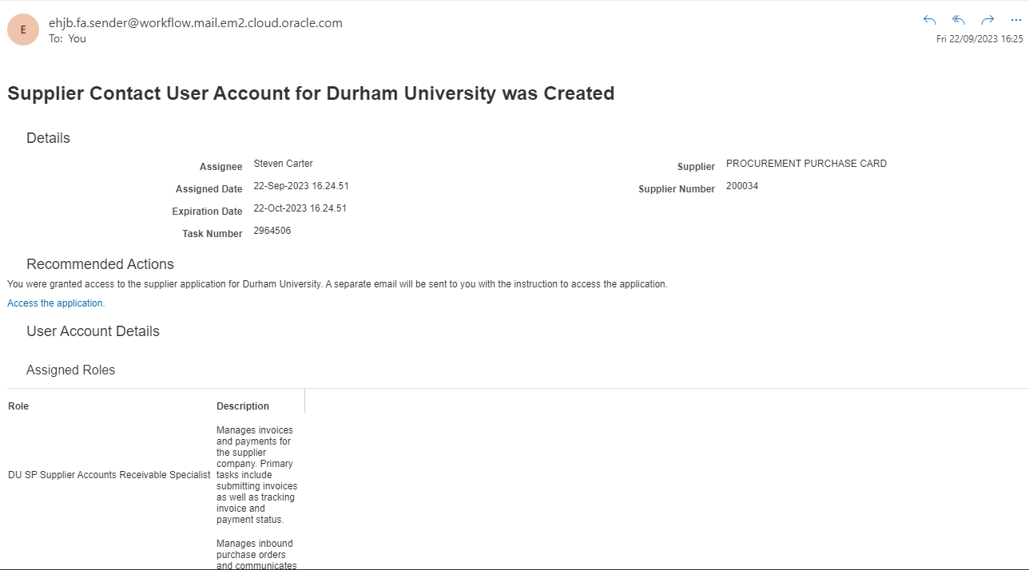

Click on link and enter reset password at the prompt screen.

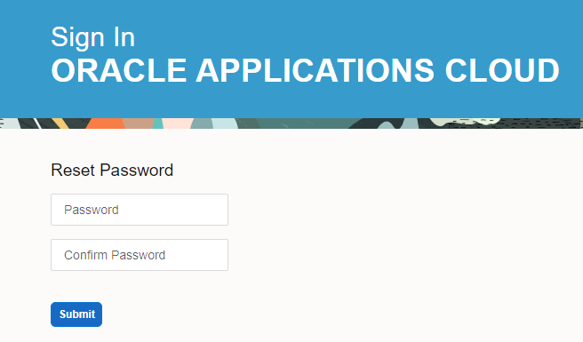

Enter email address you registered with and password you have created on previous screen.

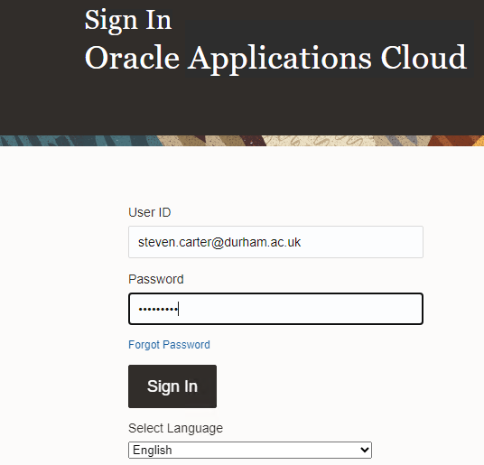

If you experience difficulty, select Forgot Password and enter full email address and Submit.

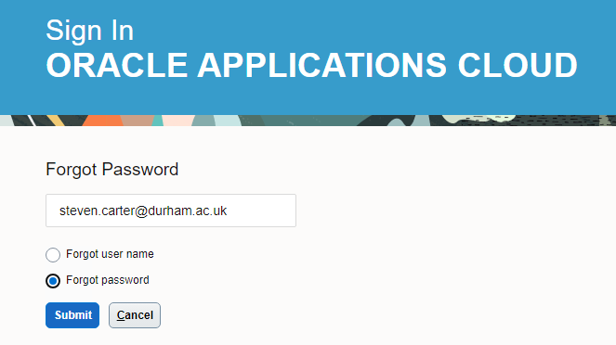

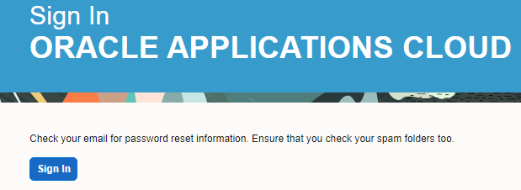

Once logged in, supplier will have following view.

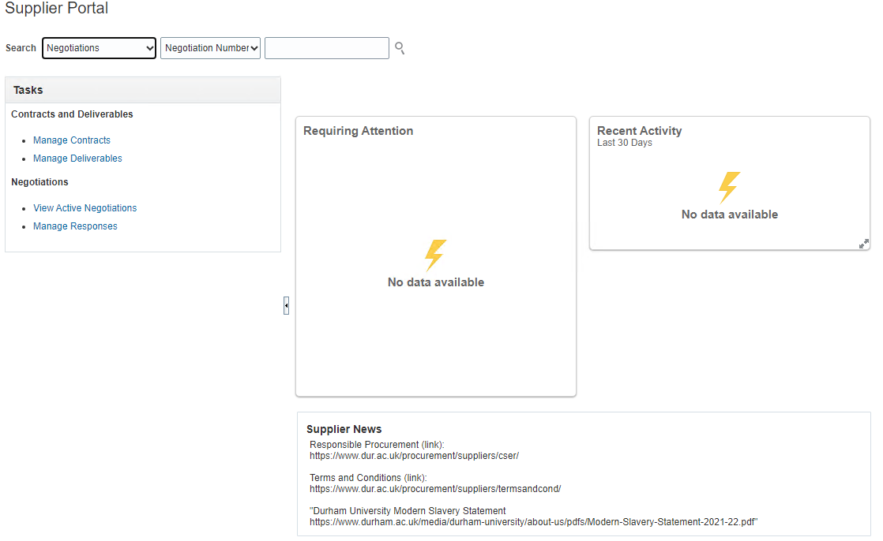

Supplier can then navigate to View Active Negotiations to view any new invite or they can see the invite via the bell notification in top right of screen view.

If building a requisition over a period of time, navigate to Manage Responses.