Section J Projects Order Form

The Customer has agreed to engage NHS Shared Business Services Limited (“NHS SBS”) to provide the Services as defined below and NHS SBS has agreed to provide such Services on the terms set out in the General Terms and Conditions of NHS SBS (the “General Terms”) and in this Order Form .

By signing this Order Form, NHS SBS agrees to provide the Services and the Customer agrees to pay for the Services in accordance with the General Terms as incorporated in the Order Form.

|  |  |
| --- | --- |
| **Customer Details** | The Customer: Public Health England, PHE Porton, Porton Down, Salisbury, Wiltshire, SP4 0JG |
| **NHS SBS Lead** | Faye Orr |
| **Customer Lead** | Mark Polglase |
| **Project Name** | Atamis Implementation – Project Support |
| **NHS SBS Project Manager** | Alexandra Long |

# SCOPE

* 1. This Section J including all its Appendices, Annexes and Schedules constitutes the Order Form as defined in the General Terms.

# SERVICES

* 1. NHS SBS will provide to the Customer the Services set out in Schedule 1 of this Order Form.
  2. The parties acknowledge and agree that any liability of NHS SBS arising out of this Agreement shall be to the Customer and that any liability of the Customer arising out of this Agreement shall be liabilities of the Customer.

# CHARGES

* 1. The fees charged by NHS Shared Business Services Limited for the provision of the Services and any materials used will be as stated in the Order Form and subject to revision as stated in the General Conditions and in the Order Form.

# THE CUSTOMER'S UNDERTAKINGS

* 1. Without limiting clause 8 of the General Conditions, the Customer shall in particular provide the following:
     1. A working day is 7.5 hours from 09:00 to 17:30 with one hour for lunch, Monday to Friday excluding UK public bank holidays. Where the Customer or the nature of the project requires working at weekends or excessive overtime, NHS shared Business Services Limited reserves the right to charge premium rates of up to 150% of the agreed day rates.
     2. Time taken off for holidays, sickness or other personal matters is not chargeable.

## Schedule 1 - Service Description

1. **Overview**

The Department of Health & Social Care (DHSC), working as a project along with other organisations that form the Health Family, recently awarded a contract to Atamis Ltd to provide a web-based system that enables the Health Family to undertake its procurement and contract and supplier management activities. For Public Health England (PHE), this would replace is current contract with Jaggaer (commonly referred to as the ‘Bravo’ system) which expires on 30 June 2021. This means that PHE would need to implement Atamis prior to its contract expiring with Jaggaer i.e. 1 July 2021.

The Secretary of State recently announced that PHE would be merging with NHS Test & Trace (NHSTT) to form the UK Health Security Agency (UKHSA). NHSTT are currently implementing their own instance of Atamis and a strategic decision was taken within PHE (and agreed by NHSTT) that PHE would implement its Atamis instance alongside NHSTT.

The plan is that both organisations would work as closely together as possible up to 30 September 2021 with a view that the two instances would be seamless and/or become one well before 1 October 2021 when UKHSA becomes fully operational and PHE and NHSTT are fully integrated.

NHS Shared Business Services will be required to work with PHE to assist them in working with NHSTT to implement Atamis within PHE. This will involve working with:

* + PHE’s Head of Procurement (Victoria Eaton) and PHE Atamis Implementation Lead (Mark Polglase)
  + PHE Procurement’s category managers and non-category staff, including the Head of PHE’s Customer Services Team
  + PHE’s Finance and Commercial Directorate staff where they are stakeholders in any implementation workstream
  + NHSTT’s implementation team.

Any decisions made that affect PHE staff will need to be approved by PHE’s Implementation Board which consists of PHE Procurement’s leadership team (Deputy Heads and above) except in case of emergency where the Head of Procurement will make the decision.

## Deliverables

1. Production of a project initiation document
2. Deliver and manage a project plan with deliverables and nominated individuals to deliver the requirements
3. Delivery of a weekly highlight report to PHE’s Implementation Board outlining progress against the project plan and include the following:
   1. deliverables achieved
   2. deliverables not achieved
   3. actions required in the week following
   4. areas of risk that need to be addressed by the Implementation Board
4. Creation of a project risk register, including identification of risk owners and mitigations
5. Stakeholder matrix created
6. Organise relevant meetings with the wider PHE Procurement Team
7. Work with the PHE Procurement Team to identity their areas of concern and how these can be addressed
8. Work with and between PHE’s Head of Procurement and Atamis Implementation Lead and the equivalents at NHSTT
9. Deliver updates to NHSTT’s implementation team as required
10. Work with PHE’s Atamis Implementation Lead on any identified deliverables that are identified as part of the implementation project
11. Report as required on areas of significant difficulty or risk to PHE’s Head of Procurement

## Scope Exclusions

This Services exclude the following:

* + Training support and bespoke collateral
  + Data migration activities
  + Hypercare support
  + Contract management module
  + Spend analytics

## Customer Dependencies

1. PHE resources made available in accordance with the PID and project plan
2. Engagement and contractual relationship with Atamis
3. Atamis performance and deliverables

## Key Assumptions

1. PHE have reviewed the Atamis solution and confirmed it meets PHE’s business requirements;
2. PHE will amend and enforce working process to enable Atamis solution delivery;
3. PHE will provide resource support to project team for delivery of appropriate tasks, such as communications and commercial processes;
4. PHE sign off on costs of Atamis solution appropriate to business need to enable licence provision, training and technical delivery.

## Schedule 3 – Charges

Charges will be billed monthly in arrears, on a time and materials basis with evidence provided by NHS SBS of days worked by relevant resource types below. The Customer will provide a purchase order that will provide a limit for expenditure under this Project Order Form and the parties will meet to agree where expenditure is approaching this predefined limit.

|  |  |
| --- | --- |
| **Resource Type** | **Daily Rate Chargeable (Ex Vat)**  **£** |
| Director/Principle Lead | 1,000 |
| Senior Project Manager/Transition Lead | 874 |
| Project Manager / Workstream Owner | 698 |
| Subject Matter Experts / Delivery Lead | 569 |

Estimated Effort for the Services:

|  |  |  |  |  |
| --- | --- | --- | --- | --- |
| **Resource Type** | **Resource Assigned** | **Daily Rate Chargeable (Ex Vat)**  **£** | **Estimated Days** | **Estimated Charges (Ex Vat)**  **£** |
| Senior Project Manager/Transition Lead | Faye Orr | 874 | 4 | 3,496 |
| Project Manager / Workstream Owner | Alex Long | 698 | 50 | 34,900 |
| **Total Estimated Charges** |  |  |  | **38,396** |

## Schedule 4 – Dates

The project will commence on the 6 April 2021 and is estimate to complete by 30 June 2021. Individual milestone dates will be agreed with the Customer within the PID and project plan.

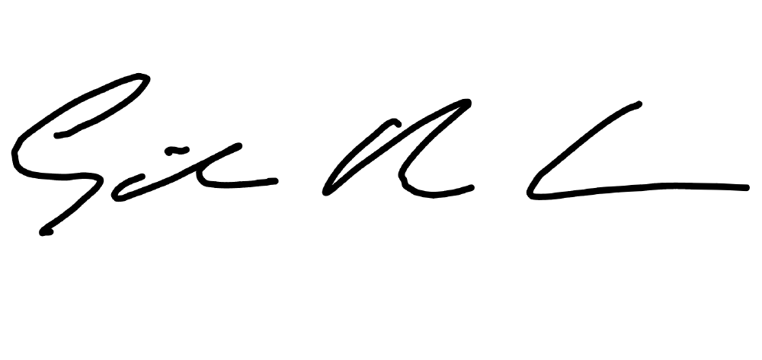**Signatures**

|  |  |  |  |
| --- | --- | --- | --- |
| **For and on behalf of Customer** | | **For and on behalf of NHS Shared Business Services Limited** | |
| Text, letter  Description automatically generated  Signature: | | Signature: | |
| Name: | Timothy John Purchase | Name: | Giles Brooks-Usher |
| Title: | Lead Category Manager | Title: | Director – Legal and Commercial |
| Date: | 23rd April 2021 | Date: | 30/04/2021 |