University of Plymouth

Uncrewed Surface Vessel (USV) Bauza - Repair and Upgrade

Tender Specification

Introduction

Suitable companies are sought to reply to this tender entitled ‘USV Bauza - Repair and Upgrade’, for the Uncrewed Surface Vessel (USV) C Enduro platform ‘USV Bauza’, currently held by the University of Plymouth, but owned by the Royal Navy. It is intended to use the USV as a demonstrator for Marine Data Gathering (MDG) roles and conventional academic oceanography.
Whilst not part of this tender specification, this document is issued with a footnote on a possible future construction of a parallel ‘dry physical twin’ USV system that mirrors the revived command, control, and communications system within USV Bauza. It is intended that this dry physical twin become a subject of Cyber Security research in the University of Plymouth Cyber-SHIP lab. It is anticipated that a singular company would be best placed to eventually deliver both specifications, but this is not essential. Companies replying to this tender specification are asked to comment on their level of interest in this future project.

Background – USV Bauza

USV Bauza is a C Enduro class, uncrewed surface vessel built by ASV global (Now L3 Harris) in 2017. It was designed as a long endurance, uncrewed, remote controlled/autonomous marine surface vehicle, used to collect data at sea through the integration of a bespoke payload suite. Views of the Vessel shown in Figure 1 to Figure 4 below. The original vessel specs are given in Table 1 and Table 2 below.
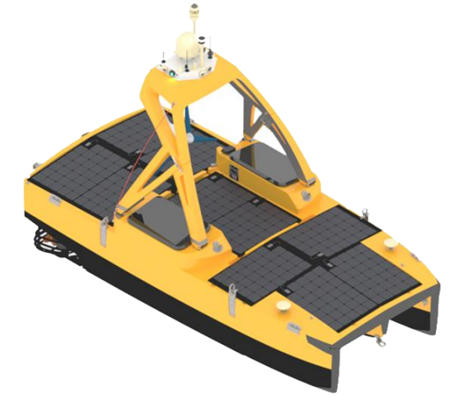
Figure 1. C-Enduro Isometric View (Image: L3Harris)
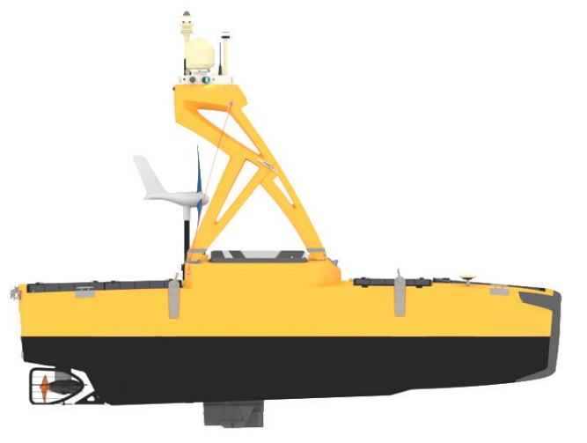
Figure 2. C-Enduro Starboard Profile (Image: L3Harris)
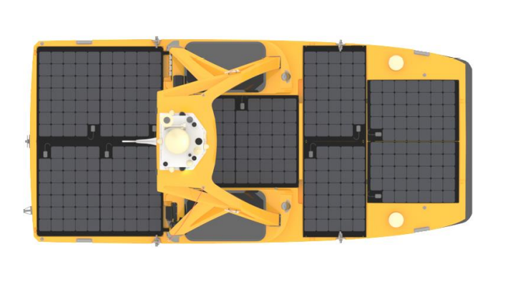
Figure 3. C-Enduro Plan View (Image: L3Harris)
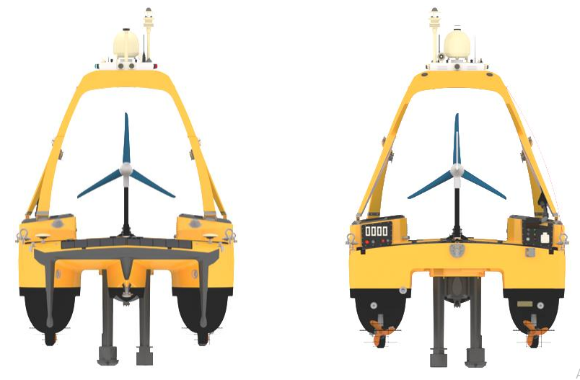
Figure 4. C-Enduro Forward View (Left) and Aft View (Right) (Image: L3Harris)
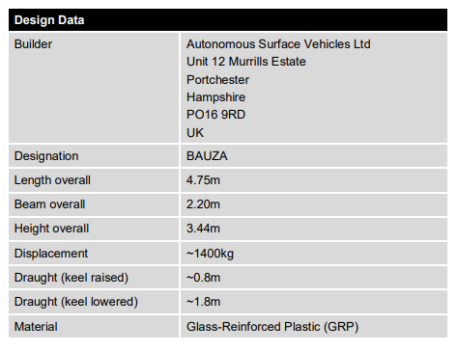
Table 1. Design Data (Source: L3 Harris)
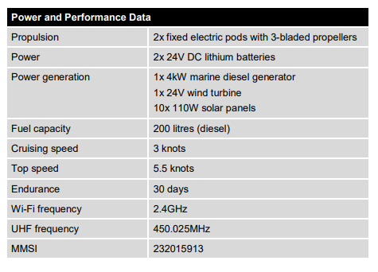
Table 2. power and Performance Data (Source: L3 Harris)
The vessel is a hybrid propulsion-based data gathering platform, built with hydrographic and MetOcean sensor payload.
Currently the vessel relies on Wifi, UHF, Iridium and Fleet Broadband (Sailor 150) satellite communications. The command-and-control software is a bespoke version of the ASView control system from L3 Harris.
The Vessel has not been used since 2018. The vessel was stored outside with little technical input. As a result, water ingress and degradation over time have compromised the communication system, the command-and-control system, and the battery system. However, all other systems are sound, or require minimal technical attention to be serviceable. The vessel hull structure and superstructure is sound. The vessel has a 300m dipping winch from OSIL.
The Vessel is currently owned by the Royal Navy, but on long term loan to the University of Plymouth under the terms of an MoU to undertake mutually beneficial research and development. There is considerable ambition from the Royal Navy and the University to repair and upgrade the USV to operate as a remote, long endurance platform for both demonstration of new methods of Marine Data Gathering (MDG) and remote academic oceanography. The University of Plymouth are managing the project to repair and upgrade the vessel.

Specification overview – USV Repair and Upgrade

A Third-Party Contractor is sought to repair and upgrade the USV to the following standard:

The vessel should retain the situational awareness and core functionality of the original design

The vessel should be able to operate within the UK MAS Code of Practice version 4 (published November 2020) and the vessel should be able to operate in as close accordance as possible with the draft MCA workboat code proposed USV annex, and be capable of achieving a load-line exemption certificate. The vessel should also meet the requirements of the Defence Maritime regulator (DMR).

The vessel command and control software should be repaired or replaced so that it is fit for purpose

The vessel should be able to operate inshore on a new terrestrial communications system with an appropriate level of situational awareness

The vessel should be able to operate offshore on a new satellite communications system with an appropriate level of situational awareness

The vessel should be updated with additional equipment to improve situational awareness and functionality over-and-above the original design specification

The vessel should be modified to better fit the expected payload

Specification Detail

The vessel should retain the situational awareness and core functionality of the original design

The following functionality should be retained/reinstated by the contractor that wins the tender:

The ability to operate with the approximate speed and endurance capabilities highlighted in Table 2 above (The lithium batteries in the vessel will require either maintenance or replacement, but the current diesel generator, wind generator, solar arrays, charge controllers, and Torqueedo thrusters are serviceable and need to be revived. The contractor that wins the tender is to ensure that all systems are functioning as originally intended).

The ability to remotely drive the vessel manually from the base control station

The ability to set the vessel to the following autopilot modes:

Line/pattern following

Orbit

Loiter

Heading hold

Track hold

Camera feeds from the 4 daylight and 1 IR camera

The ability to monitor battery state

The ability to monitor charging current from the generator, solar arrays and wind turbine

The ability to operate the remote turbine brake

The ability to remotely stop and start the generator

The facility to set the generator to auto-start when the battery voltage gets too low

The ability to send sound signals

The ability to receive and transmit AIS and project AIS positions on a chart relative to vessels own position

The ability to remotely operate the 300m dipping winch currently fitted reliably

The ability to log key system data on board the USV computer

The facility to link the payload computer to vessel computer over a LAN

The vessel should be able to operate within the UK MAS Code of Practice version 4 (published November 2020) and the vessel should be able to operate in as close accordance as possible with the draft MCA workboat code proposed USV annex, and be capable of achieving a load-line exemption certificate. The vessel should also meet the requirements of the Defence Maritime Regulator (DMR).

It is recognised that the regulation inbound from the MCA and other agencies presents a shifting picture. The contractor that wins the tender is to modify the vessel in a spirit of consultation and cooperation with the University to match the current information available, within agreed budgetary constraints, so that it fits the requirements of the MASS Code of Practice, and the requirements from the MCA for load-line exemption and the forthcoming work boat code annex.

The contractor is not required to apply for coding under the MCA Annex or apply for a load line exemption themselves, but they are expected to work alongside the University to achieve this by providing the required information on installed equipment and modifying the vessel to gain acceptance for commercial operation by the MCA.

The requirement to meet the regulations set out by the Defence Maritime Regulator will be similar to those set out by the MCA.

Repair or replace the current command and control software to be fit for purpose

The current command and control system is not working. The contractor that wins the tender is to either arrange for the repair and upgrade of the ASView system or replace it with a completely new system. The current high level of vessel system integration from one single point of software control may not be necessary, provided there is a means to monitor and control all key vessel systems and payload computer.

It is essential that all geographically located information (AIS contacts/Vessel position/Radar) be projected onto an electronic chart (either raster or (preferably) vector) in some format that gives excellent situational awareness to the USV operator.

The vessel should be able to operate inshore on new terrestrial communications with an appropriate level of situational awareness

For terrestrial communication, the vessel currently has a plug-in ethernet cable, a Wifi link and a UHF communication link for short range communications. The UHF link is only a low bandwidth connection and does not stream video. The Wifi communication link does stream video but gives only 1 -2km range. It is anticipated that the contractor that wins the tender will remove elements of the current communications system and install/reinstate following terrestrial communications systems:

Ethernet deck cable

Short range WiFi

IP Mesh radio

4G LTE modem (Could form part of the satellite communications fit (see below))

It should be possible to access the payload computer through the terrestrial communications system through the vessel LAN.

It is anticipated that the IP radio installation will be a Wave Relay system distributed by Steatite UK. This will either be a node provided by the Smart Sound Connect Project or an independent Wave Relay node currently held by the university.

The vessel should be able to operate offshore on a new satellite communications system with an appropriate level of situational awareness

For satellite communication, the vessel currently has a Sailor 150 fleet broadband satellite communications system. It is anticipated that the contractor that wins the tender will remove the current Sailor 150 satellite communications system and fit a Thales Vessel Link 700 system currently held by the university. (This system also has inbuilt 4G connectivity potentially negating the need for a separate 4G modem).

It should be possible to establish basic communication with the payload computer through the satellite communications system either by remote desktop functionality or command line.

The command-and-control system should be operational with a basic level of control even with very poor (intermittent) satellite communication or poor bandwidth. It should be possible to reduce the camera, radar and ancillary data update rates to match the available satellite data speeds.

The contractor that wins the tender will be supplied with satellite and 4G SIM cards to ensure that the systems is functional prior to delivery.

The vessel should be updated with additional equipment to improve situational awareness and functionality over-and-above the original design specification

The command-and-control systems should be able to be distributed over multiple users, either by software being available on the cloud, or by licences being distributable to remote operators on remote computers. Transfer between users should be a secure, controlled, and robust process.

The command and control system should be able to logs basic vessel data to file at the shoreside Remote Control Centre (RCC), at a minimum this should include time, location, heading, speed, battery voltage, charging current from the solar array, wind turbine and generator.

It is intended that the contractor that wins the tender, procure and fit a Lowrance 4G Broadband radar to the vessel. It is anticipated that the radar output be projected as a chart overlay either in the command-and-control software, or a separately accessible display showing chart, radar plot and AIS target layers and own position. The radar should be able to be turned on and off remotely.

It is intended that the contractor that wins the tender engineers a remote-control option separate to the main base control station. This is to enable a support boat, or jetty crew to take manual control of the USV at short range. This should be in the form of a small mobile handheld controller linking to vessel via Wifi or 2.4GHz RC or a mobile phone app using WiFi.

It is intended to fit a capability to place a remotely operated VHF radio on the vessel that will enable the remote operator to send and receive VHF calls. An example of a virtual radio system that could be suitable is found here: TP Radio over IP Remote VHF/UHF System - Polaris Electronics (polaris-as.dk). Other solutions may be more appropriate. The contractor that wins the tender is to select and install a suitable system in consultation with the University. It is recognised that placing VHF calls over Satellite communications presents significant technical hurdles.

In addition to the camera currently installed, the vessel needs a supplementary forward-looking camera to provide redundancy in the event of primary camera failure. This supplementary camera should be in a housing with a wiper. Recording of images should be a possibility.

The vessel should be fitted with a microphone to relay sound signals and engine should over a remote IP phone. This has been done on the University’s other Offshore USV, so a working example is available if required. It is recognised that placing steaming audio over Satellite communications presents significant technical hurdles.

The vessel should be modified to better fit the expected payload

The vessel is currently mobilised with a Multibeam Echosounder (MBES), Acoustic Doppler Current Profiler (ADCP), Single beam echosounder (SBES), Irradiance sensor and conductivity/temperature probe. These sensors are mounted on two fixed masts beneath the hull. Between these two masts is a retractable keel. This collective assembly presents significant drag. The contractor that wins the tender is to modify this three part assembly, and consolidate it into a single equipment mast that will provide a mounting point for an ADCP. There is no requirement for the vessel to maintain its MBES capability.

Specification Notes

Any contractor wishing to deviate from the above specification because they believe that aspects described a) can be better achieved by other means; or b) are not feasible, is welcome to recommend as such with justifications in their response to this Tender.

Any contractor wishing to get more information on the status of the vessel before committing a formal tender response is welcome to request further information or undertake their own survey of the vessel. Original defect reports will be provided.

Responses and queries regarding this opportunity should be copied to the following email group:

aaron.barrett@plymouth.ac.uk

alex.nimmo.smith@plymouth.ac.uk

procurement@plymouth.ac.uk

steven.rice@plymouth.ac.uk

Delivery of the vessel after factory and sea acceptance testing will be required under the contract for the 15th of March 2022.

Footnote – Dry Physical Twin Future Project

The University of Plymouth Maritime Cyber Threat Research Group’s £3.2 million Cyber-SHIP Lab is a unique, hardware-based, configurable research, software development and training platform.
Combining maritime technology with leading-edge cyber security research and practice, Cyber-SHIP researchers work to enhance understanding of maritime systems’ cyber vulnerabilities and deliver world-leading cyber resilience knowledge, tools and training.
The refit of the command, control, and communications equipment within USV Bauza presents a unique opportunity to build a parallel ‘dry’ USV within the University Cyber-SHIP lab, to demonstrate and evaluate the cyber penetration resilience of a remote data gathering USV system running on multiple communication links. By integrating a cyber security element thinking from the outset of the retrofit, the concept of ‘Security by Design’ would be demonstrated.
There is considerable ambition from the Royal Navy, University, and wider industry to explore the question of cyber security in remote, long endurance USV platforms.
It is anticipated that Non-Disclosure Agreements (NDAs) will be put in place to protect the IP and privacy of whichever companies have equipment involved in the Dry Physical Twin.
A future specification (separate to this tender document) is likely to be issued to find a contractor to:

Procure an identical sent of command/control/communication/propulsion equipment as that implemented by the contractor that wins the USV Bauza upgrade contract, detailed in this document.

Construct a rack-based version of USV Bauza in the Cyber-SHIP lab on the University of Plymouth main campus.

Set up a Remote-Control Centre within the Cyber-SHIP lab that can communicate with both the ‘dry’ rack based USV and the ‘wet’ system.

Companies responding to this tender may elect to also provide an outline of their position on being part of a Dry Physical Twin USV project in the future, either as a sole contractor or in partnership with others, expressing their degree of possible interest. A future tender will be released for this work, for which a consortium of companies would also be a reasonable possibility.

