Playscheme Q&As

Questions in blue, answers in red.
Q1 It states that the contract runs from the 01/04/2019 on page 6 and on page 11 it states our contract ends after the school holiday in Aril 2019. On page 14 it states again that the contract start date is 01/04/2019. Can you confirm, as we should be operating for Easter and contract start date post this.
A1 The two contracts will run alongside each other. You will be operating for the Easter holidays but the new contract will run from 01/04/2019 to ensure everything is in place for the May half-term holiday.
Q2 I also noticed the following:
- page 12 it states from 5 – 12 years (we actually operate from 4 years 9 months to 12 years)
A2 5-12 years is the minimum expectation and this was what our contract has always been before Tinies were the supplier. Services for outside of the minimum ages ranges is a bonus.
- page 13 (last line) states the service if from 9am to 5pm – we operate 8am to 6pm
As above. 9am-5pm is the minimum requirements and anything outside of this is an added bonus.
- page 17 mentions that the provider needs to have Cyber Essentials certification. We currently have this held in our holding companies name My Family Care. Is that Ok?
The cyber security team have confirmed that this is fine.
- Page 16 mentions that we will hold data for 6 years and then it mentions 72 month period – can you clarify please. We currently hold employee data for 6 years but children and parents data for 4 years (a claim can be bought up to 3 years post leaving) and we only hold longer if we feel a claim may be made.
The tender states that the data needs to be held for 6 years after the contract expires. This is a new element of the BEIS procurement requirements so the data will need to be held for 6 years, instead of 4 years.

Q3 Reading through the tender document the I wanted to clarify the following as they relate to ‘steel’. Can you please clarify on the below.
A3 For the steel section you can just answer N/A as it only relates to steel projects.

Q4 I have also asked our HR department to look at those working on the contract and I believe TUPE will apply. I will come back to you on this as I appreciate you will need to share details if it does. Do you have a standard TUPE form that you would like us to complete is this is the case?
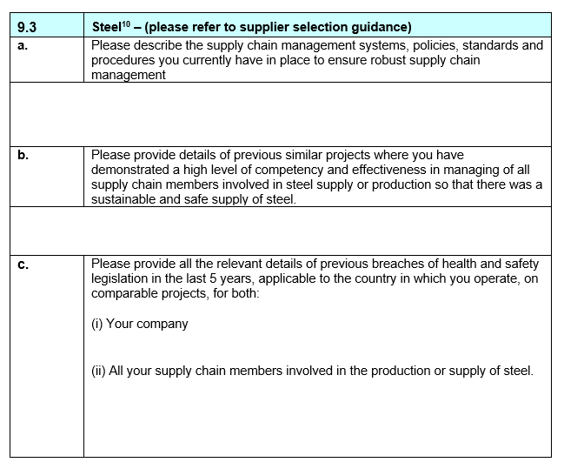

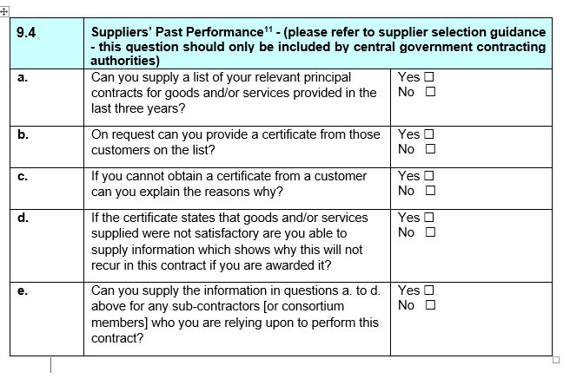
A4 I have also contacted our TUPE expert in the department to confirm the details and any further processes we need to go through. I’ll come back as soon as I hear from her.
For the TUPE information, this is the full requirement list we need if there is a change of contract. For now can we have the first two elements:
• Role titles and FTE
• information contained in the written statement of those employees

The information for bidders to be aware of are as follows:
TUPE element
1.1 TUPE 2006
i) I am required to advise you about your potential obligations under the Transfer of Undertakings (Protection of Employment) Regulations 2006 (TUPE). As BEIS would be neither the transferor nor transferee of the staff in the circumstances of any contract awarded as a result of this Invitation to Tender, you may wish to note that there is a likelihood that TUPE will apply. It is your responsibility, however, to consider whether or not TUPE applies in the specific circumstances of your bid particularly if you are proposing to submit an innovative bid, and to tender accordingly.
ii) The TUPE information detailed below has been obtained from the current contractor. BEIS has obtained this information in good faith and gives no guarantee or assurance as to the accuracy of this information. BEIS will not be held responsible for errors or omissions in it. It remains your responsibility to ensure that your tender takes full account of all the relevant circumstances. BEIS expects successful bidders to investigate whether TUPE applies in all cases.
iii) a) Job titles, FTE, salary and conditions of current contractor staff
Job Title | Employee | Average working hours per week | Rate of Pay | Average pay per week | Holiday Entitlement | Sick Pay | Additional benefits
Holiday Club Manager | Qualified | 50 | £ 10.00 | £ 500.00 | Accrued for hours worked | N/A | N/A
Play Leader | Qualified | 26 | £ 8.50 | £ 221.00 | Accrued for hours worked | N/A | N/A
Play Leader | Qualified | 32 | £ 8.16 | £ 261.12 | Accrued for hours worked | N/A | N/A
Play Leader | Qualified | 50 | £ 8.75 | £ 437.50 | Accrued for hours worked | N/A | N/A
Play Leader | Qualified | 40 | £ 8.00 | £ 320.00 | Accrued for hours worked | N/A | N/A
Play Leader | Qualified | 40 | £ 8.42 | £ 336.80 | Accrued for hours worked | N/A | N/A
Play Leader | Qualified | 50 | £ 8.00 | £ 400.00 | Accrued for hours worked | N/A | N/A
Play Worker | Qualified | 50 | £ 7.83 | £ 391.50 | Accrued for hours worked | N/A | N/A
Play Worker | Qualified | 50 | £ 8.50 | £ 425.00 | Accrued for hours worked | N/A | N/A
Play Worker | U Qualified | 15 | £ 8.50 | £ 127.50 | Accrued for hours worked | N/A | N/A
Play Worker | U Qualified | 17 | £ 7.83 | £ 133.11 | Accrued for hours worked | N/A | N/A
Play Worker | U Qualified | 24 | £ 7.38 | £ 177.12 | Accrued for hours worked | N/A | N/A
Play Worker | U Qualified | 30 | £ 7.38 | £ 221.40 | Accrued for hours worked | N/A | N/A
Play Worker | U Qualified | 50 | £ 7.38 | £ 369.00 | Accrued for hours worked | N/A | N/A
Play Worker | U Qualified | 34 | £ 7.50 | £ 255.00 | Accrued for hours worked | N/A | N/A
Play Worker | U Qualified | 50 | £ 7.38 | £ 369.00 | Accrued for hours worked | N/A | N/A
Play Worker | U Qualified | 36 | £ 7.83 | £ 281.88 | Accrued for hours worked | N/A | N/A
Play Worker | U Qualified | 41 | £ 7.00 | £ 287.00 | Accrued for hours worked | N/A | N/A
Play Worker | U Qualified | 42 | £ 7.00 | £ 294.00 | Accrued for hours worked | N/A | N/A

b) Estimated pension costs = £3,234 per month
iv) Pensions
Pension provision for private sector transferees is covered by the following legislation:
• Pensions Act 2004;
• Transfer of Employment (Pension Protection) Regulations 2005;
at: http://www.opsi.gov.uk/Acts/acts2004/ukpga_20040035_en_1 and the Transfer of Employment (Pension Protection) Regulations 2005 at: http://www.opsi.gov.uk/si/si2005/20050649

