**The Supply Chain Network - Overview**

The Supply Chain Network (TSCN) is a partnership bringing together a programme of support for businesses within the Yorkshire and Humber regions, led by East Riding of Yorkshire Council. TSCN’s priority is to continually support SME’s to make supply chain opportunities visible, accessible and winnable and assist regional businesses to be supply chain ready to access opportunities. Support is provided to businesses who are seeking guidance and help in maximising their supply chains, in order to help them become more efficient and potentially successful in winning more work. Also providing businesses with regular information and updates on what is happening within regional key sectors and helping to identify where potential new supply chain opportunities may be available.

To support the ongoing TSCN vision, European Regional Development Fund (ERDF) finance has been secured for the York, North Yorkshire and East Riding region. This programme of support is led by the East Riding of Yorkshire Council, in partnership with Richmondshire District Council, Hambleton District Council and York & North Yorkshire LEP and offers direct help through grants, workshops, diagnostics and one to one support.

**Procurement Opportunity**

TSCN is currently looking to procure an individual / organisation to identify and work with businesses within the more developed area of our region concentrating on the York area of the York, North Yorkshire LEP (as shown in Appendix 4 covering York, Selby, Harrogate and Craven) by offering direct business support on a one to one basis to help them increase their customer base and maximise opportunities to quote for and/or apply for relevant tenders.

As a representative of The Supply Chain Network the work will involve:

* Identifying businesses for support within the designated region and working with the TSCN team to confirm eligibility
* Responding to direct referrals from the TSCN team for businesses with specific supply chain requirements
* Directly working with said businesses to ensure clear understanding of individual business needs to win more customers/work and enable effective action plans to be developed
* Continuing to directly work with businesses to help them meet identified needs
* Communicating continually ensuring clear discussions and actions are recorded in agreement with the company/project
* Continually liaising with TSCN team to feed in the requirements and for ongoing additional support for the company
* Capturing all actions and meetings onto the TSCN paperwork to the required standards
* Providing ongoing business intelligence to TSCN as themes and information is identified
* Liaising, supporting and working with project team advisers as required

Contracted Targets:

* Identifying a minimum of 40 new businesses for enrolment onto the programme with identification of specific needs/requirements as above
* Working directly with a minimum of 20 businesses on a programme of one to one support offering direct supply chain knowledge and expertise
* Contributing to the projects outputs by identifying outcomes of the support offered through jobs and/or new products/services created
* Thecontract awarded is envisaged to be for 9 months in line with the TSCN project end date

**Proposal Requirements**

As a minimum responses should include:

1. Details of up to date experience of individual/agency, that substantiate you meet the requirements of the opportunity
2. Evidence to demonstrate a comprehension knowledge of end to end supply chain through the submission of previous consultancy work as appropriate
3. Demonstrate knowledge of project location and associated businesses
4. Explanation of how you will maintain a consistent and relevant delivery of information
5. Evidence of how you would manage the portfolio of work within the given timescales
6. Curriculum Vitae/s of identified parties

**Cost Information Requirements**

Please include in the proposal a breakdown of the following costs:

1. Number of days/hours proposed for the duration of the project
2. Demonstration of how the days/hours are calculated for successful delivery
3. Hourly/daily rate/s to be applied

**Milestones**

|  |  |
| --- | --- |
| 1. Tender advertised | Monday 23rd May 2022 |
| 1. Final submission of queries and questions regarding tender | Noon Wednesday 1st June 2022 |
| 1. Closing date for submissions | Noon Monday 6th June 2022 |
| 1. Scoring of submissions | w/c 6th June 2022 |
| 1. Notification to successful applicants | Monday 13th June 2022 |
| 1. Inception meetings and agreement of approach | June 2022 |
| 1. Delivery of contract | Between July 2022 – April 2023 |

**Questions about the specification should be directed to Josh Elliott-Shircore via email Josh.shircore@eastriding.gov.uk by Noon Wednesday the 1st June 2022**

**If you are interested in this opportunity responses should be sent to Josh Elliot-Shircore via email Josh.shircore@eastriding.gov.uk by Noon Monday the 6th June 2022**

**Attachments**

ERYC terms and conditions

Appendix 1: Award criteria

Appendix 2: Scoring criteria

Appendix 3: Map of area

* Marketed as The Supply Chain Network, The Sustainable Supply Chain project is part funded by the European Regional Development Fund. The project assists SMEs to enhance their competitiveness through developing their supply chain opportunities

**Appendix 1: Award Criteria**

|  |  |  |  |
| --- | --- | --- | --- |
| **Criteria** | **Weighting** | **Assessment Method** | **Description** |
| 1. Knowledge & experience | 50% | Submission | 1.1 Expertise, experience and qualifications of Project Team/Consultant (25%) 1.2 Comprehensive knowledge of end to end Supply chain (25%) |
| 2. Project Management skills | 30% | Submission | 2.1 Demonstrate knowledge of project location and associated businesses (15%) 2.2 Explanation of how you will maintain consistent and relevant delivery of information (5%) 2.3 Evidence of how you would manage the portfolio of work within timescales (10%) |
| 3. Price | 20% | Submission | The lowest overall bid will receive full marks. All other offers will be scored a comparative mark,  by calculating the percentage difference between them and the offer which achieved the highest  mark, and deducting this from the highest available mark.  e.g. Company A price = £1000 (10 points)  Company B price = £1250  Score for company B will be calculated as:  10 – (((1250 – 1000) / 1000)*10) = 7.5 points |
|  |  |  |  |



|  |  |
| --- | --- |
| **Score** | **Criteria for awarding the score** |
| 0 | Complete failure to grasp/reflect the issue or does not provide a proposal. |
| 1 -2 | Serious weaknesses, or does not address the question in a meaningful way. |
| 3 - 4 | The proposal falls short of the expected standard and reflects limited understanding missing some aspects. Significant weakness or risks associated with the answer. |
| 5 -6 | The proposal meets the required standard in most material respects but is lacking or inconsistent in others. |
| 7 – 8 | Good understanding and interpretation of requirements. |
| 9 – 10 | Excellent understanding and interpretation. Innovative and proactive with a sound strategy. |

Appendix 3: Map of area

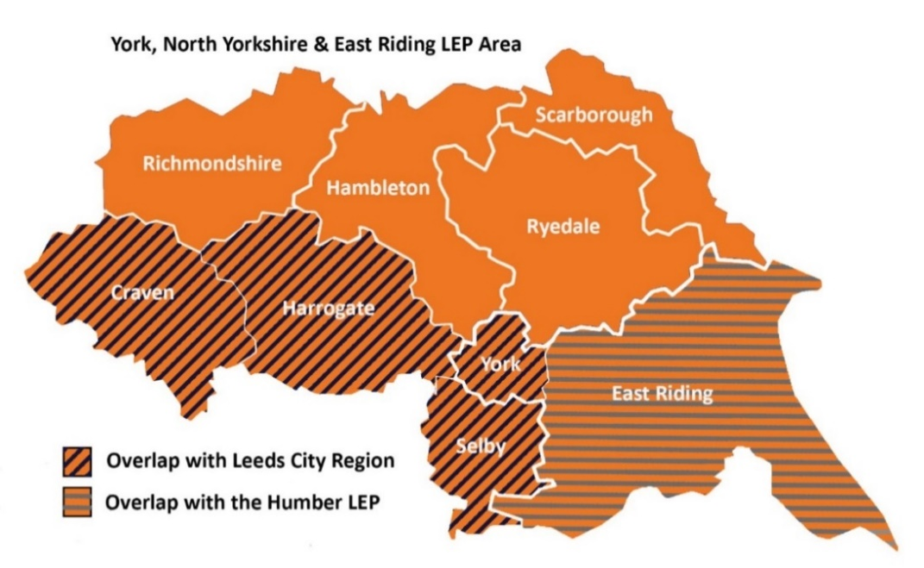

**York area**