**Expression of Interest Living England and Change Detection Field Survey Supplier Response**

The information collected from this EOI shall inform the requirements and potential future procurement routes for Change Detection and Field Surveys. Please return the completed form to [dgc.NCEA.Commercial@defra.gov.uk](mailto:dgc.NCEA.Commercial@defra.gov.uk) before 12:00 24th February 2023. The information collated shall be retained for a maximum of 5 years.

|  |  |  |  |  |  |  |  |  |
| --- | --- | --- | --- | --- | --- | --- | --- | --- |
| Supplier name: |  | | | | | | | |
| Supplier email: |  | | | | | | | |
| Are you happy to be contacted about current or future opportunities at Natural England relevant to this expression of interest | | | | | | | | Yes  No |
| Based on the information provided in Appendix 1, and the attached Living England Specification for Training Data Collection document and the Quick Start Guide to Living England Training Data Collection please: | | | | | | | | |
| Clarify which biogeographical zone (BGZ) your organisation could cover | | | | | | | | |
|  | | | | | | BGZ 1  BGZ 2  BGZ 3  BGZ 4  BGZ 5  BGZ 6  BGZ 7 | BGZ 8  BGZ 9  BGZ 10  BGZ 11  BGZ 12  BGZ 13/14  All of the above | |
| Please confirm the number of Living England Habitat Survey data points your organisation could feasibly collect during the following time periods*.  *Please note, on average surveyors collect 8 data points a day. This average is independent of estimated time spent on travel, project management and access permissions. | | | | | | | | |
| Time period | | Estimated number of points collected per BGZ | | | Number of BGZs covered | | | |
| April – June | |  | | |  | | | |
| July – September | |  | | |  | | | |
| October – December | |  | | |  | | | |
| January - March | |  | | |  | | | |
| Please confirm the number of Change Detection data points your organisation could feasibly collect during the following time periods*.  *Please note, on average we expect surveyors would collect on average 5-6 data points a day. This estimate is independent of estimated time spent on travel, project management and access permissions. | | | | | | | | |
| Time period | | Estimated number of points collected per BGZ | | | Number of BGZs covered | | | |
| April – June | |  | | |  | | | |
| July – September | |  | | |  | | | |
| October – December | |  | | |  | | | |
| January – March | |  | | |  | | | |
| Would your organisation have capacity to deliver these surveys? | | | | | | | | |
| During the 2023 survey season (from April 2023 onwards) | | | Yes, in full as described above  Yes, in part  No, we do not have capacity during this survey season to take on this work. | | | | | |
| During the 2024 survey season (from April 2024 onwards) | | | Yes, in full as described above  Yes, in part  No, we do not have capacity during this survey season to take on this work. | | | | | |
| During the 2025 survey season (from April 2025 onwards) | | | Yes, in full as described above  Yes, in part  No, we do not have capacity during this survey season to take on this work. | | | | | |
| Please confirm the availability of staff with: | | | | | | | | |
| FISC/BSBI level 3 equivalent botanical field skills, or equivalent experience. | | | | Readily available  Staff available but they have limited capacity  We are struggling to recruit staff at this level. | | | | |
| FISC/BSBI level 4 equivalent botanical field skills, or equivalent experience. | | | | Readily available  Staff available but they have limited capacity  We are struggling to recruit staff at this level | | | | |
| FISC/BSBI level 4 or above botanical field skills, or equivalent experience. | | | | Readily available  Staff available but they have limited capacity  We are struggling to recruit staff at this level | | | | |
| If you have any further comments or questions about the Living England Habitat Surveys or Change Detection Surveys, please specify these below: | | | | | | | | |
|  | | | | | | | | |

**Appendix 1**

**Expression of Interest Living England and Change Detection Field Survey**

**Introduction**

Natural England is the government’s advisor on the natural environment. We provide practical advice, grounded in science, on how best to safeguard England’s natural wealth for the benefit of everyone. Our remit is to ensure sustainable stewardship of the land and sea so that people and nature can thrive. It is our responsibility to see that England’s rich natural environment can adapt and survive intact for future generations to enjoy.

Natural England leads on both the development of the Living England model (NCEA Project 1.1) and 25 YEP indicator D1 on habitat quantity, quality, and connectivity (which it is proposed will be the basis for the Environment Bill wider habitats target). The use of remote sensing satellite data to measure and monitor the location and change in habitats is a developing area of work. Developing its capacity to detect change is critical for assessing ecosystem extent over time and change in natural capital ecosystem assets.

**Living England**

Living England produces a map of broad habitat classifications for the whole of England based on up-to date satellite imagery and a collection of ancillary data layers including elevation (and derivatives such as slope, height above nearest drainage), proximity to various features (e.g., woodland, moorland, surface water, roads) and climatic variables. The classification process starts with the identification of recent satellite imagery for each biogeographic zone, which aims to use as cloud-free imagery as possible. A segmentation process is then applied to identify parcels of land with similar appearances in the imagery – forming a series of polygons using an object-based image analysis framework (OBIA). The polygons are then classified using a random forest, machine learning algorithm to classify the habitats, informed by the field collected habitat records, satellite imagery and the ancillary data. The resulting map is a habitat probability map showing the likely broad habitat class for each polygon, creating a national picture of our natural capital assets. Living England Phase IV was published under an Open Government Licence in 2022 and can be accessed here Living England Habitat Map (Phase 4) | Natural England Open Data Geoportal (arcgis.com).

**Change Detection**

The Change Detection project is scoping the ability to use the Living England habitat probability maps to assess national scale habitat change over time. Change Detection aims to identify areas of habitat change identified between two iterations of Living England with a temporal gap of 2 years and use field data to provide details for the likely causes of habitat change which will aid validation of the change detection outputs.

Robust high-quality field survey data is needed in order to train the Living England model and validate the identification of regions of habitat change. Living England is aiming to produce an updated habitat probability map every two years in order to provide an up to date assessment of England’s natural capital assets and monitor changes in these assets over this period. Change Detection requires regular provision of field survey data from across the different habitat classes and biogeographic zones (BGZs) in order to identify recent areas of habitat change likely to have occurred within the two-year period.

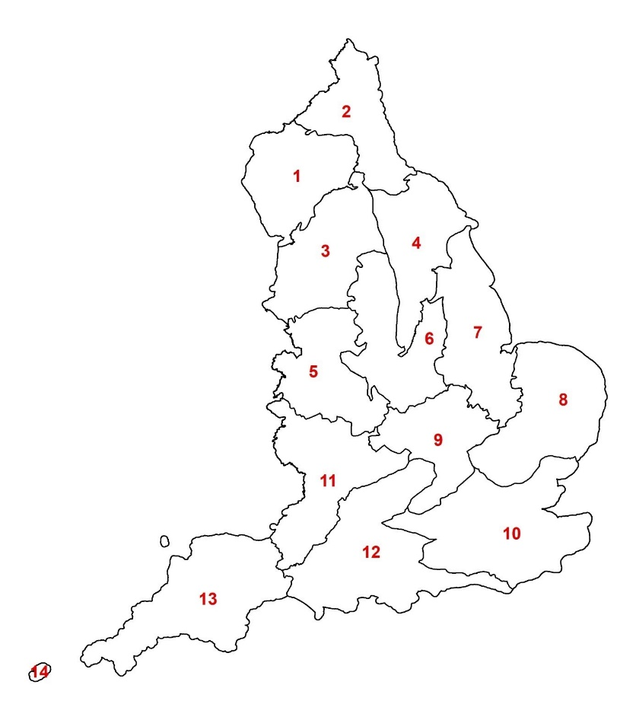

Figure 1: Living England Biographic Zones (BGZs) based on National Character Areas.

**Living England Habitat and Change Detection Field Survey**

Living England Habitat Survey and Change Detection Field Surveys require survey points to be collected in relation to the detailed habitats listed in table 1 in accordance with the methodology set out in the attached Living England Specification for Training Data Collection document and the Quick Start Guide to Living England Training Data Collection.

*Table 1: Living England (UKBAP) Classification Framework*

|  |  |  |  |
| --- | --- | --- | --- |
| **Detailed Habitat** |  | **UKBAP Level** | **Broad Habitat** |
| **Acid, Calcareous, Neutral Grassland** |  | Semi-natural Grasslands | Grassland |
| **Arable and Horticultural** |  | Broad | Cropland |
| **Bare Ground** |  | EO Resolution | Bare Ground |
| **Bare Sand** |  | EO Resolution | Bare Ground |
| **Bog** |  | Broad | Wetland |
| **Bracken** |  | EO Resolution | Grassland |
| **Broadleaved, Mixed and Yew Woodland** |  | Broad | Woodland |
| **Built-up Areas and Gardens** |  | Broad | Urban |
| **Coastal Saltmarsh** |  | Priority | Coastal |
| **Coastal Sand Dunes** |  | Priority | Coastal |
| **Coniferous Woodland** |  | Broad | Woodland |
| **Dwarf Shrub Heath** |  | Broad | Heath |
| **Fen, Marsh and Swamp** |  | Broad | Wetland |
| **Improved Grassland** |  | Broad | Grassland |
| **Montane** |  | Broad | Montane |
| **Scrub** |  | EO Resolution | Woodland |
| **Water** |  | EO Resolution | Freshwater |