**Tendring District Council and Essex County Council:**

**Levelling Up Fund Bid for Clacton Town Centre**

**Summary of proposed interventions**

The bid to the Levelling Up Fund from Tendring District Council and Essex County Council in respect of Clacton Town Centre proposes tangible interventions that will help tackle many of the problems currently facing the town and provide the catalyst for further investment and a sustainable future.

The bid represents a variation on the Councils’ previous ‘Future High Streets Fund’ proposal which, in turn, reflects the vision and objectives of the ‘Love Clacton Vision’ developed through engagement with businesses and other stakeholders. The proposals were the subject of public consultation in 2020 and have received written support from the local Member of Parliament.

The Councils have provided the previous Future High Streets Fund Expression of Interest and Business Case as appendices to this Levelling Up Fund bid as they contain a wealth of analysis and technical information that remain relevant to, and which support the current proposals.

The overall Benefit to Cost Ratio (BCR) is an estimated 2.25.

The Councils’ Levelling Up Fund bid centres around three projects:

1. A revised version of the ‘Electric Parade’ scheme in Pier Avenue which focusses on creating an events space on the town square and creating a covered market/starter units and under cover walkway utilising the M&S and Poundland stores.

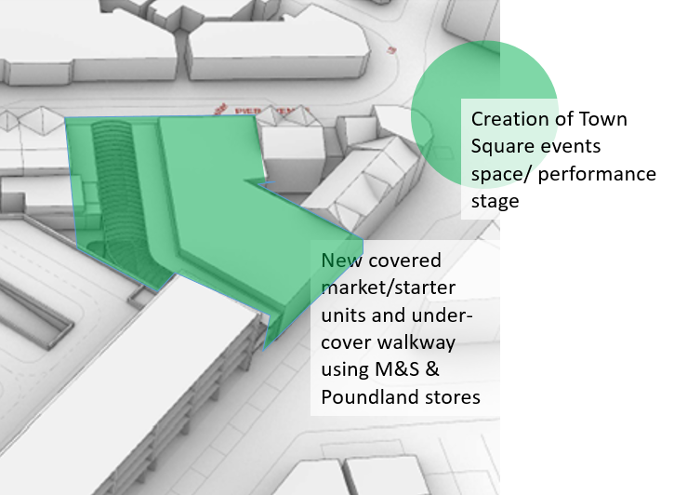

1. The ‘Carnarvon Road/Library’ scheme around Carnarvon Road, Station Road and the High Street is unchanged from ‘Carnarvon Towers’ scheme from the previous Future High Streets Fund bid. It includes a new library and adult community learning facilities with flexible office space, 129 new homes a new multi-storey car park and some start up business units. See property shown in green below.

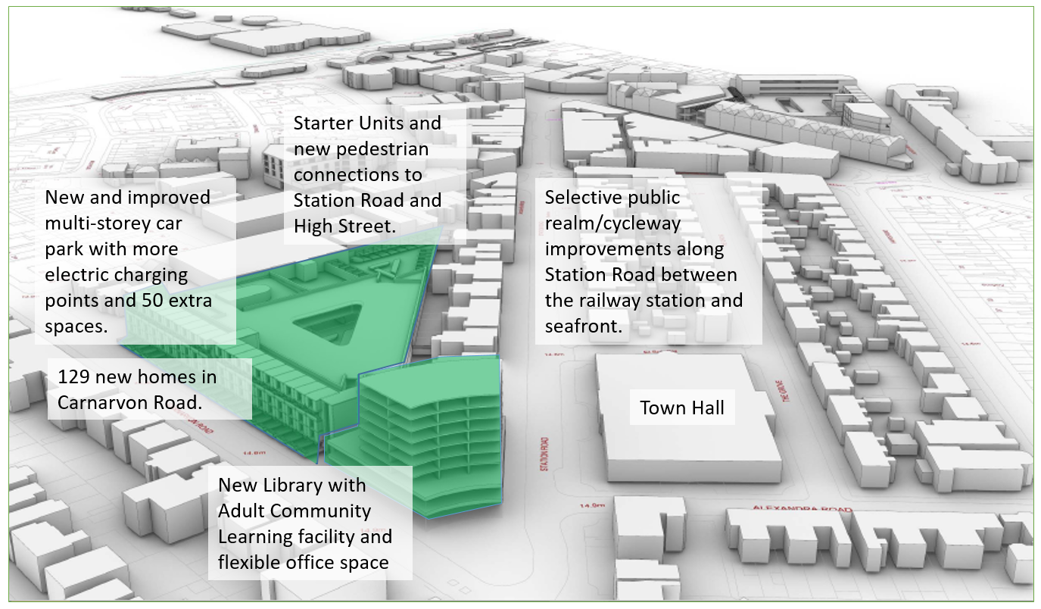

1. A revised version of the public realm and highways works with the addition of improved transport infrastructure between the town centre and the deprived community of Jaywick Sands and with a desire to promote walking, cycling, public transport and electric vehicles.

