

**Invitation to Tender**

**Legal Services Board**

**Tender for routine office cleaning services**

**Deadline for receipt of tenders: 12 noon on 8 July 2022**

**Objective**

The Legal Services Board (LSB) is seeking to appoint a cleaning service provider to provide routine cleaning of its office premises.

**Background**

Who we are

The LSB is the independent body responsible for overseeing the regulation of lawyers in England and Wales. In all our work, we seek to promote the eight regulatory objectives set out in the Legal Services Act 2007. We share our regulatory objectives with the ‘approved regulators’ of the legal profession, each of which have direct responsibility for the day-to-day regulation of the different types of lawyers.

Our office premises

Our office is in central London and 223m2 in area. The office space consists of:

* 28 work desks in an open-plan configuration
* four meeting rooms of varying size
* breakout seating
* kitchen with seating area
* small reception space
* small communications and stationery room
* shared toilets cleaned by our landlord

Annex A shows our office layout. All areas are carpeted, except for the kitchen with seating area, which is vinyl flooring. The kitchen has a dishwasher, which is generally loaded and unloaded by the cleaners, though sometimes by LSB colleagues. Cleaning equipment, such as a vacuum and mop, is currently provided by the incumbent supplier. Waste and recycling are removed to the ground floor, via a lift, by the current cleaners. We have a flexible working policy, which means that we are not all in the office every day. We have a hot-desking arrangement in the office.

We have been leasing our office since September 2019. The lease expires September 2024.

**Requirements specification (this will form part of the Contract)**

Cleaning (minimum routine cleaning requirements)

* Vacuum/sweep/mop floors (daily)
* Sanitise touch points, e.g., door handles, light switches, taps, printer (daily)
* Clean surfaces, including desks, tables, cabinets, doors, partitions and in kitchen (daily)
* Wipe clean inside microwave and kitchen sink (daily)
* Wash crockery/Load and unload dishwasher (daily)
* Dust/clean furniture (daily)
* Dust/clean blinds, ledges, fixtures and fittings (daily)
* Wipe clean inside fridge (monthly)
* Replenish consumables, e.g., hand soap, dish washing soap, dishwasher tablets, kitchen towels (as required)
* Empty and clean bins and replace bin liners (as required)
* Spot clean (as required)

Cleaning frequency and timing: Daily cleaning from 6pm, Monday to Friday (excluding bank holidays)

Equipment: To be supplied by the successful tenderer. There is a cupboard in our office that can be used to store equipment, including vacuum cleaner, mop and bucket and other items. Cupboard size is 198x98x45cm (HxWxD).

Cleaning materials and consumables: To be supplied by the successful tenderer.

Budget: Tenders are expected to be within our budget ceiling of £14,000 per annum including VAT for routine cleaning costs. Prices should be submitted in pounds sterling and inclusive of VAT. All costs must be included in tenders. We reserve the right to only honour payment of reasonable discrepancies and only when first agreed in advance in writing. Tenders must outline:

* setup costs
* routine cleanings costs
* non-routine cleaning costs, such as for deep cleans
* costs for cleaning materials and consumables charged separately
* how and when any cleaning costs would be adjusted, for example, if routine cleaning costs are adjusted annually to match adjustments to living wages

Information to provide against requirements specification: Tenders are expected to include the following information at a minimum:

* A proposed cleaning schedule, specifying the frequency of each cleaning activity, for example, daily, weeks, monthly, etc.
* An outline of your approach to quality assurance for cleaning services
* A summary of your response to Covid-19, including any changes in the services your provided to your clients.

**Transfer of Undertakings (Protection of Employment) Regulations 2006 (“TUPE”)**

We think that TUPE may apply to this contract. If you want relevant employee information from the incumbent supplier to inform your bid, please request this at tenders@legalservicesboard.org.uk. We don’t represent that the TUPE Information is complete or accurate. All the TUPE information is deemed to be strictly confidential and for use solely in connection with the preparation of your bid.

It is up to the incumbent supplier and the supplier that is awarded this contract to agree the extent to which TUPE is to apply and to make the necessary arrangements.

**Contract term**

Start: 10 November 2022

End: 3 September 2024 (end of our current office lease)

Extensions: Possible two-year extension, depending on performance and our office lease situation after 3 September 2024.

**Timeline**

|  |  |
| --- | --- |
| ITT issued | 20 June 2022 |
| Site visit (optional)  *Email* [*tenders@legalservicesboard.org.uk*](mailto:tenders@legalservicesboard.org.uk) *before this date to arrange a slot.* | 30 June, 2:30-5pm |
| Deadline for questions  *All questions and responses will be published on Contracts Finder* | 1 July 2022, 12 noon |
| Deadline for submissions | 8 July 2022, 12 noon |
| Decision made on appointment and communicated | By 10 August 2022 |
| Existing contract ends | 9 November 2022 |
| New contract commences | 10 November 2022 |

**Tender evaluation**

Tenders will be evaluated according to the following criteria. A detailed scoring matrix is provided on the next page.

|  |  |  |
| --- | --- | --- |
| Evaluation | Criteria | Weight |
| Quality | Requirements specification | 46% |
| Commercial | Price | 24% |
| Social value | Living wage | 10% |
| Equality and diversity | 10% |
| Sustainability | 10% |

Quality

A qualitative assessment will be made by reviewing the tender response against the requirements specification.

Tenderers must score a minimum quality score of at least 3 out of 5 to proceed in the evaluation process. Tenderers who do not achieve this score will be excluded from this process. The minimum quality score ensures that all reasonably compliant bids have the chance to succeed but that a bidder cannot win even with a very competitive price if there have been some concerns established with their technical bids.

Social value

A qualitative assessment will be made of the commitment tenderers demonstrate to providing social value:

* *Living wage* will assess whether tenderers provide a living wage to its employees, as specified by the Living Wage Foundation[1]. Tenderers must provide evidence.
* *Equality and diversity* will assess the commitment tenderers demonstrate to equality and diversity. Tenderers must complete the supplier equality and diversity assessment form at Annex B.
* *Sustainability* will assess the commitment tenderers demonstrate to sustainability in its cleaning products and services in accordance with the Government Buying Standards. These standards can be found here: <https://www.gov.uk/government/publications/sustainable-procurement-the-gbs-for-cleaning-products-and-services>

**Score matrix**

|  |  |  |  |  |  |
| --- | --- | --- | --- | --- | --- |
| Score | Rating | Description | | | |
| Quality: Requirements specification | Social value: Living wage | Social value: Equality and diversity | Social value: Sustainability |
| 0 | Unacceptable | Information is omitted/no details provided | Information is omitted/no details provided.  Limited or no evidence that the tenderer provides a living wage. | Information is omitted/no details provided.  Limited or no evidence that the tenderer is committed to equality and diversity. | Information is omitted/no details provided.  Limited or no evidence that the tenderer is committed to sustainability. |
| 1 | Poor | The evaluator is not confident that the tenderer understands and/or will be able to meet our requirements specification. | N/A | N/A | N/A |
| 2 | Fair | The evaluator has some reservations that the tenderer understands and/or will be able to meet our requirements specification to a satisfactory standard. | N/A | N/A | N/A |
| 3 | Satisfactory | The evaluator is reasonably confident that the tenderer understands and/or will be able to meet our requirements specification to a satisfactory standard. | The evaluator is reasonably confident that the tenderer provides and living wage. The tenderer provides some evidence to support this. | The evaluator is reasonably confident that the tenderer is committed to equality and diversity. The tenderer has policies and/or training in place with minor gaps relative to its size. | The evaluator is reasonably confident that the tenderer is committed to sustainability. The tenderer provides evidence that it meets the mandatory level for cleaning services. |
| 4 | Good | The evaluator is confident that the tenderer understands and/or will be able to meet our requirements specification to a good standard. | The evaluator is confident that the tenderer provides a living wage. The tenderer provides good evidence to support this. | The evaluator is confident that the tenderer is committed to equality and diversity. The tenderer has policies and training in place with minor gaps relative to its size. The tenderer has plans to address those gaps. | The evaluator is confident that the tenderer is committed sustainability. The tenderer provides evidence that it meets the mandatory level and some of the best practice level for cleaning services. |
| 5 | Excellent | The evaluator is confident that the tenderer understands and/or will be able to meet requirements specification to an excellent standard. | The evaluator is completely confident that the applicant provides a living wage. The tenderer provides excellent evidence to support this, including that it is accredited by a third party. | The evaluator is completely confident that the tenderer is committed to equality and diversity. The tenderer provides evidence of policies and training. | The evaluator is completely confident that the tenderer is committed to sustainability. The tenderer provides evidence that it meets the mandatory level and best practice level for cleaning services. |
|  |  |  |  |  |  |
|  |  | Commercial: Price | | | |
|  |  | Price will be assessed using a 'proportion of best' calculation. The lowest priced bidder will achieve maximum score in this category and all other bids will be awarded a score as follows: Lowest Priced Bid / Price of tender being evaluated x Max score. | | | |

**Submitting a Tender**

All tender submissions should be submitted by **12 noon on 8 July 2022** to tenders@legalservicesboard.org.uk

Submissions submitted to other addresses or beyond this time will not be accepted.

Your tender is to remain open for acceptance for 90 calendar days from the date of submission.

No qualifications are to be made to your tender. Any tender queries are to be raised before the relevant date listed in our timeline above.

LSB does not bind itself to accept the lowest or any tender and will not be liable for any costs incurred by the tenderer in preparation of their tender.

**Tender checklist**

|  |  |
| --- | --- |
|  | Proposed cleaning schedule |
|  | Outline of approach to quality assurance |
|  | Summary of your response to Covid-19 |
|  | Cost information |
|  | Evidence of providing a living wage |
|  | Supplier equality and diversity assessment form (Annex B) |
|  | Evidence of sustainability in cleaning products and services |
|  | Supplier questionnaire (Annex C) |

**Annex A: Office layout**

3rd Floor, The Rookery, 2 Dyott Street, London WC1A 1DE

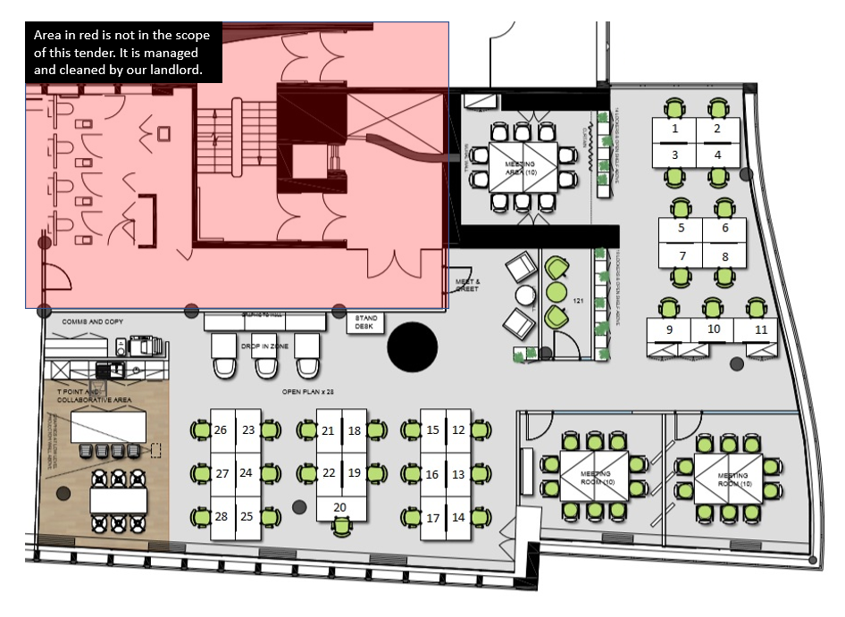

**Annex B: Supplier equality and diversity assessment form**

This form will be used to assess your commitment to equality and diversity. Please answer the following questions, providing any necessary documentation.

1. **Organisation size**

What is the total number of employees/contractors/partners in your organisation?

1. **Equality and diversity policy**

Does your organisation have an equality and diversity policy, statement or strategy?

**YES  /  NO**

If YES, please provide a copy.

If NO, are you intending to implement something in the near future, and if so, when?

1. **Bullying and harassment policy**

Does your organisation have a policy/procedure to handle issues relating to bullying and/or harassment?

**YES  /  NO**

If YES, please provide a copy.

If NO, are you intending to implement something in the near future, and if so, when?

1. **Equality and diversity training**

Does your organisation provide equality and diversity training?

**YES, and it's mandatory  /  YES, and its optional  /  NO**

If YES, please provide an outline or description of the training, its regularity, and the percentage of your organisation that has completed the training.

If NO, are you intending to implement something in the near future, and if so, when?

**Annex C: Supplier questionnaire**

To be completed and returned with tender

|  |  |
| --- | --- |
| Name of organisation |  |
| Address for correspondence |  |
| Contact name and position |  |
| Telephone number |  |
| Email address |  |
| Website address |  |
| Address of registered office |  |
| Company Number |  |
| Names and job titles of key points of contact for delivery of the service |  |
| Name of Bank and contact details for bank (financial references may be sought) |  |
| Please attach most recent audited accounts with an explanation of any significant changes since the last year end |  |
| Please provide contact details for two reference organisations |  |

1. https://www.livingwage.org.uk/