Marlborough Town Council
Tender Document
Provision to design and build a play area at Coopers Meadow Play Area
- General Requirements
Marlborough Town Council is seeking a suitably qualified company to design and build a play area to replace the existing facility at Coopers Meadow Play Area, which is detailed in this document.
The location of the site is off the George Lane Car Park, Marlborough, Wiltshire, SN8 4BX.
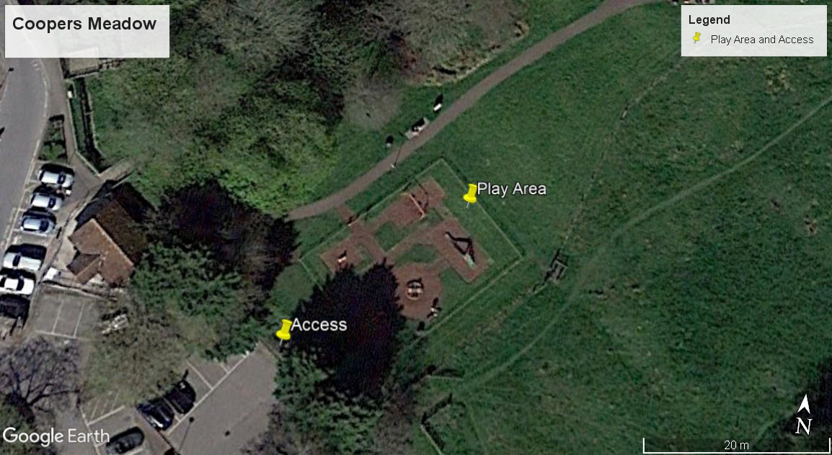
Following the formal review of submissions, and a public consultation of the preferred design which may result in some revisions, the aim is to decide on the preferred supplier and place an order in early August.
- Prices
All pricing should be exclusive of VAT and valid for 180 days from the due date of the response. Prices will be fixed and firm for the duration of the contract.

- Non-Consideration of a Tender Response
The council has the right to refuse any or all submissions without tenderers being able to claim any compensation. All costs associated with the tender process and response is the responsibility of the suppliers that have been invited to participate.
The council may refuse a tender response if there has been any attempt to vary or alter the details within the document, or is not able to provide all the information required by the council to make a full evaluation.
Any offence or inappropriate actions by the supplier, including an offence under the Bribery Act 2010 or the supplier directly canvasses any Councillor or member of staff of Marlborough Town Council concerning the tender other than “appropriate” contact made to the individuals named within this document for the purposes of clarifying the requirements or raising any questions pertaining to the tender.

- CONTRACT CONDITIONS
The successful contractor will enter into a contract by way of a Purchase Order with Marlborough Town Council.
The work is for the design, supply and installation of play equipment, surfacing, fencing and associated works which must all comply to European Safety Standards including BS EN 1176 and BS EN 1177.
The successful contractor must provide evidence of Public Liability Insurance of no less than £10m and Employers Liability Insurance to the council within the tender response.
If the length of works dictate that CDM regulations apply then for the purposes of construction (Design and Management) Regulations 2007 the appointed contractor will be required to undertake and fulfil the duties of the CDM Co-ordinator as part of the conditions of this contract.
Confirmation of work hours, storage of materials, access, location of skips and a final Programme of Works and RAMS will need to be finalised and

provided to the council before work begins, most likely at the “Pre Start” meeting.
During installation, the contractors needs to keep public and maintenance access points clear of equipment, and provide suitable HERAS fencing and safety notices around the construction site.
On completion of the project, any area that has been damaged during the installation such as the turf, surrounding pathways and fencing must be returned to the original condition at the contractor’s expense. Reinstatement of the grassed area should be new turf (not seeding).
- OVERVIEW OF PROJECT
Marlborough Town Council has set aside a budget of up to £50,000.00 (two options stated below) to redevelop the play area at Coopers Meadow. The objective is to create an exciting, challenging, and practical facility for children of up to 12 years and of all abilities while ensuring the area is enjoyable for the families of those using the play area all year round. There is also a requirement for a picnic area to the back of the play area with 2-3 new Picnic Tables onto the grass.
Option 1: £43,000.00 budget with all requirements stated below with the aim of at least 80% of area covered in new surfacing
Option 2: £50,000.00 budget with all requirements stated below plus the existing fence to be painted with play grade green paint, and the aim of 100% of area to be covered in new surfacing plus any additional items possible.
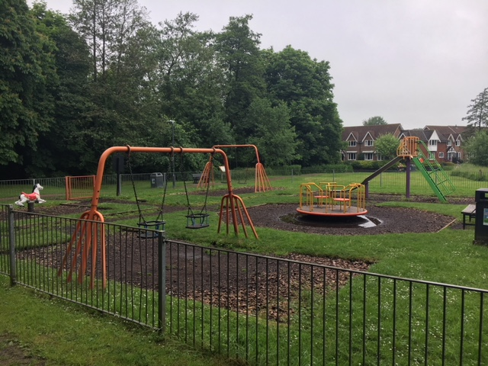
Materials
The council is seeking a very “natural” look and feel to the play area that is sympathetic to the surrounding environment. The design should incorporate good quality wooden material with steel feet where possible and a preference to a bonded mulch with a new stone base for the surfacing.
Removals
All existing play equipment, bark, edging and existing bench is to be removed and disposed of. Additionally, the two existing gates need to be replaced with yellow self-closing gates. The fence is to remain in place.
Fencing
The existing fence is to remain in place, however with Option 2, this will include painting the fence in appropriate play area quality green paint.

Furniture
The design needs to incorporate two new benches with back rests (wooden) onto the grass or new surface. Also, up to three Picnic Tables outside of the play area in the open turfed area to the rear (shown below).
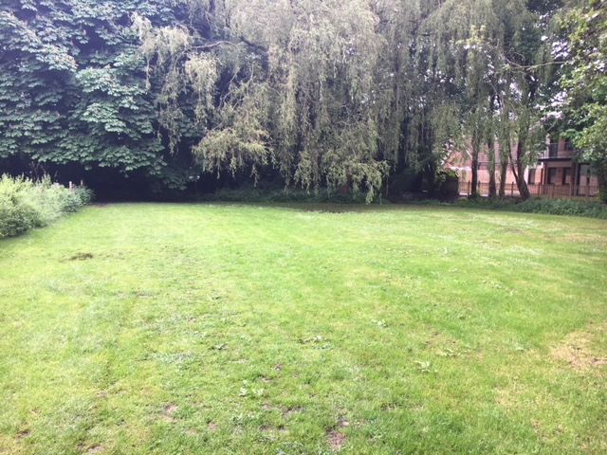
Pathways
No pathways are required, however it would be beneficial to see a path within the play area using an alternative bonded mulch colour to connect the two access gates and benches.
Drainage
Contractors are asked to cost in and provide advice of additional drainage solutions that will be suitable for the site in addition to the surfacing and baseworks that will be installed. The site does currently suffer from water saturation and pooling within and outside of the play area.

Play Equipment
Overall the design and choice of play equipment will be up to the supplier, however the items and suggestions which should be included are:
- Flat Seat Swings
- Toddler Seat Swings
- Toddler Multi Play Unit
- Junior Multi Play Unit
- Timber Trail and or “Pick Up Sticks” frame
- Basket Swing
- See Saw
- Spinning item
- Boulders for informal seating
Surfacing
There is a strong preference to using Bonded Mulch or similar within the play area with a new Stone Base. The base much have “open grade” stone and a minimum of 100mm of stone due to the issues with drainage and the area holding a considerably amount of water currently making the play area unusable for much of the year.
General Design Approach
The overall design should be based consider the natural surrounds and use more “natural” materials, encourage children to use a variety of equipment for all ages and abilities (up to 12 years of age).
Due to issues with drainage and water concentration, a key aspect is ensuring this is addressed primarily with the new surfacing, however any feedback or advice from the contractors is welcome to ensure the area can be used all year round.
Value Add
The council will be open to any additional value added options within the proposal such as (but not limited to):
  - Open Day Event
  - After care service (outside of standard warranty inclusions)

After Sales and Service Level Agreements
One critical aspect to the overall response is the ability for suppliers to respond quickly and effectively to any post installation maintenance requirements. That is, a scoring mechanism is included in this document to evaluate how a supplier will respond to the following:
  - A request to fix any issues relating to defects that are included in the warranty – time to resolve etc
  - Spare Parts – lead times to provide an replace spare parts
  - Non-warranty defects – lead time and costs associated with general inspection and maintenance – are there call out fees, what is the standard lead time to resolve
Service Level Agreements: As per the SLA table outlined in this document there will be a scoring mechanism and condition to the contract that the supplier adheres to certain SLA’s around installation and post-sales support.
Should the contractor agree to these terms for the purposes of the overall score, but fail to meet these agreements, penalties will be posed in the form of either a credit or similar that could be used for future orders or services rendered.
Post Installation Inspection
Please allow for a ROSPA inspection following the completion of the project, and any noted defects or medium to high risk reports need to be attended to and resolved before the open date noted on the table below.

- TIME TABLE FOR PROJECT
Below is the table set out for the project which suppliers will need to confirm they can achieve to ensure the primary deadline is met. Suppliers will need to provide confirmation (or Programme or Works) that these dates for starting and finishing the project can be met within tender response:

Action: | Date Due By:
Tender Site Meeting – date and time to be confirmed | 20th June 2018
Final date for any clarification or questions on tender | 2nd July 2018
Tender Response Due | 11th July 2018
Council’s written response to tender | 17th July 2018
Consultation (2 Hours) which may include the preferred supplier | 18th July 2018
Revisions to design completed (if required based on consultation) | 1st August 2018
Order Date | 2nd August 2018
Work to commence | 1st October 2018
Completion Date | 19th October 2018
All snagging / ROSPA issues resolved, fencing and storage removed, Play Area Open | 26th October 2018

- SCORING OF TENDERS
The table below will be used to score all the submissions in order to short list the responses for a final three.
Item | Detail | Score
Overall Design | Meeting the brief, design layout, aesthetics of equipment and surfacing | 50%
Quality of Materials | Maintenance, expected longevity of equipment and surfacing, baseworks | 20%
Warranties | What is covered in the warranty, length of warranty for each type of material | 10%
Presentation | Quotation, quality of the visuals, general information included and format of response | 10%
Time Table and Service Levels | Can you meet the time frames and agree to the services levels detailed in this document | 10%

SCORING SYSTEM
5 | Superior | Exceptional demonstration of the relevant ability, understanding, experience, skills, resources & quality measures required to meet the projects aims or requirement. Response highly relevant with comparable contract value.
4 | Good | A comprehensive response submitted in terms of detail and relevance and clearly meets most of the project aims or requirement with no negative indications or inconsistencies.
3 | Adequate | Reasonable achievement of the requirements specified in the tender offer & presentation for that criterion. Some errors, risks, weaknesses or omissions, which can be corrected/overcome with minimum effort.
2 | Below Expectations | Minimal achievement of the requirements specified in the tender offer & presentation for that criterion. Several errors, risks, weaknesses or omissions, which are possible, but difficult to correct/overcome and make acceptable.
1 | Poor to deficient | Limited response provided, or a response that is inadequate, substantially irrelevant, inaccurate or misleading
0 | Unacceptable | Totally deficient and non-compliant for that criterion.

- Service Level Table
The table below represents the service level requirements for this project to ensure that there are minimal time and cost implications for delivery and post-sales support.
Requirement | Details | Penalty
Completion of project on time | Other than delays due to aspects not within the control of the contractor, completion of 2 weeks beyond stated completion date | 2% of value of Project (£1000.00)  Longer than 2 weeks - 3% of value of Project (£1500.00)
Resolution of Warranty related defects | Beyond 4 weeks of notified defect if item is not safe to be used | 5% listed value of equipment in question
Retention | Any defects or quality issues within 12 months of installation | 5% of the value of the project to be withheld until 12 months following completion of the project
Project Management | Please advise if a PM will be allocated and what their responsibilities will involve | N/A – council is looking for a PM to do the Pre-Start, at least 2 site visits during installation and sign off the completion

- Reference Sites
Please provide two suitable references that ideally are of similar value and requirements for this project. Please use the format below for each reference:
Name of Council/Client
Contact Name
Contact Telephone
Contact Email
Location of Installation
Value of Project
Description of Project
Date of Installation

- Format for Response
Please provide 1 x A1 Hard Copy of any visuals / designs and 1 x A4 hard copy of any supporting material such as the quotation to the Town Council, address shown below. Additionally, send an email ONLY to Michael Carter by the due date – electronic responses are not to be sent to the council.
The items should be clearly marked “Private and Confidential - Tender Response – to be opened only by the Town Clerk”
Town Council Address for delivery:
Marlborough Town Council
Town Council Office
5 High Street, Marlborough, SN8 1AA
Attention: Shelley Parker – Town Clerk

- Contact for Tender
Marlborough Town Council is using an independent consultant for all aspects of the Pre-Sales process (and possible Project Management) who will be the primary contact for this tender.
Any questions relating to the tender and organising the time for a site visit should be directed to:
Michael Carter
Sports and Play Consulting Limited
07421 463099
michael@sportsandplayconsulting.co.uk

