CONTENTS
WHATS INCLUDED
OVERVIEW
LOTTING STRUCTURE
TIMESCALES
KEY DELIVERY DATES
CURRENT ROLES AND RESPONSIBILITIES OF THE CUSTOMER
TEST & DEVELOPMENT REQUIREMENTS
REQUIRED CAPABILITIES AND OUTCOMES OF THE SUPPLIER
TERMS AND CONDITIONS
EVALUATION STAGES, MINIMUM PASS MARKS & PRICE EVALUATION

WHATS INCLUDED
Customer Requirements (this document)
Appendix A – Award Questionnaire (template to be completed)
Appendix B – Supplier Pricing Matrix (template to be completed)
Appendix C – Call-Off Contract (Part A&B) (Customer specific terms)
– Call-Off Contract (Part C) (Standard Terms and Conditions)

OVERVIEW
CCS Project Lead: | Emilia Cedeno
Customer: | Home Office
Delivery Location: | London
Phase(s): | Alpha, Beta
Project: | DS02- 017
Required Capabilities: | Include:  ☒ Software engineering and On-going Support  ☒ Front-End Design and Interaction design  ☒ System Administration and Web Operations
Subcontracting Permitted? | ☐Yes ☒ No
Supplier Partnering Permitted? | ☐Yes ☒ No
Contract Charging Mechanism (Alpha Phase): | Fixed Price
Contract Charging Mechanism (Beta Phase): | Fixed Price
Tender Publish Date: | 14/08/2015
Tender Submission Deadline: | 02/09/2015
Proposed length of phase: | 4 months for both phases
Proposed Commencement Date of Project: | 05/10/2015

LOTTING STRUCTURE

The Customer has structured this procurement as follows:
Lot 1 | Software engineering and On-going Support (Developer) (Technical Architect)  Front-End Design and Interaction design (Designer- Junior-)  System Administration and Web Operations (Web Ops- Intermediate)
- Remote Developer can only be deployed where there is a co-located Supplier team onsite with the customer. Remote Developers cannot be deployed as a standalone resource.

TIMESCALES
The Customer or CCS may change this timetable at any time. The Potential Provider will be informed by email if there are any changes to this timetable.

It is the Potential Provider’s responsibility to monitor the online messaging facility (e-Sourcing).

TIMESCALES
DATE | WHO | ACTIVITY
14/08/2015 | CCS | Publish requirements to Potential Providers:  Clarification period starts
19/08/2015 | CCS, Customer & Potential Providers | Clarification Webinar 14:00:  Invite to webinar will be issued via the CCS eSourcing Suite. All questions and responses will be published via eSourcing Suite.
26/08/2015 | Potential Providers | Clarification Question period closes  Please submit all clarification questions by 23:59hrs  Please note that we aim to publish all response to Q&A within 24hrs
02/09/2015 | Potential Providers | Submission Deadline  Potential Provider must upload submission to the eSourcing suite by 12:00noon
15-18/09/2015 | Potential Providers & Customer | Demonstration and Scrutiny  Presentations 45 minutes
24/09/2015 | CCS | Award Notification  Publish Successful and un-successful Potential Providers.
05/10/2015 | Customer | Expected "Commencement Date" for Call-Off Contract/s

KEY DELIVERY DATES
PROJECT PHASES | START DATE | COMPLETION DATE
Alpha | 05/10/2015 | 30/10/2015
Beta | 02/11/2015 | 01/02/2016

CURRENT SITUATION / BACKGROUND INFORMATION
Building capability is one of our Civil Service’s top priorities. Civil Service Learning is at the heart of this agenda, in fact our mission is to ‘get Civil Servants fired up about learning’. To do this we’ll support all Civil Servants with a simple, modern, efficient learning service designed around Civil Servants’ needs.

Our service will make life easier for Civil Servants by giving them the ability to:

- easily search for the learning they’re looking for
- efficiently book learning and link any supporting material to their calendar
- view their ‘profile’ which will show mandatory learning ‘to do’ and recommend career paths and learning for their profession or development ambition.
- see at a glance where resources, skills and capabilities are, what learning their team have planned and completed
- show how our capability is growing from a strategic view of the Civil Service.

The cross government team is developing the service to the high standards the Government Digital Service (GDS) apply to public facing services. Following a Discovery for a wider cross-Government service, the team is moving into Alpha focusing on the learning element of the service, and deeper user research will be carried out to confirm user needs. We’ll be doing this for around 12 weeks from August 2015.

We are looking to work with a supplier to develop the service and integrate with an existing back-end service (see attached Architecture and CSL Roadmap documents).

We are looking for a supplier to work collaboratively with the CSL project team (see table below) and our current supplier LEO (http://leolearning.com/). Together we will adhere to the government's policy with regards to the Technology Code of Practice, building services in accordance with the Government Service Design Manual and ensuring they are compliant with the Digital by Default Service Standard.

CURRENT ROLES AND RESPONSIBILITIES OF THE CUSTOMER
Role | Responsibilities
Service Manager | Deliver an effective user focused digital service, including all related processes, for which they are responsible and accountable.
Product Owner | Responsible for the delivery, on-going success and continuous improvement of one or more digital products and/or platforms
Delivery Manager | Set the team up for successful delivery. Remove obstacles, or blockers to progress, constantly helping the team become more self-organising.
Designer / Front End Dev | Front end development of the service including interaction, graphic and UX design.
Business Analyst x2 | Work closely with the Agile team to define a product approach to meet the specified user need. Rationalise complex information to make it understandable for others to work with.
User Researcher | Understanding who the users are, understanding their needs and maintaining a close focus on designing digital services that best meet their needs
Content Designer | Make sure that the writing on the site or service meets the needs of the user as clearly, simply and quickly as possible.

CURRENT TECHNOLOGIES AND LANGUAGES
Civil Service Learning is composed of eight separate but also interdependent systems
Single sign on between the master system (Drupal portal) and the other systems is a mixture of Open ID, Drupal shared cookies and usernames/passwords
The technology is primarily PHP/MySQL, plus .NET (Course Booker, Ashridge) and other technologies (Good Practice, Google Search)
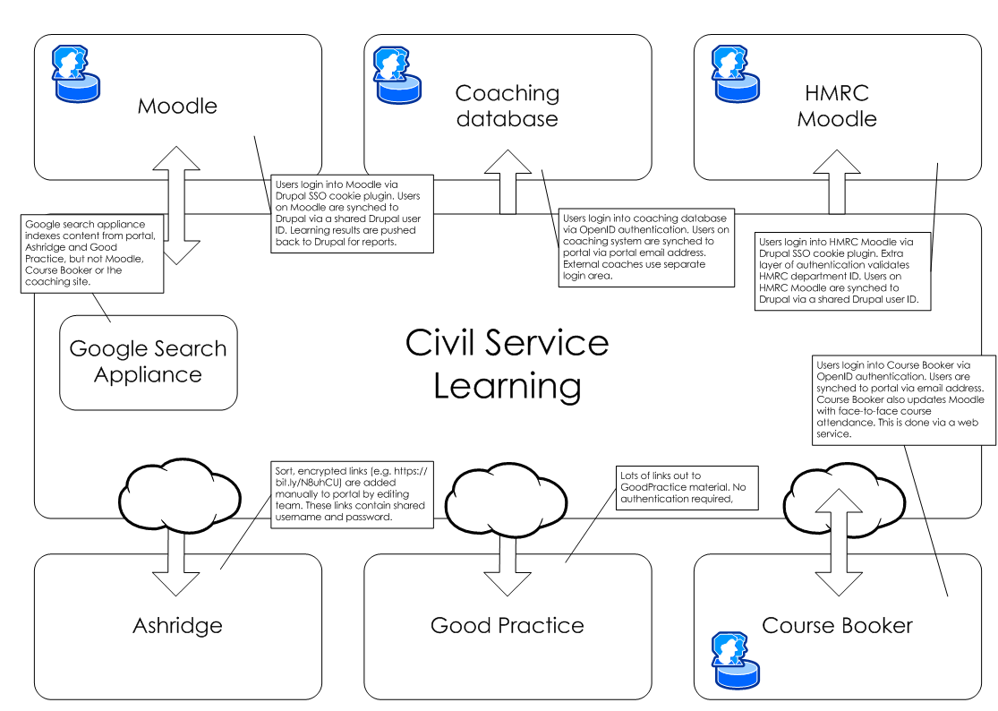

- Moodle is used to deliver all core learning material as well as evaluation forms and competency framework questionnaires
- As users click through to Moodle, their accounts are created/updated
- Moodle passes all results back to Drupal in the form of learner records and other reports
- Moodle also accepts face to face attendance data from Course Booker
- The version of Moodle currently in place is 2.5.3
- The HMRC Moodle is a copy of the mater Moodle system, with Single sign on restricted to users within HRMC. The HMRC Moodle does not provide reporting data to the portal
Coaching

- The coaching site (often referred to as the “coaching database”) is a separate Drupal system (version 7.14)
- Civil servants log into the coaching site through single sign on (Open ID), while external coaches use a separate login form
- As with the Moodle system, user accounts are created as users first log in, and are updated each time they are authenticated
- No data from the coaching site is passed back to the portal

Course Booker

- Course Booker is hosted externally and managed by Capita/V1
- Course Booker is used to manage face to face bookings and also accepts payment through an e-commerce system
- Users are authenticated on Course Booker via Open ID from the portal
- Course Booker provides Moodle with information on user attendance

Google Search appliance

- Google Search Appliance (GSA) provides the main search features for the site
- GSA is a physically separate service which indexes content on the portal, Virtual Ashridge and Good Practice
- GSA does not index content on Moodle, Course Booker or the coaching site, but content for Moodle and Course Booker is well-referenced on the portal

REQUIRED OUTCOMES
The current agile team have completed a discovery and have developed a Roadmap. They are currently working to develop User Needs through research and prototypes of the proposed service. The Roadmap features are;
- Secure sign-on – creates profile and secure structured data store
- Search – by keyword and filters (to be defined by users)
- Book – Content (what do I need up front?), make booking, (F2F, online & other learning and coaching), approval, confirm booking, payments and changes
- Do the learning – Record attendance, confirm that I’ve completed / passed the course, give me proof
- Record and evaluate – Record “other” learning, send evaluation (learning), send feedback (service)
- Data views – searchable repository of data and configurable reports available at different levels e.g. User, manager, head of Dept, Dept Learning Lead etc.

Cross Government Tools Discovery – Summary of findings relating to Learning

The user needs for the Cross Government Tools initiative were captured in Maslow.
The needs relating to learning are summarised below;

It should be noted that these do not constitute a complete set of needs for the new learning service.
Professions
- Know if I'm in a profession and if so which one(s)
- Know the important themes / areas for my profession
- Understand what the professional development structure and offer is
- Find learning opportunities relevant to my profession

Management
- Have oversight of the money that has and will be spent on training
- Have oversight of my teams training
- Find data on what learning has been completed

Learning Records
- Maintain a comprehensive learning record
- Look at my teams learning record

Access to learning
- Access learning remotely to suit my level
- Access learning in a suitable format
- Access learning at a time and place to suit me

Coaching & Mentoring
- Find a coach / mentor to work with
- Be able to advertise my availability as a coach or mentor
- Find someone to help me run the activity

Identify learning needs
- Obtain 360 feedback
- Identify development areas
- Have a learning plan
- keep up to date with learning opportunities

Booking
- Book onto training courses

Suppliers
- I want to engage a supplier

TEST & DEVELOPMENT REQUIREMENTS
The customer requires a digital service to be designed and delivered to meet user needs, which:
- adheres to the government's policy with regards to the Technology Code of Practice
- is built in accordance with the Government Service Design Manual
- is compliant with the Digital by Default Service Standard

The supplier is free to deliver these outcomes using its capabilities as it sees fit.

REQUIRED CAPABILITIES AND OUTCOMES OF THE SUPPLIER
Capabilities | Outcomes
Software Engineering and Ongoing Support  Developers  Technical Architect | Implement APIs for internal and external use.  Build up a useful, robust automated test suite to support continuous deployment  Bring specialist knowledge of wider web technologies, identifying good practices we can adopt and sharing our experiences.  Share knowledge of tools and techniques with wider team (both developers and non-developers)  2nd line support of applications and platforms  The supplier will also need to demonstrate the following capabilities / standards;  Cloud migration, legacy service integration, discovery, and ISO27001 accredited
Front-end Design and Interaction Design  Designer | Work as part of a multi-disciplined team to design user focussed and successful services  Deliver designs that meet web standards, ensuring that key elements are built in from the outset  Contributing to the development and continual enhancement of products  Partnering with colleagues to facilitate a consistent user experience.
System Administration and Web Operations | Operational management of servers, delivering a complex web application stack  Building and configuring new server platforms and automated tooling to do so  Testing, debugging and troubleshooting of platform level problems  Supporting development teams with configuring applications for deployment  Sharing on-call duties

Proposed individuals who are non-British/EEA nationals must either be in possession of leave to remain with no restrictions on their time to live/work in the UK or their leave to remain must be valid for the duration of this award and permit work in this capacity.

THE METHODOLOGY
This project must be delivered under an agile methodology.

GOVERNANCE
The supplier will work closely with the agile team and take active roles in daily stand-ups, 2 weekly Sprint Reviews, monthly Show and Tells, 2 weekly Retrospectives and any ad hoc Stakeholder management that may be required.

TERMS AND CONDITIONS
Please note that Customer specific Terms and Conditions apply to this agreement. Please refer to the Call-Off Contract Part A, for further information. Please note that these terms will supersede the standard terms within Call-Off Contract Part C Call-Off Terms and Conditions

EVALUATION STAGES, MINIMUM PASS MARKS & PRICE EVALUATION

Evaluation will follow the approach below:

Technical & Cultural evaluation

Demonstration, Testing and Scrutiny

Pricing evaluation

MINIMUM PASS MARKS:

In order for Potential Providers to progress they must achieve or exceed the Minimum Pass Mark, as defined in the Award Questionnaire.

Stage 1: Technical & Cultural evaluation | All Potential Providers who achieve the required Minimum Pass Mark for a Lot will be added to the Short List, and will be eligible to continue in the Further Competition.
Stage 2: Practical Demonstration, and Scrutiny of the resources proposed by the supplier | Suppliers who meet the Minimum Pass Marks specified for Part A Supplier Confirmation, and Part B1 Written Submission; will be required to complete Part B2 Practical Demonstration of a particular skill (specified within the Award Questionnaire) in order to evidence capability.  Supplier resources will be required to respond to the Scrutiny questions stipulated within the Award Questionnaire. Each shortlisted Supplier must achieve the Minimum Pass Marks identified in the Award Questionnaire to continue in the Further Competition.
Stage 3: Pricing evaluation | For each Further Competition the Customer has a choice as to how they wish the pricing to be evaluated.  In this instance the Customer has specified Combined Evaluation as their chosen price evaluation method. For more information please see the Evaluation Guidance document held on the e-Sourcing suite.  Please note that pricing will only be evaluated for those shortlisted suppliers that have met the Minimum Pass Marks for the preceding evaluation stages

