# **Our ref:** 2017-01055

**Date:** 15th March 2019

Dear Sir or Madam

**INVITATION TO TENDER FOR THE PROVISION OF CONSULTANCY SUPPORT FOR INFORMATION SHARING**

This Invitation to Tender ("ITT") has been made available to suppliers expressing an interest in the above opportunity via our e-tendering portal.

This Invitation to Tender ("ITT") has been produced to enable WMCA to evaluate the solutions and services offered by bidders and identify the bidder which best meet its needs. Alongside this letter the ITT consists of the following separately attached document. Please ensure you read the below listed documents in full before responding to this opportunity:

|  |  |
| --- | --- |
| **File Name** | **Brief Description** |
| Qualification, Technical and Commercial Envelopes | Bravo Solution Envelopes: Please submit your response via these envelopes |
| Information Sharing Specification | Specification of requirements. Please read this document in full before submitting a response to this tender. |
| Consultancy Agreement | The terms and conditions that the successful supplier will contract on. |

This letter sets out an overview of WMCA's requirements, details of how tenders will be evaluated and the terms and conditions that apply to this procurement process.

Bidders are invited to submit their response to this ITT by the closing date of 12 noon on 03/04/2019.

**DETAILS OF REQUIREMENT**

WMCA are pleased to announce a procurement opportunity for the provision of consultancy services for Information Sharing.

The overall aim of this work is to provide a roadmap and deliverables to help WMCA partners improve information sharing. The work covers engagement, planning, and technical support as summarised below:

1. Work with partners to develop a “roadmap” to guide the development of our approach to information sharing
2. Provide expert support to engage the WMCA partners on information sharing issues
3. Develop an Information Sharing Charter agreement between WMCA partners, and advising on associated required changes e.g. its use as the basis for decision making, and necessary staff development.
4. Preparatory work around a wider information management strategy for the region:
5. Develop appropriate information governance arrangements in consultation with with the IG community across the partners.
6. Support engagement with civic society groups and local citizens on the case for information sharing, acceptable uses and approaches, and ethical considerations
7. Deliver a series of 2-3 “demonstrator projects” information sharing and analysis projects. Suggested projects are safeguarding (child and/or adult) and multiple complex needs “radical prevention” (building on Coventry’s MEAM pilot).
8. Advise on the technical requirements of a federated data platform for information sharing in the region

Please refer to the separately attached brief for more details.

**PROGRAMME**

The deadline for return of tenders is 12:00 Noon on 03/04/2019

The indicative procurement timetable is set out below. This is intended as a guide only and whilst WMCA does not intend to depart from the timetable, it reserves the right to do so at any time.

|  |  |
| --- | --- |
| **Activity** | **Date** |
| Invitation to Tender – Publication Date | 15/03/2019 |
| Deadline to Raise Clarifcation Questions | 12:00 Noon on 29/03/2019 |
| Invitation to Tender – Deadline to Respond | 12:00 Noon 03/04/2019 |
| Contract Award | Week commencing:  29/04/2019 |
| Mobilisation Period/Contract Commences | TBC |

**QUERIES FROM BIDDERS**

The point of contact for all bidders throughout this procurement process is via WMCA’s Bravo eTendering system (**https://wmca.bravosolution.co.uk**) using the message/correspondence feature except as otherwise advised by WMCA from time to time.

Bidders should refrain from using any other forms of direct communication other than the Bravo eTendering message/correspondence feature during a tender provision as this reduces the effectiveness of the audit trail. For the avoidance of doubt, WMCA will not accept any telephone clarifications from any bidder in any circumstance whatsoever.

All questions and requests for clarification or further information from bidders may only be made, and will only be entertained, if made by 12 noon on 29th March 2019. WMCA reserves the right not to reply to any clarification submitted after this deadline.

On receipt of a request for clarification or further information, WMCA may, at its sole discretion, endeavour to respond to the bidder and provide such bidder with any additional information to which WMCA has access, but WMCA shall not be obliged to comply with any such request and does not accept any liability or responsibility for failure to provide any such information (and absence of a response from WMCA shall not entitle a bidder to make any particular assumptions about the matters sought to be clarified).

WMCA will endeavour to circulate responses to questions and requests for clarification or further information from bidders by 12 noon on 3rd April 2019

All such queries received and their responses will be circulated to all bidders unless they are commercially sensitive. As a matter of course, the identity of the enquirer will not be circulated. If a bidder believes a query and/or its response is confidential, it must mark the query as “confidential”. If WMCA agrees that the query and/or its response should be answered confidentially, WMCA will send a response only to the bidder that submitted the query. If WMCA is of the opinion that it would be inappropriate to answer the query/request on a confidential basis it will notify the bidder and require the bidder to either withdraw the query or to raise any objection within two (2) working days of such notification and state the grounds for its objection. If the bidder does not withdraw the query/request or raise any objection within the specified period, or if WMCA is of the opinion that, notwithstanding the objection of the bidder, the query/request is not confidential, WMCA may issue the query and its response to all bidders.

WMCA reserves the right to amend the ITT documentation (including the terms and conditions of contract) as a result of questions which affect the overall nature of the scope. In the event of this occurring WMCA will write to all bidders with the same information and tenders will be assumed to take such amendments into account.

**Any requests to amend the ITT documentation, including terms and conditions of contract, after the deadline for clarification questions and including in the post tender period, will be rejected to ensure equal treatment of bidders.**

**PROCEDURE FOR SUBMISSION OF TENDERS**

This ITT consists of Minimum Requirements (Qualification), Technical and Commercial Envelopes.

**Tenders and accompanying documentation must be uploaded onto WMCA’s BravoSolution e-tendering system (https://WMCA.bravosolution.co.uk) by 12 noon on 3rd April 2019 otherwise it will not be considered.**

Bidders should be aware that a 50mb file size is the maximum for individual files that the system can accommodate. Bidders wishing to submit information in excess of this file size should therefore submit multiple files.

Bidders are asked to avoid the use of punctuation in file names as their inclusion prevents WMCA downloading documents to its systems.

It is the responsibility of bidders to ensure that tenders are delivered on time and to obtain an electronic receipt via the system. WMCA shall have no responsibility in relation to tenders which are not submitted on time and reserves the right to reject any such tenders in their entirety and not consider the bidder further in the procurement process.

All tenders must be provided in English or accompanied by a full English translation.

**EVALUATION**

**Overarching Award Criteria**

It is WMCA’s intention to award this opportunity to one supplier.

The Supplier with the most economically advantageous tender will be appointed. Responses to Bravo Solution Envelopes will be evaluated against the following evaluation criteria (applicable to all framework lots):

* Mandatory/Minimum Requirements – PASS/FAIL
* Technical (Quality) - 55% Weighting
* Commercial (Price) – 40% Weighting
* Social Value 5% Weighting

Each of the above sub headings are further explained below:

**Mandatory/Minimum Requirements – PASS/FAIL**

Responses to this ITT will first be checked for compliance and completeness. WMCA reserves the right to reject any submissions that do not comply with the requirements of this ITT, that are incomplete in any way or that are submitted after the applicable deadline. WMCA will then evaluate responses to the Minimum Requirements Envelope.

The Minimum Requirements Envelope includes a Qualification and Technical envelope and includes selection criteria that WMCA considers are relevant and proportionate to the subject matter of the contract and reflect WMCA's minimum suitability requirements for the contract.

The suitability of bidders for this contract will be assessed using the information submitted in the Minimum Requirements Envelope as follows:

A FAIL to any of the below listed criteria will indicate that the Supplier is disqualified from the process and their tender response will not be evaluated any further:

|  |  |  |
| --- | --- | --- |
| **Qualification Envelope** | | |
| |  | | --- | | **Section within Qualification Envelope of Bravo Portal** | | **Question Detail** | **Weight** |
| Part 1  Declaration | An answer of ‘NO’ to this question will result in the supplier being excluded from this process and their tender submission not being considered any further within the process. | PASS/FAIL |
| Part 2  SQ-2.1(a).1 – SQ-2.1(a).6  Grounds for Mandatory Exclusion | You may be excluded from the procurement process if there is evidence of convictions relating to specific criminal offences listed within these questions.  If you have answered yes to question 2.1(a), please provide further details. Date of conviction, specify which of the grounds listed the conviction was for, and the reasons for conviction, Identity of who has been convicted If the relevant documentation is available electronically please provide the web address, issuing authority, precise reference of the documents.  For further guidance please see:  <https://www.gov.uk/government/uploads/system/uploads/attachment_data/file/551130/List_of_Mandatory_and_Discretionary_Exclusions.pdf> | PASS/FAIL |
| Part 2  SQ-2.3(a) Regulation 57(3) | An answer of ‘YES’ to this question will result in the supplier being excluded from this process and their tender submission not being considered any further within the process. | PASS/FAIL |
| Part 2  SQ-3.1(a) – SQ-3.1(j)-(iv)  Grounds for Discretionary Exclusion – Part 1 | The authority may exclude any Service Supplier who answers ‘Yes’ in any of the following situations set out in these questions  For further guidance please see:  <https://www.gov.uk/government/uploads/system/uploads/attachment_data/file/551130/List_of_Mandatory_and_Discretionary_Exclusions.pdf> | PASS/FAIL |
| Part 3  SQ-4.1, SQ-4.1(a-c)  Economic and Financial Standing | You are asked to self-certify that you can meet the economic/financial standing requirements as stated within this question section.   |  | | --- | | Audited Accounts Explanation - If a Supplier states ‘NO’ to question SQ-4.1 and audited accounts are not available upon request then alternative documentation should be provided. |   Based on the information provided WMCA may reject a tender as non-compliant if a Supplier is unable to provide requested audited accounts or suitable alternative means of demonstrating financial status. | PASS/FAIL |
| Part 3  SQ-8.1  Additional Questions Insurance | An answer of ‘NO’ to this question will result in the supplier being excluded from this process and their tender submission not being considered any further within the process. | PASS/FAIL |

**Should any bidder not meet WMCA's minimum requirements for this contract its tender will be rejected by WMCA at this stage and will not be evaluated further.**

**Technical (Quality) - 55% Weighting**

The quality of tenders will be assessed using the information submitted in the Technical Envelope. Each quality response will be marked out of a maximum score of 10 using the following scale:

|  |  |  |
| --- | --- | --- |
| **Score** | **Description** | |
| 0 | Unacceptable | The information required is either omitted or fundamentally fails to demonstrate and evidence that WMCA’s requirements in the area being measured will be delivered in accordance with the tender/contract documents. |
| 2 | Poor | The information submitted has insufficient evidence to demonstrate assurance that WMCA's requirements in the area being measured will be delivered in accordance with the tender/contract documents. |
| 4 | Fair | The information submitted provides some evidence to demonstrate how WMCA’s requirements in the area being measured will be delivered in accordance with the tender/contract documents, but contains minor omissions. |
| 6 | Acceptable | The information submitted satisfactorily evidences and demonstrates how the requirements in the area being measured will be delivered in accordance with the tender/contract documents and is satisfactory in most respects and there are no major concerns. |
| 8 | Very Good | The information submitted provides very good evidence to demonstrate how the requirements in the area being measured will be delivered in accordance with the tender/contract documents and any concerns are identified and addressed. |
| 10 | Excellent | The information submitted provides excellent and strong evidence to demonstrate how the requirements in the area being measured will be delivered in accordance with the tender/contract documents, a full and robust response with no concerns. |

Higher scores will be awarded where responses take into account the specific requirements set out within the brief and the environment in which WMCA operate within. Where possible, responses should be supported with examples to demonstrate how your proposed solution will add value and expertise.

**Weightings**

Quality will have an overall weighting of 55%. Quality will be further be broken down as follows:

|  |  |  |  |
| --- | --- | --- | --- |
| **Quality Questions** | **Scoring Guidance** | **Maximum Available Score (prior to weighting application)** | **Weighting** |
| The proposed approach to deliver the required deliverables and outcomes | Approach is clear and practically deliverable. | 10 | 10% |
| The outputs that will be provided | Detail of outputs and fit with the outcome objectives of the ITT. | 10 | 15% |
| How contractors will engage with the local public services “system” in a cost-effective way and “socialise” the changes required | Detailed, clear and practical proposals. | 10 | 5% |
| Potential added value (e.g. access to external funding streams, connection to central government initiatives) | Robust proposals for added value | 10 | 5% |
| Project plan and timeline, showing the order in which the work areas will be addressed and the timing of each specified output | Clear and practical plan with all outputs included. | 10 | 5% |
| Relevant skills and experience of the staff allocated to the project (and days input per person) | Clarity on staff actually working on the project, their skills and experience. | 10 | 10% |
| Experience in helping other local areas develop information sharing arrangements. | Depth and relevance of experience. | 10 | 5% |

**Price Evaluation (40%)**

**Price will have an overall weighting of 40%. Please confirm your fixed prices within the commercial envelope of the Bravo solution portal.**

A fixed fee proposal will be submitted for the consultancy support services**.** The fixed fee must include all expenses and will be broken down by work stream and phase.

Commercial evaluations will be conducted on the total fixed fee confirmed within the commercial envelope within the Bravo Solution Portal.

The pricing response of tenders will be assessed using the equation:

$$\frac{Lowest Tendered Price}{Tenderer^{'}s Price} ×100$$

For example: Using the above equation the bidder that submits the lowest pricing will score full marks, a bidder that submits pricing that is twice as expensive as the lowest pricing submitted will score 50% of the maximum available score for price and a bidder that submits pricing that is 10% more expensive than the lowest pricing submitted will score 90.9% of the maximum available score for price.

The maximum available score for price is: **40**

**Social Value Evaluation (5% Weighting)**

You will be required to complete Social Value responses per lot submission. Please note the following reference numbers which will be needed in order to compliantly submit a social value response:

|  |  |
| --- | --- |
| **Title** | **Reference** |
| CONSULTANCY SUPPORT FOR INFORMATION SHARING | SVP00698 |

We are committed to a performance and evidence-based approach to social value. Based on the National TOMs (Themes, Outcomes and Measures) developed by the Social Value Portal, bidders are required to propose credible targets against which performance (for the successful bidder) will be monitored. The TOM’s within this tender process have been adapted only to reflect the specific needs of the organisation. A copy of the WMCA’s TOM’s are available via the Social Value Portal. Please see ‘Steps for submitting your Social Value Response’ for more information.

Weighting

Social value has been allocated a total weight of 5%, which will be evaluated on the following basis:

Qualitative share of the score: 40%

Quantitative share of the score: 60%

WMCA does not wish to be prescriptive in terms of the detail of bidders’ social value proposals, as a key success factor will be ensuring that proposals are effectively aligned with the bidder’s own corporate purpose and its ability to deliver them.

However, the following areas of social value are particularly important to the authority:

Apprenticeships

Work Experience

Steps for submitting your Social Value Response

**Please note that social value responses are submitted on The Social Value Portal. This is separate portal to the technical and commercial responses envelopes on the Bravo Solution Portal.**

1. Before attempting to submit a social value response, please refer to the ‘Social Value ITT Requirements’ and ‘Social Value portal User Guidance’ included at Appendix A and B of this Letter. These documents further set out how social value is evaluated and also how to register on the Social Value Portal.
2. When prompted within the Technical Envelope of the Bravo Solution Portal, please visit <http://socialvalueportal.com/supplier-registration/> to submit your Social Value response for this tender. It is a mandatory requirement that a social value response is submitted via The Social Value Portal as part of your tender submission.

Social Value Management Fee

**Please note:** The successful bidder will be charged ongoing management fees at 0.1% up to a maximum of £5,000/contract/year for access to The Social Value Portal. Fees will be invoiced directly from The Social Value Portal to the successful bidder and this payment will provide the bidder with quarterly reports and support in each Social Value submission and access to a project management dashboard. A minimum fee of £500/year/project and a maximum fee of £5000 is chargeable depending on the contract value. Further details are within the below table (N.B. There is no charge for bidders unless they win the project):

|  |  |
| --- | --- |
| **Contract Value** | **SVP Fee (Annual)** |
| <£500,000 | £500 |
| £1,000,000 | £1,000 |
| £2,000,000 | £2,000 |
| £3,000,000 | £3,000 |
| £4,000,000 | £4,000 |
| £5,000,000 | £5,000 |
| >£5,000,000 | £5,000 |

**SUPPLEMENTARY INFORMATION AND MEETING WITH BIDDERS**

WMCA reserves the right to require bidders to clarify their tender submissions or to submit supplementary information and to take such clarifications or supplementary information into account in evaluating tenders. Bidders should be aware that WMCA is under no obligation to seek clarification and it is the responsibility of the bidder to ensure that its responses are unambiguous and complete and to seek clarification if necessary of WMCA's requirements.

**TERMS AND CONDITIONS**

By submitting a tender in response to this ITT you are confirming your acceptance of these terms and conditions:

1. **LIABILITY OF WMCA**

WMCA shall not be liable for any costs incurred by bidders (or any third parties) in responding to this ITT or participating in the procurement process that is the subject of this ITT. In particular, WMCA reserves the right to terminate the procurement process or change it from that envisaged in this ITT without thereby incurring any liability to bidders.

WMCA has not made and is not making any contract, agreement, warranty or representation that a contract will be offered or executed by issuing this ITT.

The ITT has been prepared by WMCA in good faith but does not purport to be comprehensive or to have been independently verified. Bidders should not assume that the information is accurate, complete and/or sufficient and should carry out their own due diligence checks and verify the accuracy of the information. Nothing in this ITT is or shall be a promise or representation as to the future conduct of WMCA.

1. **Contract Issuance:**

Upon notification of contract award, the successful supplier(s) will be issued with final contract documentation to sign and return to West Midlands Combined Authority (WMCA) within twenty one (21) days of the date of the covering letter. In the event that contract documentation is not returned by the supplier(s) by the fourteenth (14) day of the twenty-one (21) day period, WMCA shall contact the supplier(s) to remind them of the process accordingly.

Should this process exceed the specified twenty-one (21) day period, WMCA reserves the right to engage in award discussions with other bidders in the interests of ensuring this provision is provided within the required timescales.

1. **WHISTLE BLOWING POLICY**

WMCA has a Whistle Blowing Policy in place, which is available on request that serves to protect its employees and is available to contractors to use if required. WMCA expects bidders to also have in place good systems of corporate governance to ensure their staff are vigilant as to any malpractice. If any malpractice does occur please be aware that staff will be protected if it is revealed to WMCA or to an external authority.

By submitting a tender you are confirming that you have such whistle blowing systems in place.

1. **DATA PROTECTION**

By submitting a tender you are confirming that you are compliant with the requirements of the Data Protection Act 1998 (as may be amended from time to time) in so far as they apply to this contract.

1. **FREEDOM OF INFORMATION AND CONFIDENTIALITY**

WMCA is subject to the requirements of the Freedom of Information Act 2000 (“FOIA”), subordinate legislation made under FOIA and any guidance and/or codes of practice issued (from time to time) in relation to FOIA.

Where a bidder considers that any of the information included in its tender submission is commercially sensitive, the bidder should identify this and explain in broad terms what harm might result from disclosure of the information in response to a relevant information request received by WMCA, as well as the time period applicable to such commercial sensitivity. Alternatively, where a bidder considers that any other exemption applies to information submitted; this should be identified and explained.

Bidders should however be aware that, although WMCA will take into account the reasons given for treating information as commercially sensitive or otherwise exempt, WMCA may nevertheless be required to disclose it under FOIA where such disclosure is considered to be in the public interest. WMCA shall be responsible for determining, in its absolute discretion, whether any exemption under FOIA applies.

1. **CANVASSING AND NON-COLLUSION**

Bidders must not canvass or solicit or offer any gift or consideration whatsoever as an inducement or reward to any officer or employee of, or person acting as an advisor to WMCA in connection with the selection of the bidder in relation to this procurement.

Bidders must not, in connection with this procurement:

* fix or adjust the amount of any tender or any of its pricing proposals by or in accordance with any agreement or arrangement with any other bidder;
* enter into any agreement or arrangement with any other bidder that it shall refrain from taking part in the ITT process or producing a tender or as to the amount of any tender or its pricing proposals to be submitted;
* cause or induce any person to enter such agreement as is set out in above or to inform the bidder of the amount or approximate amount of or pricing proposals of any rival tender; and/or
* communicate to any person other than WMCA, the amount or approximate amount of its pricing proposals submitted at any time during the procurement process (except where such disclosure is made in confidence in order to obtain quotations necessary for the preparation of any such pricing proposals or the tender, for example, for insurance, a contract, guarantee, bond or performance bond).

By submitting a response to this ITT you are confirming that you understand these canvassing and non-collusion obligations and are confirming that no canvassing and/or collusion has taken place in respect of this ITT and the procurement generally. Any bidder that is found to have been involved in any canvassing and/or collusion activity in relation to this ITT and/or the procurement will be disqualified (without prejudice to any other civil remedies available to WMCA and without prejudice to any criminal liability which such conduct by a bidder may attract).

1. **CONFLICT OF INTEREST**

By submitting a response to this ITT bidders are confirming that their organisation (and in the case of consortiums, their consortium members) has no conflicts of interest in relation to both taking part in this procurement exercise and, should the bidder be successful, the delivery of the contract.

If a bidder identifies either a potential or actual conflict of interest that could arise if they were awarded the contract they should seek clarification from WMCA prior to submitting a tender, when seeking clarification bidders should detail how any conflicts of interest would be dealt with.

1. **ACCURACY OF INFORMATION AND CHANGES TO INFORMATION**

**SUBMITTED**

It is the bidder's responsibility to ensure that WMCA is not misled. The information provided by each bidder in its tender will be relied upon and taken to be complete, accurate and true. If it is subsequently determined that any information supplied was inaccurate, incomplete or untrue and was relied upon for evaluation purposes, WMCA reserves the right to exclude the bidder from the procurement process. In addition, WMCA reserves the right to pursue all costs which may be incurred in re-commencing this procurement process and any other remedies available to WMCA in law.

The bidder shall indemnify and keep indemnified WMCA against all actions, claims, demands, proceedings, damages, costs, losses, charges and expenses whatsoever in respect of any breach by the bidder of any of its obligations in this ITT documentation. Any bidder that submits a tender will be deemed to have accepted this requirement without qualification.

WMCA is relying on the information provided by bidders in their submissions. Bidders are required to inform WMCA immediately if any of the information supplied in response to this ITT changes in the ensuing evaluation period, or at any stage thereafter (subject to the bidder remaining within the procurement process at the relevant time).

In the event that a bidder alters its composition or legal character WMCA may require that bidder to undertake a further Minimum Requirements Envelope submission for re-evaluation as a condition of its further participation in the procurement process.

WMCA reserves the right to withdraw a bidder's tender at any time where any other changes occur that would cause the bidder to no longer meet WMCA's minimum requirements (as set out in the Minimum Requirements Envelope) or the tender submissions to be re-evaluated in the light of those changes.

1. **TRANSPARENCY AND PUBLICITY**

WMCA may disclose a bidder's documentation/information (including any that the bidder considers to be confidential and/or commercially sensitive) submitted by the bidder in its tender to WMCA during this procurement process to partner organisations for the purpose of ensuring value for money and related aspects of good procurement practice. Additionally, in compliance with WMCA's statutory transparency obligations, WMCA will publish details of the successful bidder and the award of the contract on Contracts Finder: [www.contractsfinder.service.gov.uk](http://www.contractsfinder.service.gov.uk).

Each bidder taking part in this procurement process will be deemed to consent to these terms as part of the procurement process.

1. **ABNORMALLY LOW BIDS**

WMCA will investigate any tenders that appear (in WMCA's absolute discretion) to amount to an abnormally low bid. In these circumstances WMCA will consult with the relevant bidder and request further information on the pricing/costs of its tender.

Outcome of consultation on abnormally low bids:

* WMCA may reject a bidder where the evidence supplied by the bidder does not satisfactorily account (in WMCA's absolute discretion) for the low level of price/costs proposed, having consideration to the elements set out at Regulation 69(2) of the Public Contracts Regulations 2015.
* WMCA will reject any bidder where it establishes (in WMCA's absolute discretion) that its tender is abnormally low because it does not comply with applicable environmental, social and labour law obligations (please refer to Regulation 56(2) of the Public Contracts Regulations 2015).

1. **COPYRIGHT**

The copyright in this ITT documentation and all other documents issued by WMCA is vested in WMCA and its advisers, where appropriate, and their content may not be reproduced, copied or stored in any medium without the prior written consent of WMCA. Such documents are and shall remain the property of WMCA and must be returned upon demand.

1. **LAW**

The laws of England shall apply to this ITT and this procurement generally.

**ESCALATION PROCEDURES**

The WMCA Procurement Team is committed to the principles of fairness and transparency and applies the highest standards of honesty, integrity, impartiality and objectivity in all of its procurement activity.

If you have a complaint or concern regarding a procurement process managed by a member of the WMCA procurement function please follow the steps set out below.

To help us with our investigation, we ask that you include as much information in your complaint as possible, for example;

• Your contact details;

• The unique reference or title of the procurement exercise.

• Detail of your complaint; and

• Any other relevant information that you can provide.

For each of the below stages we will attempt to respond in writing within 10 working days.

**Procurement escalation Process:**

Stage 1

Relay your concerns to the WMCA Procurement Officer leading the procurement exercise as soon as possible. Comments should be raised via the message facility of the [Bravo Solution Portal](https://wmca.bravosolution.co.uk/web/login.html) and should be placed under the unique reference or title of the procurement exercise.

Stage 2

If the Procurement Officer who is leading the exercise cannot resolve the issue, or you are unhappy with the outcome of stage 1, you may request for the matter to be escalated to the Head of Governance, [Tim Martin](mailto:tim.martin@wmca.org.uk?subject=Procurement%20Complaint%20Escalation%20) ([tim.martin@wmca.org.uk](mailto:tim.martin@wmca.org.uk))

Stage 3

If the issue remains unresolved you may make an official complaint via the [WMCA Complaint Procedure](https://www.wmca.org.uk/policies#Compl) - <https://www.wmca.org.uk/policies#Compl>

Yours faithfully

**Darren Robertson**

**Procurement Lead Officer ICT/Digital**

Enc

**Appendix A - Social Value ITT Requirements**

# Overall Approach

We are committed to a performance and evidence-based approach to social value. Based on the National TOMs (Themes, Outcomes and Measures) developed by the Social Value Portal, bidders are required to propose credible targets against which performance (for the successful bidder) will be monitored. A copy of the WMCA’s TOM’s are available via the Social Value Portal. Please see ‘Steps for submitting your Social Value Response’ within the above ITT letter for more information.

Bidders can see from the proxy values included in the TOMs matrix how the social value calculation will be derived from the range of commitments made by the bidder. The aggregate projected social value will form the basis of the quantitative social value evaluation, subject to the assessment made by the evaluators of the credibility and robustness of the proposals.

It is important that the bidder should be confident of its ability to deliver its social value proposals, as the Authority will work with the winning bidder to contractualise these commitments, and they will then be monitored and reported on periodically.

Measuring and reporting on social value is a developing field and the Authority recognises that flexibility and a collaborative approach are required. Agreed social value commitments may require a certain amount of refinement as a result. A key requirement is the willingness of the contracting partner to work openly and transparently with the Authority.

# Bid Requirements

Bidders are required to complete the following as part of their tender:

* A quantified Social Value Proposal; and
* A Method Statement

In the Social Value Proposal bidders will make specific social value commitments, using the TOMs, for the duration of the contract.

The Method Statement will accompany this Proposal and explain how the commitments will be delivered.

Each of the above are explained in more detail below.

**Social Value Proposal**

Bidders have been provided online access to the National TOMs Calculator. Bidders are required to complete and submit this form in line with the overall deadline for the tender. The completed Calculator forms the basis of the quantitative element of the Social Value Proposal.

Bidders must accompany input target figures for specific social value measures with a brief rationale for each social value proposal in a Description / Evidence Box on the form. The rationale should also specify whether this value will be delivered directly by the bidder or through its supply chain. Supporting documentation may be provided where necessary to justify the bidder’s approach.

**Method Statement**

The Method Statement should support the Social Value Proposal. The Method Statement should contain the following sections:

1. **Thematic Approach**

This section should cover the bidder’s broad approach under each Theme and explain how the bidder will make best use of the opportunities created by project to contribute to the delivery of sustainable social value outcomes.

This section should reference the bidder’s specific proposals made in the Calculator and place these and the Themes in the context of the community needs and opportunities in the relevant area.

1. **Delivery Capability**

This section should cover:

* An identified single point of responsibility for delivery of the social value strategy;
* Identification of quantified resource support, both internal and external, including any third-party support required;
* Processes for defining social value outcomes on specific projects
* Processes for monitoring, measurement and reporting social value outcomes

1. **Continuous Improvement Plan**

This section should include an explanation of how the bidder will progressively improve and expand the delivery of social value outcomes over the life of the project and what continuous improvement targets it plans to set.

1. **Engagement and Collaboration Plan**

This section should explain how the bidder proposes to put in place a systematic process for engagement and collaboration with relevant stakeholders and prospective delivery partners on the delivery of social value, identifying key stakeholders needed to support the plan, setting out detailed plans for the early phases on engagement and drawing on previous relevant experience.

**Appendix B -Social Value portal User Guidance**

|  |  |
| --- | --- |
| **The Social Value Portal** |  |

User Guidance

v4.1

Summary

* Register at <https://socialvalueportal.com/supplier-registration/>
* You will receive a username, and be prompted to setup a password.
* Login at <https://socialvalueportal.force.com/login>
* Navigate to your account page, or press ‘Click here to start’
* Navigate to a specific project from the project table
* Under ‘Social Value Questionnaire’, click ‘*Enter Social Value Targets’* or *‘Enter Delivered Social Value’ to* enter or update your Social Values, including any short descriptions/evidence.
* Enter your tender/contract value, if it has been requested.
* Once you are satisfied with your Social Values, select ‘*Submit Social Values’* and follow the instructions.

1 Introduction

This guide will take you through the steps necessary to calculate your Social Value scores for projects and/or tenders, both for target commitments during the bid stage, and for monitoring actual Social Value delivered during project delivery. It will also outline how to upload evidence to the Social Value Portal, and how to produce PDF reports outlining your Social Value Scores.

Figure 1 illustrates the Social Value Portal process.

*Figure 1: Social Value Portal Outline Process*



* Updates
* User Guide
* Useful Links

Home Page

Social Value Record

* Enter Target/ Actual Social Values
* Enter Contract/Tender Value if requested
* Upload Evidence and Download Reports

Submit Social Values

* Submit your Social

Values

2 Register

Please visit <https://socialvalueportal.com/supplier-registration/> to register with the Social Value Portal. After registration, you will receive a login name, and will be prompted to set up a password.

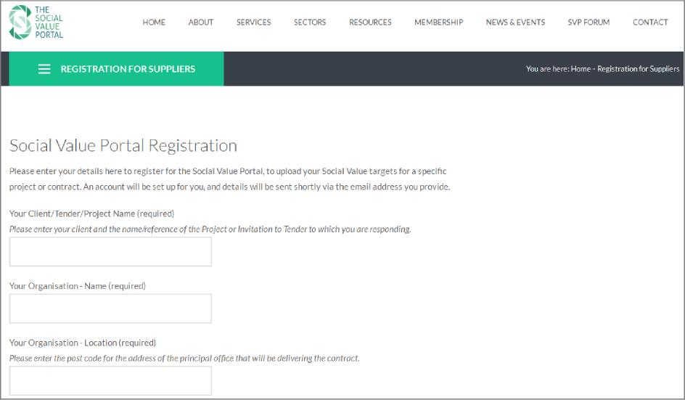

*Figure 2: Registration page*

To ensure the security and confidentiality of your information, the permissions given to each account are checked manually by our team before being released. This means that there will be a short delay between registering and receiving your account details while your Account and Social Value questionnaire are set up. Your data will be visible only to your client and to the admin team at the Social Value Portal, and is not accessible to any third parties without your express permission.

3 Logging In

The standard login page to access your Social Value Account is: <https://socialvalueportal.force.com/login>

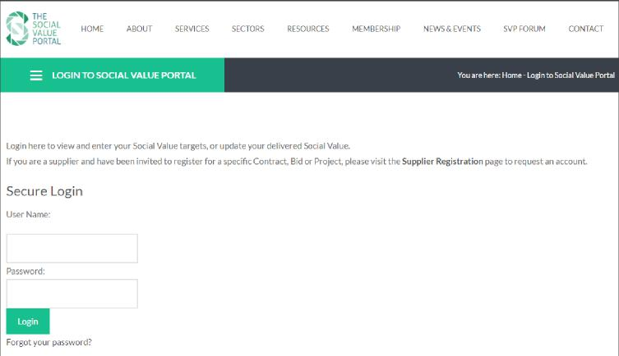

*Figure 3: Login page*

If you forget your password, clicking ‘Forgot Your Password?’ will reset the password, and email a link to make a new one. This will be sent to the email address with which you registered.

4 The Home page

When you have successfully logged in, you will arrive at the Home tab.

*Figure 4: The Home page*

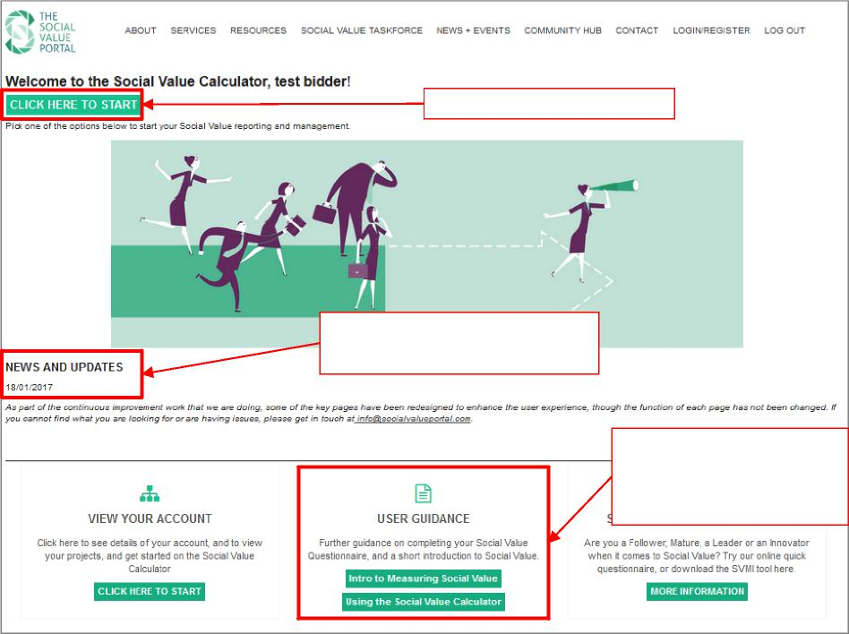

Any news or updates to the site will

be listed on the home page

Click here to view your projects

A link to the latest version of this guide, and a guide to the Social Value measurement process.

Press ‘*CLICK HERE TO START’* or *‘VIEW YOUR ACCOUNT’* to view a list of your projects.

A link to this User Guide is on the Home page, as well as a short introduction to the Social Value Measurement process for suppliers. This explains briefly what Social Value is, how it is being measured here, and what you are required to do. For more information on Social Value, please visit: <https://socialvalueportal.com/what-is-social-value/>

5 Finding your Social Value Questionnaire

Your Account home page

Viewing your Account home page, you can view the project (or projects) that have been assigned to your organisation’s Account.

*Figure 5: Social Value records (*

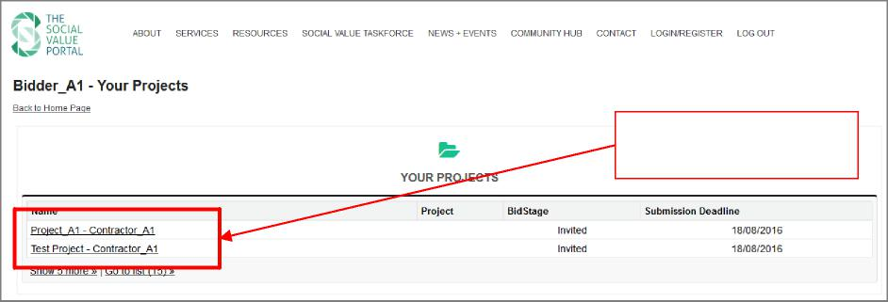

Your projects – click on the

Social Value name for details.

To view the details for each Project, click on the name.

Entering and Editing Social Values

The Social Value record allows you to enter and edit your Target and Actual Social Values, and upload evidence supporting your responses (see Figure 6).

Use the *‘Social Value Questionnaire’* section to open the Social Value questionnaire. This will allow you to enter your responses and short descriptions to each question (see Section 5.3 below). You can download a copy of the questions to view offline by clicking the link *‘View/Export your Questions’*. If it has been requested, please enter your *Contract Value/Bid Price* and press *‘Save’*.

Once you are satisfied with your Social Value responses, and your overall Committed or Delivered Social Value score, press the *‘Submit Social Values’* to indicate to submit to your client that your values are ready for submission (see Section 5.4 below).

If you would like to create a pdf report showing your Social Vales against each question, use the *‘Print Social Values to PDF’* button. A report will be generated, and will be stored in the *‘Evidence and Reports’* section. To open the report in your browser, press *‘View’*.

The *‘Evidence and Reports’* section is also used to upload longer supporting evidence and documentation for your Social Value Reponses. In order to upload evidence, press *‘Attach File’*, and follow the onscreen instructions. Make sure that each piece of evidence is labelled clearly, to show which question(s) it is supporting.

Entering your Social Values

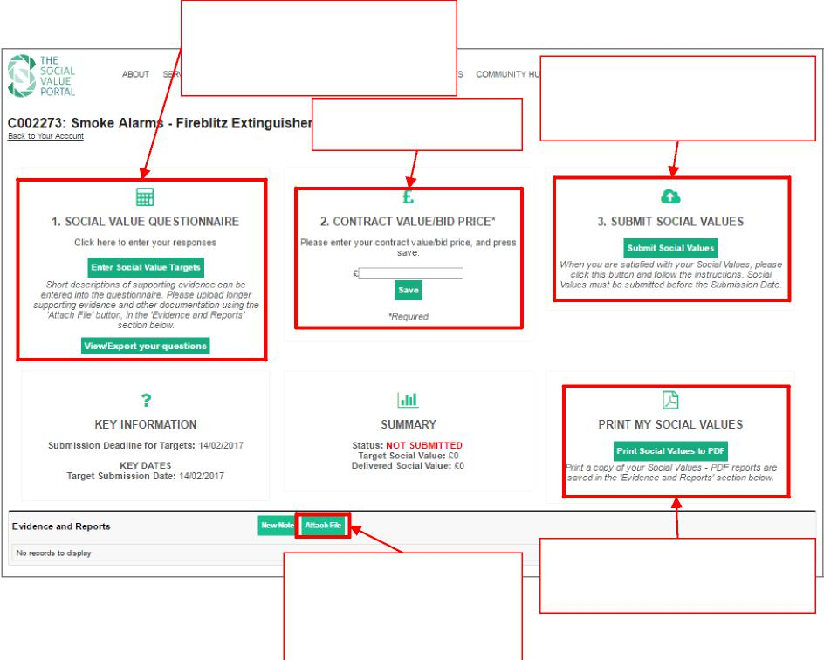

*Figure 6: The Social Value record*

***‘Social Value Questionnaire’ -*** View your Social Value Questions, and enter your responses. You can also export a copy of your questions

Press ‘Attach File’ to upload any documentation to provide descriptions or evidence for your Targets

Enter your ***bid price/ contract value***, if required.

Press ‘Print Social Values to PDF’ to produce a pdf output document, outlining your responses.

Press ‘Submit Social Values’ to submit your Social Values once you are satisfied with your response.

Press the *‘Social Value Questionnaire - Enter Social Value Targets’* button to open the Social Value Questionnaire page. This contains all of the questions relating to your Project, organised by Theme. Each question includes a measure, the Social Value associated with each measure, and provides a link to supporting information. Mandatory questions will be marked as such.

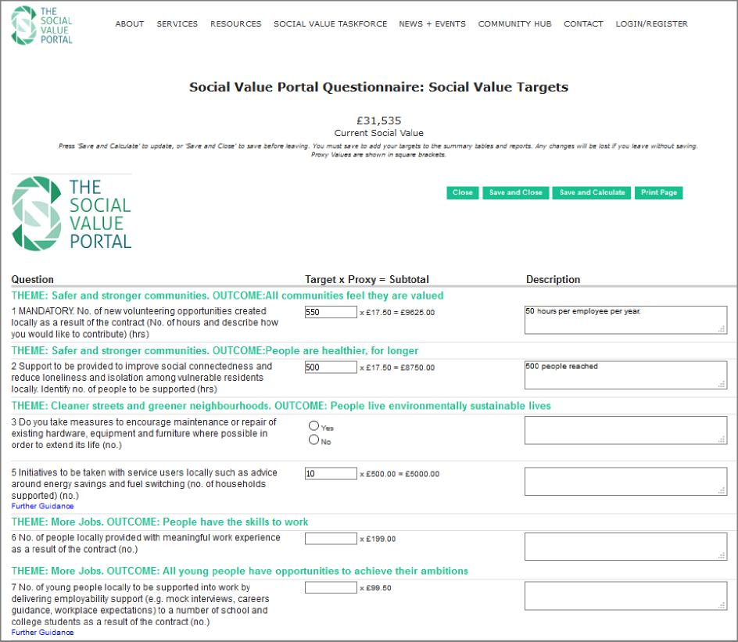

*Figure 7: The Social Value Target Questionnaire*

For each question please enter your Target number, and a brief description of how you intend to fulfil this. If you need to upload any further supporting documentations or evidence, please upload this on the Social Value record page using the ‘*Attach File’* button.

Where a Social Value proxy has been linked to a measure, the calculation and resulting social value add is shown. For more information on the Social Value process, please see the *‘Social Value Portal Summary Guidance*’ document, available to download on the home page.

You can recalculate your Target Social Value at any time by pressing *‘Save and Calculate’*. The updated Target Social Value will appear at the top of the page. When you have finished editing your Answers, recalculate the Target Social Value, and press *‘Save and Close’* to go back to the Social Value record.

Pressing *‘Close’* will return you to the Social Value record page without saving your changes. Pressing ‘*Print Page’* will open your browser print dialogue.

If you are in the delivery phase of a project, and are measuring the Actual Social Value that you have delivered, the process is the same. Press the *‘Social Value Questionnaire - Enter Social Value Delivered’* button, and enter results into the calculator, as above. If targets have been set, a Red/Amber/Green light will indicate your progress against the target.

Submitting Your Social Values

Once you are satisfied with your Social Values, press *‘Submit Social Values’.* You will be asked to confirm submission of your values. Once you have successfully submitted, a notification message will appear to confirm this.

You must submit your Social Value Target before the submission/reporting date.

*Figure 8: Submit your Social Value*

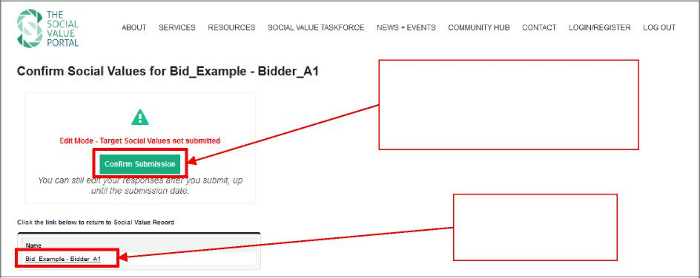

When your Social Values are finalised, press ***‘Confirm Submission’*** to ensure that your Social Value Scores are visible to your client.

Click on the Social Value name to return to your Social Value record.

Before the submission/reporting date, you can edit your Social Values by pressing *‘Edit Social Values Scores’*. However once the submission date passes, your responses will be fixed.

To return to the Social Value record page, please click the name of the Social Value at the bottom of the page in the section labelled *‘View your Social Values’*.

Further Information

For further information, please get in touch with the Social Value Portal team at: [support@socialvalueportal.com](mailto:support@socialvalueportal.com).