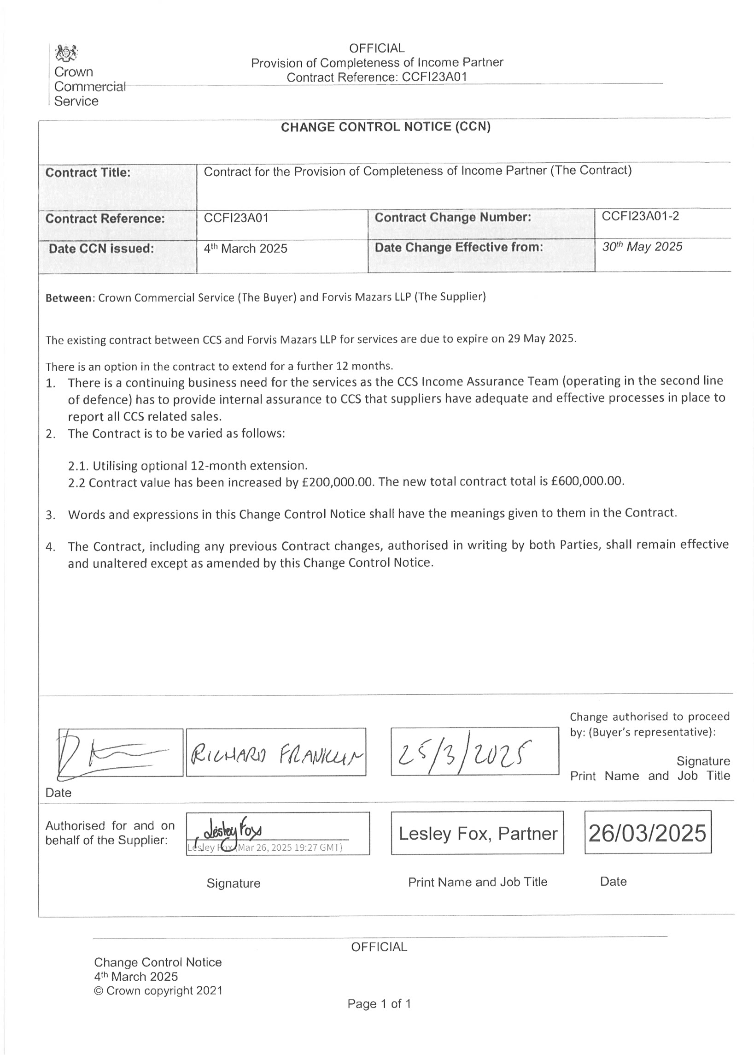

REDACTED TEXT under FOIA Section 40, Personal Information

REDACTED TEXT under FOIA Section 40, Personal Information

REDACTED TEXT under FOIA Section 40, Personal Information

REDACTED TEXT under FOIA Section 40, Personal Information

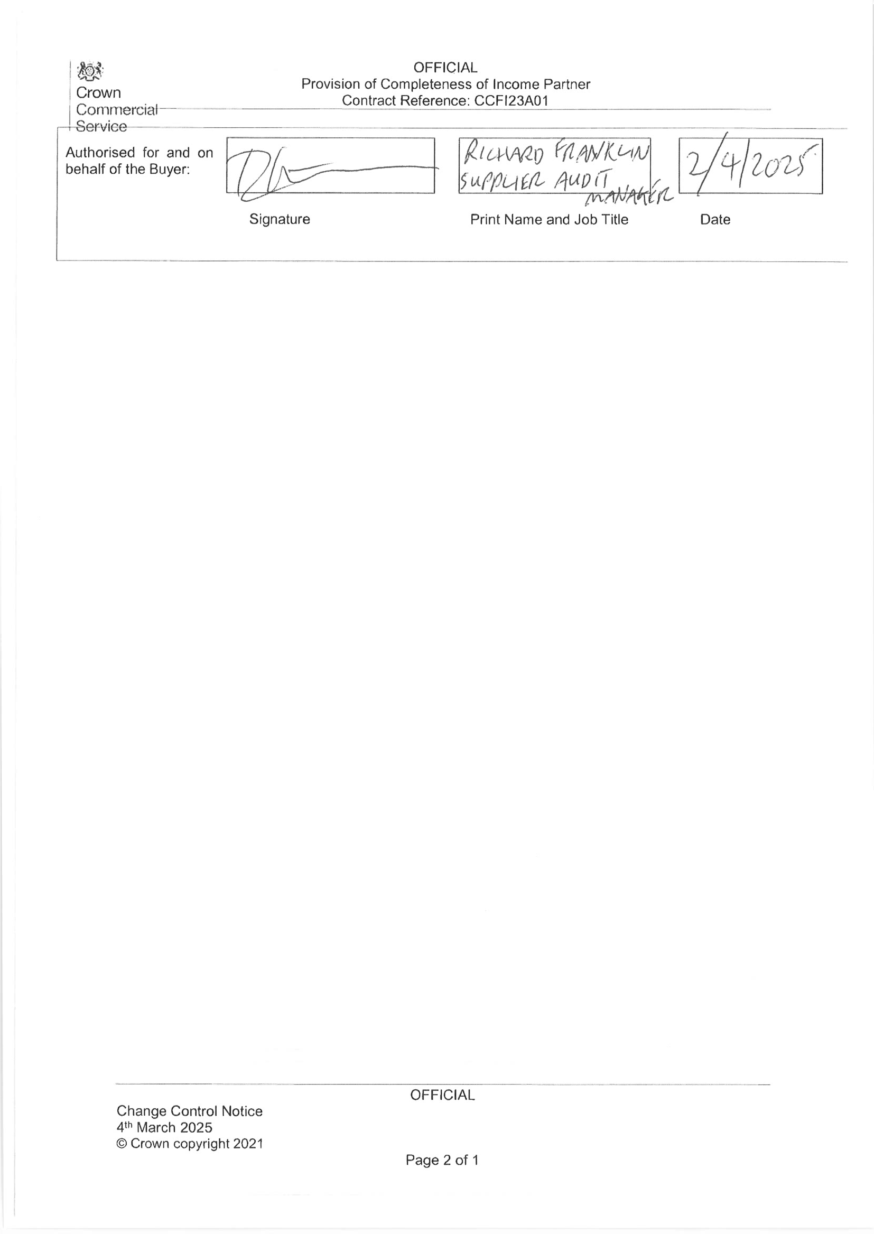

REDACTED TEXT under FOIA Section 40, Personal Information

REDACTED TEXT under FOIA Section 40, Personal Information