Appendix C
BAA-103 Baa Lambs car park basic drawing
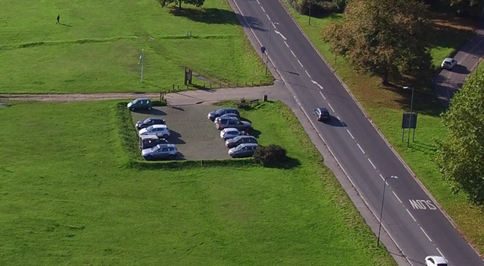
CAR PARk extended back by 3.5m to roughly in line with edge OF gorse bush. Arisings landscaped into new bund

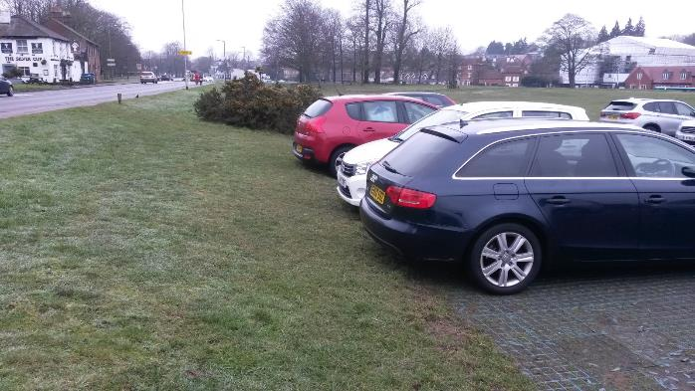
AREA TO BE WIDENED

