Calverton Fish Farm “B” Row Polytunnels (existing).
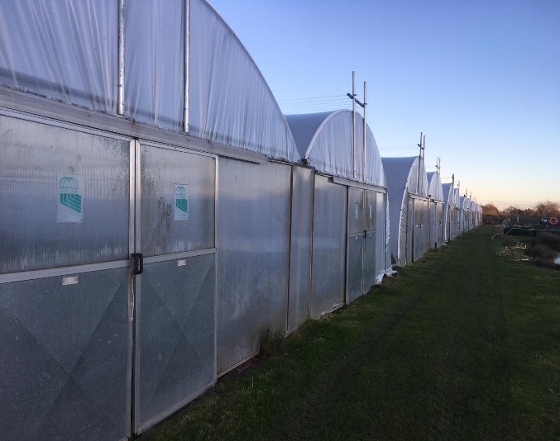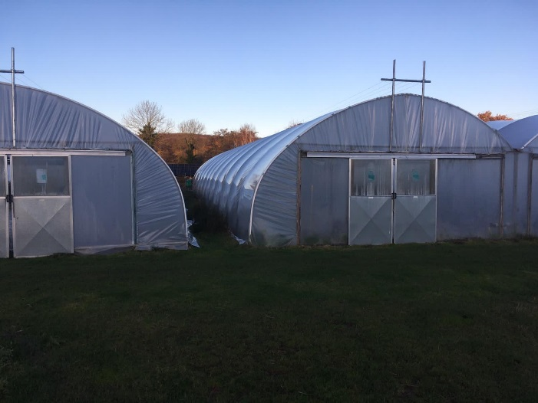
External view of existing structures. Note there are 2 spans per pond.
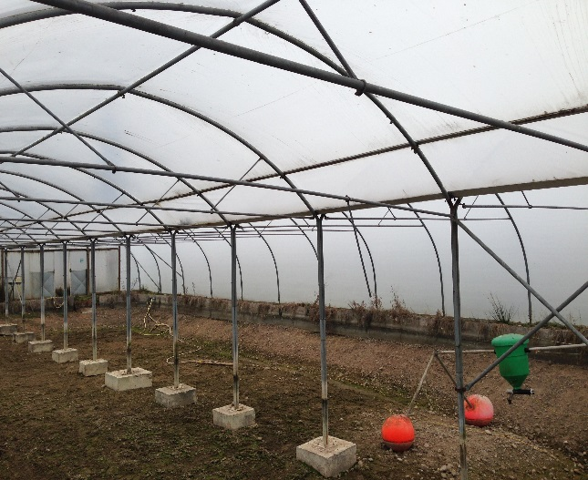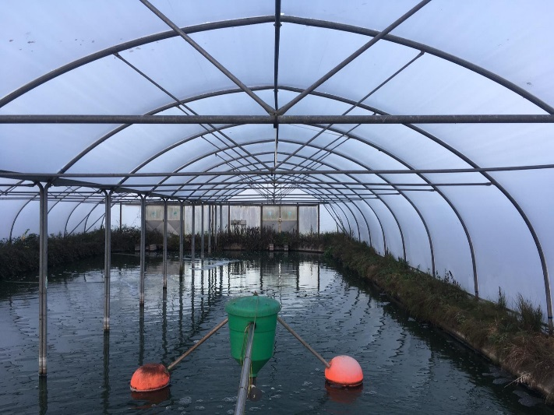
Internal view of existing structures and concrete blocks.
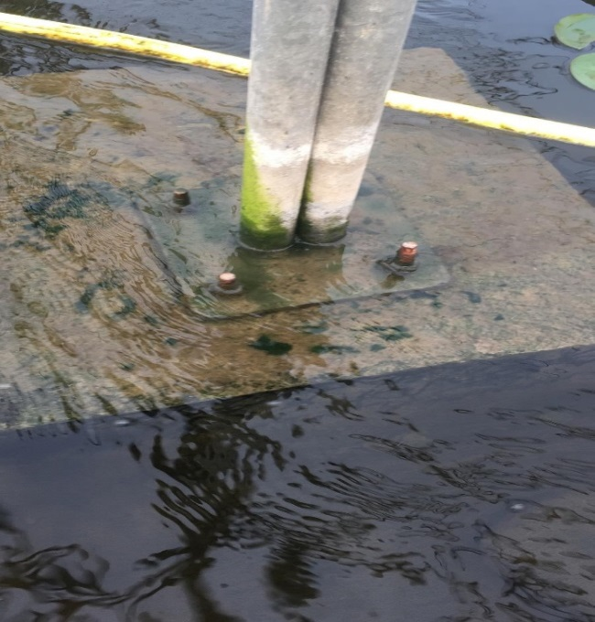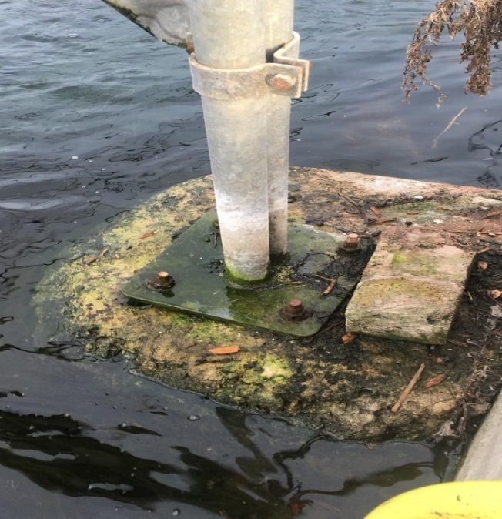
Detail showing centre legs and plates bolted to pre-existing concrete blocks.

