**North Fawley site map**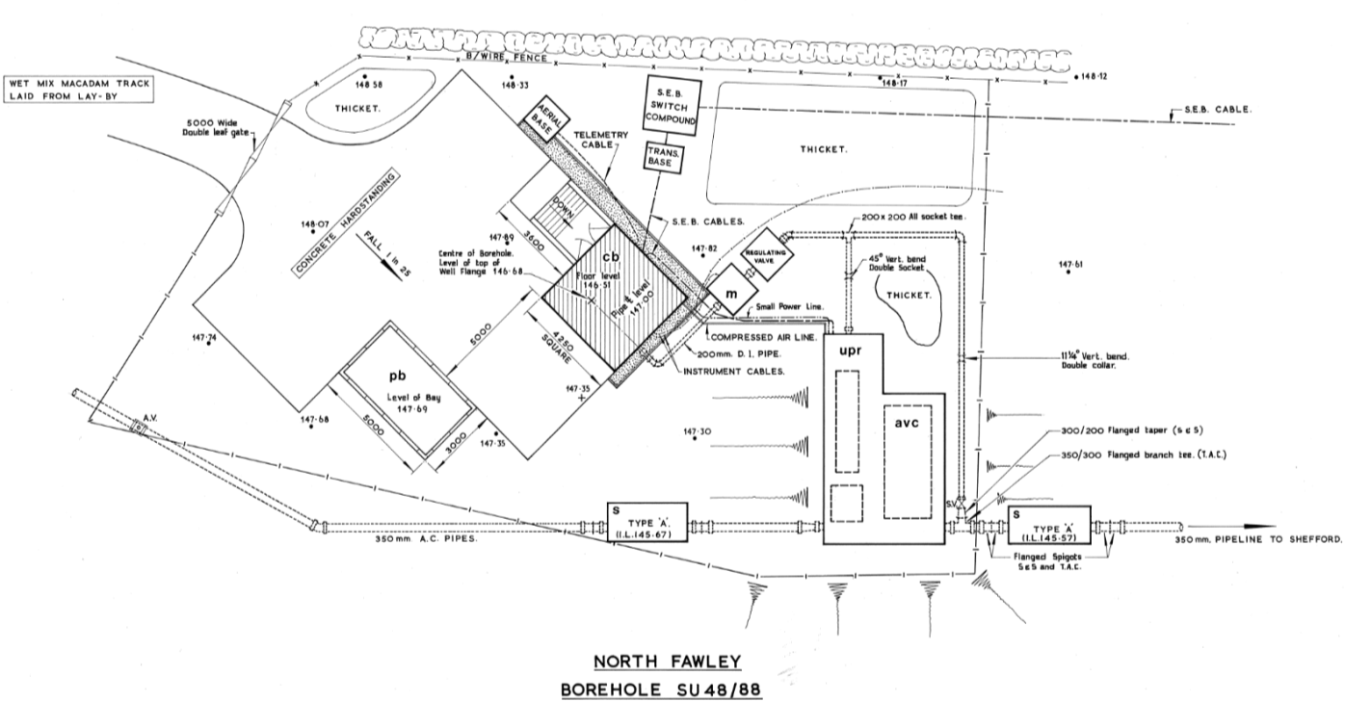

Surge vessel seen below

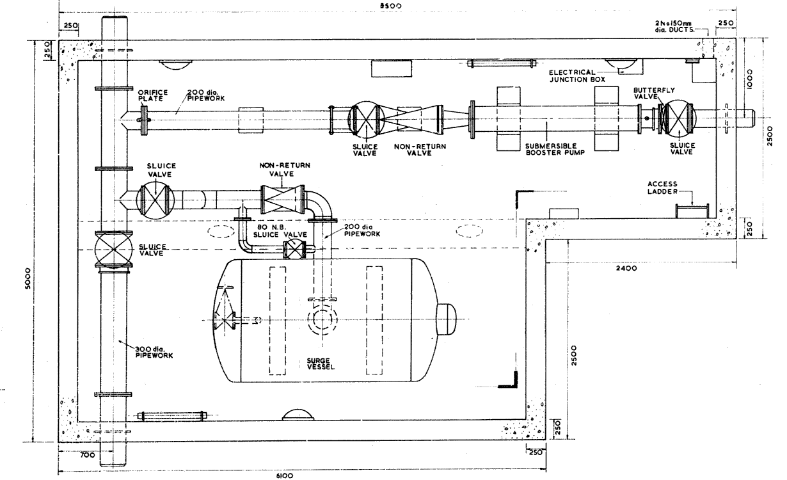**North Fawley Surge Vessel**