

Specification

Replacement of pitched roof at block 49 – 59A scott road, Kettering.

Version Control Delete prior to sending and/or publishing externally
Version Ref: | V0001
Owner’s Name: | Head of Procurement  To whom all feedback and comments should be sent.
Info Source(s): | - None
Review Process: | Annual review to take place no later than the one (1) year anniversary of the Date Amended, below.
Adopted On: | Monday, 13 December 2021
Date Amended: | 13-Dec-2021 | Date Circulated: | 13-Dec-2021
Amended By: | Category Manager | Circulated By: | Category Manager
Details of Changes Made in this Version |  |  | Item Ref. | Page No.
0. This line is an example only. |  |  | 2.1.2.a | 3
- Filled in the blanks |  |  | 2.1 | All

Contents
1. Introduction 3
2. Background 3
3. Scope 3
4. Conditions of Service and/or Works 3
5. Continuity of Service and/or Works 4
6. Key Supplier Staff 4
7. Statement of Requirements 4
8. Sustainability, Environmental Considerations and Reducing Waste 6
9. Social Value 6
10. Supply Chain Visibility 6
11. Continuous Improvement 6
12. Data Management / UK General Data Protection Regulation (UK GDPR) 7
13. Quality Requirements 9
14. Whole of Life Support and Warranties 9
15. Security 9
16. Training 10
17. Programme of Works and Implementation Criteria 10
18. Contract Management, Performance Monitoring, and Review 10
19. Risk Management 11
20. Performance and Compliance Audits 11
21. Performance Bond, Parent Company Guarantee and Other Sureties 12
22. Other Relevant Details 12
23. Corporate Social Responsibility 12
Annexes 12
Appendix 1 – Definitions 13

Introduction

  - Carry out pitched roof improvements and replacements to a number of properties in Scott Road, Kettering.

  - The dwellings are

Block 49 – 59A Scott Rd Kettering

1.3 No other dwellings will form part of this contract.

1.4 A plan of the dwellings involved is outlined in Appendix 3 of this document.

Background

  - Description of the works is to remove the existing roof coverings which have reached the end of their useful life (as concrete tiles) and replace the roofs so that the properties remain watertight and functional shelter.

  - The larger blocks of flats are exhibiting signs of structural movement due in part to thermal expansion of the concrete roof tiles, which has manifest itself as the outward leaning or gable end walls. Part of this work is to help alleviate the structural movement by allowing for thermal expansion within the designed refurbishment.

  - The refurbishment is an opportunity to introduce movement ‘breaks’ into the roof covering by the strapping of the roof structure to direct the movement of the roof covering to prescribed locations.

  - Due to the age of the subject properties, it is anticipated that there will be some rot of the timber roof structure. This rot will need to be rectified at the time of the roof works as this is the only time the timbers are exposed.

  - The refurbishment works will include a new ventilated eaves and ridge tiles, that will help to improve the ventilation of the lofts, and thus reduce the possibility of condensation in the roofs (and thus future rot). This ventilation is a modern building regulation requirement in response to higher levels of loft insulation now required.

  - The refurbishment works will also include the structural bracing of the roof timbers that was not originally required when the dwellings were built, however, the failure of the gable ends clearly indicate the need for this bracing.

  - There will also be the rebuilding of defective gable ends where the roofs have pushed the brickwork out of position. This is seen as essential for the long-term structural stability of the relevant structures. Again this is the ideal time to carry out this work whilst the weight of the tiles is removed from the roof.

  - The works will be carried out to structures that will remain occupied for the duration of the works. Amongst issues of safety and security, the occupiers will require continuous use of their TV aerial systems.

  - Works to the roof could include potential issues related to asbestos, and this may include asbestos removal works to certain elements of the roof.

Scope

  - The scope of the works requires the installation of materials specified in this document, not materials of an alternative source unless agreed with the Contract Administrator in writing before commencement on site.

  - All materials specified shall be installed as specified by their respective manufacturer’s requirements. The tenderer shall allow for all costs associated with obtaining the specified materials and no claims to change materials as they can’t be found in the vicinity will be entertained.

  - The works include the provision of roofing improvements at the same time as the roofs are stripped and refurbished. These improvements are designed to overcome failures in original design, and to allow updating of the design in line with modern requirements set out in the building regulations.

  - The works require the temporary provision of scaffolds or other temporary access that meet the current requirements for safety. If scaffolds are erected, they shall not hinder the tenants or owners of adjoining dwellings whilst works are in progress. Any scaffolds must be made safe, and secure at all times, and all scaffolding shall be removed as soon as reasonably practicable to avoid unnecessary allurement.

  - In compliance with good practice any access scaffold shall be checked over every week and shall be repaired if damaged. The Contract Administrator may wish to check records proving inspection on a weekly basis, as part of the safe working practices.

  - The works and vehicles used by the appointed contractor shall not hinder or obstruct the tenants or general public unnecessarily and any unfixed material shall be stored in an agreed location with relevant protection for security and weather.

  - Due to the nature of the works, and the fact that all properties will be occupied, it is important that the appointed contractor provide a very detailed Risk Assessment for the works to the Employer before works commence on site. Note that the appointed contractor will not be allowed to commence on site until such time as all the relevant paperwork related to safety is in place.

  - In compliance with the CDM regulations the Contract Administrator will advise the Employer of any breach of safety, ensuring that the appointed contractor complies with that risk assessment they have proposed at all times.

  - The tenderer shall carry out a survey of any roof or chimney aerial systems and shall ensure that they have all the information necessary to ensure they can move the aerial or dish out of the way of the works for the duration of that specific period the roof is being worked on.

  - The appointed contractor will be responsible for the disconnection and reconnection of the systems as work progresses on a ‘one by one’ basis. The specification will demand the continuity of aerial signals to all dwellings (private and tenanted) at all reasonable times.

  - The tenderer will assume that there is no asbestos on site in the areas of work, for tendering purposes, and will however, put in ‘ADDITIONAL PRICES’ against certain items set out in Appendix 2 of this contract document, so that such costs can be added if asbestos related materials are discovered. However, the operatives on site shall be trained to identify potential asbestos materials and be trained in the issues of what to do when finding asbestos.

  - The appointed contractor shall carry out any ‘works’ and deal with issues of asbestos to the relevant standards, including any potential disposal and waste management of asbestos found as required within the contract. All relevant operatives working on stripping out the roofs shall be trained in the issue of knowing what actions to take when asbestos is discovered.

  - The scope of the works shall include the removal of the rainwater goods, and the existing soffits and fascia’s from the dwelling to be re-roofed. These components will be replaced with different components that will reduce maintenance and improve roof ventilation within the roof space as specified within this document.

  - The tenderer will be deemed to have visited the site before submitting this quotation and with the assistance of the North Northants Council only, having gained access to sample dwellings to enable the tenderer to fully understand and investigate the proposed works, the construction and present condition of the dwelling and the nature of the site generally, shall submit a fixed price in accordance with the contract conditions and this specification.

  - The works will include an element of tenant liaison and also liaison with private owners as well as building control officers. This liaison forms part of the contract and the Contract Administrator will from ‘time to time’ check that such liaison has been undertaken in accordance with good practice.

  - The works will not be extended to include additional works without the specific and clear design and instruction of the Contract Administrator, as appointed under the JCT standard form of minor works contract.

  - The appointed contractor will be responsible for the temporary removal of telephone wires from soffits and fascia’s. The appointed contractor will need to coordinate the works on site with relevant authorities, for the provision and maintenance of telephone services.

Conditions of Service and/or Works

 | Contract Preliminaries
4.1 | The main conditions of Contract are those required by the JCT standard form of Minor Works Contract (as specified elsewhere) which will be completed in accordance with the details given in the Appendix 4 elsewhere in this document.
4.2 | The other conditions of contract are set out in the Appendix to this document. Other documents related to the works are either mentioned or included in this document, and include such things as:  Manufacturers information  Good Practice Guides (including the Calder Good Practice Guide to Leadwork).  Plan of the work area (in Appendix 3 of this document).  Detailed drawings of the works as required. (as section 7 and Appendix 3 of this document).  Information required relating to health and safety including a Clients/Designers Risk Assessment as set out in Appendix 5).  Any information the Client has obtained related to Asbestos in the relevant properties (as set out in Appendix 7 of this document).  Manufacturers information of products relevant to this specification.  Legislation and standards mentioned in this.  All these items shall be considered by the tenderer to ensure they fully understand all the implications of tendering for this Contract.
4.3 | The Contract will involve the installation of roofs to occupied properties, and the works will require the appointed contractor to respect the tenants (and private owners) and their use of their property, as well as the requirements of the general public to access all properties on a day-to-day basis
4.4 | The appointed contractor will ensure all works are left in a clean and tidy state EVERY day after completion of working, so that there is no danger to any person from trips slips and similar hazards, and so that unfixed materials or waste are not scattered during high winds.
4.5 | Similarly, the appointed contractor shall ensure all the works are left in a safe and tidy state EVERY time they break for bad weather or stop for tea/lunch breaks.
4.6 | The requirements of the Construction (Design and Management) Regulations shall be met in full, as well as a range of other health and safety regulations that may apply in this Contract. This is for the protection of the occupants and the operatives involved in the works.
4.7 | This will include the provision of a full CDM compliant Health and Safety file at the completion of the works. The file shall include all information as required and shall include a suitable folder and separation of sections within the file.
4.8 | The appointed contractor will be required to clear all debris from the roofs and clear away in a safe and proper manner, all relevant debris and disposed materials. Note for example, the throwing materials from the roof or the scaffold is not acceptable safe behaviour.
4.9 | Contractor must allow to clear away all building materials and rubbish for site on the completion of each individual dwelling or block, and at regular intervals during the works to one property.
4.10 | To ensure that there is quality of workmanship related to the roof, the appointed contractor shall be a member of the National Federation of Roofing Contractors.
4.11 | The works shall be completed to all properties no later than 31 March 2023. If due to weather or other difficulties the appointed contractor is unable to complete the works within the contract period, then the Contract Administrator has the option to reduce the size of the Contract or extend the Contract period if relevant.
4.12 | The appointment of the Contractor is likely to take as long as 4 Months after the end of the tendering process, and all tenderers shall allow for delay between tendering and being allowed to commence on site within the prices they submit in this tender.  Whilst this may seem a rather extended period it is hoped that North Northants Council will endeavour to reduce the period of time between tendering and start on site, where possible.
4.13 | It is the appointed contractor’s responsibility to organise a ‘programme of works’, taking into account any tenant or adjoining owners’ requirements and shall issue the programme to the Contract Administrator.  This programming can only occur after consultation with tenants, through the appointed contractor’s liaison officer.
4.14 | The appointed contractor shall issue the programme of works to the Contract Administrator during the approximately four-week period between being named as the appropriate tenderer and commencement on site.
 | Site Establishment.
4.15 | The appointed contractor will be permitted to have a limited site establishment at the location shown on the relevant plan in Appendix 3 within this document.
4.16 | The appointed contractor shall ensure there is no damage to the three saplings that are located on the green area.  The appointed contractor shall, where necessary, protect the relevant saplings against damage. Any damage cause to the saplings will be repaired by the Employers agent and cost will be deducted to sums paid to the appointed contractor.
4.17 | The appointed contractor shall fence the compound in order to ensure a secure facility and shall maintain the fencing in good order for the duration of the Contract.
4.18 | The allocation of a compound is made by the client in compliance with the CDM regulations, but there is no obligation to accept this if the appointed contractor elects to make alternative arrangements for the provision of adequate welfare facility.
4.19 | If the appointed contractor does construct a compound, then they will be required to provide their own electricity supply.  Such electricity supply may be via a generator and any the generator shall be designed to run very quietly. The use of standard generators without special silence facility will not be permitted.
4.20 | If the appointed contractor does not use the site for welfare facilities the Contract Administrator will require details of the alternative welfare facilities made available to operatives and staff. This is an important part of the CDM Regulations and the Workplace (Heath, Safety and Welfare) Regulations.
4.21 | At the end of the contract site must be clear of all materials and equipment used to carry out the works. This includes the removal of all site hutments and reinstatement of the grassed area allocated for site establishment.
4.22 | Any debris left on site at the end of the works, or any repairs that are required after the site establishment has been removed will be undertaken by the Employers agents and counter-charged to the appointed contractor via deduction of moneys due under the contract.

Continuity of Service and/or Works

 | Basic requirements required as part of the contract.
5.1 | During the works the appointed contractor shall ensure there is no reason why the tenants or private owners cannot continue to occupy their homes, cannot continue to live their lives in the normal fashion with all their current facilities. This includes where the tenants or occupiers park their cars, and the means of access to and from their home.
5.2 | During the works it is important that the appointed contractor shall ensure that the dwellings affected by the works remain ‘watertight’ at all relevant times. This includes the appointed contractor checking weather conditions and weather forecasts to improve programming and probabilities of working to the maximum effect.  Failure to ensure watertightness will lead to claims for repairs and loss. Therefore, the levels of insurance are an important factor in the appointment of this Contract.
5.3 | At all times and despite any provocation the appointed contractor and all operatives directly employed or sub-contracted shall remain respectful and courteous to tenants and private owners who are affected by this work.  Any operative, sub-contractor or member of staff of the appointed contractor found to be unnecessarily arguing with the tenants or private owners affected by the works, will be removed from the site by the Contract Administrator.
5.4 | The works will be regularly inspected by the Contract Administrator and the appointed contractors’ representative management on site. The inspections by the Contract Administrator do not relieve the appointed contractor of the duty to inspect the site regularly.
5.5 | The appointed contractor shall at all times, fully comply with the requirements of other relevant agencies necessary to carry out the works. These agencies including (but not exclusively) the Health and Safety Executive and Building Control.
5.6 | The appointed contractor shall complete one roof at a time, including all ancillaries to the roof before the commencement of the next roof.  This requirement is also designed to ensure a minimum of properties would be affected adversely during extreme adverse weather over the winter months.
5.7 | The appointed contractor shall only store the materials for the one property being worked on at one time. Mass storage of materials for the whole of the works will not be permitted on site, as the allocated space for the works is insufficient in size for such storage.  The appointed contractor is required to ensure all such material deliveries are kept secure within the compound, or fitted in its final location.
5.8 | The appointed contractor shall maintain and update the programme of works at monthly intervals to ensure that they remain on programme. Where there are changes in programme the appointed contractor shall provide details to the Contract Administrator in a revised programme and shall adjust the number of operatives and staff on site to still complete the whole of the works by the end of the contract period.
5.9 | From the programming aspect, it should be noted that loft insulation, bracing. strapping and other unforeseen works (as set out in Appendix 2) will all be accommodated in the programme of works.  Due to the nature of the works, it is reasonable to expect other additional works will be required, so these additions must be allowed for by the tenderer in the programme of works, and by the appointed contractor in the subsequent modifications to the programme of works.

Key Supplier Staff

 | Workmanship standards
6.1 | The appointed contractor shall appoint a person who is liaison officer between appointed contractor and persons living in the dwellings affected by the works. This person shall have a mobile phone number which will be made available to those persons who’s homes are affected by the works.  Those affected by the works includes the adjoining private occupiers of the properties where only half of a semi-detached pair is being re-roofed.
6.2 | The appointed contractor shall employ a site manager to communicate with the Contract Administrator in relation to matters pertaining to the Contract. This person will be responsible for the day to day running of the site and ensuring that the site remains clean and tidy during the works.  The site manager shall have the authority to make decisions on site and shall be able to receive formal instruction from the Contract Administrator.
6.3 | The appointed contractor shall employ all suitable persons necessary to carry out joint inspections of the roofs with the building control officer, and to take instruction regarding compliance with the Building Regulations.
6.4 | The appointed contractor shall have a suitably qualified person on site during meetings with the Contract Administrator to ensure that the appointed contractor is able to offer the Contract Administrator properly calculated requests for interim payment in writing.  The qualified person shall be able to answer any relevant contractual or technical questions sought by the Contract Administrator at the regular site meetings.
6.5 | The Contract is dependent on weather and on the good will of tenants, both of which can be very unpredictable. Therefore, the tenderer shall allow within this tender for potential changes in order of the works, and for increases and decreases in operatives necessary to maintain the programme.
6.6 | The appointed contractor shall have a specialist health and safety officer who will visit the site, and who will help in the preparation of risk assessments and the Health and Safety plan monitoring.
6.7 | The tenderer shall include within the box provided below the name of the firm of roofers that will be used and are members of the National Federation of Roofing Contractors along with their unique reference number that will allow the evaluation team to check their current membership status.
6.8 | Firm Name and Address  Warkton Roofing Ltd  Unique membership number
6.9 | The tenderer shall include within the box provided below the name of the firm of electricians that will be used and are members of the National Inspection Council for Electrical Installation Contractingalong with their unique reference number that will allow the evaluation team to check their currrent membership status.
6.10 | Firm Name and Address  Unique membership number.
6.11 | The tenderer shall include within the box provided below the name of the firm of aerial engineers that will be used and are members of the Confederation of Aerial Industries trade association along with their unique reference number that will allow the evaluation team to check their current membership status.
6.12 | Firm Name and Address  Unique membership number.
 | Materials
6.13 | Only materials specified in this document shall be used on site. Any alternative materials can only be used if there are supply difficulties AND if the appointed contractor can prove to the Contract Administrator that the alternatives proposed, are of equal quality.
6.14 | Where the appointed contractor is allowed to use alternative products, the appointed contractor shall give details of the savings they will be making and will then offer a reduced price for the works accordingly.
6.15 | The tenderer shall remember at tender stage, that the finished works shall be of reasonable quality and the Contract shall not be compromised by the use of inferior quality products being installed.
6.16 | The tenderer shall look carefully at Section 11 of this report, with respect to any attempts to change the materials specified.  Whereas the Employer in the evaluation does allow the use of alternatives, this will be judged carefully by the evaluation team and could improve or worsen the tenders’ evaluated tender.

Statement of Requirements

Specification

This is the basic specification of materials and workmanship that are required, as part of the works.

7.1 | Scaffolding
7.1.1 | The appointed contractor will be responsible to allow for all scaffolding or safe access and associated equipment necessary for the undertaking of the works where required and described herein.
7.1.2 | Scaffolding shall only be undertaken by CISRS BASE qualified scaffolders, who should carry their ‘card’ with them at all times they are working on site. The Contract Administrator has the right to check the cards of scaffolders on site and insist on the removal of all such unqualified persons if unaccompanied on a one-to-one basis with a qualified person.
7.1.3 | Scaffolding details shall be including Health & Safety requirements and risk assessments. All scaffolding used is to be fitted with ‘Scaff tags’ attached to each of them before being used.  Scaffolding is to be maintained and inspected each week through-out the works until dismantled, regardless of whether in use, or not.  Scaff tags shall be updated each week and the responsible person (for scaffolding inspections) shall also keep a register of scaffolds on site (similar to the F91 standard register) which will form part of the Health and Safety file.
7.1.4 | All scaffolding shall comply with BS EN 12811:1 and BS1139 if appropriate. The workmanship shall be of the standard required by this Contract, which means that all scaffolds shall be identified separately.
7.1.5 | Scaffolding shall be designed to allow for the removal of waste from the roof and shall not simply be designed for minimal inspection. Scaffolds may need to allow for shoots or other means of disposal of debris, and for carrying roof tiles or he like, ready for disposal
7.1.6 | The appointed contractor shall store all unused scaffolding materials within the site compound or remove them from site completely upon dismantling.
7.1.7 | The scaffolders shall not ‘bomb’ or drop fittings as scaffolds are dismantled and shall not throw fittings up operatives working at height.  The Employer is seeking safe and proper scaffolding installation that is unlikely to damage the existing structures.
7.1.8 | The scaffolds shall be fitted with relevant brightly coloured foam protection at low levels near to walkways and paths. And other areas shall have standards fitted with reflective tape to ensure the scaffolding standards can be seen during dark hours.
7.1.9 | At ground level the scaffolds shall be surrounded with ‘heras’ fencing to prevent persons (operatives and tenants) from walking into a relatively dangerous are, where materials may fall onto them.
7.1.10 | Where a scaffold is provided for access and crosses a right of access such as a front door, the appointed contractor shall apply a boarded roof over the access and shall mechanically fix some polythene or roof felt to the top to prevent dust or damage to those walking below.
7.2 | Stripping back the roof
7.2.1 | Allow to carefully strip existing roof coverings to property, remove all battens, sarking felt and lead work, de-nail rafters and leave ready to receive new works.
7.2.2 | Allow for the temporary protection of the dwelling at roof level during all bad weather and ensure that the protection is put in place and fixed down at each and every occasion when the weather is adverse.
7.2.3 | Remove the existing gutters and downpipes from the subject property and ensure where these gutters are connected to a property not being re-roofed, that the remaining gutter remains in fully functional condition with temporary stop ends as necessary.
7.2.4 | Clean out the drains from the downpipes of the subject property and ensure they are in full working order. After reasonable attempts to clear drains.
7.2.5 | Where it is found that there is a blockage in the drains, this must be reported in writing to the Contract Administrator, and the Contract Administrator may choose to instruct to carry out a drain survey.
7.2.6 | The visible surfaces of the soffit and fascia board are to be stripped completely leaving behind the structure or sub-structure that supports the finishes.
7.2.7 | The appointed contractor shall ensure that the materials removed from the roof are disposed of at regular intervals during the works, and that where possible such waste materials do not go to landfill.
7.3 | Bats
7.3.1 | Prior to commencement of stripping a roof, the appointed contractor shall carry out an inspection of the roof and shall seek out bats.
7.3.2 | If at any point during the inspection or during stripping of a roof bats are discovered, the appointed contractor shall immediately stop work on the roof and shall make watertight.
7.3.3 | The appointed contractor shall immediately make the Contract Administrator aware of the presence of bats (even a singular bat) and shall attempt to re-programme works commencing on the next available property to be re-roofed.
7.3.4 | To ensure that the appointed contractor is not ‘out of pocket’ due to such unforeseen works. the tenderer shall complete the relevant price in appendix 2 of this document, so that the appointed contractor can be paid for the scaffolding being left unused, but fully functional during the stoppage.
7.3.4 | The tenderer and potential appointed contractor are reminded that bats are a protected species and destroying their habitat or them can result in an unlimited fine or up to 6 months in prison.
7.4 | Removal of telephone wires.
7.4.1 | The tenderer shall allow within the relevant price for the temporary removal of the telephone wires connected to the structures that are to be stripped. The price shall be included in the individual property price.
7.4.2 | The tenderer shall allow for all relevant costs associated with the removal of the wires to a safe location and the refixing of the wires upon completion of the works.
7.4.3 | Where the wires are found to be redundant the appointed contractor can obtain a quotation from the relevant body to permanently and legally remove or terminate the wire. This quotation to be discussed and passed on to the Contract Administrator.
7.4.4 | Where it is agreed that additional works are undertaken to reduce the number of redundant phone lines from dwellings, the appointed contractor shall obtain a fixed price quotation from the statutory authority and shall add overheads and profit according to the percentage agreed in Appendix 2.  The appointed contractor shall also undertake a review of the programme of works and advise the Contract Administrator of the projected changes in the programme.
7.5 | Gable end wall replacement  This is currently restricted to both ends of block 49 to 59A Scott Road.
7.5.1 | Strip the roof tiles and protect the roof from weather damage.  Structurally support the roof to prevent roof failure and ensure the relevant timbers remain in the relevant locations once the gable wall is removed.  Allow for all relevant loading being transferred from the ridge and purlins to the front and rear eaves, and for all temporary bracing to ensure these built in elements do not move.
7.5.2 | Remove the inner and outer leaf of the gable wall down to the head of the first-floor gable end window lintols, externally, and take the inner wall down to the level of the ceiling.  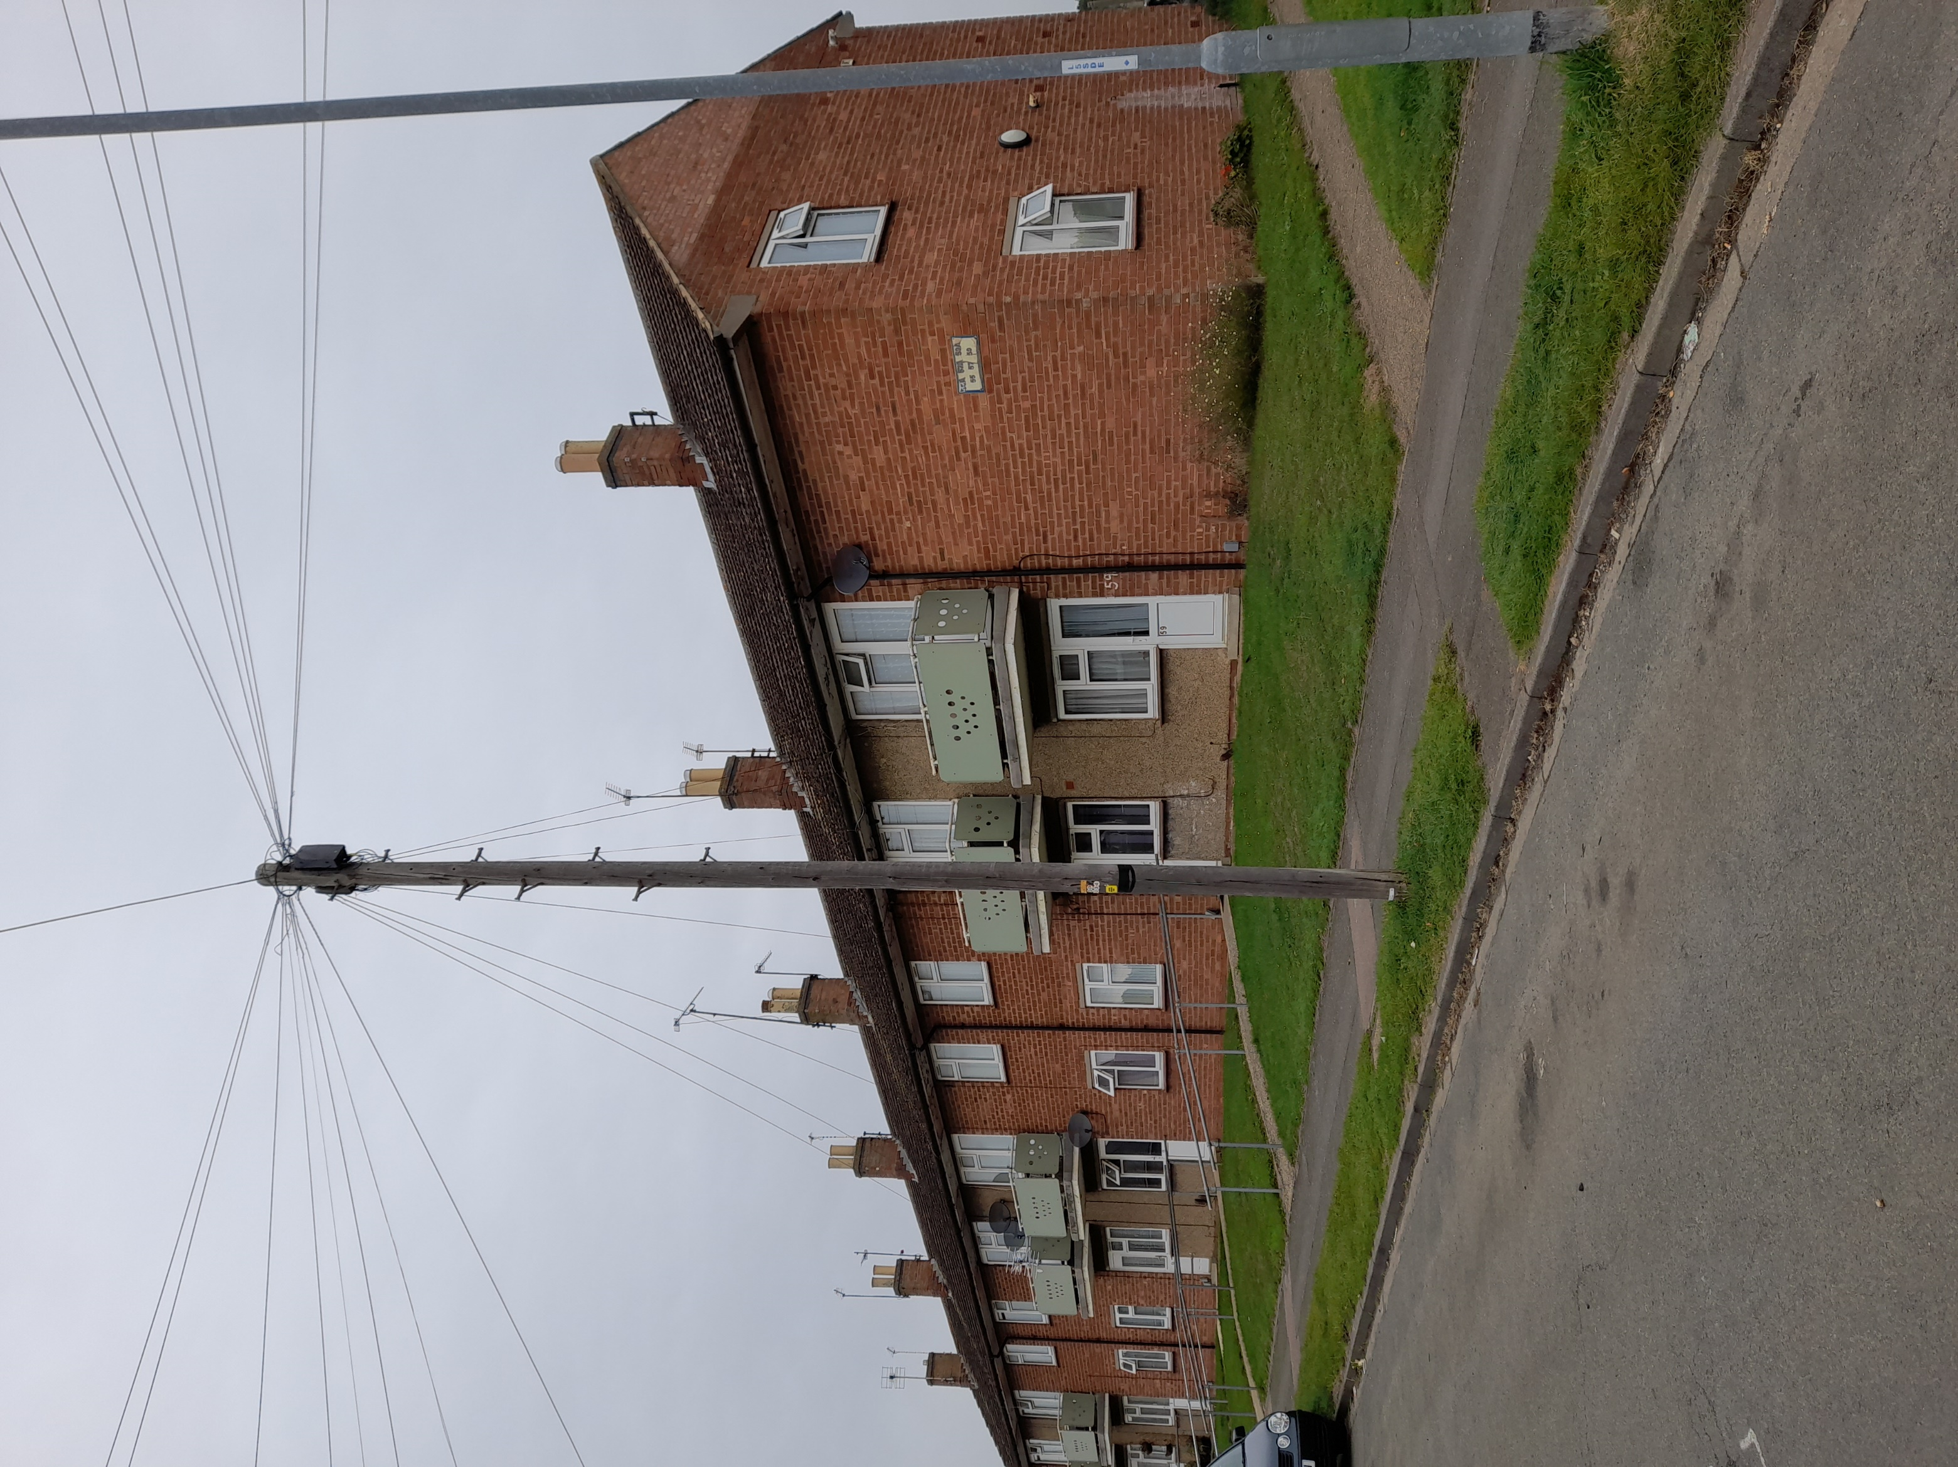
7.5.3 | Rebuild the inner leaf of wall in 100mm thick dense concrete block with a minimum bearing capacity of 7.3N loading. Blockwork to be cut to shape and will support the ends of the purlins and ridge.
7.5.4 | In accordance with good practice, the ends of the purlins and ridge that are to be built into the blockwork shall have padstones as necessary to spread the load, and the ends shall also be wrapped in damp proof membrane to prevent rot.  Damp proof membrane shall be nailed to the timber ends and shall be visible inside the roof when the roof is completed.
7.5.5 | When rebuilding the inner block wall install stainless steel cavity ties at each course of block in order to provide a very strong link between inner and outer wall.
7.5.6 | Provide 50mm rockwool batt insulation to the cavity ready to receive the external brick skin. The insulation shall be specifically for masonry cavity walls and chosen from the Rockwool range in accordance with manufacturers recommendations.
7.5.7 | New external brickwork shall be installed either using the existing brick that have been cleaned off, or new Forterra LBC Rustic bricks.  Forterra LBC bricks are available through a range of suppliers and builders merchants.  Address Forterra Building Products Ltd  5 Grange Park Court, Roman Way,  Northampton NN4 5EA  Phone 01604 707600
7.5.8 | When carrying out a gable wall replacement the appointed contractor shall provide Heras fencing around the whole of the gable end and shall allow for the temporary blocking up of pathways to ensure that the public/visitors do not walk near to the works.
7.5.9 | To avoid cutting off all access to the rear of the block where the appointed contractor is to rebuild the gables, the appointed contractor must complete one gable end before commencing the other and shall erect signage for tenants and visitors.
7.5.10 | The appointed contractor shall include details of when the gable end brickworks are to be undertaken as part of the programme of works, clearly showing what gable is being done and when.
7.6 | Party Wall situations  These clauses only apply where the adjoining semi-detached dwelling is not part of the works and falls outside the Contract.
7.6.1 | The appointed contractor will need to involve other parties outside those that are tenants of the Employer, in order to ensure that they are kept fully aware of what will be happening to their neighbour and to ensure they have a point of contact.
7.6.2 | The appointed contractor shall ensure that they have adequate liaison capacity to deal both with tenants of the properties that form part of the Contract, and these adjacent owners.
7.6.3 | As part of the works, allow to strip the roof coverings up to centre line of party wall where adjoining property excluded from the works. Provide suitable protection to all exposed roof structures and the joint with the adjoining owners.
7.6.4 | Careful consideration shall be given by the appointed contractor to the adjoining owners with respect to the positioning of the roof joint and ensuring temporary roofing works do not allow rainwater damage to the private owner property.
7.6.5 | The appointed contractor shall liaise in detail with the owners of adjoining properties and shall share details of the design as necessary to ensure the owners are kept fully aware of the situation.  On this contract there are three adjoining owners (one per semi-detached dwelling).
7.6.6 | The appointed contractor has responsibility to carry out the works adjacent to private property and shall allow for this within the tender.
7.7 | Working in the loft area.
7.7.1 | The appointed contractor shall make safe access into the ceiling area in each property loft. This can be achieved in a number of ways, but the tenderer will need to allow for this process in each case, as bracing and strapping will be the minimum necessary in each loft.
7.7.2 | In many cases it is anticipated that the appointed contractor will be required to carry out a number of other works that have been included in the ‘adhoc’ list of Appendix 2 to this document.
7.7.3 | The tenderer is reminded that such work in lofts does come under the realms of ‘working at heights’ as this is working over fragile surfaces at around 2m above floor level.
7.8 | Rotten timbers
7.8.1 | On removal of the main roof covering, it will be possible to see the timbers of the roof such as rafters, purlins and the sub-structure to the eaves.  The careful inspection of the timbers forms part of the Contract, and the appointed contractor will then advise the Contract Administrator of any defects or rotten timbers.  The appointed contractor shall also allow for reasonable access to allow the Contract Administrator to see and photograph such defective timbers in person.
7.8.2 | Where there are defective timbers these shall be repaired and the appointed contractor shall allow for the repair within their contract programme and provide suitably qualified person to carry out the repairs.
7.8.3 | The works of ad-hoc rectification shall be paid for on the basis of the schedule of rates included in Appendix 2 of this document. The sums will be added to the Contract sum by Contract Administrator variation and paid upon completion of the specific property roof replacement.
7.8.4 | All replacement and repair timbers shall be carried out in stress graded rough sawn softwood, that has been treated with Sika Universal 5 Star Wood Treatment, prior to fixing.
7.9 | Additional timber bracing.
7.9.1 | From outside the property, the appointed contractor shall install within the loft new diagonal bracing to each elevation of the roof rafters. The brace shall be on a ‘per dwelling basis’ and not a ‘per block basis’.  This means that every loft within a block of flats will require bracing, not one loft per block.
7.9.2 | The new braced timber shall be fitted inside the roof (not on the surface to be tiled. The brace shall be screwed at least twice to the back of each rafter on the relevant side with stainless steel screws (not nailed).
7.9.3 | Each roof shall have a minimum of 2 No braces added within the roof space. The bracing timbers shall be treated sawn softwood of minimum cross section dimensions 100mm x 22mm.  Where the brace timbers are cut to get them into the roof, the contactor shall allow for joining them in an approved manner or shall put more than one brace in place to ensure that all the rafters are included.
7.9.4 | The new timber braces shall be treated before fixing with Sika Universal 5 Star Wood Treatment.  Sika Universal 5 Star Wood Treatment is available from:  Everbuild – A Sika Company  Address: Site 41 Knowsthorpe Way  Cross Green Industrial Estate  Leeds  West Yorkshire LS9 0SW  Phone : 0113 240 3456  E-mail: everbuild.sds@uk.sika.com
7.9.5 | Timber braces shall be installed in all loft spaces as they are stripped back. The tenderer shall ensure that the roof is braced on both sides in each case.
7.9.6 | 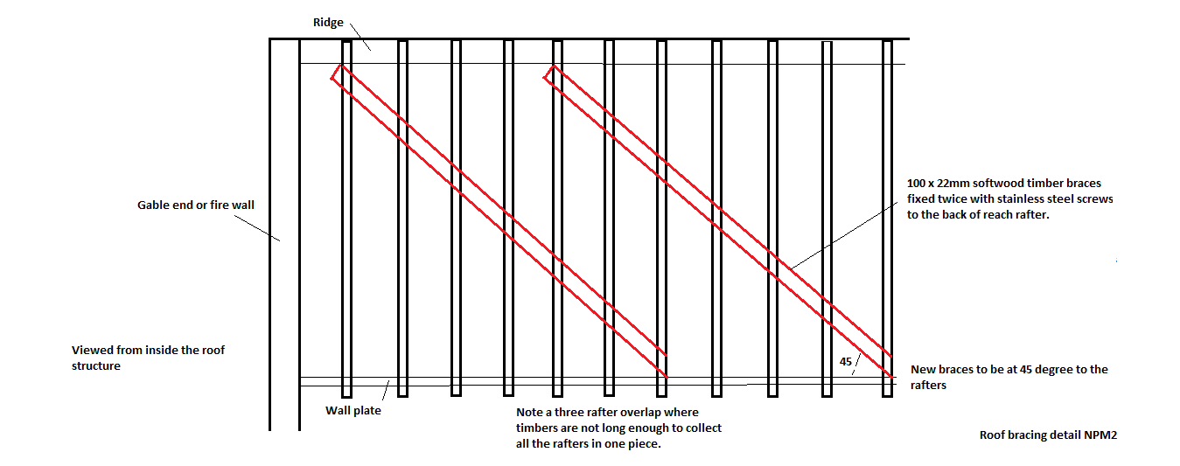  A copy of this drawing is included in Appendix 3 of this document.
7.10 | Strapping the ceilings
7.10.1 | Each roof shall be strapped at one end of the loft. The ceiling rafters and the roof rafters shall be strapped at one end only (the same end). All roofs shall be strapped.
7.10.2 | The ceiling strapping shall be completed to each dwelling and on the top floor of each block of flats. The strapping will all be undertaken in accordance with the enclosed details.  A copy of the schematic drawing for the location of strapping is enclosed in Appendix 3  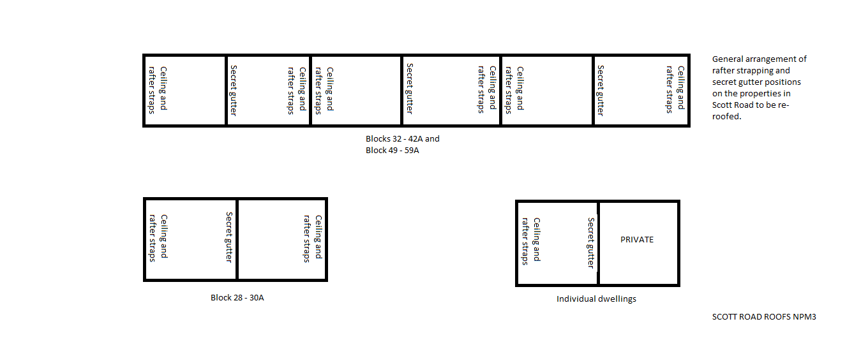
7.10.3 | The ceiling straps shall be pick up a minimum of the first three ceiling rafters. This will require the pulling back of the existing loft insulation and the fixing of 30x5mm galvanised steel section straps with a minimum of two 60mm long stainless screws per ceiling rafter.
7.10.4 | The ceiling straps are to be placed at 2m intervals across the entire width of the ceiling that meets the gable wall. And shall be screwed to the walls with the tail facing upwards. The tail (the short length) shall be drilled into at least three separate coarse of brickwork or two separate courses of blockwork where relevant.  The tails of the straps shall be fixed in place with 80mm long (minimum) stainless steel screws in Rawlplug 4ALL universal plugs.  Rawlplug Ltd  Address: Skibo Drive  Thornliebank Industrial Estate  Glasgow G46 8JR  Phone +44(0)14 1638 7961  Email rawlinfo@rawlplug.co.uk
7.10.5 | In each case the first strap to the ceiling shall be within 300mm of the external front or back wall parallel to the direction of the straps.
7.10.6 | The contract documents indicate which end of each roof shall have the straps fitting as shown above and in Appendix 3  The layout of strapping is important because it then dictates the layout of the secret gutters.
7.10.7 | The existing insulation shall be reinstated after the ceiling strapping has been completed.  Note that if the Contract Administrator wishes to see this strapping in place, they shall advise the appointed contractor in advance, and shall be allowed to inspect all fixings f the straps before the straps are covered with the existing insulation.
7.10.8 | 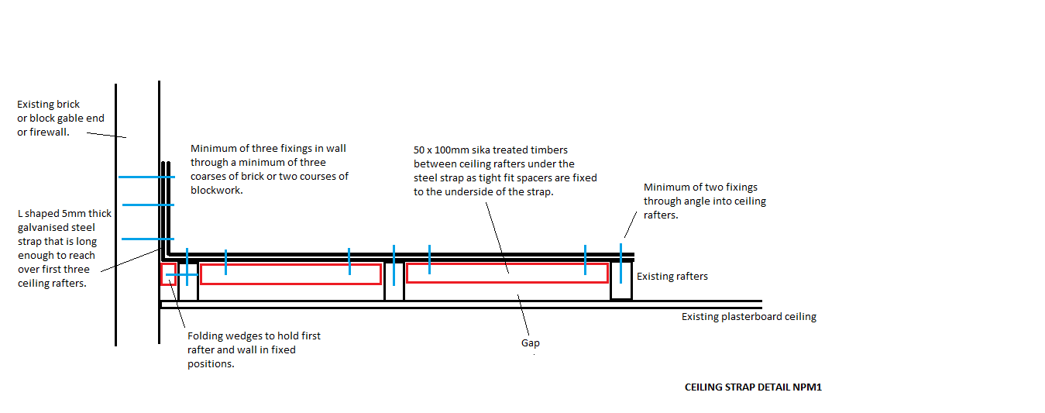  A copy of this drawing is included in Appendix 3 to this document.
7.11 | Strapping the roof.
7.11.1 | Again, each roof shall be strapped at one end. The ceiling rafters and the roof rafters shall be strapped at one end only (the same end). All roofs shall be strapped.
7.11.2 | The rafter strapping shall be completed to each dwelling and on the top floor of each block of flats. The strapping will all be undertaken in accordance with the enclosed details.
7.11.3 | The roof rafter straps shall be pick up the backs of a minimum of the first three rafters. This will require coordination with the bracing of the rafters so that there are no clashes.
7.11.4 | The ceiling straps are to be placed at 2m intervals down both slopes of the roof, for the width of width of the roof that meets the gable wall. The tails shall be screwed to the walls with the tail facing downwards. The tail (the short length) shall be drilled into at least three separate coarse of brickwork or two separate courses of blockwork where relevant.  The tails of the straps shall be fixed in place with 80mm long (minimum) stainless steel screws in Rawlplug 4ALL plugs.
7.11.5 | In each case the first strap to the ceiling shall be within 100mm of the ridge timber, which is parallel to the direction of the straps.
7.11.6 | The straps shall not be fixed to the ridge timber or any purlin, as this could inhibit structural movement.
7.11.7 | 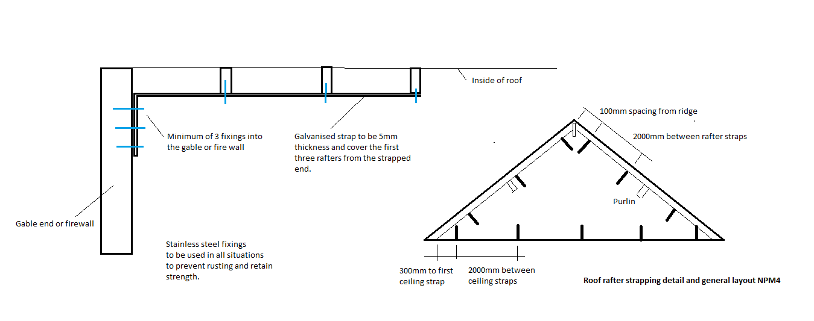  A copy of this drawing is included in Appendix 3 of this document.
7.12 | TV aerials & Satellite dishes
7.12.1 | In this digital age, of entertainment the television and computers are now significant comfort for many people in the UK, disconnection of that service can be a cause of discomfort for some people and even cause anxiety. Therefore, as part of this Contract, the tenderer will allow for Professional persons to work on Aerials.
7.12.2 | Whilst the Contract Administrator tries to be unbiased in response to claims by tenants, it is in the interests of the appointed contractor to obtain a signature upon completion of works to each individual aerial that the system was left working and was to the full satisfaction of the tenant/private owner
7.12.3 | Where required, allow to remove the existing tv aerial and satellite dish and allow to temporarily relocate the aerials and dishes whilst works are being carried. The appointed contractor will ensure that the aerials etc are in full working order in their temporary locations and shall employ a specialist installer to make sure that the relevant aerials etc are in ‘full working order’ at all times
7.12.4 | The Contractor shall be responsible for the maintenance of the signal and reception for the duration of the time the aerial etc is in the temporary location. This includes responding to ‘call outs’ during evenings and weekends in order to carry out repairs and reinstatement of signal.
7.12.5 | The appointed contractor shall also allow to refix the aerial/dish back in same position it will be the contractors’ responsibility to make sure the tenant has a clear signal once works have been completed. The appointed contractor shall employ specific qualified engineers for this purpose.
7.12.6 | At the completion of each dwelling, the appointed contractor shall provide to the Contract Administrator with a letter signed by the tenant of the property or the private owner to show that the aerial of dish has been fully reinstated to the satisfaction of the relevant occupier.
7.13 | Loft insulation
7.13.1 | In coordination with the tenant move the tenant’s belongings from the loft area to allow the increase of the ceiling/loft insulation where appropriate.
7.13.2 | The existing insulation shall be laid flat and made ready for an increase in the level of insulation.
7.13.3 | To be fair and reasonable to the appointed contractor the level of insulation improvement will vary from one property to another, and so different levels of ‘make-up’ insulation are given in Appendix 2 of this document and will be applied as a variation to the works.
7.13.4 | All new loft insulation as required to be installed by the Contract Administrator shall be Rockwool Roll, Twinroll and Rollbatt (according to individual situation.  Rockwool products are available from:  Address ROCKWOOL Limited  Pencoed  Bridgend  CF35 6NY  Tel: 01656 862 621  Email info@rockwool.co.uk
7.13.5 | The roofs shall be insulated from outside the property, bringing the materials up the external elevation in a safe and proper manner.
7.14 | Insulation Trays
7.14.1 | When the loft insulation is in place, and before the roof is felted and battened, the contractor shall fit Klober Roll out rafter Trays to the roof to allow the roof to be ventilated.
7.14.2 | The trays shall be 600mm wide with at least 150mm of tray visible above the insulation from within the loft.
7.14.3 | The trays shall be installed in accordance with the recommendations of the manufacturer and shall be fixed down in place.
7.14.4 | Klober products available from:  Address: Unit 6F East Midlands Distribution Centre  Short Lane  Castle Donington  Derbyshire  DE74 2HA  Tel 01332 813 050  Email klober.marketing@klober.co.uk
7.15 | Soffit & Fascia boarding
7.15.1 | Having removed the existing soffit and fascia the appointed contractor shall install additional timbers in accordance with the enclosed drawings for the relevant structures. All new softwood shall be treated prior to fitting with Sika Universal 5 Star Wood Treatment that has been specified elsewhere.
7.15.2 | The uPVC products to be used shall be Kestrel Range and shall be white in colour. Kestrel Products are available from:  Address: 1B Stratford Court,  Cranmore Boulevard,  Solihull, B90 4QT  Email: info@kestrelbce.co.uk  Website www.kbp.co.uk
7.15.3 | Dwellings shall have 9mm ventilated soffit, and fascia that are 22mm thick (K22), including a groove for the soffit to fit in. Kestrel offer a wide range of thickness of products that can be used for different circumstances.  The tenderer is responsible for measuring the relevant soffit and the appointed contractor shall ensure that the correct product is obtained.  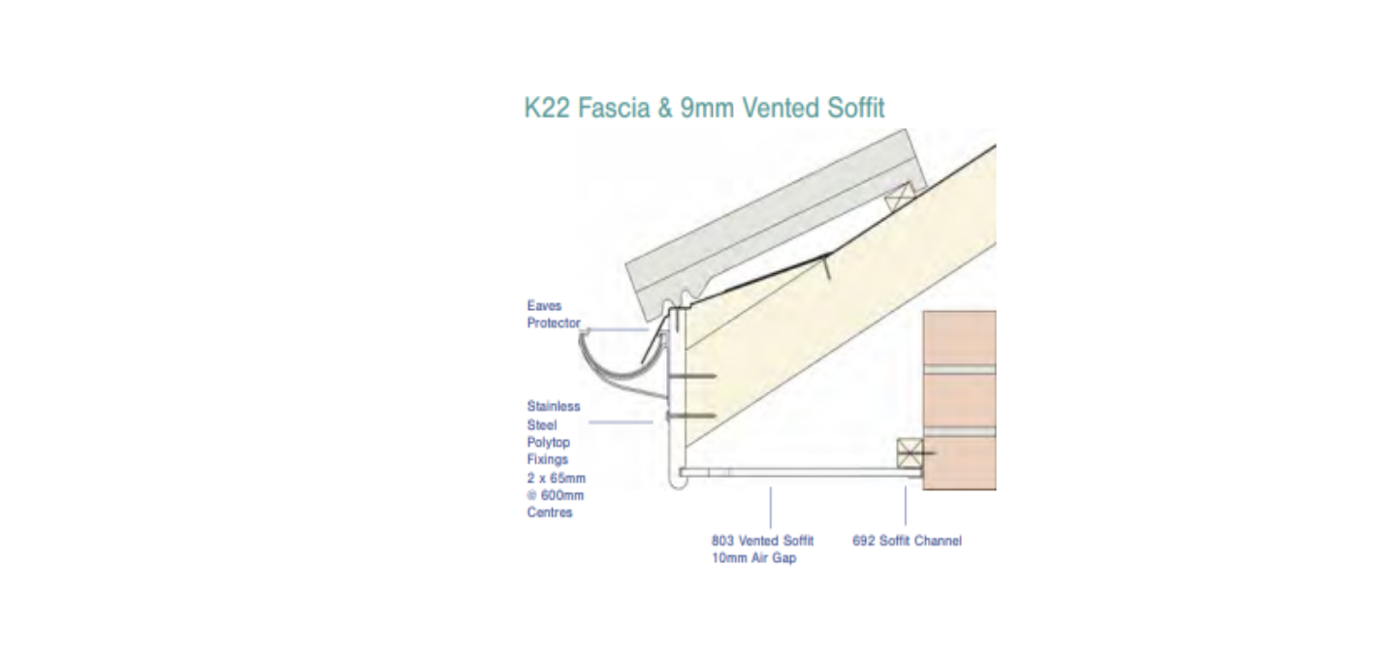  A copy of this drawing is included in Appendix 3
7.15.4 | Blocks of flats shall have multiple Kestrel Products100mm wide soffit boards including a vented board at the fascia edge, and a different fascia board 018 (Ogee form), as drawing.  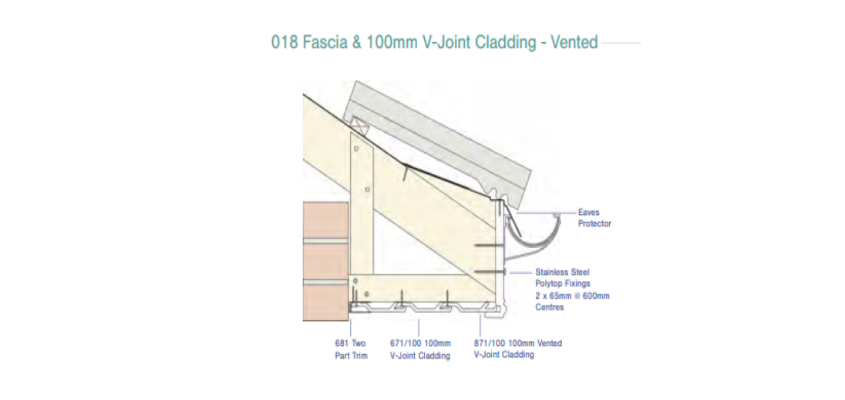  A copy of this detail is included in Appendix 3
7.15.5 | The appointed contractor shall install K Shield Eaves protection system to the eaves as per the drawings at the eaves of each roof, (either dwelling or flats). The Kestrel product code for roof protectors is K708/150.  The eaves protector shall be fitted under the sarking felt and shall be fixed in accordance with manufacturers recommendations.
7.15.6 | The appointed contractor shall install K Shield Bird Comb Filler to protect the tiles of the roof, from the ingress of birds.  The combs shall be fitted to all new roofs (dwellings and flats). The Kestrel Product Code is K713. And the product shall be installed in accordance with the manufacturers’ recommendations.
7.15.7 | The installation of the soffits and fascia’s shall include the provision of all relevant corner components and edges as designed for purpose by the Kestrel Products.
7.15.8 | In direct line with the Marley Roof defence and the firewalls of the subject property each soffit/fascia box shall have a frame constructed of 50mm x 50mm Sikagard treated softwood, ana layer of Rockwool Firepro 50mm Ablative coated Batt fixed to the frame to form passive fire protection.  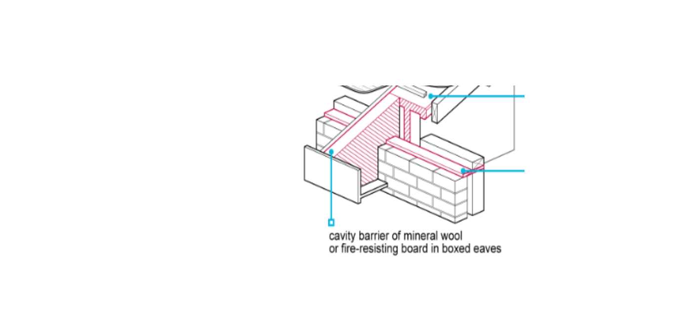
7.16 | Sarking felt
7.16.1 | Supply and fit Marley breathable felt, underlay and fix underly felt in full compliance with the manufacturer’s recommendations: lay rolls parallel to eaves maintaining consistent tautness over the roof structure and with horizontal and vertical laps between sheets in accordance with manufacturers recommendations.  Fix underlay to the rafters with galvanised steel extra large head felt nails
7.16.2 | Allow in the sarking felt for Penetrations – cut neat hole through underlay to allow for pipe entry, size diameter of hole less than pipe, dress underlay over pipe and seal with duct tape
7.16.3 | Also allow for dress up underlay to chimney stacks not less than 50mm, dress under flashings and saddle leadwork.
7.16.4 | Allow in sarking felt for a gap at the ridge in compliance with the requirements for the Marley vented dry ridge system.
7.16.5 | Support sarking felt on eaves guards, trim and dress underlay to suit finishing 25mm behind leading edge of tiles
7.16.6 | The appointed contractor shall extend underlay fully across outer leaf of the gable walls all in accordance with the requirements of the Marley dry verge system requirements.
7.17 | Roof Defence
7.17.1 | After fitting the sarking felt and as part of the works and in accordance with good practice, where the roof passes over a fire wall, the contractor shall fit Marley ‘Roof Defence’ intumescent barriers.
7.17.2 | Marley roof defence shall be placed on the fire walls prior to battening and over the sarking felt.
7.17.3 | Where there is a secret gutter over the firewall of the semi-detached dwellings, the roof defence shall be located at the side of the secret gutter on the Employers side of the joint.  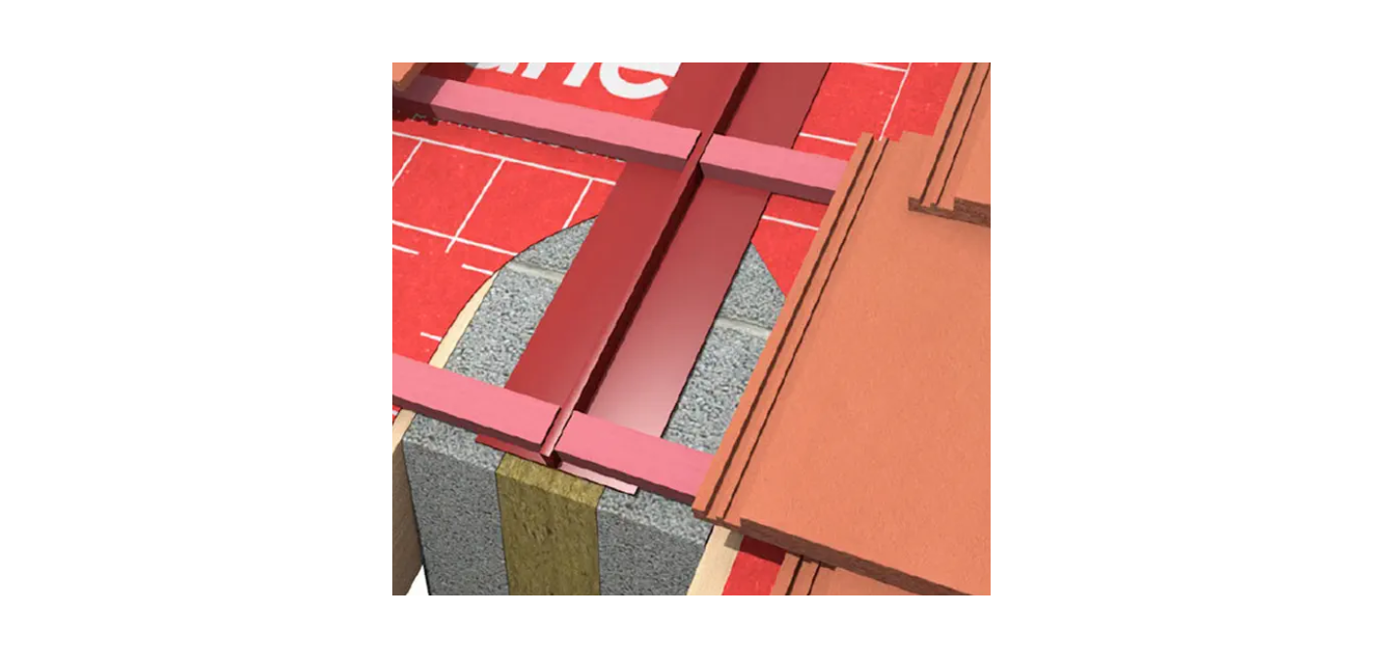
7.18 | Lead flashing
7.18.1 | Allow to apply lead flashing to abutments and chimney formed from code 4 lead, rolls not to exceed 1.5m long, provide 100mm min overlaps between rolls. Flashing to be dressed over profile of top course of tiles to provide no less than 150mm cover
7.18.2 | All new leadwork shall be treated with patination oil as set out in the Calder Guide to Good Leadwork. Patination oil is available from  Address: Ground Floor, Building 7  Queens Park,  Queensway  Team Valley Trading Estate  Gateshead, NE11 0QD  Email sales@calderlead.co.uk  Phone +44 191 482 7350
7.18.3 | All leadwork details shall be as set out in the ‘Calder Guide to Good leadwork’. This document is available online and from the company themselves.  The guide shows the manner in which the Contract will require the lead to be installed. No alternative leadwork formations will be acceptable.
7.18.4 | The Calder Industrial Materials Ltd Guide to Good Leadwork is a pdf document ref:  Calder – GTGLW – 210213.pdf.  Is available from Calder lead.  Website : www.calderlead.co.uk  Email : info@calderlead.co.uk  Phone : 01244 390093
7.18.5 | The leadwork details around a chimney shall be constructed in accordance with Calder Leadwork details as set out on page 18 of ‘The Guide to Good Leadwork’.
7.18.6 | At the joint of semi-detached dwellings, there shall be a secret leadwork gutter as shown on page 21 of ‘The Guide to Good leadwork’.  Alternative secret gutters manufactured from other products are not acceptable as they will not have a similar material guarantee and do not have the same guaranteed life expectancy.  The secret gutter shall be fitted over the firewall between the two properties and shall be fitted on top of the sarking felt.
7.18.7 | At the firewall of flats, where indicated on the relevant drawing in appendix 3, there shall be a secret leadwork gutter as shown on page 21 of ‘The Guide to Good leadwork.  In the case of flats the actual secret gutter width shall be 100mm and not 75mm as shown, and the gap between tiles shall be 25mm rather than 15mm as shown in the detail. This increase in size is to allow to thermal movement of the roof covering.
7.18.8 | All vertical upstands to be 100mm high, leadwork to be dressed tightly against brickwork fold and bed top edge of flashing 25mm in to mortar joints, secure with lead wedges at 150mm spaces, allow for chasing out mortar joints and repointing mortar
7.19 | Pipe Flashing
7.19.1 | Pipe flashings shall be either pre-manufactured lead collars that are made from code 4 leadwork, with a minimum upstand of 100mm or alternatives as below.
7.19.2 | The appointed contractor can use as an alternative to leadwork code 4, propriety flashings made by Seldek.
7.19.3 | The Seldek flashings shall be from the ‘Aluminium’ range which will allow for pipes from 12mm to 450mm (according to choice of product), and can also include high temperature options for boiler flues.
7.19.4 | Seldek flashings are available from Deks products.:  Email : sales@deks.co.uk  Telephone : 01275 85 88 66  Address West End Trading Estate,  Blackfriars Road,  Nailsea,  Bristol, BS48 4DJ
7.19.5 | Seldek flashings can be used in conjunction with code 4 leadwork pre-manufactured upstands if required. There is no objection to a combination of fittings around projections through the roof coverings.
7.20 | Tile Battens
7.20.1 | Supply and fix 50mm x 25mm treated battens. Each batten to be not less than 1200mm long, lay battens with butt joints centrally over rafter/supports, fix battens to each rafter/support using 65mm x 3.35mm galvanised rig shank nails.
7.20.2 | The battens to be to the minimum standards set out in BS5534:2014 Code of Practice for slating and tiling. They shall be pre-treated before arrival on site and shall be of adequate grade for purpose.
7.20.3 | Battens shall specifically be set out to offer the correct lap for the Marely tiles specified. If this is different to the adjoining roof of a neighbouring property, this will not be a problem due to the installation of the secret gutter arrangement.
7.21 | Roof tiles
7.21.1 | Allow to supply and fit Marley Ludlow Major concrete interlocking tiles, each tile fixed in place with non-ferrous fixings in the manner recommended by the manufacturer. The roof tiles shall be Smooth Brown in colour.
7.21.2 | Where the roof adjoins a private property the gauge of the battens and tiles shall reflect the adjoining property unless this will result in an inferior construction.  Remember the provision of the leadwork secret gutter will allow a break between roofs. However if the gauge of the remaining existing roof is less than the recommended spacing of the new roof, the contractor shall use the lesser gauge for the battens.
7.21.3 | To improve the working environment in winter conditions, the roofs will be fitted with dry ridges, and dry verges, avoiding the need for wet trades.
7.21.4 | Ridge to be Marley Ventilated Dry Ridge System dry fixed to the existing ridge timbers and the new tiles. The ridge shall be round topped, and mechanically fixed in place in accordance with the manufacturers’ recommendations.
7.21.5 | Verges to be in Marley dry verge system and installed to all gable ends. This will require the removal of previous mortar verges and under-cloaking.
7.21.6 | The whole roof shall be constructed in accordance with BS5534 Code of practice for installing slates and tiles.
7.21.7 | The roof ventilation shall be in accordance with BS5250 Managing moisture in Buildings.
7.22 | Marley Universal Dry Verge Detail
7.22.1 | The Marley Universal Dry Verge system shall be used on all verges include the provision of segmental ridge end caps for round ridges.
7.22.2 | All components to the verge system must be fitted in accordance with the manufacturers recommendations.
7.22.3 | The appointed contractor shall adapt the new roof to allow the fitting of the verge system and ensure that the verge system is constructed in a robust manner that will meet the requirements of the manufacturers recommendations.  This may include the provision of additional timbers to the roof in order to support the system, and the tenderer is required to ensure that they have allowed for all such additional support.
7.22.4 | Where possible the dry verge shall be kept as close as possible to the gable end surface. The Employer would prefer not to have a gap behind the verge system.
7.23 | Ridges
7.23.1 | The ridge tiles shall be concrete segmental 457mm wide, in brown with Marley Ventilated Dry Ridge System fixings.  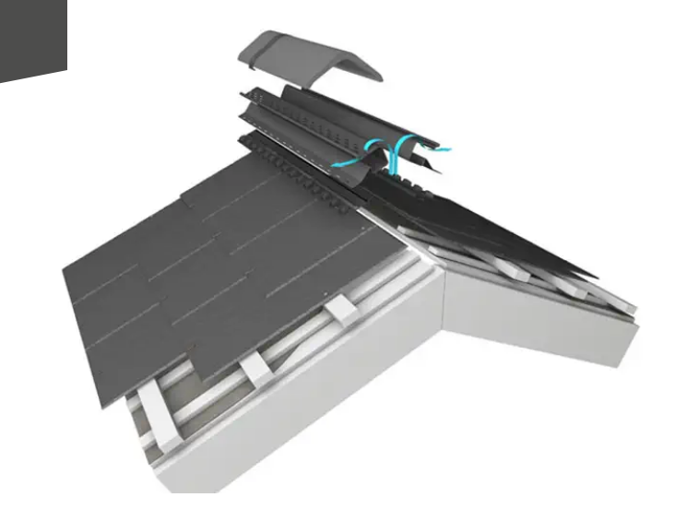  For more technical guidance see the Marley website.
7.23.2 | The Ridge fixing system shall be fitted in such a manner that it is a ‘dry fix’ system with none-ferrous fixings.
7.23.3 | Where the new roofing system meets the existing ridge on an adjoining property, the ridge shall be cut on the property line and dressed with a lead flashing to protect the ingress of water into the ventilated system.
7.24 | UPVC Guttering
7.24.1 | Allow to remove the existing rainwater guttering, down pipes, brackets and any other fittings, replace with new black Marley UPVC deepflow guttering, (110 x 75mm) and black down pipes. Allow to fit guttering brackets at 900mm space maximum or less according to manufacturers’ recommendations.
7.24.2 | Allow for all new 68mm Marley downpipes with fixing backets at 1000mm centres maximum. The downpipes shall be black in colour.
7.24.3 | Gutters and downpipes are supplied by:  Marley Plumbing and Drainage products.  Email: marketing@marleypd.co.uk  Website www.marelyplumbinganddrainage.com  Phone 01622 852779
7.24.4 | All gutters and downpipes shall be fitted in the existing locations unless otherwise instructed by the Contract Administrator.
7.24.5 | All drains shall have been unblocked before the new downpipes are put in place.

Sustainability, Environmental Considerations and Reducing Waste

  - The appointed contractor will be required to reduce the amount of waste on the Contract by considering methods of recycling various products removed from the roof. The products to consider are:

 | Material to dispose of. | Possible recycling as (use or purpose).
8.1.2 | Concrete tiles (complete)
8.1.3 | Concrete tiles (damaged)
8.1.4 | Timber battens
8.1.5 | Removed bituminous Sarking felt
8.1.6 | Lead flashings
8.1.7 | Timber soffit and facia boards
8.1.8 | uPVC Rainwater goods including downpipes.
8.1.9 | Removed bricks from the gable ends.

  - The tenderer can choose to reduce the tender sum by any profits from the recycling of the materials or the scrap value of the leadwork currently in place.

  - The new timber battens used shall be from well-managed forests and /or recycled sources. Therefore’ all timber battens shall be FSC certified products. Use of none certified FSC products is not permitted.

  - FSC is the Forest Stewardship Council and they provide the certification. FSC is available on.

Address : The Billiard Room,
Town Hall,
Great Oak Street,
Llanidloes,
Powys, SY18 6BN.
Website www.uk.fsc.org

  - The appointed contractor will provide to the Contract Administrator a copy of the certification with respect to the battens and shall place such certification in the Health and Safety file as well.

  - BATS If for any reason during the works bats are discovered during the stripping of a roof, all works to that roof are required to cease completely and the roof made watertight as a temporary measure. The Contract Administrator shall then be advised.

  - All bat species, their breeding sites and resting places are fully protected by law - they’re European protected species. You may be able to get a licence from Natural England if you cannot avoid disturbing them or damaging their habitats, or if you want to survey or conserve them.

  - What you must not do
You’re breaking the law if you do certain things including:
deliberately capture, injure or kill bats
damage or destroy a breeding or resting place
obstruct access to their resting or sheltering places
possess, sell, control or transport live or dead bats, or parts of them
intentionally or recklessly disturb a bat while it’s in a structure or place of shelter or protection.

  - Either or both of the following could happen if you’re found guilty of any offences:
you could be sent to prison for up to 6 months
you could get an unlimited fine

  - The Employer has made provision in case of this naturel issue, and the appointed contractor, shall act in a legally responsible manner with respect to such possibilities.

Social Value

  - This Contract is designed to improve the longevity of the properties mentioned in the documentation by providing them with new roofs. It is noted that the roof tiles and ancillary products have reached the end of their useful lives, and this contract is designed to rectify this issue and conserve the dwellings for future habitation.

  - This Contract is also designed to improve ventilation into lofts, and especially designed reduce the prospect of condensation in the loft space, which will lead to rotten roof support timbers. This is in line with Building Regulations that did not exist when the subject properties were originally constructed.

  - This Contract is designed to make better use of modern materials that will reduce maintenance and thus disturbance of the tenants. The use of uPVC soffits and fascia’s will remove the need for decoration, and regular disturbance of tenants. This alternative surface finish will also reduce the maintenance

  - The improvement of the loft insulation (undertaken as part of this works) will reduce energy costs for the tenants and reduce the CO2 by saving on heating.

  - This Contract is designed to improve the structural stability of the roofs and prevent movement of the roof structures which currently have inadequate bracing and support.

  - There is currently no allowance within the roof structure for thermal movement and this is being addressed in order to compensate for global warming.

Supply Chain Visibility

 | Contract issues.
10.1 | Under the terms of the JCT Standard Form of Contract, the appointed contractor shall allow the Contract Administrator and the Contract Administrators appointed representatives access to the site at all reasonable times.
10.2 | Where tenants make claims to the office of the Contract Administrator concerning relevant issues, the appointed contractor shall investigate these matters as soon as reasonably practical and shall report back to the Contract Administrator.
10.3 | The appointed contractor shall at all times inform the Contract Administrator of all unanticipated issues and unforeseen technical issues that have been discovered on site and will need to be resolved.
10.4 | The appointed contractor shall provide prices for such unforeseen works as are not included in Appendix 2 within 5 working days of notification so that the Contract Administrator can make additional arrangements as necessary.
10.5 | A monthly review meeting will take place prior to the submission of any valuation, and the Contract Administrator shall be present.  The meeting shall deal with  Programme  Valuations  Technical issues  Unforeseen works  Safety review
10.6 | The Employer will not be responsible for any materials left on site and will only pay for completed works, i.e. where materials are fixed in place as part of the works.  The reason for this is that the materials could be used in alternative circumstances and are not ‘specialist’. Therefore, all materials on site could be removed by the appointed contractor and sued elsewhere.

Continuous Improvement

  - The tenderer can offer within this section of the tender, to provide a better system of working or better materials than those specified.

  - Where this offer is made by the tenderer, and it is considered by the evaluation team to be an improvement in quality upon that specified herein, this will be considered as a positive attribute and will be scored better than those tenderers that do not make such an offer.

  - Please be aware that offering a change of materials will not necessarily be acceptable to the evaluation team and may not improve the quality bid. It is only when significant benefits associated with a different product can be easily identified by the evaluation team that such an issue will count towards improved quality of tender bid.

  - Please be aware that offering a change of materials could be detrimental to the evaluation of the tender if the quality of the overall work would suffer in respect of quality. To illustrate this a table of the evaluation is included in Appendix 6 of this document.

  - Please state here what improvements on the specification or materials the tenderer believes they can offer to the Contract?

  - If the evaluation team do not accept the improvements suggested by the tenderer in the above box as a positive step to improve quality or reduce price, the tender will be marked down as set out in Appendix 6,

  - Where the tenderer has not won the tender due to such attempts to alter the specification, there will be no sums payable for abortive tendering processes.

Data Management / UK General Data Protection Regulation (UK GDPR)

 | Data Protection and Information
12.1 | Where the appointed contractor is offered phone numbers or details of tenants in order to facilitate the works, the appointed contractor shall treat these details with the strictest of confidence and shall keep the details securely.  This is regardless of whether the information is provided by the Contract Administrator or has been collected by the appointed contractor themselves.
12.2 | Any data provided by the Contract Administrator concerning tenants, that is given to the appointed contractor, must be protected at all times, and when no longer required shall be securely ‘disposed of’ or returned to the Contract Administrator.  The Contract Administrator may enquire as to the means of disposal of such information and then check that such information has been adequately disposed of.
12.3 | The Contractor Administrator has the right to remove from site permanently any operative or manager of the appointed contractor that is found to be excessively fraternising with the tenants in person or by other forms of communication.
12.4 | All electronic information presented to the Contract Administrator shall be via the email system. This is due to the nature of the Employers computer system.  Information presented on Dongles and in disc format will not be approved.
12.5 | All certificates associated with the works must be in place prior to payment for that works. No works for electrical, aerial or gas works will be approved for payment as completed works if an electronic copy of the relevant certificate has not been lodged with the Contract Administrator.
12.6 | The final Health and Safety file as required under CDM regulations shall be a digital document. This will be backed up by hard copy information where appropriate and requested by the Contract Administrator.

Quality Requirements.

 | Quality Qualification
13.1 | The appointed contractor shall be a National Federation of Roofing Contractors member, and the works of roofing shall comply in full with the NFRC standards.  As can be seen in the evaluation if the roofers are not qualified members, they will be eliminated from the evaluation process.
13.2 | The scaffolding to support the works shall be carried out by operatives that have a minimum standard of training equal or better than that provided by the CISRS BASE.
13.3 | The scaffolders or scaffolding sub-contractor shall ensure all scaffolds that are erected (in use or just standing), shall be checked and the ‘Scafftag’ provided to each scaffold. This will ensure operatives on site will be able to check if the scaffold is safe.
13.4 | The scaffolders shall also provide an F91 Scaffolding register (or equivalent) shall be kept up to date each week for the duration of scaffolds being erected.
13.5 | The appointed contractor shall only use the products specified in the is document unless they have agreed alternative products in writing prior to start on site.  If this is permitted the alternative product will be agreed prior to the commencement of the Contract, in the evaluation process. No other changes will be permitted, and the tenderer shall have researched all the products in this document to ensure they are available.  No claim will be tolerated by the Contract Administrator that the specified materials are ‘on long back-order’ or are not available from local merchants.
13.6 | The appointed contractor shall only use tile battens and timber that is approved and certified by the FSC. This is to improve the environmental credentials of the works generally.
13.7 | Any electrical works shall be carried out by a NICEIC approved contractor. Proof of qualification will be provided to the Contract Administrator by the appointed contractor prior to the electrician starting on site.
13.8 | Any gas works shall be carried out by a ‘Gas Safe’ contractor. Proof of qualification will be provided to the Contract Administrator by the appointed contractor prior to the gas engineer starting on site.
13.9 | To ensure that the temporary aerial works and the permanent aerial works are carried out to a good standard, the aerials shall only be carried out by members of the Confederation of Aerial Industries Association.  The tender evaluation will include checking to ensure the appointed sub-contractors are a member of this organisation. Again, lack of relevant membership will lead to not evaluating the tender received.
13.10 | All complaints made by tenants to the appointed contractor shall be recorded on site by the site manager and shall be related each week to the Contract Administrator via email with any relevant photographs taken of the situation if necessary.
13.11 | All complaints made directly to the Employer, and pertaining to the Contract will be shared with the site manager, and where relevant the site manager shall carry out investigations and report back to the Contract Administrator within 2 working days.

Whole of Life Support and Warranties

 | Warranties
14.1 | The appointed contractor shall carry out all defects to the new works and refurbishment for the duration of 12 months following Practical Completion (as defined in the JCT standard form of Contract).
14.2 | The appointed contractor shall gain guarantees from the manufacturers of the various products specified and shall pass them on to the Client as part of the final Health and Safety file.
14.3 | The appointed contractor shall allow for the provision of copies of notices related to ‘building control’ being included in the Health and Safety file.
14.4 | Contractor to provide electrical certification in NICEIC form for any alterations required. The certificate to be sent to the Contract Administrator in digital format via email within 24 hours of works being completed, and copies of the certificates shall be placed in the Health and Safety file.
14.5 | Contractor to provide gas certification on Gas Safe certification forms for any alterations required. The certificate to be sent to the Contract Administrator in digital format via email within 24 hours of works being completed, and copies of the certificates shall be placed in the Health and Safety file.
14.6 | The appointed contractor will be required to provide copies of all necessary insurances in compliance with the terms and conditions of the JCT standard form of contract.
14.7 | The appointed contractor shall guarantee the whole of the works for a minimum of ten years. This includes guarantees against severe weather and high winds.
14.8 | The appointed contractor shall respond to all issues of remediation for the first twelve months following the agreed end of the Contract period on site, in accordance with the JCT standard contract.  Responses to remediation shall be within hours rather than days as leaks through the roof can be very destructive in bad weather.
14.9 | Building Regulations
14.10 | All drainage and structural improvement will require a Building Notice to be submitted to the Local Authority Building Control Dept. with the appropriate fee.  The Employer will make application on behalf of the appointed contractor, but will take advice from the appointed contractor to ensure that all the relevant items are covered properly in the application.
14.11 | It will be the appointed contractor’s responsibility to inform Building Control when the required inspections are due giving 48 hours notice, i.e.  - Drainage  - Structural Works  - Completion
14.12 | The local Authority will issue a Completion Notice Certificate on completion which must be forwarded to North Northamptonshire Council with the final invoice before payment can be made.  A copy of the Building Control notices to be included in the Health and Safety file.

Security

15.1 | The appointed contractor is required to ensure that all information given by the Contract Administrator remains confidential at all times.  This includes during evenings and weekends when information may have been left in the site accommodation.
15.2 | The appointed contractor shall have full responsibility for any site hutments and storage provided by themselves, and all fencing.  Any materials removed from the site compound or from the works are not the responsibility of the Employer. The Employer is only responsible for loss once the work is completed and the scaffolding is fully dismantled.
15.3 | The appointed contractor shall ensure that tenants own security measures are not breached by the works at any time. This includes the careful location of scaffolding to avoid security breaches.
15.4 | The information concerning asbestos, must be kept secure at all times, and shall not be made public to tenants. Tenants have a completely separate method of obtaining information via the Employer, and the appointed contractor shall not breach confidentiality at any time.  In instances of insistent tenants, the appointed contractor shall advised the tenant to use the methods of obtaining information that are available to them through proper channels, and if tenants remain persistent shall inform the Contract Administrator of the issue.
15.5 | Items of IT used by the appointed contractor on site shall remain in a secure format and shall be password protected to ensure that it is not accessible by any person gaining illegal access to the site hutments.
15.6 | Secure information will include such items as the programme of works, the valuations, and the certifications that accompany individual completions of properties.  Other secure information includes asbestos registered items and personal data about tenants.

Training

 | Staffing
16.1 | This Contract has no element of training related to specified trades. Operatives are required to be fully trained in their relevant trades if the operative is from one of the trades highlighted.  North Northamptonshire Council openly encourage the development of future tradesmen, however, the use of operatives in trades they are not qualified to work in, cannot be disguised as ‘being a trainee’.
16.2 | Where the tenderer believes its operatives or sub-contractors use trainees, the persons who are trainees shall at all times be accompanied by a fully qualified trades person on site.
16.3 | The appointed contractor is responsible for ensuring that all sub-contractors they employ as part of the works fully comply with all conditions of this document and monitor carefully the use of any trainees.
16.4 | The appointed contractor shall ensure that the operatives on site have all relevant training to install all relevant products in accordance with the manufacturer’s recommendations.
16.5 | The Contract Administrator may choose to seek confirmation that products are installed in accordance with the manufacturers recommendations by bringing to site a relevant consultant from the manufacturer concerned.  If this person finds the work to be sub-standard, the works shall be removed and reinstated at no extra cost to the Employer.

Programme of Works and Implementation Criteria

17.0 | Programming
17.1 | The Contract completion date is 31 March 2022, however starting the contract is subject to certain scrutiny by other departments within the North Northants Councill.
17..2 | The tenderer is made aware that the anticipated Contract will commence approximately one calendar month after the tenders are returned (not sooner).  The tenderer should allow for this delay within the prices submitted, as the Employer has a number of processes to perform before the Contract can be signed and works started on site.
17.3 | The appointed contractor shall provide a detailed programme of works no later than two weeks before the proposed start on site. The programme shall illustrate the dates on which scaffolding will be erected and dismantled, as well as dates upon which works to a roof will be opened up.
17.4 | The appointed contractor will have no ‘come back’ if they do not provide enough detail and expect the Contract Administrator to attend site at short notice to agreed works when ‘opening up’.  The programme of works is an important document to the Contract and will be used by the Contract Administrator to ensure all relevant notification is give to the tenants and private owners that will be affected by the works.
17.5 | The programme of works shall include details of working over the Christmas period, and other bank holidays, if appropriate.  The programme will need to come to a logical conclusion over the Christmas/new year break, with all roofs being completed as new or not started.  The appointed contractor will not be permitted to leave any property with temporary watertightness during the Christmas holidays.
17.6 | The programme of works shall include lead in times for materials, critical paths, site establishment and establishment removal dates.  The programme shall also include an order of works, and monitoring of the works as they progress to allow analysis of progress against the programme.
17.7 | This order of works may be changed, if there are relevant circumstances causing delay, however, this can only occur with the consent of the Contract Administrator and shall not be in response to a failure on the part of the appointed contractor to obtain sufficient operatives to meet the anticipated programme.
17.8 | The appointed contractor shall update and amend the programme and will issue new copies of the revised programme to the Contract Administrator on each occasion that the programme is altered or amended.
17.9 | The programme shall show actual completion dates for each of the dwellings and each of the blocks, so that tenants can be made aware of when and for how long the works will be undertaken to their homes.
17.10 | The final programme of works will be included in the Health and Safety file for the works.

Contract Management, Performance Monitoring, and Review

  - The contract management arrangements and payment terms are set out in the JCT Standard form of contract for Minor Works, and subject to the recitals and terms set out in Appendix 4 of this document.

  - The terms set out in Appendix 4 are those by which the tenderer will set out the tender, and the appointed contractor will be required to provide such information concerning insurance, indemnities and the like in compliance prior to the signing of the Contract.

  - The Liquidated Damages for non-completion of the works after assessment by the Contract Administrator are set out in Appendix 8 of this document.

  - The Contract will be monitored for the duration of the works, and late completion on behalf of the appointed contractor without good reason will lead to the imposing of liquidated damages, in line with the JCT Standard form rules of engagement.

  - The Contract Administrator shall manage all issues related to the contract on behalf of North Northamptonshire Council and will be ‘the point of contact’ for the appointed contractor at all times.

  - The individual named as Contract Administrator will furnish the appointed contractor with a point of contact telephone number and email address.

  - Very occasionally the named person appointed to act as Contract Administrator may change, but the Employer will provide similar details for any such replacement person, in such an eventuality.

Risk Management

 | Risk Issues
19.1 | As part of the risk management process in construction the Employer provides a risk assessment in line with the Construction (Design and Management) Regulations 2015  This risk assessment is included in Appendix 5 of this document and is specifically prepared as part of the Employers responsibility under the CDM Regulations.
19.2 | Again, in compliance with the CDM regulations this risk assessment shall be developed and improved to help provide the basis of the documentation in the Health and Safety file and for site use during the Contract works.
19.3 | The appointed contractor shall be aware that there will be checks on the management in respects of health and safety during the Contract, and the North Northamptonshire Health and Safety advisor may choose to visit the site with the Contract Administrator.  Health and Safety is a very important feature of this Contract, as it includes the safety of tenants, occupants of adjoining properties as well as the Health and Welfare of operatives.
19.4 | At the end of the Contract, the appointed contractor is required to provide a full and detailed Health and Safety file.  This will be hard copy but can also be provided in digital form via email.
19.5 | Within the realms of Health and Safety the following issues are brought to the attention of the appointed contractor.
19.6 | Working with Asbestos
19.6.1 | North Northamptonshire Council issues the following warning to tenderers in relation to their health and safety when working with asbestos materials.  Attention should be paid to the following:  The Health and Safety at Work Act 1974.  Control of Substances Hazardous to Health Regulations 2002 (sixth edition).  Management of Health and Safety at Work Regulation 1999  The Control of Asbestos Regulations 2006  Approved Code of Practice LL 143 (approved code of practice and guidance 2nd Edition 2013)  “Work with asbestos insulation, coating and asbestos insulating board”  Approved Code of Practice L27; (Fourth Edition – Revised 2002)  “Work with asbestos that does not normally require a licence”  Approved Code of Practice L127, “The Management of Asbestos in Non-domestic Premises”.  The Special Waste Regulations 1996  Some or all of these standards may apply to this Contract.
19.6.2 | Before commencement of any work which will expose, or is likely to expose, any person to asbestos, the appointed contractor shall ensure a suitable and sufficient assessment has been undertaken of the potential risk created by any exposure. This will be based on the site conditions and results of an appropriate asbestos survey.
19.6.3 | The appointed contractor should be aware that all personnel involved with the removal of licensed asbestos materials have an obligation to notify the Health and Safety Executive, within 14 days via an ASB1 notice and the contractors removing it must be licensed. All licensed product are detailed in the Control of Asbestos Regulation 2006.
19.7 | The Transport of Asbestos Waste
19.7.1 | The transport of waste, where asbestos is greater than 0.1% (by volume), is regulated and therefore not permissible to those who are not licensed waste carriers.
19.7.2 | Generally, the removal and transport of small quantities of waste (between site and disposal point) arising from work on bonded, non-licensable, asbestos products (for example Artex and floor tiles) will not require licence. There is, however, a requirement that waste in this category will be transported in the following manner:  The waste will be double bagged in bags produced for the purpose of containing asbestos waste. The waste is contained within a red bag marked ‘Asbestos’, which itself is contained within a clear bag, which displays an asbestos warning sign; both will be sealed. The bags will be transported within a vehicle which has a segregated container / compartment which is easily cleanable and lockable.
19.7.3 | Asbestos waste may only be disposed of at a licensed asbestos disposal centre.
19.7.4 | For non-licensed materials, the appointed contractor must have received awareness and other training associated with working with non-licensed asbestos products, under Section 10 of The Control of Asbestos Regulations 2006 and is able to provide certification of this training.
19.7.5 | The works covered by this schedule are for a domestic customer and are not notifiable under the regulations.
19.7.6 | The appointed contractor is responsible for carrying out a Health and Safety Risk Assessment to cover all operations involved under the works specified and prior to the works commencing on site.
19.7.7 | EXCEPTIONAL RISKS notifiable to appointed contractor under Designers Risk Assessment. At the time of preparing this document none has been noted.
19.8 | Electrical Work
19.8.1 | Any electrical installation must be carried out by a contractor registered with NICEIC Certification Services Ltd
19.8.2 | All electrical works are to comply with the current IEE Regulations, relevant Code of Practice, British Standards and manufacturer’s instructions and recommendations
19.8.3 | Test installation in accordance with BS7671 (Part 7) and ‘Part P’ of the Building Regulations. Give at least 24 hours notice before starting test. After satisfactory completion of tests, submit two copies of inspection and completion certificates t the Contract Administrator. Ensure that labels and signs required by regulations are securely fixed in correct locations. Electrical Installation Certificate must be forwarded to North Northamptonshire Council with the final invoice in order that payment can be made.
19.9 | General site rules on risk.
19.9.1 | Works where excavation required should be subject to a cable avoidance tool (CAT) test carried out by the appointed contractor before work begins to ascertain the location of underground cables and services.
19.9.2 | All services are to be ideally maintained throughout the duration of the works. Any interruption to mains services must be notified and agreed with Employer and the Contract Administrator. Temporary services must be provided for the tenant or private owner to have adequate heating, lighting and cooking facilities, should the mains services be unable to be fully reinstated at the end of each days working.
19.9.3 | The appointed contractor is to provide all necessary protection to the existing structure, finishings, fittings, furniture, services etc., including for the making good of all areas disturbed to the satisfaction of the Contract Administrator.

Performance and Compliance Audits

  - Performance requirements during the Contract are covered by the JCT standard form of Contract conditions. These conditions are supplemented by the recitals etc which are set out in Appendix 4 of this document.

  - The Employer does not bind itself to accept the lowest tender, or any tender submitted if the tenderer qualifies the tender that is not acceptable and does not offer fair competition.

  - The Employer will evaluate the tenders submitted based upon a mix of price, and compliance with the conditions of this tender document. Where the tenderer offers alternatives to the materials specified, and does not offer a saving to the Employer, the Employer is very unlikely to make this as a positive evaluation.

  - The evaluation criteria are set out in Appendix 6 of this document and the tenderer is advised to look at this required criteria carefully.

  - The evaluation will be based upon the main contractor AND the sub-contractors appointed. If the sub-contractors do not meet the minimum standards of the specification, this will be a negative aspect to the evaluation. It should be remembered that the tenderer has the opportunity to pick their own sub-contractors from the professional trade associations.

Performance Bond, Parent Company Guarantee and Other Sureties

  - The appointed contractor shall pass on to the Employer all relevant guarantees related to the various materials used in the works. These guarantees shall be provided in the Health and Safety file.

  - The appointed contractor shall under no circumstances carry out such works as would be detrimental to the guarantees related to the products used, therefore as a general principle the appointed contractor is required to install all materials in accordance with the Manufacturers recommendations.

  - The Contracted Works shall be guaranteed for a minimum of one year, and the appointed contractor shall attend to any remedial works reported during that period within 5 working days. This guaranteed repair is known under JCT as remediation.

  - The appointed contractor will need to ensure that all relevant insurances related to the works are in place prior to signing of the Contract, and any outdated insurances are renewed accordingly before commencement of the works.

Other Relevant Details

  - The tenderer shall be aware that the tender return submitted shall be evaluated in respect of both price (i.e. being the lowest calculated price when corrected) and in respect of quality of submission.

 | Tender priced submission
22.2 | Overall costs for tender purposes.  This is the section that the tenderer will put most of the costs. In addition the tenderer needs to complete Appendix 2 prices as well.
22.3 | Establishment. This cost reflects the full site establishment including safe storage of materials in compliance with the manufacturers’ recommendations, all welfare facilities for operatives in compliance with CDM and other regulations. This item also includes the cost of full compliance with risk assessments in all aspects of construction and protection.  Site establishment will be for the full duration of the contract and shall include all reasonable costs of protection against vandalism and theft during the works. | item
22.4 | This item shall also include for the provision of development of the original risk assessment and the provision of Risk Assessments and Method Statements to carry out the works. It shall also include the Health and Safety file at the end of the works, which is an integral part of the health and safety issue as defined in the Construction (Design and Management) Regulations 2015.  This item will only be paid for at the completion and delivery of the Health and Safety file to the Contract Administrator. | item
22.5 | Site establishment also includes the liaison between the appointed contractor and tenants and private owners. Also, the appointed contractor shall liaise with such statutory bodies as required by the contract. | item
22.6 | For the signing of the JCT standard form of contract and all associated documentation including all legal costs incurred by the appointed contractor for such contractual management.  This cost will also include any copying of the documentation by the appointed contractor to ensure that they have an up to date hard copy of the information. Along with any copying of standards, or manufacturers information. | item
22.7 | For the provision of an up to date programme including all subsequent revisions of the programme as works progress and the appointed contractor becomes aware of issues on site. | item
22.8 | 28 to 30A Scott Road including:  Not required | item
22.9 | 32 to 42A Scott Road including:  Not required | item
22.10 | 41 Scott Road including:  Not required | item
22.11 | 45 Scott Road including:  Not required | item
22.12 | 49 to 59A Scott Road including:  Rebuilding to and strapping to two gable ends.  Three leadwork secret gutters as per drawings  Roof bracing as detailed to each dwelling.  Six roof and ceiling strapping sets as detailed in drawings.  New roofs soffit and fascias’ as detailed  New gutters and downpipe as detailed  New code 4 leadwork including a secret gutter and chimney flashings as per Calder Leadwork guide.  Provide all new fire stopping as specified  Allow for any improvements and upgrading including loft insulation, chimney repairs and potential repairs to woodwork all as set out in the Appendix 2 (on an adhoc basis)  Roof tiling including Marley dry ridge and Universal dry verge systems.  Allow for all safe access  Allow for disposal of all redundant materials. | item
22.13 | 71 Scott Road including:  Not required | item
22.14 | Additional items as the contractor may wish to add (include description and price in relevant columns).
22.15 | Tender sum  (note this is the sum of all costs associated with this contract other than those set out in Appendix 2.

Corporate Social Responsibility

The Council has a responsibility to ensure the Suppliers it works with are ethical organisations. This section should be used to set out any mandatory requirements on the Supplier to confirm they must comply with legislation related to any corporate social responsibility. Examples are included blow (this list is not exhaustive).
- Equality and accessibility;
- Modern slavery, child labour, and/or inhumane treatment;
- Income security;
- Working hours; and/or
- Sustainability.

  - Although this tender is open to all responsible and adequately qualified contractors, any tenderer that is new to the authority will be required to complete forms related to their corporate identity.

  - In February 2019, HM Government published a Supplier Code of Conduct setting out the standards and behaviours expected of the appointed Contractors who work with government. (https://assets.publishing.service.gov.uk/government/uploads/system/uploads/attachment_data/file/779660/20190220-Supplier_Code_of_Conduct.pdf)
  - The Employer expects its appointed contractors and subcontractors to meet the standards set out in that Code. In addition, the Employer expects its appointed contractors and subcontractors to comply with the standards set out in the code.

  - The appointed contractor therefore acknowledges that the Employer may have additional requirements in relation to corporate social responsibility. The Employer expects that the appointed contractor and its subcontractors will comply with such corporate social responsibility requirements as the Employer may notify to the appointed contractor from time to time.

  - In addition to legal obligations, the appointed contractor shall support the Employer in fulfilling its Public Sector Equality duty under S149 of the Equality Act 2010 by ensuring that it fulfils its obligations under each Contract in a way that seeks to:
- eliminate discrimination, harassment, or victimisation of any kind; and
- advance equality of opportunity and good relations between those with a protected characteristic (age, disability, gender reassignment, pregnancy and maternity, race, religion or belief, sex, sexual orientation, and marriage and civil partnership) and those who do not share it.

  - Modern Slavery Helpline - means the mechanism for reporting suspicion, seeking help or advice and information about modern slavery available online at https://www.modernslaveryhelpline.org/report or by telephone on 08000 121 700.

  - The appointed contractor
- shall not use, nor allow its subcontractors to use forced, bonded or involuntary prison labour;
- shall not require any appointed contracdtor staff or subcontractor staff to lodge deposits or identify papers with the employer and shall be free to leave their employer after reasonable notice;
- warrants and represents that it has not been convicted of any slavery or human tracking offenses anywhere around the world;
- warrants that to the best of its knowledge it is not currently under investigation, inquiry, or enforcement proceedings in relation to any allegation of slavery or human tracking offenses anywhere around the world;
- shall make reasonable enquires to ensure that its officers, employees, and subcontractors have not been convicted of slavery or human tracking offenses anywhere around the world;
- shall have and maintain throughout the term of any of its Contracts, its own policies, and procedures to ensure its compliance with the Modern Slavery Act and include in its contracts with its subcontractor’s anti-slavery and human trafficking provisions;
- shall implement due diligence procedures to ensure that there is no slavery or human trafficking in any part of its supply chain performing obligations under any of its Contract;
- shall prepare and deliver to the Employer or Contract Administrator, upon request, a slavery and human trafficking report, setting out the steps it has taken to ensure that slavery and human trafficking is not taking place in any of its supply chains or in any part of its business with an annual certification of compliance;
- shall not use, nor allow its employees or subcontractors to use physical abuse or discipline, the threat of physical abuse, sexual or other harassment and verbal abuse or other forms of intimidation of its employees or subcontractors;
- shall not use or allow child or slave labour to be used by its subcontractors;
- shall report the discovery or suspicion of any slavery or trafficking by it or its subcontractors to the Council and Modern Slavery Helpline.

  - The appointed contractor shall:
- ensure that that all wages and benefits paid for a standard working week meet, at a minimum, national legal standards in the country of employment;
- ensure that all appointed contractor staff are provided with written and understandable Information about their employment conditions in respect to wages before they enter employment and about the particulars of their wages for the pay period concerned each time that they are paid;
- All operatives shall be provided with written and understandable Information about their employment conditions in respect to wages before they enter employment and about the particulars of their wages for the pay period concerned each time that they are paid;
- not make deductions from wages:
  - as a disciplinary measure;
  - except where permitted by law; or
  - without expressed permission of the worker concerned.
- record all disciplinary measures taken against Supplier staff; and
f ensure that appointed contractor staff are engaged under a recognised employment relationship established through national law and practice.

  - The Supplier shall:
- ensure that the working hours of appointed contractors Staff comply with national laws, and any collective agreements;
- that the working hours of the appointed contractors Staff, excluding overtime, shall be defined by Contract, and shall not exceed forty-eight (48) hours per week unless the individual has agreed in writing;
- ensure that use of overtime used responsibly, considering:
- the extent;
- frequency; and
- hours worked by individuals and by the Supplier Staff as a whole.

  - The total hours worked in any seven (7) day period shall not exceed sixty (60) hours, except where covered by items below.

  - Working hours may exceed sixty (60) hours in any seven (7) day period only in exceptional circumstances where all the following are met:
- this is allowed by national law;
- this is allowed by a collective agreement freely negotiated with a workers’ organisation representing a significant portion of the workforce; appropriate safeguards are taken to protect the workers’ health and safety; and
- the employer can demonstrate that exceptional circumstances apply such as unexpected production peaks, accidents, or emergencies.
  - All appointed contractor staff shall be provided with at least one (1) day off in every seven (7) day period or, where allowed by national law, two (2) days off in every fourteen (14) day period.

Appendices

There are no annexes to this document. There are however a number of Appendices.

Appendix 1 Definitions.
Appendix 2 Potential works following exposure of the roof frame.
Appendix 3 Enlargement of drawings used in this Contract Document.
Appendix 4 Conditions of JCT standard form of Contract.
Appendix 5 Risk Assessment
Appendix 6 Details of the tender evaluation process.
Appendix 7 Information obtained concerning asbestos
Appendix 8 Calculation to determine loss to the Employer for none completion by the appointed contractor (liquidated damages).

Appendix 1 – Definitions

Term or Acronym | Definition
Contract | The legal agreement between the Supplier and the Council, which details the Council’s requirements, terms, and conditions.  The Contract is formed from the JCT Minor works document and this document.
Contract Period | This shall be from approximately 4 months after the tender return date until the 31 March 2022. The exact date of commencement will be entered in the JCT form of contract.
Employer | The Capital works team of North Northamptonshire Council. The Employer is the term used in the JCT Standard form of Contract, and is replicated in this document.
The Works | A term used to describe the goods, supplies, service, works and/or any part, thereof and/or any other requirement to be provided and/or delivered by the Supplier, to fulfil the obligations and/or requirements of this document and all supporting documents.
Tenderer | The organisation who is pricing this document with a view to undertaking the works if successful. There is no guarantee that the tenderer will be appointed to carry out the works.
Appointed Contractor | The organisation who wins the Contract, following evaluation of all bids received by the Employer. The appointed contractor is the organisation who will enter into Contract and will sign the JCT standard form of contract before commencement on site.
Contract Administrator | The Contract Administrator is defined under the terms and conditions of the JCT Standard for of contract. In this instance the Contract Administrator will be The Interim Strategic Lead for Housing Property Services, or a representative of his/her staff as appointed by the post holder.
The site | The allocated compound, and the properties mentioned in this document, as well as adjacent properties attached. This includes all roads, paths, balconies and the like associated with those properties.  The site is not the whole or part of the public accessible areas of Scott Road, nor the gardens of dwellings or common areas of flats.
Manufacturer | This shall mean the Supplier of goods that manufactures the product and will provide both product information and fixing details for the product concerned for the specific use.

Appendix 2 – Potential works following exposure of the roof frame.

 | NOTE. The tenderer shall price each of these items based upon what can be determined from site. The prices given here in this Appendix
 | Also note these prices will also form part of the evaluation, where realistic quantities will be used to determine the lowest prices between tenderers.
A2.1 | Apply woodworm treatment to all sides of an existing rafter from eaves to ridge  Price per rafter (any size) | Per full rafter | 9.75
A2.2 | Apply woodworm treatment to all sides of existing purlin.  Price per purlin (any cross section) per roof void. | Per full purlin | 18.00
A2.3 | Replacement of up to 1linear meter of rafter to a block of flats. The new rafter to have the same dimensions as the existing and to be cut to shape. The rafter to then be spliced in place using Expamet BAT splicing plates or a traditional rafter splice carried out by a competent carpenter.  Expament details  Email: expament.sales@birtleygroup.co.uk  Phone: 0191 411 2244  Address: Greatham Street, Longholl Industrial Estate (North), Hartlepool, TS25 1PU.  Works to include the fixing of the new rafter end and the preservation of the new timber by the application of Sika Universal 5 Star Wood Treatment. | Per lin m | 17.25
A2.4 | Replacement of up to 1linear meter of rafter to a single dwelling house. The new rafter to have the same dimensions as the existing and to be cut to shape. The rafter to then be spliced in place using Expamet BAT splicing plates or a traditional rafter splice carried out by a competent carpenter.  Expamet BAT details as previous. | Per lin m | 17.25
A2.5 | Replacement of a full rafter to a block of flats including all cutting to shape and fixing in position and the application of Sika Universal 5 Star Wood Treatment.to the new rafter. | Per full rafter | 53.00
A2.6 | Replacement of a full rafter to a single dwelling house including all cutting to shape and fixing in position and the application of Sika Universal 5 Star Wood Treatment.to the new rafter. | Per full rafter | 50.40
A2.7 | Upgrading of the loft insulation to meet the requirements of the current regulations (as a minimum). 200mm thickness of insulation to be laid per square metre of loft.  Insulation to be Rockwool as specified in the main document. | Per m² of ceiling | 5.63
A2.8 | Upgrading of the loft insulation to meet the requirements of the current regulations (as a minimum). 150mm thickness of insulation to be laid per square metre of loft.  Insulation to be Rockwool as specified in the main document. | Per m² of ceiling | 4.66
A2.9 | Upgrading of the loft insulation to meet the requirements of the current regulations (as a minimum).100mm thickness of insulation to be laid per square metre of loft.  Insulation to be Rockwool as specified in the main document. | Per m² of ceiling | 3.94
A2.10 | Provide temporary protection to loft insulation and provide adequate means of access to gain full and proper access to a flat block single chimney. | Per chimney stack | 450.00
A2.11 | Provide temporary protection to loft insulation and provide adequate means of access to gain full and proper access to a single dwelling chimney. | Per chimney stack | 450.00
A2.12 | Block of flats single chimney. Allow for the removal of all lead flashings, and any aerials from the surface of the brickwork, and rake out the chimney to a depth of 20mm. Apply Unibond or similar PVA glue to the open joints and then then fill the joints with new mortar including the same PVA additive.  Refix all aerials and new lead flashings to the Chimney and leave the chimney in full working order. | Per chimney stack | 375.00
A2.13 | Single dwelling chimney. Allow for the removal of all lead flashings, and any aerials from the surface of the brickwork, and rake out the chimney to a depth of 20mm. Apply Unibond or similar PVA glue to the open joints and then then fill the joints with new mortar including the same PVA additive.  Refix all aerials and new lead flashings to the Chimney and leave the chimney in full working order. | Per chimney stack | 300.00
A2.14 | Remove existing clay chimney pot and replace with new tall stack pot as per the others on the flat block. Include for all securing of the new flue and for making good to the flaunching around the chimney. | Per pot | 80.00
A2.15 | Remove existing clay chimney pot and replace with new tall stack pot as per the others on the individual dwellings. Include for all securing of the new flue and for making good to the flaunching around the chimney. | Per pot | 120.00
A2.15 | Add to existing chimney pot where necessary, a new flue ventilator as the pot is no longer in use.  Flue terminals shall be located in the top of the chimney pot and shall be Red Bank Flue Ventilators.  The ventilator shall be installed in accordance with manufacturers instructions. No other similar alternative products will be provided. The product reference is ‘List No 120’ and comes in a range of sizes.    Red Bank products are available from:  Forterra Building Products Ltd  Address: 5 Grange Park Court, Roman Way. Northampton NN4 5EA.  Phone: 01604 707600 | Per ventilator fitted. | 85.00
A2.16 | Permanently relocate an aerial or dish from a chimney to a new location and set up the same at the new location agreed with the Contract Administrator.  Allow for all new cabling and for all new cable fixings and access. | Per aerial or dish | 170.00
A2.15 | Permanently remove from site a redundant aerial or dish no longer in service and dispose of same from site completely.  This item includes the provision of all safe access to the aerial or dish whether fixed to a chimney or other location. | Per aerial or dish | 40.00
A2.16 | Block of flats single multi-flue chimney. Take down the existing chimney to 300mm below the lowest point of the roof. Remove all brickwork from the roof area and dispose of same from site.  Retain trimmers on the roof around the chimney where possible and add any missing rafters as a splice (above).  Include in this price for the additional roof covering and allow deduction of all new leadwork around the chimney.  Fit Expamet Mesh 19-98SR cut to size on top of the open flues and then fix in place by mechanical means of screws and washers, or by laying an additional course of bricks back on top of the chimney around the perimeter. | Per chimney | 350.00
A2.17 | Single dwelling multi-flue chimney. Take down the existing chimney to 300mm below the lowest point of the roof. Remove all brickwork from the roof area and dispose of same from site.  Retain trimmers on the roof around the chimney where possible and add any missing rafters as a splice (above).  Include in this price for the additional roof covering and allow deduction of all new leadwork around the chimney.  Fit Expamet Mesh 19-98SR cut to size on top of the open flues and then fix in place by mechanical means of screws and washers, or by laying an additional course of bricks back on top of the chimney around the perimeter. | Per chimney | 275.00
A2.18 | Flaunching Carefully hack off the mortar flaunching to the top of the chimney and dispose of all waste from site. Check the chimney pots before re-flaunching.  Re-flaunch the chimneys with new mortar mixed to a suitable mix and including glass fibre strands. The flaunching to be reinstated as the original over the whole of the roof chimney, and tightly around the pots. | Per chimney | 40.00
A2.19 | Asbestos ‘under-cloaking’ Additional cost for removal of the under-cloaking board and flaunching at a gable end, only if the boarding is found to have an asbestos content.  This will include all notifications and certifications as well as waste disposal notes in compliance with Asbestos Regulations.  Note this is an ADDITIONAL cost, and the tenderer shall have allowed for the removal of the asbestos product and will not be used if the testing proves that there is no asbestos. | Per gable end | 240.00
A2.20 | Asbestos Soffit Boarding. Additional cost for removal of the soffit boarding to ‘dwellings’ only if the soffit is found to have an asbestos content.  This will include all notifications and certifications as well as waste disposal notes in compliance with Asbestos Regulations.  Note this is an ADDITIONAL cost, and the tenderer shall have allowed for the removal of the asbestos product and will not be used if the testing proves that there is no asbestos. | Per dwelling | 240.00
A2.21 | Site Establishment. This is a fair and reasonable opportunity for the tenderer to allocate a cost per additional week of site establishment. This item will only be used if the contractor has made a legitimate claim for an extension of time agreed with the Contract Administrator.  If the appointed contractor fails to obtain written evidence for an extension of time and has provided a new programme reflecting the extension of time, then this item will not apply. | Per week or part of week. | 800.00
A2.22 | Discovery of Bats. This item is in connection with the discovery of bats. It is a price per week for a scaffold to stand in place, and the subject property to be taken out of programme sequence until decisions are made as to what will be done in each individual case.  The minimum duration is one week, or multiples thereof. | Price per week or part of week. | 60.00
A2.23 | Drainage. This item is to carry out a CCTV inspection of a drain to the downpipe and will be used at the discretion of the Contract Administrator only.  The outcome of the CCTV inspection should be a report submitted in written format or electronically to the Contract Administrator. The Contract Administrator will then decide what works (if any) are undertaken. | Price per drain survey. | 350.00
A2.24 | Overheads, profit and attendance on statutory bodies. This only applies to works not included in the specification and found necessary as unforeseen works, or requested as additional works by the Contract Administrator.  Where a service is provided by a statutory authority, and the work is requested by the appointed contractor, the appointed contractor shall allow for overheads, profit and attendance upon the statutory authority.  This attendance shall be a percentage of the quotation received, and as a reference this percentage will be based upon £1000.00 worth of quotation. | Addition to £1000 worth of quotation from statutory body. | 15%

Appendix- 3 Enlargements of drawings used in this Contract document.

Appendix 3 Ceiling strapping drawing.
Appendix 3 Eaves detail of Flat Blocks
.
Appendix 3 Roof bracing detail.
Appendix 3 Eaves detail for house.

Appendix 3 Roof defence detail.

Appendix 3 General arrangement of secret gutters and strapping.
Note – to block 49 – 59A only

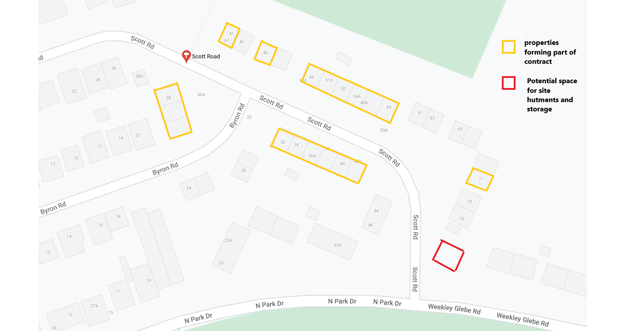

Appendix 3 site plan.

Appendix 4 Conditions of JCT standard form of Contract.

These to be completed in the JCT standard form of contract. The tenderer shall ensure they have read these terms as it may affect the price.

RECITALS

First | Roof refurbishment and associated works  at  block 49 – 59A Scott Road, Kettering.
Second | Roofs details as set out in the specification document, and including the details and materials specified.
Third | The whole of this specification including the works as included, the materials as specified and the conditions of contracting as included in the Specification document.
Fourth | The Contractor has supplied the Employer with a copy of the priced Specification.
Fifth | For the purposes of the Construction Industry Scheme (CIS) under the Finance Act 2004, the status of the Employer is, as at the Base Date that is stated in the Contract Particulars.
Sixth | For the purposes of the Construction (Design and Management) Regulations 2015 (the CDM Regulations).the status of the project that comprises or includes the Works is stated in the Contract Particulars.
Seventh | The Contract is not supplemented by a Framework Agreement.
Eighth | Whether any of the Supplemental Provisions 1 to 6 apply is stated in the Contract Particulars.

ARTICLES

Article 1  Contractors obligations | The Contractor shall carry out and complete all of the works in accordance with the Contract Documents.
Article 2  Contract Sum | (to be determined)
Article 3  Architect/Contract Administrator | Mr Daniel Hannam (Interim Strategic Lead for Housing Property Services) or whomever he so chooses to appoint , of North Northamptonshire Council.
Article 4  Principal Designer | The Principal Designer for the purposes of the CDM Regulations is the Contractor.
Article 5  Principal Contractor | The Principal Contractor for the purpose of the CDM Regulations is the Contractor.
Article 6  Adjudication | If any dispute or difference arises under the Contract either Party may refer it to adjudication in accordance with clause 7.2
Article 7  Arbitration | Where Article 7 applies, then subject to Article 6 and the exceptions set out below, any dispute or difference between the Parties of any kind whatsoever arising out of or in connection with this Contract shall be referred to arbitration in accordance with Schedule 1 and the JCT2016 edition of the Construction Industry Model Arbitration Rules (CIMAR). The exception to this are Articles 7 are:  Any disputes or differences arising under or in respect of the Construction Industry Scheme or VAT to the extent that legislation provides another method of resolving such disputes or differences: and  Any disputes or differences in connection with the enforcement if any decision of an Adjudicator.
Article 8  Legal Proceedings. | Subject to Article 6 and (where it applies) to Article 7, the English courts shall have jurisdiction over any dispute or difference between the Parties which arises out of the connection with the Contract.

Contract Particulars

Fifth Recital and Schedule 2 | Base date. Date of this agreement.
Fifth Recital and clause 4.2 | Construction Industry Scheme (CIS). Employer at the Base Date is not a ‘contractor’ for the purpose of the CIS
Sixth Recital | CDM Regulations. The project is notifiable.
Eighth Recital and Schedule 3 | Supplemental Provisions (where neither entry against one Supplemental Provision 1 to 6 below is deleted, that Supplemental Provision applies).  Supplemental Provision 1. Collaborative Working applies.  Supplemental Provision 2. Health and Safety  applies  Supplemental Provision 3. Cot saving and value improvements  applies  Supplemental Provision 4. Sustainable development and environmental considerations  applies  Supplemental Provision 5. Performance Indicators and monitoring  applies  Supplemental Provision 6. Notification and negotiation of disputes  applies  Where Supplemental Provision 6 applies, the respective nominees of the Parties are Employer’s nominee
Article 7 | Arbitration  Article 7 and Schedule 1 (arbitration), apply.
2.3 | Works commencement date  (four weeks after the tender return date).  Date of Completion  31 March 2023  Or such later date for completion as fixed under clause 2.8
2.9 | Liquidated damages at the rate of £101 per week.
2.11 | Rectification Period  12 months from the date of practical completion.
4.3 | The first interim Valuation Date is one month after the Works commencement date and thereafter at intervals of one month.  Payments due prior to practical completion will be at the rate 95%  Payments due after practical completion 97.5
4.3 and 4.8 | No fluctuations provision applies.
4.8.1 | The supply of documentation for computation of the amount to be certified will be 1 month from the date of Practical Completion.
5.3 | Contractors Public Liability Insurance not less than £10 million for any one occurrence or series of occurrences arising out of one event.
5.4, 5.5 and 5.6 | Clause 5.4 (Works insurance by Contractor in Joint Names) applies.
7.2 | Adjudication.
Schedule 1 (paragraph 2.1) | Arbitration – President or Vice President:  The Royal Institution of Chartered Surveyors.

Appendix 5 Risk Assessment

The enclosed risk assessment has been prepared as part of the design and is a minimum requirement of the Construction (Design and Management) Regulations as a Client responsibility.

This risk assessment is to be developed by the Contractor as part of the works and the results shall be included in the Health and Safety file. The developed risk assessments and method statements associated with it will be produced prior to commencement on site, in line with the CDM regulations.

Risk Level Quantification

Use these tables to help you determine the Risk Level presented by each Hazard identified.

Probability of Occurrence

So unlikely that probability is close to zero | A
Unlikely to occur, though conceivable | B
Likely to occur sometime | C
Occurrence not surprising. May occur more than once | D
Occurrence inevitable. May occur many times | E

Potential Maximum Consequence (Hazard Severity)

Minor injury/illness resulting in lost time of 3 days or less | 1
Injury/illness causing lost time more than 3 days | 2
Major injury/illness to one or more persons not causing permanent disability | 3
Single fatality or single /multiple permanent disability | 4
Multiply fatality | 5

Risk Level Matrix

Hazard Severity Index | Probability Index
 | A | B | C | D | E
1 | N | N | A | H | H
2 | N | A | H | H | H
3 | N | A | H | S | S
4 | A | H | S | S | S
5 | A | F | S | S | S

Risk Level | Description | Action by Designer
N | Negligible | None
A | Acceptable | Check that risks cannot be further reduced by simple design changes
H | High | Amend design to reduce risk or seek alternative option. Only accept option if justifiable on other grounds. Record actions on Record of Designers Actions to Reduce Risk form
S | Severe

 | Roofing at Scott Road |  |  |  | October 2022
 | Preliminary design risk assessment. |  |  |  | Prepared by N. Marsden on behalf of North Northants Council
 |  | P | S | R |  | P | S | R
Ref | Hazard |  |  |  | Designers Actions
1.0 | Falling from roofs. | C | 4 | S | Insist within the contract documents that safe access is provided. | A | 4 | H
1.1 | Scaffold is unsafe to use. | C | 4 | S | Insist within the contract documents that ‘scaff tags’ are provided so that operatives can check before going on a scaffold. | A | 4 | H
1.2 | Access to dangerous areas under the scaffold. | C | 2 | H | Insist that scaffolds are fenced in with heras fencing to reduce likelihood of accidents | A | 2 | N
1.3 | Access to property under scaffolds could be dangerous | C | 2 | H | Insist on boarding over such access points and polythene to reduce dust in eyes. | A | 2 | N
1.4 | Throwing down brickwork and other roofing materials during demolition and stripping back | D | 3 | S | Use of chutes suggested in the specification but scaffolds must be constructed to support them properly | B | 3 | A
1.5 | High level works to gable ends could cause dangers to persons walking below. | D | 4 | S | Require paths to be blocked up and Heras fencing during gable end rebuilding works. | A | 4 | A
2.0 | Works within the loft could lead to falling through top floor flat ceiling. | C | 3 | H | Contractor required to assist tenant to remove belongings and the strip back insulation to then provide proper support. | A | 3 | N
3.0 | Mortar dropping onto persons walking under scaffolds whilst work is in progress. | D | 1 | H | Design excludes the use of wet trades to avoid issue. | A | 1 | N
3.1 | Mortar dropping onto persons in the vicinity of the gable ends to be rebuilt. | D | 1 | H | Design requires the contractor to block nearby paths temporarily to dissuade persons from walking nearby. | B | 1 | N
4.0 | The current roofs are subject to movement, which is causing the roofs to push the gable ends out of place. | C | 4 | S | Bracing and strapping of the roofs, along with secret gutters to allow the roof to expand in hot weather will reduce the movement of gable ends. | A | 4 | A
4.1 | The current roofs are not protected from the passage of fire over the firewalls. | C | 4 | S | Installation of Roof Defence and fire barriers in the soffit box are to be installed. | A | 4 | A

Appendix 6 Details of the tender evaluation process.

To be fair and reasonable to the tenderer, this Appendix is designed to illustrate how the tender return will be evaluated.

The evaluation will include the following aspects.
Items | Description | Measurement | Percentage of total evaluation
Membership of relevant organisations. | The tenderer shall indicate within the tender the membership | The potential appointed contractors’ membership will be checked by the evaluation team for actual current membership of  National Federation of Roofing Contractors.  National Inspection Council for Electrical Installation Contracting  Confederation of Aerial Industries trade associations. | Non- membership means no evaluation the tenderer does not meet the minimum criteria for the works.
Tender Price | The lowest tender receiving the best score. | The lowest tender sum will be given the 60% figure and then each subsequent lower tenderer will be given a percentage based upon the formula.  (Lowest tender ÷ tendered sum), x 60% | 60% Maximum
Appendix 2 prices | The employer will draw up a realistic list of potential unforeseen works quantities (based upon previous experience), and multiply the sums given in Appendix 2 by the tenderer | The lowest appendix sum will be given the 20% figure and then each subsequent lower tenderer will be given a percentage based upon the formula.  (Lowest tender ÷ tendered sum), x 20% | 20% Maximum
Materials used. | Where the tenderer chooses to use an alternative material to that specified.  Section 11 of the main document offers the opportunity to offer alternative products that will improve the quality of the finished products. | Using all materials specified will gain 10%  Using an alternative material which is approved (plus 5% per material, up to 10% max addition)  Using an alternative material which is not approved by the evaluation team (minus 5% per material, down to 10% max deduction). | 20% Maximum

Appendix 7 Information obtained concerning asbestos

The following information has been retrieved from the Employers Asbestos Management computer systems.
The Contractor is required to keep this information secure at all times and not to relate it to any other party that is not involved in this contract.
The information shall not be related to tenants or private owners and the contractor is to ensure that such persons are excluded from sight of such documentation.
More information will be made available when it becomes available, however, for tendering purposes and undisclosed asbestos found and not included in the information available at tender stage, will be treated as newly discovered or unforeseen for the purpose of this contract.
The asbestos management reports that will be made available to the tenderer are to be sent to the contractor before works commence.

Appendix 8 Calculation to determine loss to the Employer for none completion by the appointed contractor (liquidated damages).
There may be instances where the appointed contractor does not complete the works within the designated contract period and the Employer then claims back any loss or expense for the extension of the Contract period.
Below are given reasons for each element of the claim to ensure that the claim is viable and is agreed with the appointed contractor before the signing of the Contract.
Loss will be calculated on a weekly basis, and late completion shall be measured in whole weeks (not pro-rata). This is agreed in the acceptance of the contract.

- Loss of revenue (rent). There is no loss, as rents will still be charged for old or new roofs to the existing structures.
- Loss related to site establishment. There is negligible loss to the general amenity if the contractors compound remains on site for longer than anticipated.
- Loss of costs related to additional site administration. There will need to be additional site visits by the Contract Administrator to manage the extended Contract.
Professional Surveyor costs per week (including mileage allowance) for a member of staff to act as Contract Administrator.
£49,000 per annum average gross costs.
Approximately working 2000 hrs per annum.
Anticipated visits of 1 hour, twice a week, for each additional week to undertake inspections. Additional administration 1 hour per week
Cost (£49000/year ÷ 2000hrs/year) x 3hrs/week = £73.50 per week
Team leader cost per week for a senior member of staff to offer support and advice to the appointed Contract Administrator, and to prepare reports and alter budgets related to the delay.
£55,000 per annum average gross costs
Approximately working 2000 hrs per annum
Anticipated 1 hour per week administrative time.
Cost (£55,000/year ÷ 2000hrs/year) x 1hr/week = £27.50 per week

Total liquidated damages loss. £101.00 per week.

