Tender 1 Diagram – Football Pitch Markings
Leicester Road
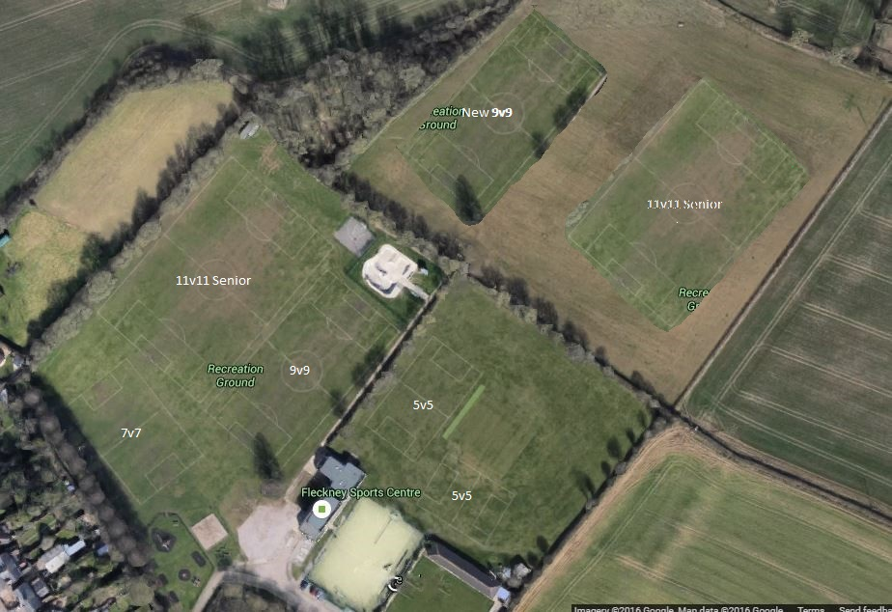

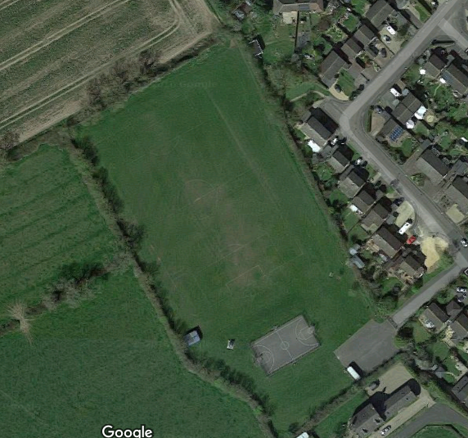
Lodge Rd Marking

