

**REQUEST FOR INFORMATION:**

**CAPABILITY ENHANCEMENTS FOR SONAR 2087**

**Reference: RFI0019**

**October 2022**

**RFI Title:** Capability Enhancements for Sonar 2087

**Issue Date:** 24 Oct 2022

**Reference:** RFI0019

**Version:** 1.0

Contents

1. Introduction 3

2. Background 3

3. RFI intended outcomes 3

4. Spearhead Process. 4

5. Requested Information: 5

6. How to submit responses to this RFI 6

7. RFI Procedure: 7

8. Confidentiality & Proprietary Information 7

9. Costs of preparing your RFI response 8

10. Contact 8

Annex A: 9

Annex B: 13

# Introduction

The Spearhead innovation initiative provides a way of testing new concepts at reasonable scale and inserting capability into existing systems at pace. This initiative seeks to combine emerging technological solutions with innovative acquisition practices to solve real-world military problems much more quickly than traditional processes would allow. It offers the prospect of transformational capability enhancement. The vision statement for the portfolio is: *More risk – Greater reward. Our focus is the purpose of the portfolio, not the process that enables it.*

The vision statement for Spearhead Capability Insertion Project (CIP) for Sonar 2087 (S2087) is:

“*S2087 Capability insertion shall deliver the RN’s key surface ASW sensor for the T23 FFTA. S2087 shall provide persistent operational advantage in the North Atlantic against peer/near peer capability until at least the mid-2030s. It shall furthermore deliver the persistent ASW sensor to the MTG and shall support pervasive awareness particularly in the North Atlantic through interoperability with other sensing platforms/units and C2 nodes. S2087 Capability insertion will support persistent detection and cuing and combined arms prosecution. It should deliver a Human Computer Interface (HCI) that is intuitive to operators of all levels of experience and supports maximum flexibility of manning through use of appropriate stimuli to alert watch standers of fleeting SM contacts*”.

# Background

Sonar 2087 is a Low Frequency Active (LFA) and passive Variable Depth Sonar (VDS), in service in the RN Type 23 Frigates. The Ministry of Defence (The “Authority”) is currently seeking information about options that are available as potential capability upgrades/insertions for Sonar 2087.

The Authority intends to use the responses to this Request for Information (“RFI”) to inform future decision making regarding the potential supply of capability enhancements to Sonar 2087. For clarity, this RFI is not a bidding opportunity but a means by which industry can provide information to the Authority to inform the Spearhead Technology Demonstration Programme (TDP). The Authority makes no obligations or undertakings in any way to:

1. Invite tenders for the capability which is the subject of this RFI.
2. Accept any RFI information received from suppliers.
3. Include suppliers responding to this RFI in any future tender invitation.
4. Make any other commitment to respondents whatsoever, including any intention to form a contract with any respondent for provision of the capability.

# RFI intended outcomes

This RFI aims to gather a list of candidate proposals that may be suitable for technology demonstrations within the Spearhead timeframe (2021-2026) which could collectively and/or individually be capable of delivering the following six (6) Spearhead benefits:

1. Increased lethality of ASW platforms and associated effectors.
2. Improved detection, tracking, prosecution and networking of sensors and platforms.
3. Improved shared awareness of maritime platforms delivering ASW
4. Improved data handling and analysis.
5. Transforming defence acquisition by delivering increased capability to the front line as soon as equipment becomes available.
6. Improved UK Prosperity by promoting defence exports

# Spearhead Process.

Capability Assessment (Step 1) – this process has been conducted by NCHQ.

Brief industry and collect RFI submissions (Step 2a): An Industry Day will be held to brief on the Spearhead process and provide opportunities for industry/academia to participate. The date and venue for this event will be published in due course (currently expected to be 5th December 2022 at HMS Collingwood, Gosport, but may be subject to change). A list of S2087 Capability Insertion Requirements is available on request. The S2087 Capability Insertion Requirements are classified Official-Sensitive so can only be released to those that can provide evidence of their ability to handle this information – access to these is not required to submit a response to the RFI and this RFI document contains enough context to allow those unable to access them to determine if their solutions may be in scope.

Review of RFI submissions (Step 2b): Following the Industry briefing day all submissions will be grouped into 7 technology areas and reviewed by a Military Judgement Panel (MJP). A summary of the process (which includes the technology areas) is show below in Fig 1. A response will be provided to all respondents stating if the submission was excluded or selected for either Pool A or Pool B, but no feedback will be provided on submissions. Multiple submissions from multiple suppliers may be considered for the same technology area. The process for assessment of RFI responses is shown in Fig 1 below. Selection into Pool A does not imply exclusivity to the supplier or any commitment to proceed to demonstration at this stage.

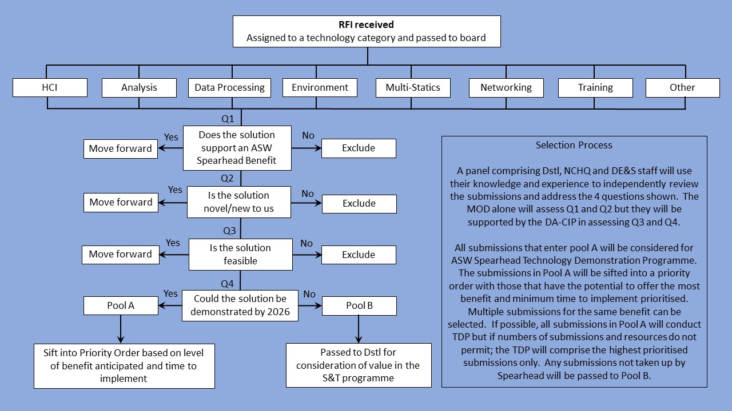

Figure - RFI response assessment process

Technology Demonstration Programme (TDP) Scheduling (Step 3): Submissions selected for pool A will be prioritised and scheduled for a demonstration event (not all demonstrations will be at sea). Funding is available to support submissions that are selected for TDP.

TDP Design (Step 4): Submissions that are scheduled for the TDP will be invited to engage with the S2087 Design Authority for the Capability Insertion Project (DA-CIP) to develop an architecture design for a demonstration. The set of architecture documents will then be submitted by the S2087 Design Authority to the relevant MOD authorities for scrutiny and approval to proceed to demonstration. It is not until the MOD authorities have approved the architecture description for trial that any commitment will be made to proceed to demonstration.

Technology Demonstration (Step 5): When a submission has been selected for demonstration the supplier will be informed of the timeframe and invited to develop a product and trials order with the S2087 DA-CIP. When the trials order has been approved and system assured, the demonstration will be conducted and all data in the trials order collected for submission to the Military Judgement Panel (MJP).

Performance Review (Step 6): The collated TDP performance data will be submitted to the Military Judgement Panel (MJP) for review and the capability benefits will be assessed by the MJP against a set of Key Capability Requirements (KCR). The S2087 KCRs are classified but will be made available to TDP participants when selected at step 3 above (providing the TDP participants have suitable clearances and handling facilities). Feedback on the MJP assessment of a particular candidate will not be made to the supplier as this could prejudice any subsequent procurement action.

Procurement (Step 7): Once the Technology Demonstrator Programme (steps 3-6 above) has delivered performance data for a particular capability requirement to the MJP the merits of procurement action will be assessed against the impact on the Spearhead benefits. If it is decided to proceed to procurement this will be conducted in accordance with MOD procurement guidelines and regulations by separate commercial activity. Proposals in response to procurement action are not necessarily constrained to TDP participants only.

# Requested Information:

The Authority wishes to assess candidate proposals that could be integrated with (or in) S2087 for use by the Royal Navy to deliver the Spearhead benefits set out in para 3 above.

Potential suppliers and interested parties are invited to provide information in relation to all/any candidate proposals for potential inclusion in the Spearhead TDP. Candidate proposals do not need to be established products to be considered for further investigation. Technology under development is of interest but would be expected to be at least at Technology Readiness Level (TRL) 5 or above and be capable of being developed into a product within the timeframe of the Spearhead CIP. Technology areas of interest (see also Fig 1) include, but are not limited to:

1. Improvements to the HCI to enable operators to handle multiple contact data (including from multiple sources) to manage a future integrated (complex) UW picture.
2. Introduction of near real-time analysis to improve classification in a networked environment.
3. Exploiting emergent processing techniques and waveforms to enhance detection and tracking performance, particularly against fleeting (non-continuous signatures) and low doppler contacts.
4. Introducing real time environmental exploitation to optimise sensor performance.
5. Exploiting multi-static operations with coalition units (including remote and un-crewed vessels) to improve detection performance.
6. Introducing data exchange with ASW Data Network Architecture to extend reach of ASW surveillance.
7. Upgrade and improve training solution for all users to maintain SQEP whilst deployed and engaged on other tasking (A Training Needs Analysis is currently underway and proposals to deliver training solutions will be considered by the Training Steering Group in due course).

Notwithstanding the above, we would welcome all/any innovative submissions from respondents to include:

1. Readily available solutions
2. Improvements to Availability, Reliability and Maintainability
3. Any solutions which may offer reduced (more efficient) human workload.
4. Any solutions which may offer improved detection and localization of fleeting targets.
5. Technologies which are not yet, but could be, adapted for use in the maritime underwater environment.

# How to submit responses to this RFI

To register for the industry day please submit Annex B to the email in section 10, the deadline for industry day registration is 12:00 Friday November 18th 2022. The day will be limited to OFFICIAL.

Due to the anticipated volume of interest we may only accept 1 registration per company. If the level of interest exceeds our venue capacity we will random draw the attendees from those who register. In support of the Defence SME action plan we will be guaranteeing at least 40% of the available spaces to SMEs, this will be reflected in the random draw process should one be needed.

A summary of any relevant Q&A that may benefit the wider market the occurs in the run up to the industry day or on the day will be published between the event and the RFI submission deadline below.

Respondents should provide responses in accordance with the format provided in **Annex A,** every response should include the cover sheet however respondents only need to fill out the ‘Response’ (1 to 3) based on the appropriate timeline at the top.

We will accept responses to the RFI before the industry day, but we suggest waiting until afterwards as relevant information may come out of the day.

Once completed, please return electronically to the e-mail address shown below in **section 10,** no later than **12:00 Friday 6th January 2023.**

Responses will be acknowledged electronically by return e-mail.

# RFI Procedure:

Responses to this RFI will be reviewed by subject matter experts from various functional areas within the Authority (including Navy Command Headquarters, Dstl, DE&S and the S2087 Design Authority for S2087 CIP). See Fig 1 above.

Any details provided in response to this RFI will be used for information purposes only and will not be used to determine the potential Suppliers who may be invited to bid, should the Authority proceed to tender. Multiple responses can be submitted by each supplier.

The results and analysis of this RFI and subsequent TDP shall not constitute any form of pre-qualification exercise. In order to avoid prejudice to any future procurement activities, no feedback will be provided to suppliers on the scrutiny of submissions or findings of the TDP.

Any future procurements relating to this requirement will follow standard UK Government procurement policy and procedures.

Nothing in this RFI, or any other engagements with Industry prior to a formal procurement process, shall be construed as a representation as to the Authority’s ultimate decision in relation to the future requirement.

# Confidentiality & Proprietary Information

No information included in your response, or in discussions connected to it, will be disclosed to any third party other than those specified in 7 above (this panel includes Thales UK as DA-CIP but this entity will be required to sign a non-disclosure agreement with the MOD).

If you choose to include propriety or commercially-sensitive information in your response, you should keep this to a minimum and you must mark it clearly. In the event that you do include propriety or commercially-sensitive information this will be seen by the MOD review panel but redacted before your response is shared with the DA-CIP (Thales UK) who will be advising the panel on assessment questions 3 and 4 only (in fig 1).

If selected for the Spearhead TDP (as described in para 4, steps 4-5 above) candidate suppliers will be invited to declare existing IP (under DEFCON 632) with all deliverables for the TDP (Demo System Integration Design, interfaces, assurance evidence and trails data) provided to the authority under DEFCON 705 (limited rights). If procurement (step 7) is commenced, this will conducted by separate commercial activity and DEFCON provisions for such activity will be promulgated as part of the procurement process.

The Design Authority for the S2087 Capability Insertion Project (DA-CIP) is Thales UK Ltd and this body will be required to demonstrate evidence that it will remain separated from Thales UK Ltd as a potential supplier to the TDP. The S2087 DA-CIP must not be involved in any tender process or supporting any party involved in the TDP or tender processes.

# Costs of preparing your RFI response

Any costs relating to the preparation and submission of a response to this RFI are the sole responsibility of the respondent.

# Contact

Please submit i) any requests for clarification and ii) all responses to this RFI including industry day registration, to:

NAVYCOMRCL-RFI@mod.gov.uk

## Annex A:

Capability Enhancements to Sonar 2087 – RFI Response:

Cover Sheet

|  |  |
| --- | --- |
| **Required:** | **Response** |
| Company Name |  |
| Company Address |  |
|  | |
| Name of Company representative completing the RFI |  |
| Contact details (e-mail and telephone number) |  |
| Company web site address |  |
|  | |
| Main products/services/line of business |  |
| Main market sector |  |
| Number of years in this market sector |  |
| Ability to deliver classified projects |  |

|  |
| --- |
| **RESPONSE:** |
| 1. Technical Solution(s) available for demonstration now: |
| (Note: We recommend a response of up to 2-3 pages for each solution):  Please Indicate:   1. Description of the anticipated benefit: 2. Description of proposal: 3. Technology / Manufacturing Readiness Level of the Solution & description of testing completed to date: 4. Anticipated integration route (how do you anticipate your option could be integrated) 5. Further Information / Solution assumptions, dependencies, exclusions and constraints: 6. Link to product catalogue (if applicable): |
| **RESPONSE:** |
| 1. Technical solution(s) which could potentially be available within 12-24 months: |
| (Note: We recommend a response of up to 2-3 pages for each solution):  Please Indicate:   1. Description of the anticipated benefit: 2. Description of proposal: 3. Technology / Manufacturing Readiness Level of the Solution & description of testing completed to date: 4. Anticipated integration route (how do you anticipate your proposal could be integrated): 5. Further Information / Solution assumptions, dependencies, exclusions and constraints: 6. Link to product catalogue (if applicable): |
| **RESPONSE:** |
| 1. Technical solution(s) which could potentially be available within 24 months to 5 years: |
| (Note: We recommend a response of up to 2-3 pages for each solution):  Please Indicate:   1. Description of the anticipated benefit: 2. Description of proposal: 3. Technology / Manufacturing Readiness Level of the Solution & description of testing completed to date: 4. Anticipated integration route (how do you anticipate your proposal could be integrated): 5. Further Information / Solution assumptions, dependencies, exclusions and constraints: 6. Link to product catalogue (if applicable): |
| **Innovative solutions are most welcome, even if they do not meet all of the indicative requirements.** |

## Annex B:

Industry day registration;

(Formatted for administration purposes, please use this layout)

|  |  |  |
| --- | --- | --- |
| Company | Company website | Are you an SME? |
|  |  |  |

|  |  |  |  |  |
| --- | --- | --- | --- | --- |
| Name of company representative | Email | Phone number | Nationality | Vehicle make, model, colour  and registration number  (or Taxi company/arrival time) |
|  |  |  |  |  |

Note: there is no Nationality requirement for this event as it is limited to OFFICIAL, however our security team may need additional details from non-British Nationals – we will be in touch if more details are needed.