**WOKINHAM WITHOUT PARISH COUNCIL**

**Pinewood Allotment Fencing Specification**

**March 2021**

**Purpose**

* To replace existing allotment perimeter fencing within the grounds of Pinewood Leisure Centre, Old Wokingham Road, Wokingham RG40 3AQ.

**Fencing Specification**

* Remove and dispose of existing chicken / rabbit wire fencing and wooden posts in sections (to maintain overnight security against pedestrians, deer / rabbits).
* Supply and install 290 m of green 2m high wire mesh profiled panel 5/5 mm, mesh size 50 x 200 mm on 40*40 *3 mm galvanized and power coated steel posts whilst retaining the existing pedestrian gate.
* Supply and install 290 m1050 mm rabbit fencing, laid in a trench to a depth > 150mm and clipped to the inside of the wire mesh fencing.

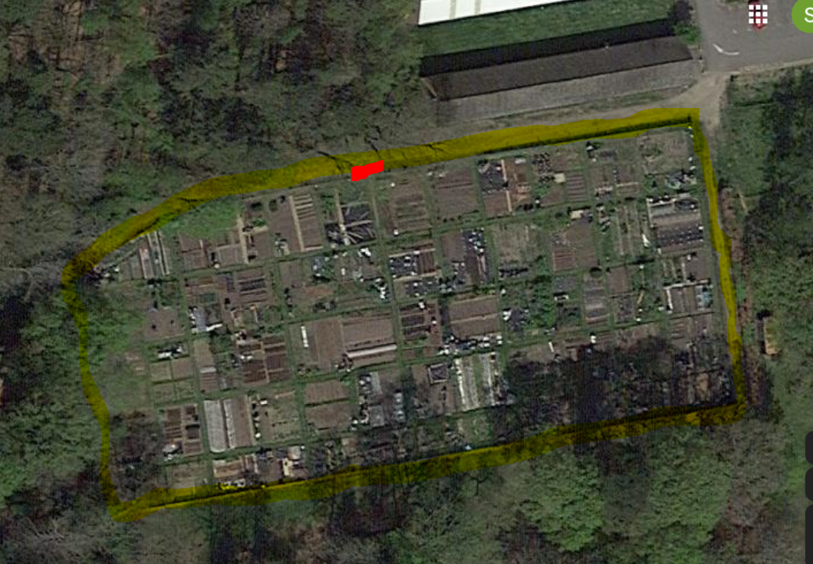

**Satellite image of site**

Yellow highlight is the fence line, red is location of pedestrian gate, blue rectangle is the buried water supply pipe.

**Pictures of site**

NE corner looking west SE corner looking north

SE corner looking west SW corner looking east

SW corner looking north NW corner looking NNE

NW edge looking east NW edge pedestrian gate

**Proposed Fencing Style**

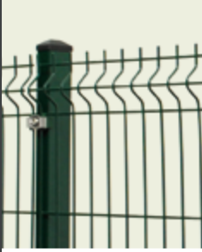

**Statutory Undertakers**

* Electrical Services. A copy of the Pinewood electric schematics is attached, showing the approximate location of the power supplies near the allotment site. Whilst we are not aware of other power supplies in the proximity of the allotments, this site previously operated as a hospital and we cannot guarantee there are no other utilities within the area. As such, all necessary precautions should be taken to check for the existence of utilities and this should be included within the quotation, in line with guidance from the Health and Safety Executive ‘Avoiding danger from underground services’ : https://www.hse.gov.uk/pubns/priced/hsg47.pdf )
* The water supply pipe for the allotments is located as shown on the above diagram

**Additional Information:**

* If successful, you will be required to provide RAMS.
* Please include a copy of your public liability insurance with your quote.
* Please provide details of a reference with your quote.
* Please provide expected duration of works with your quote.
* Funding, and thus timing, is dependent on obtaining a grant from existing S106 money from our local authority.

Please submit your quotation, along with a copy of your public liability insurance and details of a reference, to Wokingham Without Parish Council **by 9.00am on Wednesday 31 March 2021.**