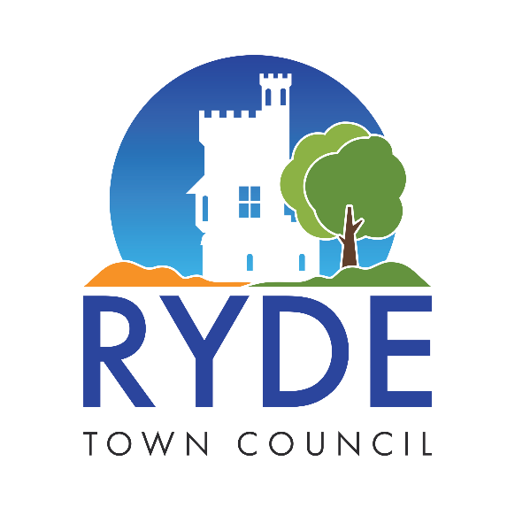

Appendix 3
Pricing schedule / bills of quantities
Checklist

Section 1  RYDE TOWN COUNCIL –  ST Thomas’ Church-Stained Glass & Leaded Light Conservation | Description | Quantity | Unit | Rate (£) | Additional information | Total Cost (£) per annum
Overall cost (£) for Section

GRAND TOTAL FOR THE SUPPLY, ERECTION, INSTALLATION, MAINTENANCE AND REMOVAL OF DECORATIVE LIGHTING/ MOTIFS AND CHRISTMAS DISPLAYS CONTRACT. | £

