T LEVELS QUALIFICATION PROCUREMENT MARKET ENGAGEMENT EVENTS
TIME: 10.00am -5.00pm
DATE: Monday 11th June and Thursday 14th June
VENUE: The morning plenary session will be held at ETC venues, One Drummond Gate, Victoria, London SW1V 2QQ
VENUE: The interviews will be held in Sanctuary Buildings, Great Smith Street SW1P 3BT
To book a place at one of these days, please email procurementlicensing.team@education.gov.uk with the following information:
a. Organisation name;
b. Attendees (max of 1 supplier representative for the plenary session and 2 for the one to one session)
c. Contact details
Each event will comprise two sessions:
Session 1: The morning session will be a plenary session at which representatives from the contracting authority will provide detailed information about the scope of the services and how they will be commissioned; information about regulation and approvals; and information about the procurement process envisaged.
Session 2: 16 spaces are available each day for interviews with individual suppliers/trade associations. Allocation of these slots will be on a first come first served basis and will be limited to 1 slot per supplier organisation. Interested parties are therefore encouraged to register for the event at the earliest opportunity.
Interested suppliers will be provided with further information about the day and supporting notes, which will be made available to all those unable to attend via the virtual data room at https://education.bravosolution.co.uk/web/ login.shtml.
Please note: The Virtual Data Room will be accessible on 29th May 2018.

INSTRUCTIONS FOR LOGGING INTO BRAVO AND VDR
First of all, log into the Bravo use this link
https://education.bravosolution.co.uk/web/login.shtml
When logging into Bravo your home screen should look like the screen shot below.
Virtual Data Room is actually a file sharing functionality in Bravo.
To access click on either “Projects or Invitation to Tender”
Access through Bravo
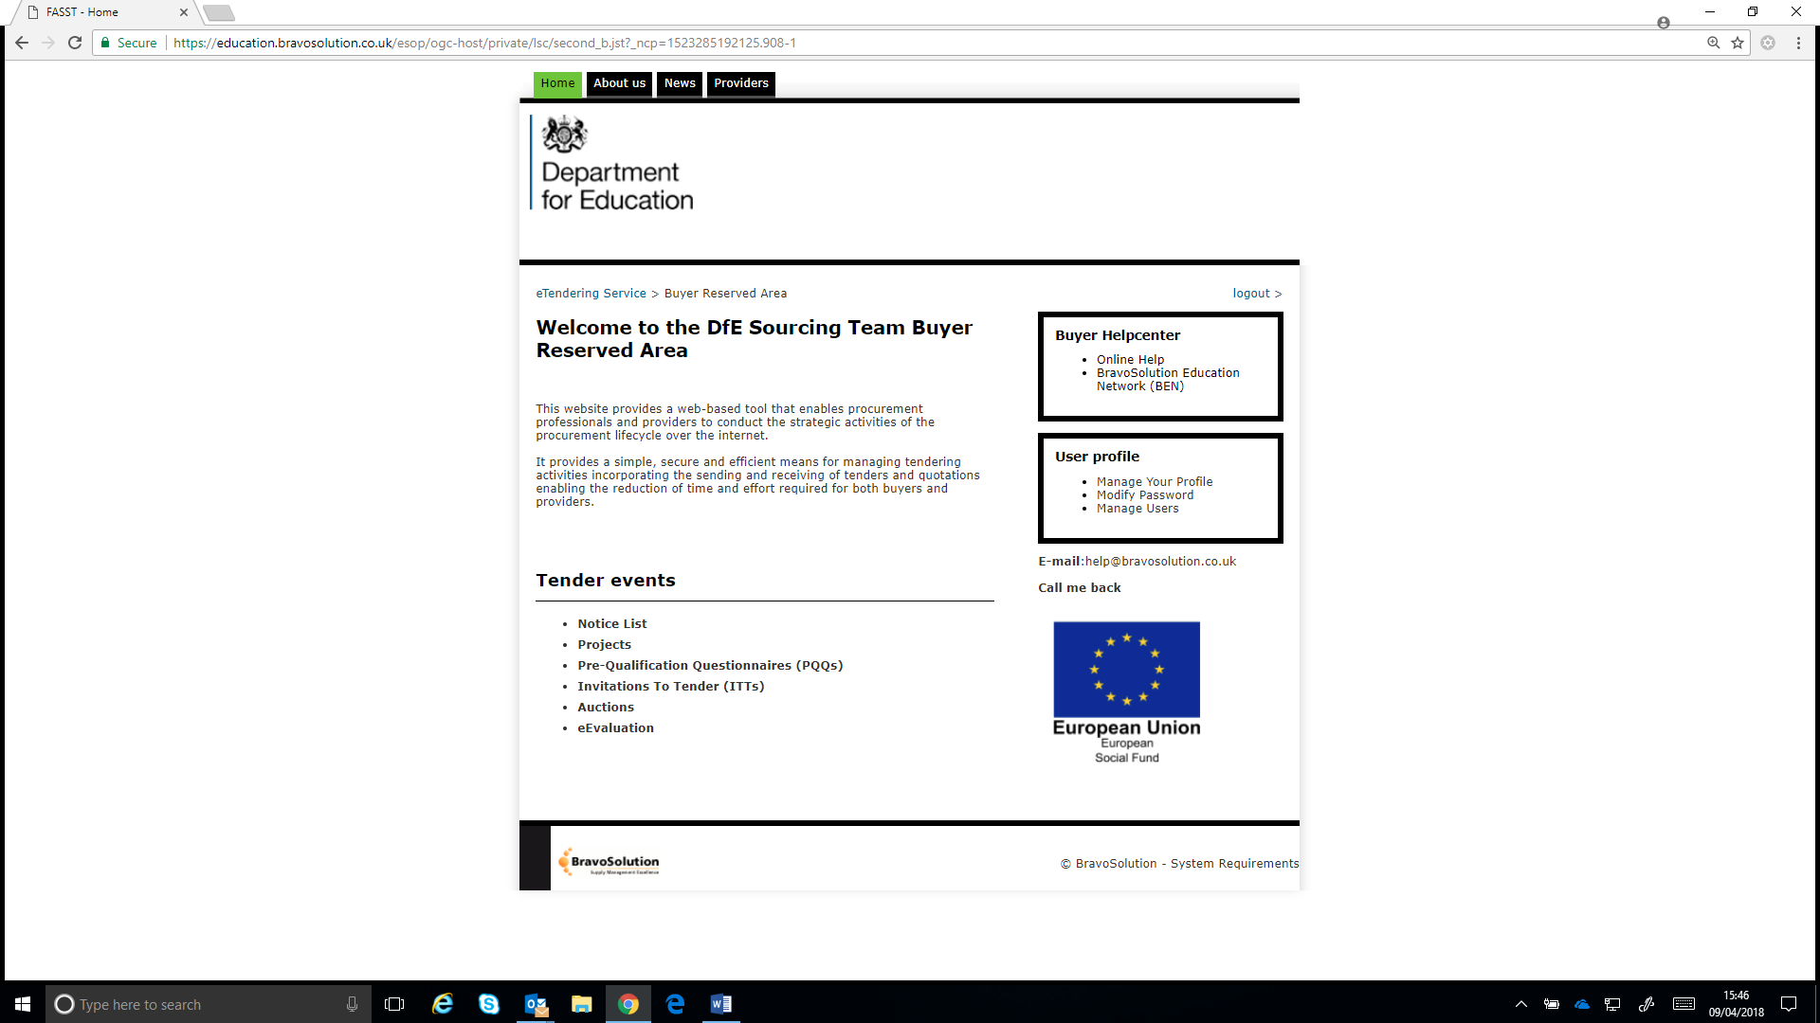

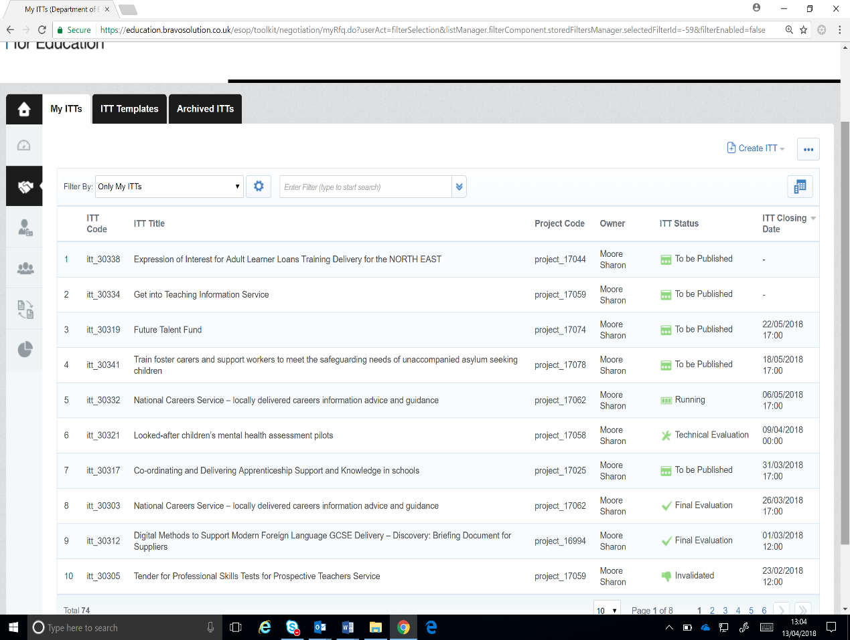
Select the file sharing icon from the options on the left hand side [6th one down]
Files > Directories will bring you to the following screen.
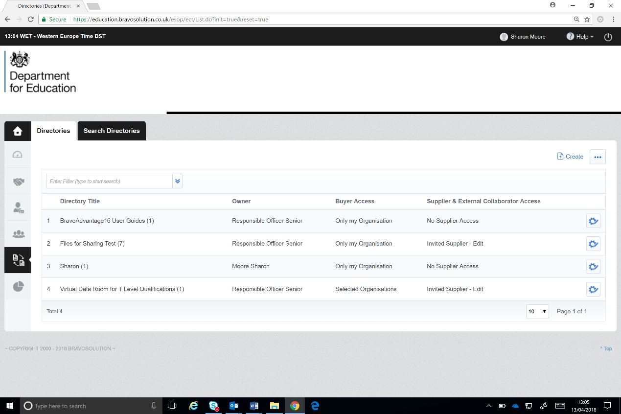
You will see only one directory title in your list “Virtual Data room for T level qualifications”

