Request for Bids for Engagement Activities with Patients Receiving Healthcare in West Midlands Prisons
Background
The Health and Justice Commissioning team working across the West Midlands region is responsible for the commissioning, including contract management and clinical quality assurance, a range of health services within the justice system including 12 Prisons. The health services commissioned in these establishments includes primary care (nursing, medical, podiatry, dental, optometry, physiotherapy, health promotion and prevention and sexual health), mental health (primary and secondary care), substance misuse (clinical and psychological therapies) and medicines management.
The table below provides information about the 12 establishments:
Establishment | Area | Information about this establishment
HMP Birmingham | Birmingham | https://www.justice.gov.uk/contacts/prison-finder/birmingham
HMPYOI Brinsford | Staffordshire | https://www.justice.gov.uk/contacts/prison-finder/brinsford
HMP Dovegate | Staffordshire | https://www.justice.gov.uk/contacts/prison-finder/dovegate
HMP Drake Hall | Staffordshire | https://www.justice.gov.uk/contacts/prison-finder/drake-hall
HMP Featherstone | Staffordshire | https://www.justice.gov.uk/contacts/prison-finder/featherstone
HMP Hewell | Worcestershire | https://www.justice.gov.uk/contacts/prison-finder/hewell
HMP Long Lartin | Worcestershire | https://www.justice.gov.uk/contacts/prison-finder/long-lartin
HMP Oakwood | Staffordshire | http://www.justice.gov.uk/contacts/prison-finder/hmp-oakwood
HMP Stafford | Staffordshire | https://www.justice.gov.uk/contacts/prison-finder/stafford
HMPYOI Stoke Heath | Shropshire | https://www.justice.gov.uk/contacts/prison-finder/stoke-heath
HMPYOI Swinfen Hall | Staffordshire | https://www.justice.gov.uk/contacts/prison-finder/swinfen-hall
HMPYOI Werrington | Staffordshire | https://www.justice.gov.uk/contacts/prison-finder/werrington

NHS England Health and Justice services are commissioned to the ‘principle of community equivalence’ which means that those detained within secure settings receive as a minimum the same range and standard of health services as that offered to the rest of the population.
Patient Engagement in the Health and Justice Service
There is a duty for all NHS Commissioners to engage with patients when planning and commissioning services. The legal duty relating to the commissioning of NHS England Health and Justice Services is set out in Section 13Q of the National Health Service Act 2006 (amended by the Health and Social Care Act 2012). This requires that patients are involved in the:
- Planning of commissioning arrangements.
- Development and consideration of proposals for changes in the commissioning arrangements.
- Decisions affecting the operation of commissioning arrangements.
These requirements can be mapped against the commissioning cycle below:
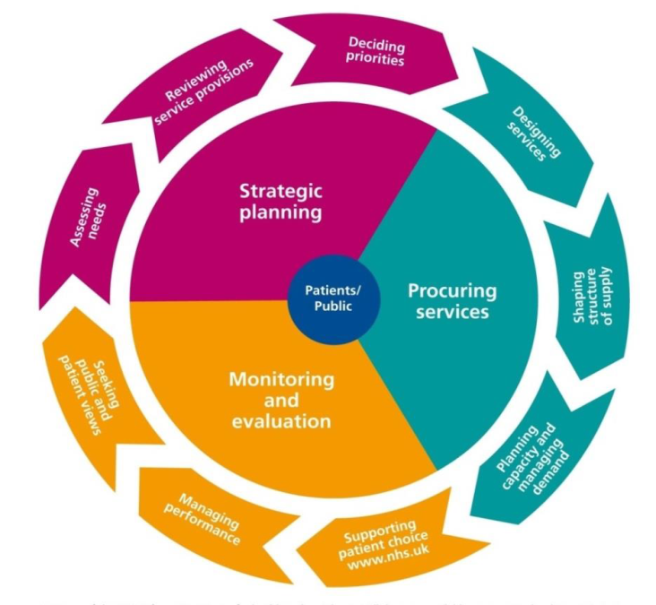

Further information about the patients and public involvement in the Health and Justice Service is available from:
https://www.england.nhs.uk/publication/framework-for-patient-and-public-participation-in-health-and-justice-commissioning/
Where patients are effectively involved in the planning, procurement and monitoring of health services this results in services that are better at meeting the needs of the patients and improved patient experience.
It is important to recognise that the duty on NHS England Commissioners to engage with patients is separate from the duty of providers to engage with patients.
Service Specification
The Health and Justice Team covering the West Midlands geography is requesting bids from organisations that can undertake engagement activities with patients that will enable commissioners to fulfil their statutory duty to engage with patients receiving healthcare in the 12 prisons across the West Midlands Region.
The intention is to reach agreements with a range of Providers who can be called upon to undertake engagement activities across the 12 prisons at different times across the year.
In addition where services are being tendered the ability to engage with patients in the development and evaluation of the tender has proven invaluable.
Required Activities
- Patient engagement prior to a Clinical Quality Visit.
- Ad hoc patient engagement activities where an urgent need is identified
- Support to facilitate patient engagement in healthcare tenders; these are ad hoc activities that will be instructed on a case by case basis.

Clinical Quality Visits
- NHS England undertakes annual clinical quality visits to each prison. Patient engagement is required before the visit to identify areas of good practice/ concern regarding patients’ experience of healthcare including access and quality of the services. This information is then utilised to inform the agenda of the clinical quality visit.
- Providers can express an interest in supporting engagement is any / all of the prison settings.
- NHS England Health and Justice Commissioners will instruct patient engagement prior to Clinical Quality Visits a minimum of 3 months before the visit will take place.

- Particular requirements for the Provider include:
- Contacting the healthcare provider to plan pre visit patient engagement including agreeing the patient cohort to be invited and the methods to be used.
- Ensuring that appropriate risk assessment, security and safeguarding processes are in place.
- Undertaking a focus group with patients / service users to seek their views on access and quality of the healthcare they receive.
- Working with the Healthcare provider to make questionnaires available to patients who want to take part but are not able to attend the focus group.
- Collecting equal opportunities information about the protected characteristics of the patients who engage with the process and report this to Commissioners.
- Reporting any immediate safeguarding concerns identified during the engagement to the Healthcare Provider and Commissioners as soon as possible.
- Producing a written report setting out the views expressed by the patients through the questionnaires and focus group to be sent to Commissioner a minimum of 4 weeks before the Clinical Quality Visit takes place. Where appropriate the report will include relevant information regarding the local health economy.
- Agreeing the process and timescales with NHS England Commissioners to feedback to patients the response to the issues identified through the engagement activity (You Said/ We did).
- Completing a 13Q form for this activity.

Ad hoc patient engagement activities
- Where significant issues emerge there may be a requirement for a rapid patient engagement exercise to inform remedial action planning or an unannounced assurance visit.
- This is to be undertaken using the same methodology as for the Clinical Quality visit although a more rapid time frame may be required.

Tenders
- This activity will be delivered in conjunction with NHS England commissioners and procurement leads.
- Particular requirements for the Provider will include:
- Contacting the prison to plan and deliver patient/service user engagement activities including inviting patients to take part.
- Ensuring that appropriate risk assessment, security and safeguarding processes are in place.
- Facilitating approximately 3 meetings with patients / service users to:
  - Provide information and training on the process to be followed
  - Working with patient’s to design a range of questions / scenarios to be included in the tender
  - Scoring and moderating the bids received
- Collecting equal opportunities information about the protected characteristics of the patients who engage with the process and report this to Commissioners.
- Completing a 13Q form for this activity.

NB: Healthcare tenders activities must be undertaken independent of the healthcare provider and under strict confidentiality and conflict of interest arrangements to protected the probity of the tender process. Expert procurement advice and guidance will be provided via NHS England’s procurement arrangements with Arden GEM Commissioning Support Unit.

Expected Outcomes from all Engagement Activities:
- A written report on the patients’ experience of access and quality of healthcare.
- Feedback to patients on issues identified during engagement activities.
- Completion of a 13Q report forms outlining the engagement activities undertaken. It will be the responsibility of NHS Commissioners to submit this form but the organisation supporting the engagement will be required to populate it.

Provider Requirements

Confidentiality and Information Governance
- It must be made clear to patients who provide feedback on the services they receive that this process does not replace the healthcare providers or NHS England’s complaints processes.
- Patients will not be required to provide personal information e.g. their name or details about their health. However, it should be recognised that some patients may want to give examples of the care they have received.
- Patients must be informed how any disclosure regarding safeguarding issues will be communicated to the healthcare provider and NHS England
- Any personal data must be stored and processed in accordance with the Data Protection Act 2018 and the General Data Protection Regulations.
- Information collected will belong to NHS England and should not be shared without the Commissioner’s agreement.
- The Provider is required to work within the remit of their governing bodies governance arrangements.
- All information and intelligence obtained will be owned by NHS England and must only be used for purposed agreed by NHS England

Health and Safety
The Provider’s Health and Safety Policy must comply with current legislative requirements, be regularly reviewed and contain appropriate risk assessments.

Security and Safeguarding
- Staff undertaking any engagement activities must have the relevant skills and experience to undertake that activity.

- Staff undertaking engagement activity must have enhanced DBS checks.
- The Provider must have appropriate policies relating to personal safety for staff undertaking engagement activities.
- The Provider will work with the Healthcare provider and prison colleagues to ensure that appropriate security checks are carried out prior to the engagement activity.
- The Provider will work with the prison to ensure that the security requirements of the prison are known and adhered to at all times.
- Any information patients provide that show that they or someone else is at risk of harm must be passed on the Healthcare Provider and NHS England.

Equalities
- Consideration must be given to seeking views from patients with different protected characteristics.
- Equal opportunities monitoring data relating to the protected characteristics of the patients taking part in the engagement activity must be collected and reported to NHS England Commissioners.
- The Provider must have a formal Equality & Diversity/Equal Opportunities policy that complies with current legislative requirements.

Conflict of Interest
Provider’s will be required to declare and manage any conflict of interest e.g. where they have a separate commercial relationship with the Health and Justice provider(s) relevant to the engagement activity.

Insurance
The organisation must confirm that they hold:
- Employer’s (Compulsory) Liability Insurance = £5,000,000
- Public Liability Insurance = £10,000,000
- Professional Negligence = £5,000,000

Bid Timetable and Submission

The outline timetable for this bidding process is as follows:

Request for applications issued | 07/01/2019
Deadline for bids | 15/02/2019
Evaluation of bids complete | 01/03/2019
Contract Awarded | 15/03/2019
Contract commences | Apr-19

Bids should be received by 17.00 on the 15th February 2019. 4 hard copies should be sent to:
Sue Daykin
Business Manager
NHS England
Anglesey House
Towers Business Park
Rugeley
WS15 1UL

Price and Payment Terms

Providers are asked to identify which prison sites they would be interested in covering and the cost for:

- Pre-clinical quality visit engagement

- Ad hoc patient engagement exercise in a single prison.

Tender engagement exercise in a single prison.

The cost stated should be the full cost to deliver the full requirements in the service specification. In formulating the bid price, bidders are asked to show their daily rate and the number of days assumed for each stage of the work.

Any bid which does not clearly state the price will be rejected. NHS England also reserves the right to reject any application that it considers to be a significant outlier in terms of cost.

Should the engagement work fail to fully meet the requirements of the service specification or deadline (unless due to factors outside of the Provider’s control) NHS England reserves the right to withhold up to 10% when paying the final invoice.

Contracting Model

NHS England terms and condition for the provision of services will be the contractual framework used, and can be found here:

https://assets.publishing.service.gov.uk/government/uploads/system/uploads/attachment_data/file/681011/NHS_TERMS_AND_CONDITIONS_FOR_THE_PROVISION_OF_SERVICES__CONTRACT_VERSION_.docx

Evaluation and Scoring

Providers are asked to:

- Submit an application using the bid template below, completing each section.

- Note that the contract and subsequent purchase order will be raised in the name of the bidder and any invoices must correspond to the name on the purchase order and the bid.

Scoring Matrix
The scored questions will use the following scoring method:
Assessment | Score | Interpretation
Excellent | 5 | Exceeds the requirement. Exceptional demonstration by the Bidder of the relevant ability, understanding, experience, skills, resource & quality measures required to provide the supplies / services. Response identifies factors that will offer potential added value, with evidence to support the response.
Good | 4 | Satisfies the requirement with minor additional benefits. Some minor additional benefits by the Bidder of the relevant ability, understanding, experience, skills, resource & quality measures required to provide the supplies / services. Response identifies factors that will offer potential added value, with evidence to support the response.
Acceptable | 3 | Satisfies the requirement. Demonstration by the Bidder of the relevant ability, understanding, experience, skills, resource & quality measures required to provide the supplies / services, with evidence to support the response.
Minor Reservations | 2 | Minor reservations. Some minor reservations of the Bidder’s relevant ability, understanding, experience, skills, resource & quality measures required to provide the supplies / services, with little or no evidence to support the response.
Major Reservations | 1 | Major reservations. Considerable reservations of the Bidder’s relevant ability, understanding, experience, skills, resource & quality measures required to provide the supplies / services, with little or no evidence to support the response.
Unacceptable | 0 | Does not meet the requirement. Does not comply and/or insufficient information provided to demonstrate that the Bidder has the ability, understanding, experience, skills, resource & quality measures required to provide the supplies / services, with little or no evidence to support the response.

To be considered Providers must achieve a total score of 60% or more.

BID TEMPLATE
Engagement Activities with Patients Receiving Healthcare in West Midlands Prisons
Name of the provider organisation

I confirm (please tick) that the above organisation has the following in place, as specified above:

Health and Safety Policy

Equal Opportunities Policy

Insurance

Information Governance Policy

QUALITY
- Please describe the experience your organisation has of engaging with patients in secure/ detained settings or the skills and experience that your organisation will use to ensure appropriate engagement methods are used. (400 words maximum)

- Please describe how you will work with NHS England Commissioners, the Healthcare Provider and the prison, to plan and deliver the engagement activity? (400 words maximum)

- Please describe how will you ensure staff with the correct skills and experience will be engaged in this work? (400 words maximum)

- Please describe how will you safeguard patient information and confidentiality? (300 words maximum)

- Please describe what process you would follow should a patient safety/risk issue be raised through an engagement exercise. (300 words maximum)

- Please provide the details of 2 referees for whom you have completed engagement activities. NHS England will contact these for a reference as part of the bid evaluation.

PRICE
Please confirm which establishments you are interested in delivering engagement activities in and the cost per engagement activity
Establishment | Engagement can be undertaken | Total cost per engagement activity (£) **
 |  | Pre-Clinical Quality Visit | Ad hoc engagement | Tenders
HMP Birmingham | Yes / No
HMP YOI Brinsford | Yes / No
HMP Drake Hall | Yes / No
HMP Dovegate | Yes / No
HMP Featherstone | Yes / No
HMP Hewell | Yes / No
HMP Long Lartin* | Yes / No
HMP Oakwood | Yes / No
HMP Stafford | Yes / No
HMP YOI Stoke Heath | Yes / No
HMP YOI Swinfen Hall | Yes / No
HMP YOI Werrington | Yes / No
*HMP Long Lartin is a Category A prison and staff working with patients require a high level of security checks which can take up to 6 months. If this presents a barrier to holding a focus group with patients alternative methods to seek feedback should be used.
**Please provide a breakdown of the costs listed above. This should include planning and preparation, delivery, report writing, follow up and feedback to patients, travel expenses etc.

